Below is the list of features of the current VKLogger which are essential to it’s operation and that going forward:

The VKLogger was developed by Adam VK4GHZ for the purposes of spotting DX across VK, ZL and even the world. It has been an ***essential*** and effective tool in effectively identifying DX in real time for the benefits of all amateurs.

The logger mainly consists of the following:

1. 2m & Above Logger
2. 6m Logger
3. LF/MF/HF Logger

# Spotter:

* Ability to spot DX. DX spots consist of the following

1. DX callsign
2. DX Grid (automated lookup available if user has already signed up to the logger and entered these details in)
3. Type: Beacon, CW, SSB, FM, FSK, FT8, JT4x, JT65, PSK31, Radar, Repeater, RTTY, SSTV, WIDE FM, WSPR
4. Frequency in MHz
5. RST report (i.e. 599)
6. Comments

A submitted spot is then entered into the database and displayed in row form, sorted by UTC date and time. Example below:

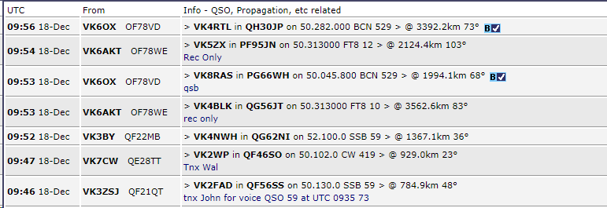

In addition, spots have lines drawn between the grid locators of stations on an interactive Google Map known as the DX path map. Legend and example are below which is self-explanatory.

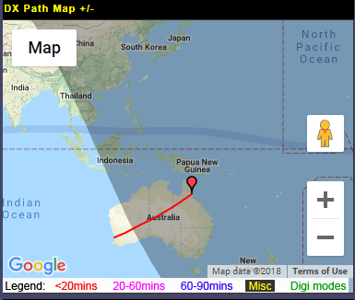

Calculations are also down in the spotted row as to the distance and azimuth from the spotted station.

A bearing and distance calculator is also available:

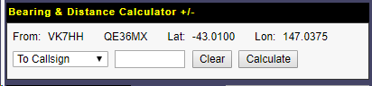

# iChat:

* General use chat window consisting of a limited amount of characters assisting in liasing with other stations on the logger. List of users displayed. Clicking on said user then prepopulates their callsign into the box as a message being sent to the particular user. User then gets a message that will be in a highlighted colour to stand out from the rest of the messages.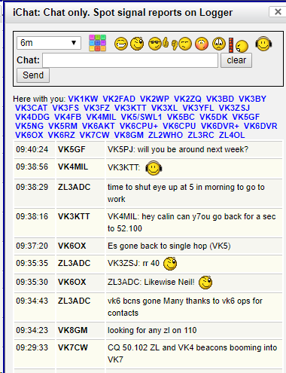

# Current User list:

* Displays all users currently logged in and active on the logger. Clicking on any callsign reveals “Op Info” that has been entered into that particular users profile at sign up, or updated at any time in “Profile”

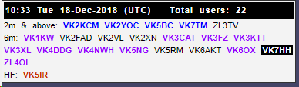

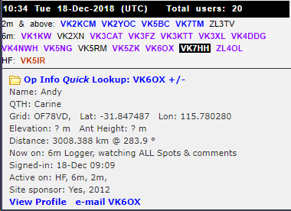

# Profile:

Profiles allow the user to update the following information (viewable) to others, which aids in contacting the said station. Such things such as the grid locator, Lat/Long also aids in the distance calculating process of the logger.

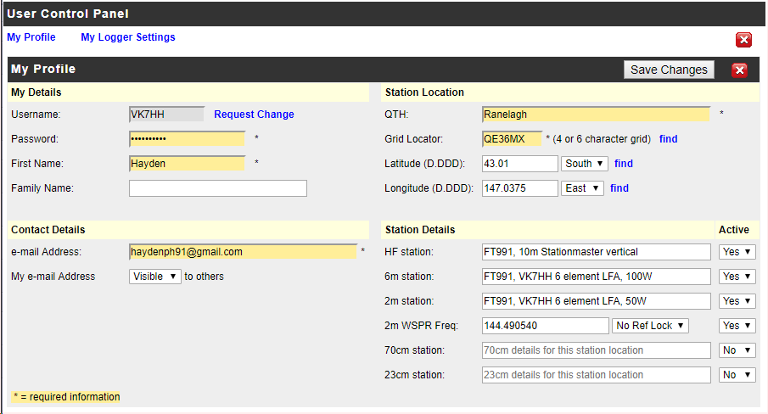

In addition to profiles an “Operator Information” tab is available allowing all users to search for other logger users to obtain the above information. The information in profiles are also used in the DX lookup portion of the Spotting process.

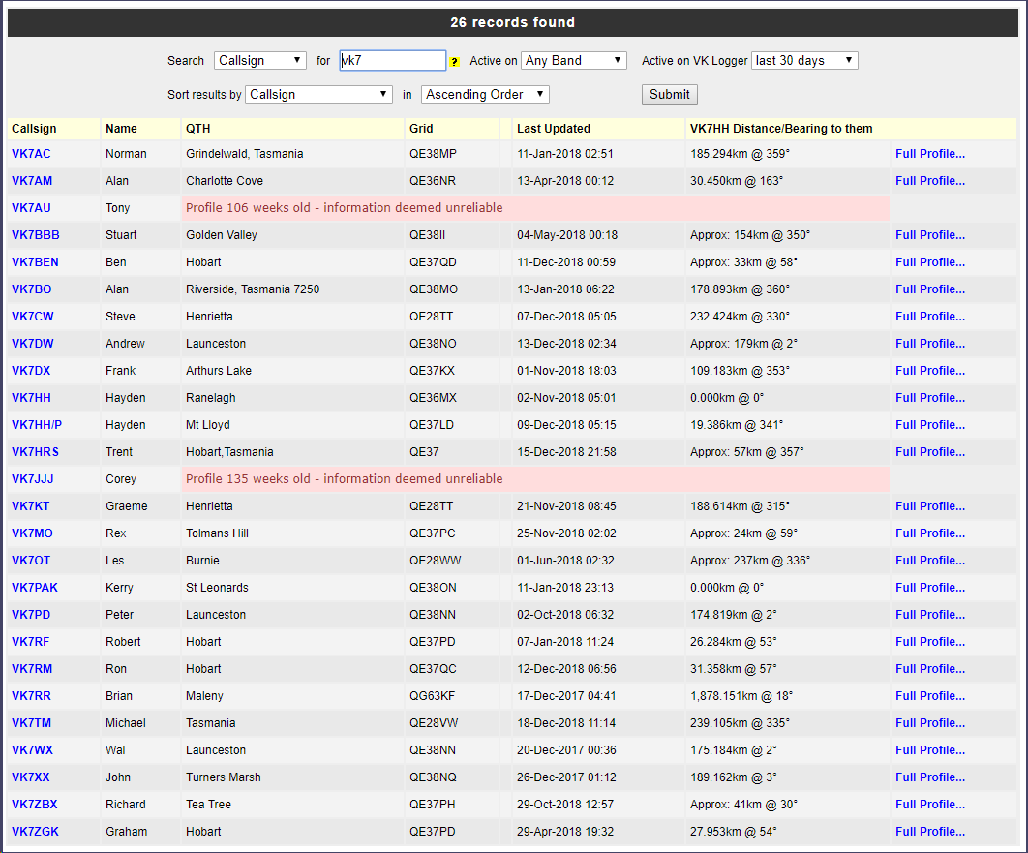

# Beacons:

An active list of beacons from 28MHz and above are available on the Logger. New beacons can be user submitted and existing entries can be updated either manually OR they are updated automatically when someone SPOTs them. As can be seen, the last 10 records of the beacon being spotted is available from the detailed page which is linked to the spots page.

Below is an example of a beacon list and the detail available:

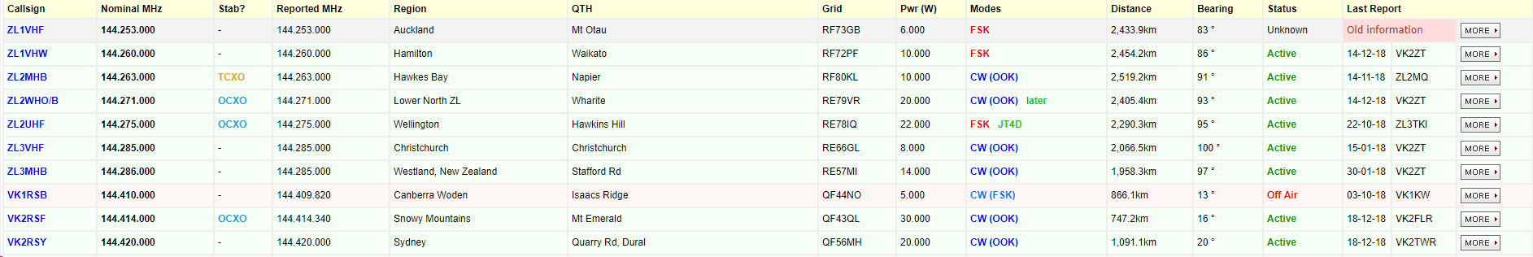

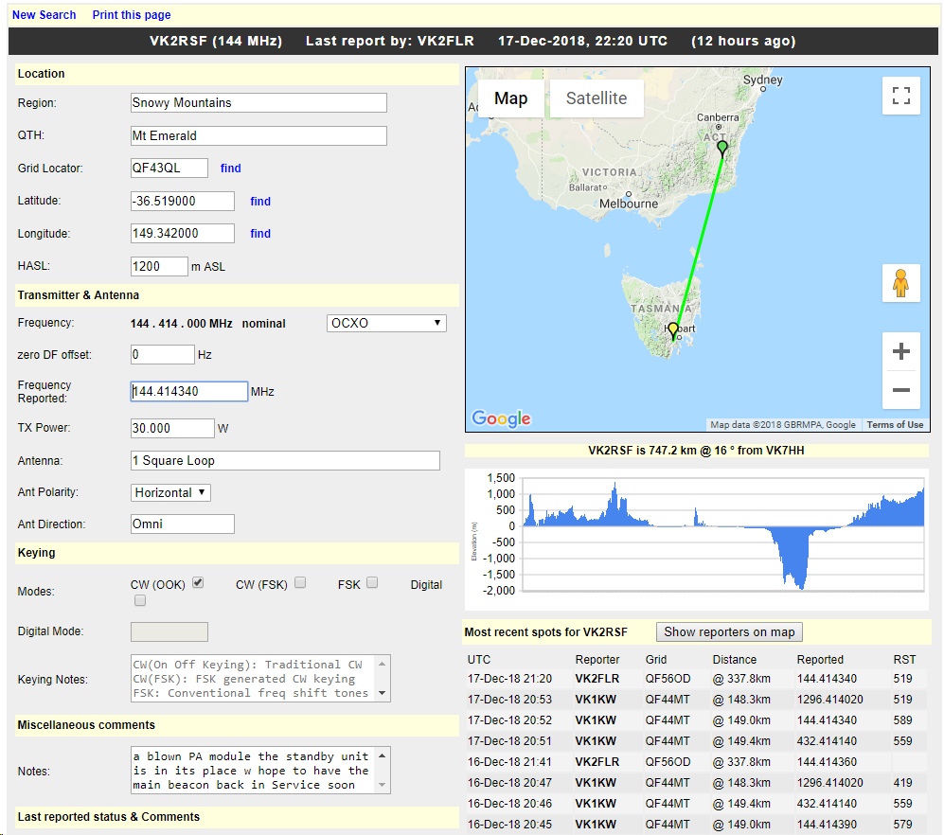

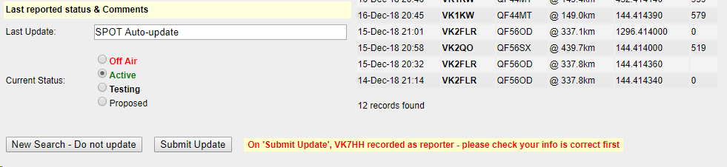

# Repeaters

A similar database is available for all active repeaters on 29MHz and above.

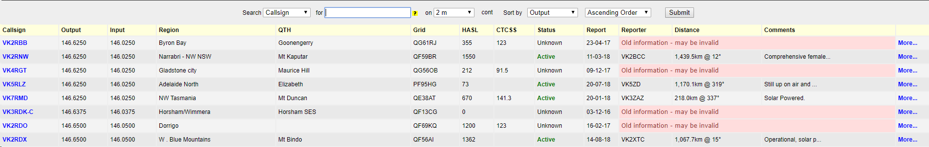

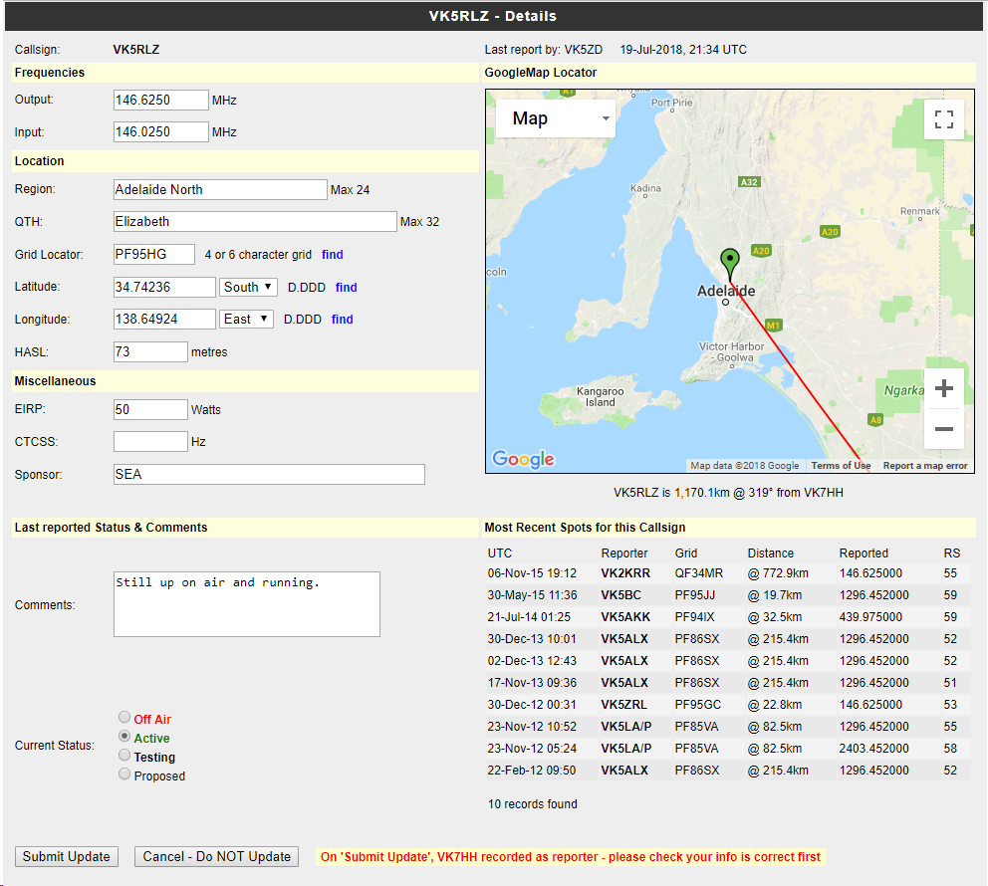

# History

A history of archived spots is available in a searchable format. This merely retrieves old spot data. Filters are listed below:

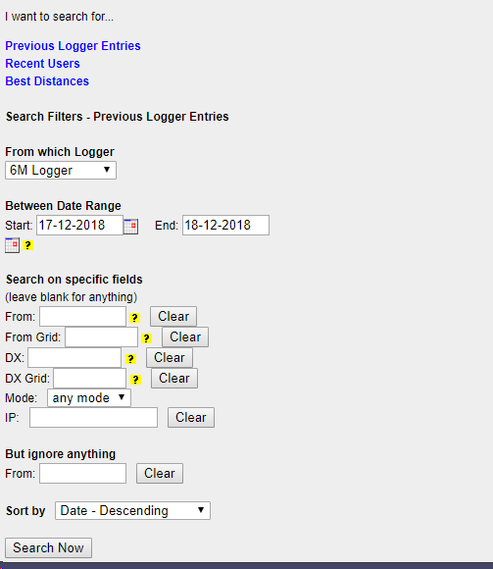

# Mapping Tool:

Lastly, a powerful mapping tool is available for users to plot paths, distances and draw lines etc between stations, repeaters, beacons etc.

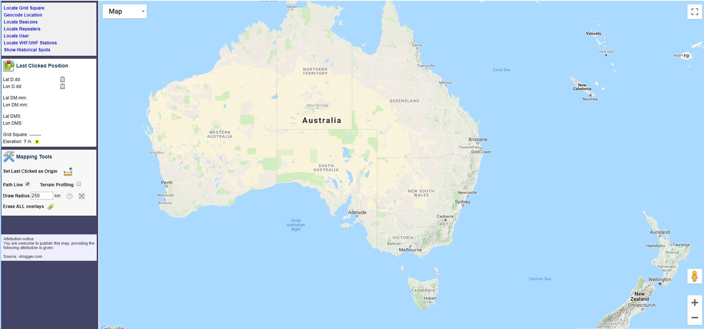

A more detailed explanation of this can be found at the following YouTube video (for now) –

<https://www.youtube.com/watch?v=PRkU3DW9Yow>