Test management tools
Testlink and Jenkins

Remark: Testlink is not working for Mac.

Installing Jenkins and Testlink

- Install Docker on your computer. https://docs.docker.com/desktop/install/windows-install/
- Download the archive vvss.zip.
- Unzip the archive in a directory.
- Open a Command Prompt as administrator to the unzip directory.
- Run the command: docker-compose up -d
- If needed, use the newer WSL kernel version.

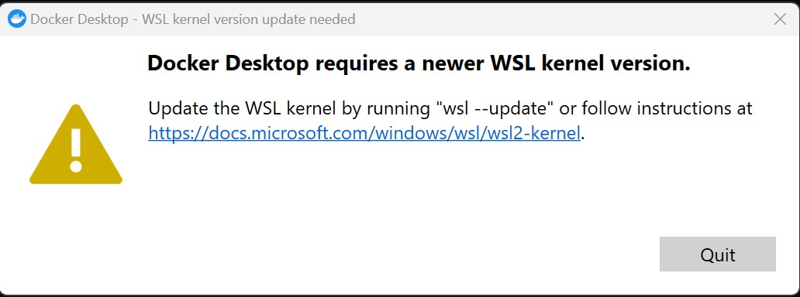

- Accessing Testlink
http://localhost:8090/
user:student
password:student

- Accessing Jenkins
http://localhost:8080/

user:student
password:student

Steps for using Testlink

User
http://localhost:8090/
user:student
password:student

Create a project
Each team will create a project for their SSVV project. Click the “Create” button and create
Example: Project_NameStudent1NameStudent2

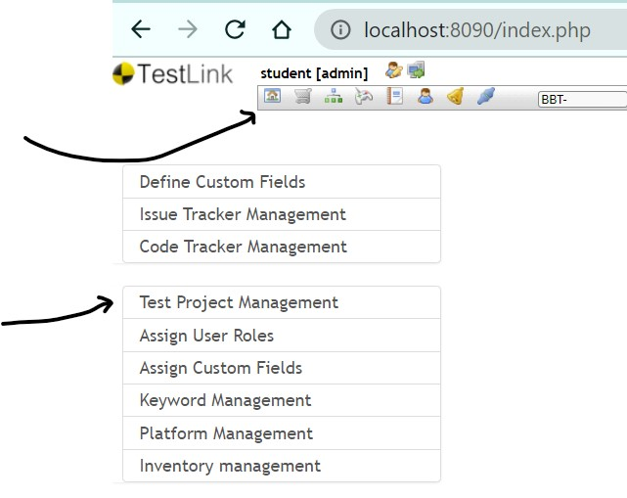

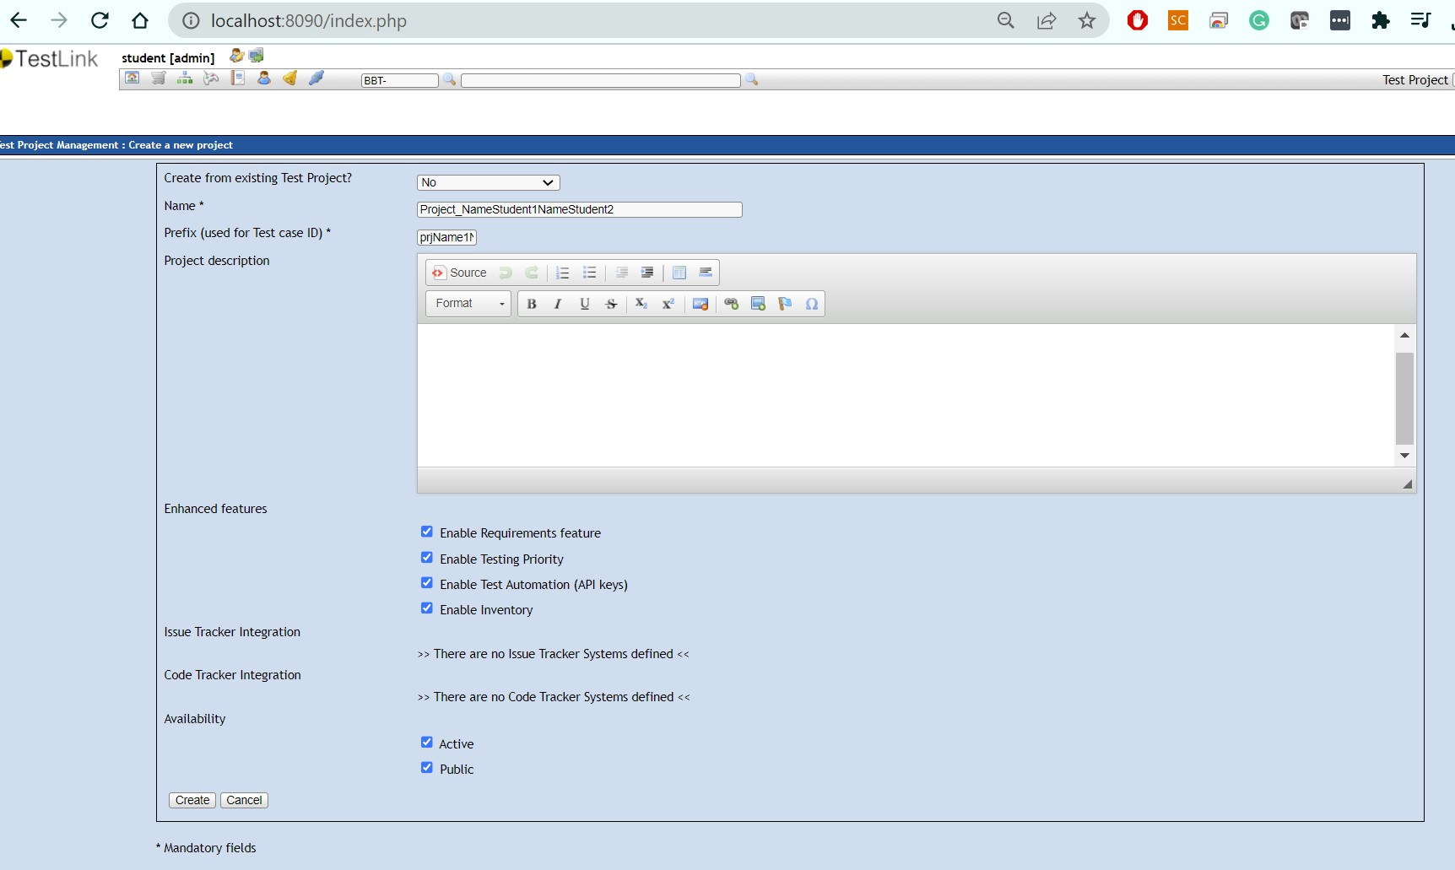

Assign custom fields

In the Project Menu, in the upper right corner select from the combo box your Test Project.
In the Project Menu, select Assign Custom Fields, select both JavaClassName and JavaTestMethodName and click button Assign.
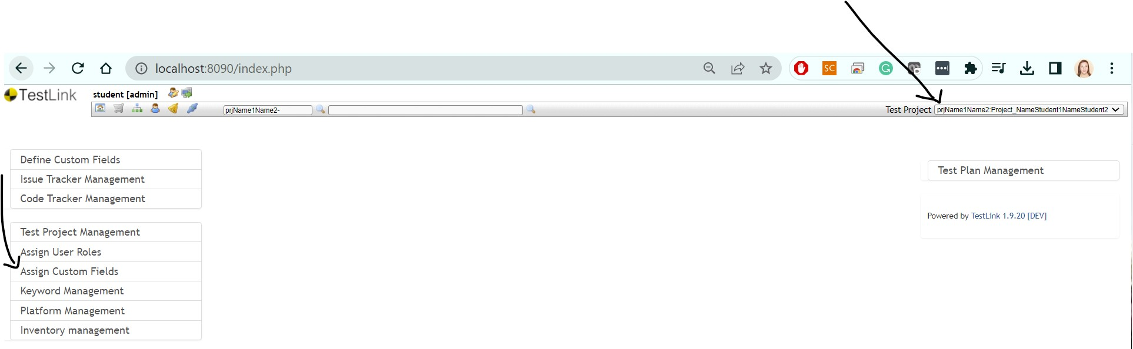

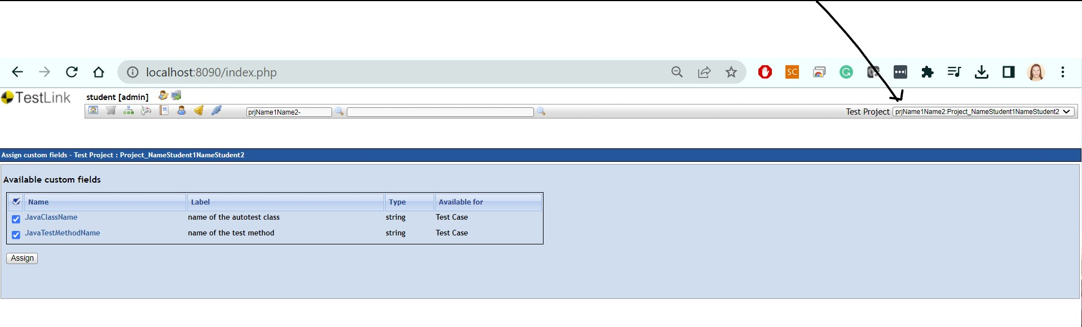

Create a Test Plan
Each team will create his/her own Test Plan, the name of the test plan will be composed by groupNumber followed by the names of the team members concatenated with TestPlan.
93X_Name01Name02_TestPlan

Select “Test Plan Management” and create the test plan using the naming convention above.

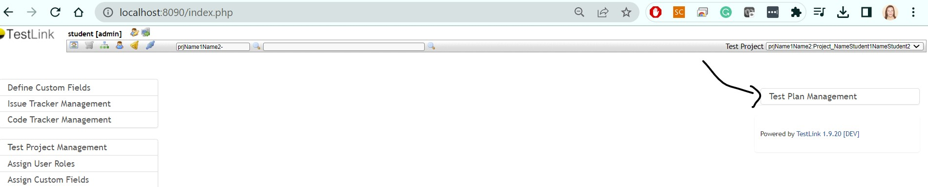

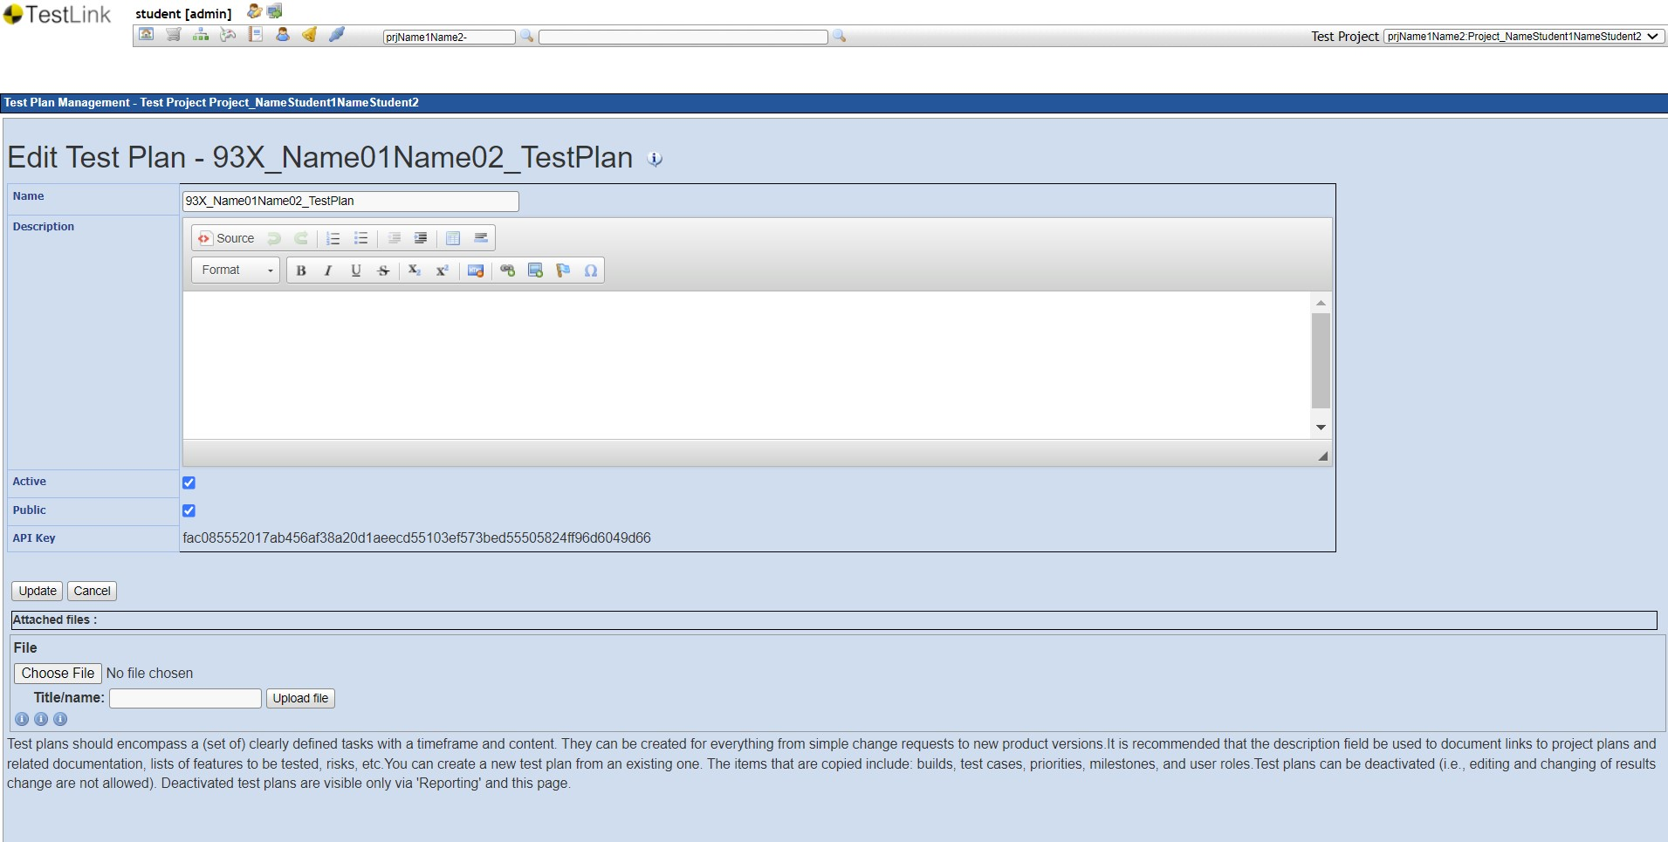

Create Test Suites/ Test Cases
Each student will create in total 3 test suites:
- 1 test suite from laboratory 2 - black-box testing
  - Test Suite Name = Name01Name02_BBT
- 1 test case from laboratory 3 - white-box testing
  - Test Suite Name = Name01Name02_WBT
- 1 test case from laboratory 4 - integration testing.
  - Test Suite Name Name01Name02_IntegrationT
Create Test Suites - STEPS
- Project/Desktop menu --> Test Specification section -->click on Test Specification
- Select your test project in navigation tree (left side screen)
- In the Test Suite Operations panel click on the Action button and then on the Create button.
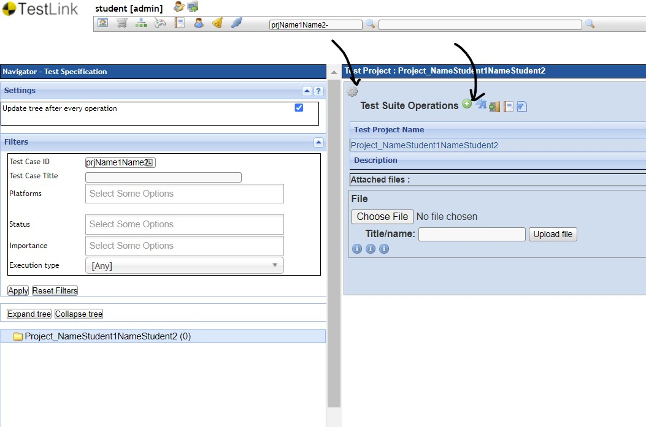

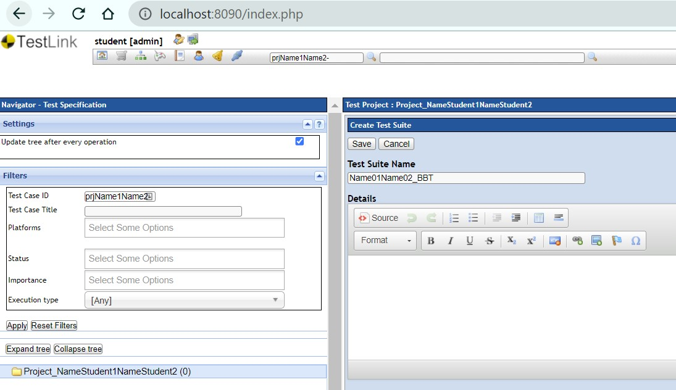

Create Test Cases - STEPS
- Select your test suite in navigation tree (left side screen)
- In the Test Suite Operations/ Test Case Operations panel click on the Create button (from Test Case Operation). Figure 6a and Figure 6b. Remember to modify Execution type to automated.
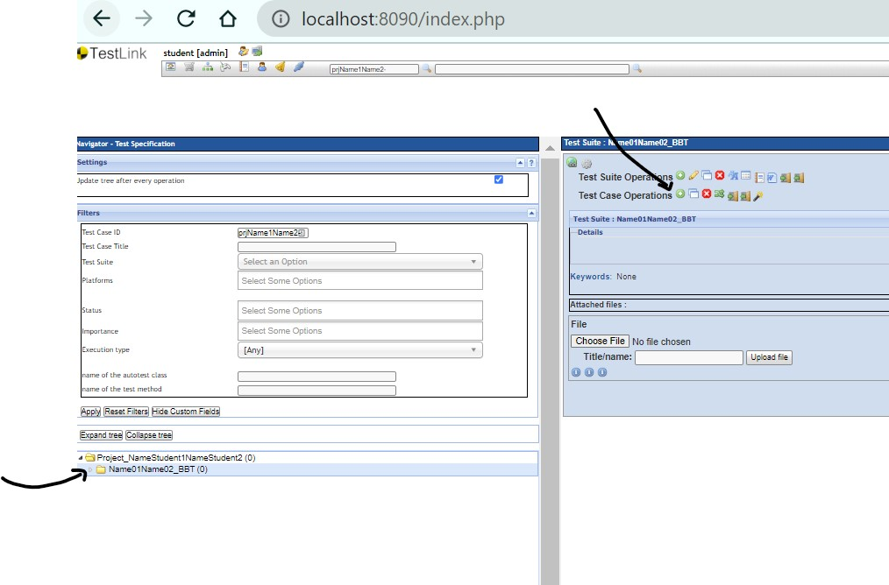

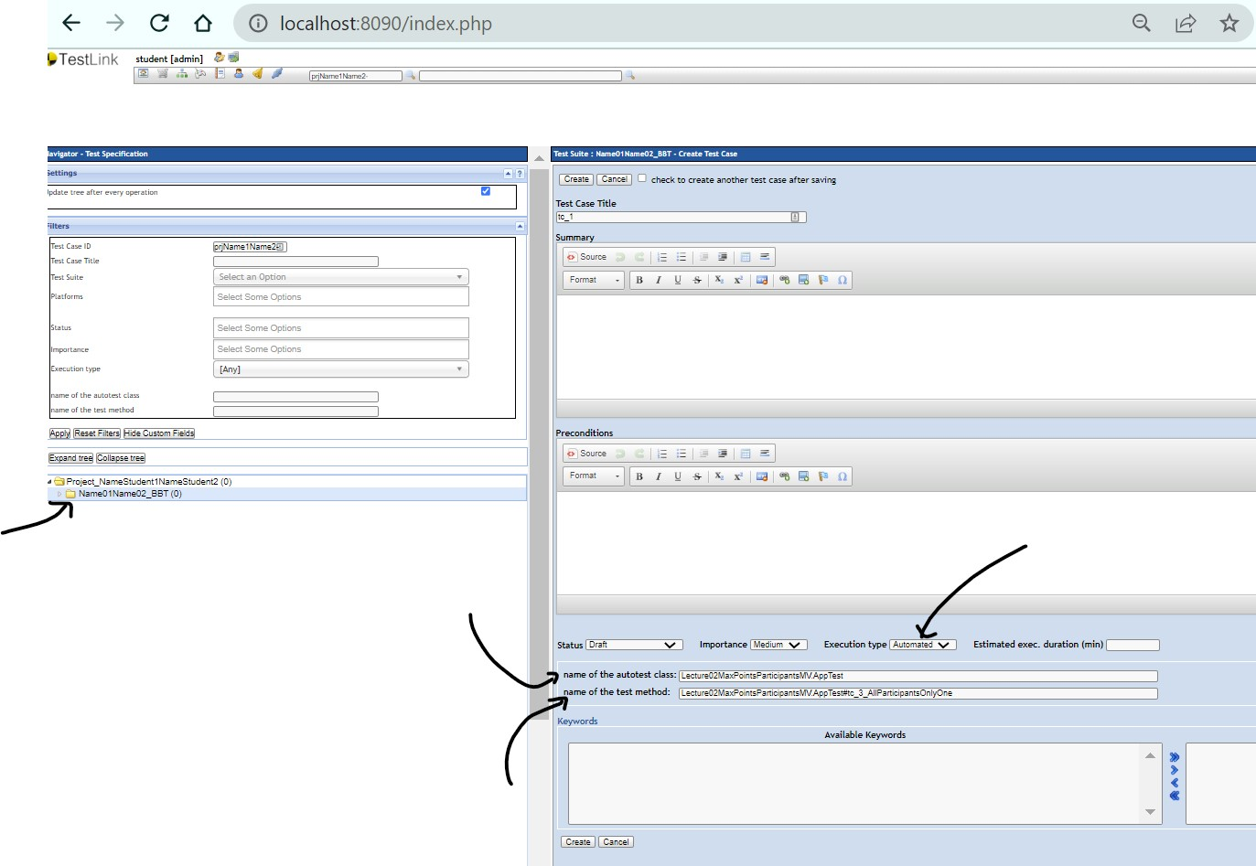

Add a Test Case to a Test Plan
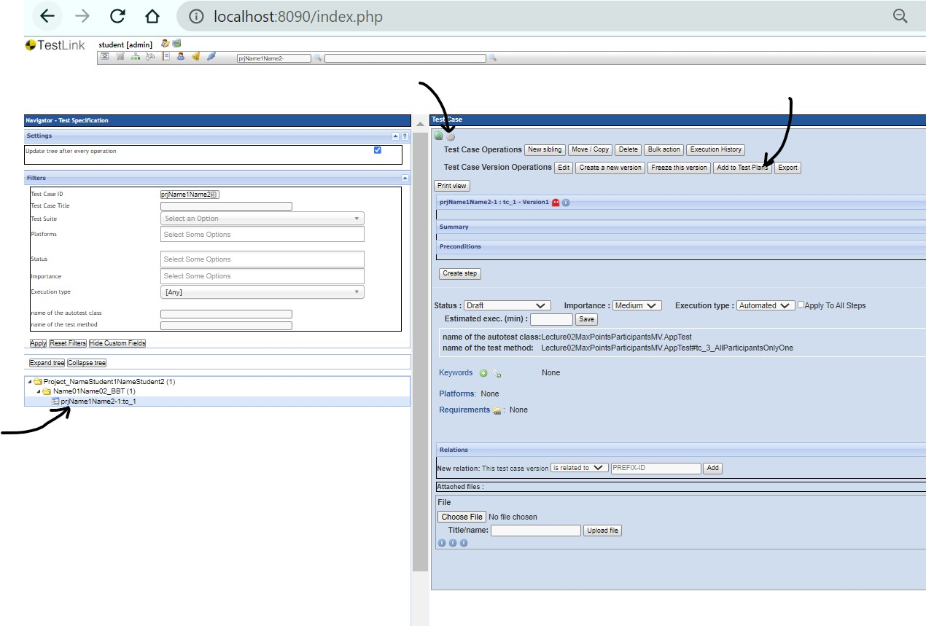

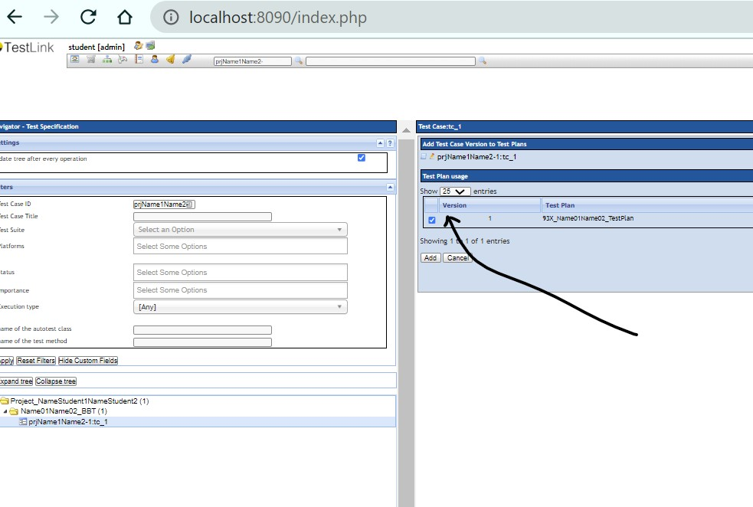

Steps for using Jenkins

User

Accessing Jenkins
http://localhost:8080/

user:student
password:student

Create a new Job

Each team will create his/her own Job (for the TestPlan created in Testlink), the name of the job will be composed of: groupNumber followed by the names of the team members concatenated with the word Job. (93X_Name01Name02_Job)
- for example, for one of the team in group 931 Pop and Popescu the name of the job will be:
  - 931_PopPopescu_Job.

Create a new Job from other existing job
- In the Dashboard, click on the + NewItem
- Use “Copy from”: Job_Lecture02_BBT
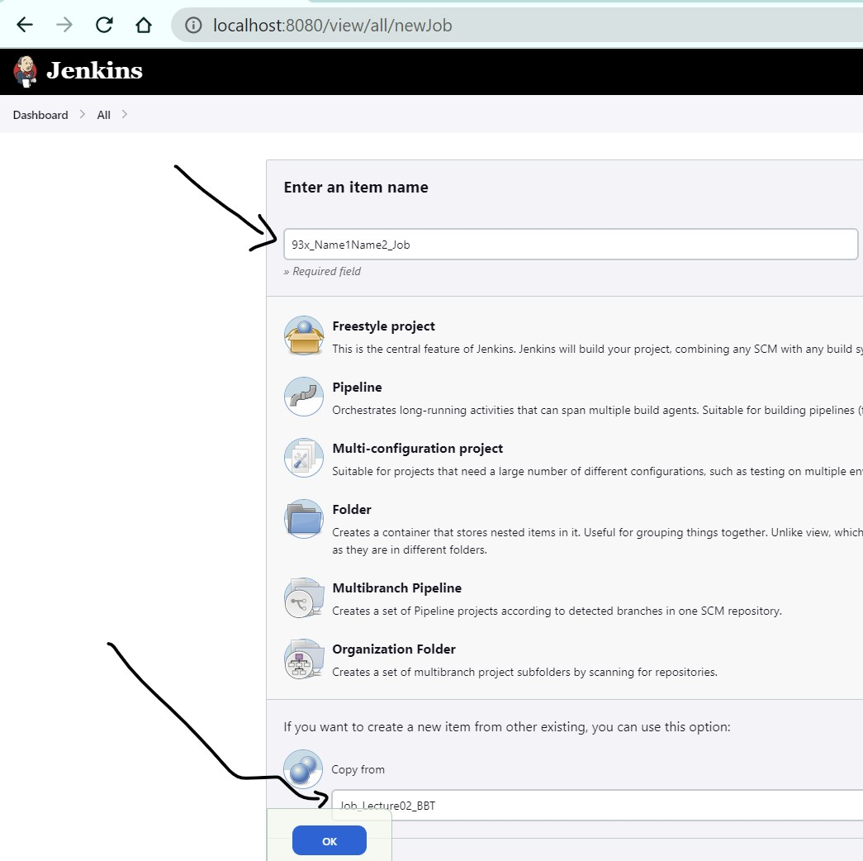

- Modify in your Job the following elements
  - Click on the created Job and click on the Configure (left side menu)

  - Github link with your Github link
  - Test Project and Test Plan with
    - Lecture01_Demo_BBT with Project_NameStudent1NameStudent2 (the name of the Project that you created in Testlink)
    - Lecture02_TestPlan_BBT with 93X_Name01Name02_TestPlan (the name of the Test Plan that you created in Testlink).

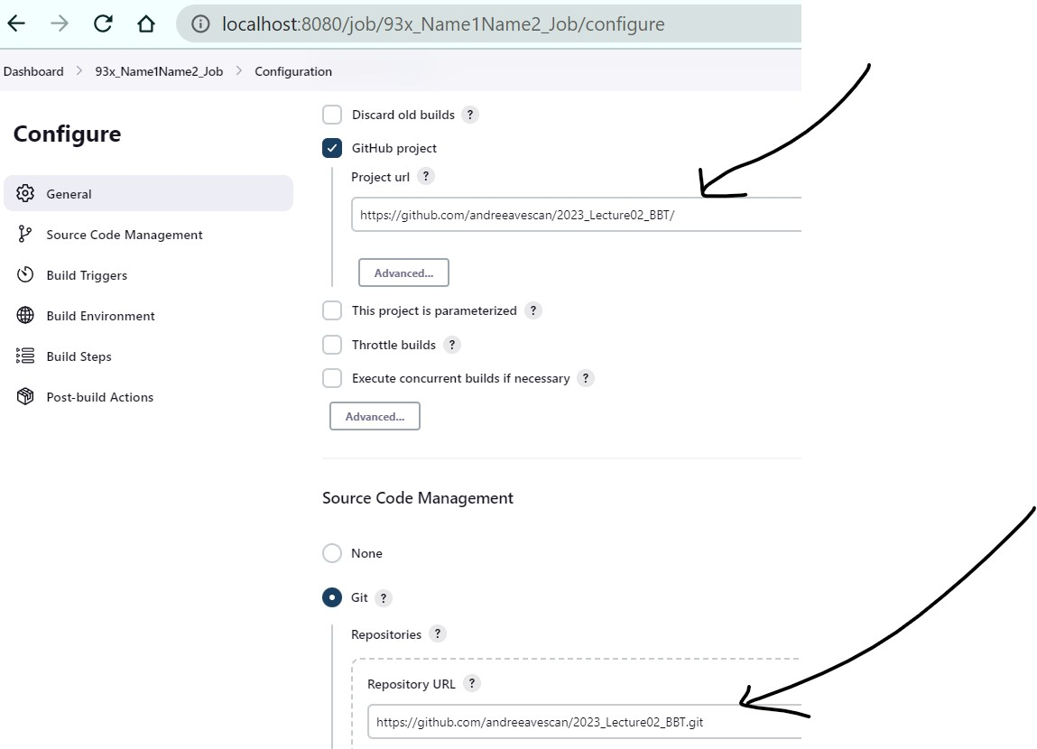

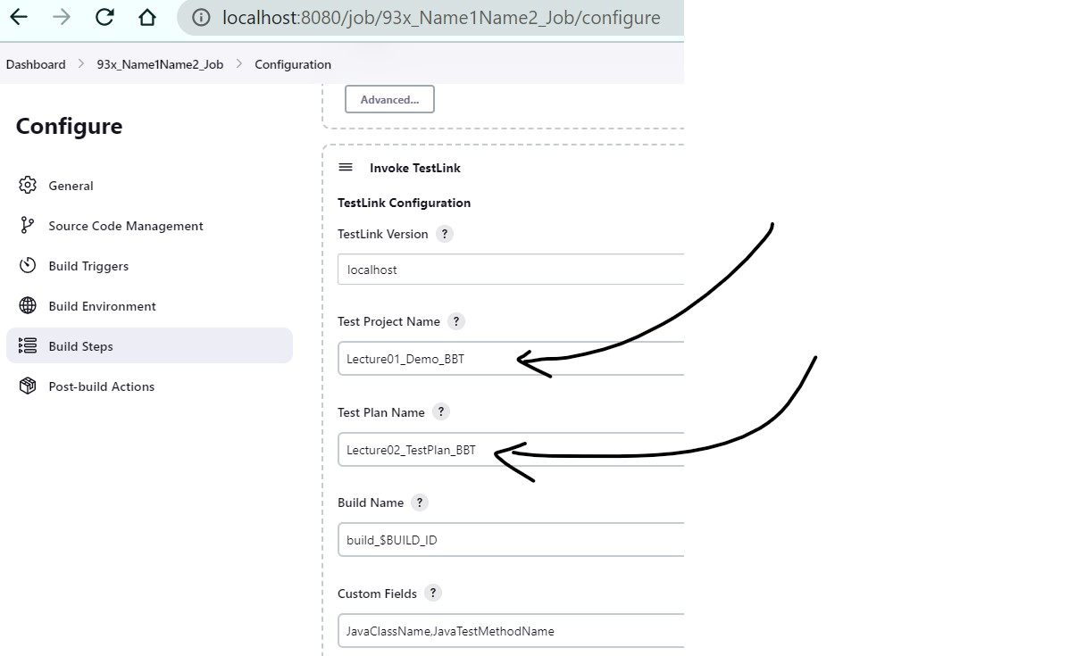

Build
  - Select the Job
  - Select Build Now
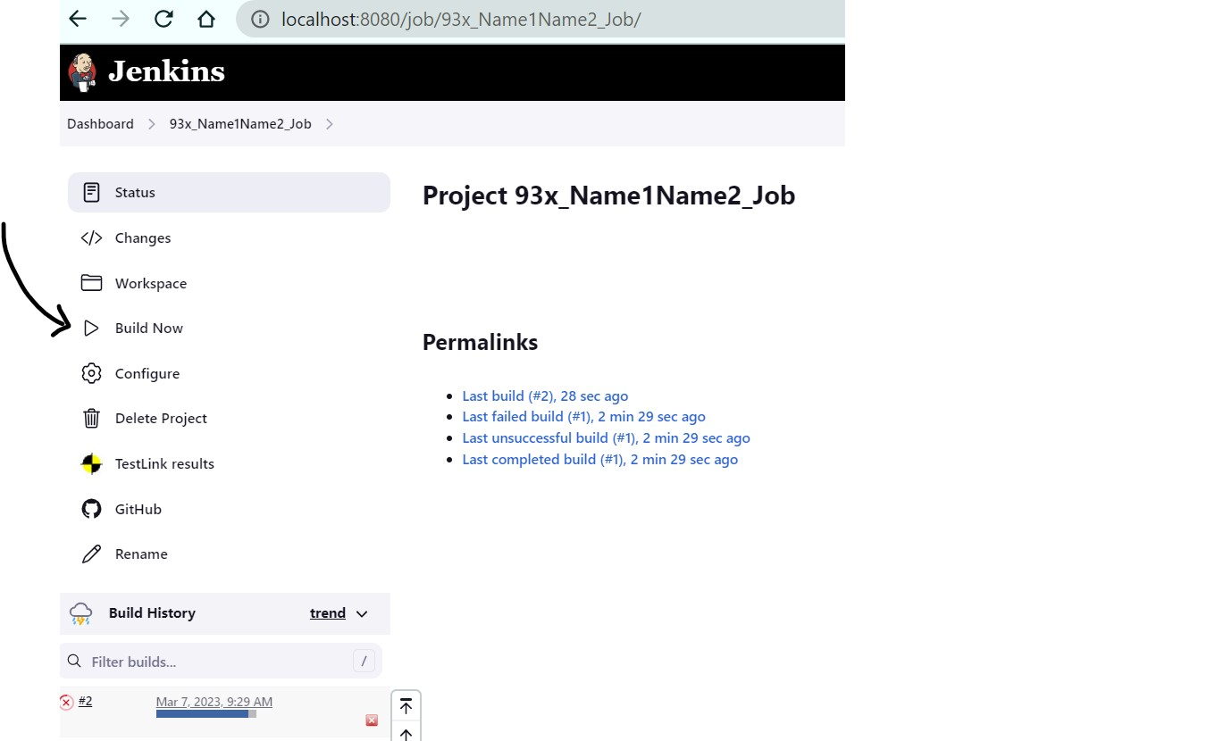

  - Console Output

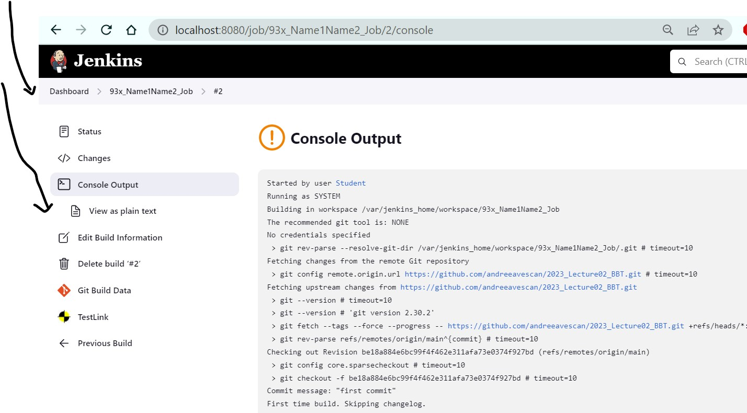

Sending results from Jenkins to Testlink
After successfully running the job, in Testlink it is updated automatically the status of the test cases in Not Run, Passed, Failed, or Blocked.

View the state of a Test case in Testlink
In the Execute Tests menu, within the chosen project, eg Projects931, a desired Test Suite is selected, e.g., abie1234_BBT, and a test case.

