Daniel Smith
Comp8005 Assignment 2 Comparing Server Implementations

COMP8005 Assignment 2

Comparing Server Implementations

Table of Contents
Comparing Server Implementations 2
Table of Contents 2
Table of Figures 3
Instructions 4
Objective: 4
Your Mission: 4
Constraints: 5
To Be Submitted: 5
Abstract 6
Introduction 6
Design and Functionality 7
Header 8
Client 9
Script 9
Multi-threaded Servers 10
Select 11
Epoll 12
Testing 12
Results 12
Light Tests 12
Multi-Thread 12
Select 13
Epoll 13
Stress Test 17
Multi-thread 17
Select 18
Epoll 19
Conclusions 19
Instructions to Run Programs 20
References 22
Websites 22
Files available on disk 22

Table of Figures
Figure 1 – Three way handshake 7
Figure 2 – Simplified view of how the echo server interacts with the client 8
Figure 3 - Sample output of the server’s looping child thread. 8
Figure 4 - Sample output from the client. The value is the current iteration for that client process. 9
Figure 5 – Multi-thread server spawning multiple child threads to handle each client 10
Figure 6 – How the select server handles clients 11
Figure 7 – Light test #1 on the multithread server 14
Figure 8 - Light test #2 on the multithread server 14
Figure 9 - Light test #1 on the select server 15
Figure 10 - Light test #2 on the select server 15
Figure 11 - Light test #1 on the epoll server 16
Figure 12 - Light test #2 on the epoll server 16
Figure 13 – Stress test done on muti-threaded server 17
Figure 14 – Stress test done on select server 18
Figure 15 – Stress test done on epoll server 19

Instructions

Objective:
To compare the scalability and performance of the select-, multi-threaded-, and epoll-based client-server implementations

Your Mission:
Design and implement three separate servers:
1. A multi-threaded, traditional server
2. A select (level-triggered) multiplexed server
3. An epoll (edge-triggered) asynchronous server
All the servers must be designed to handle multiple connections and transfer a specified amount of data to the connected client. To simplify things you may want to simply implement an extended (or more sophisticated) echo server.
You will also design and implement a client that really is no more complex in this case then an echo client. However each client will have the ability to send variable-length text strings to the server and the number of times to send the strings will be a user-specified value.
Note that you will need to have the client maintain the connection for varying time durations (depending on how much data and iterations). The idea is to keep increasing the load on the server until its performance degrades quite significantly. In other words we want to measure how many (scalability) connections the server can handle, and how fast (performance) it can deliver the data back to the clients.
To that end you will have to maintain statistics on both the server and the clients.
In order to have a meaningful test you will need to generate client requests from multiple machines but each machine can have many instances of the client as well.

Constraints:
• The server will maintain a list of all connected clients (host names) and store the list together with the number of requests generated by each client and the amount of data transferred to each client.
• Each client will also maintain a record of how many requests it made to the server, the amount of data sent to server, and the amount of time it took for the server to respond (i.e., echo the data back).
• You are required to summarize all your data and findings in a properly formatted technical report. Make extensive use of tables and graphs to support your findings and conclusions.
• You may want to make use of the libevent library to track all your events and the associated performance statistics.
• You can find more about this library at: http://www.monkey.org/~provos/libevent/

To Be Submitted:
• You are also required to demonstrate your working programs during the lab the day the assignment is due.
• Ensure that you clearly explain in detail, all of your testing procedures for your programs and summarize your results in tabular and graphical form. Provide test programs if necessary.
• Hand in complete and well-documented design work (pseudocode, MHDs or STD’s) and listings of your program.
• Provide all your code listings, test results, documentation, and an executable file on a disk.

Abstract
This paper demonstrates the scalability and performance of multi-threaded, select, and epoll based servers. Each server is flooded with a surge of client connections until they crash or slow down in performance. I predict that epoll would be the most effective server to run while a multi-threaded server would get overwhelmed by clients very quickly.

Introduction
Writing a server that interacts with a few clients is very simple. However we have to worry about how our server handles 20,000+ connections at the same time. If it’s not handled properly then the server will most likely slow down, freeze up, or just crash. The purpose of this assignment was for us to experiment with the old ways of programming servers then to be shocked at how big an improvement epoll programming is. The only downside is that there’s not a lot of documentation with epoll other than a man page and an faq on the website.
Multi-threaded servers seem very risky, at least the way I designed it, because it essentially makes a child thread for every new client connection. This is very easy to exploit with a surge of clients. With enough connections this server will run out of memory very fast.
Select’s weakness is that it can only handle up to what the Linux kernel allows. If you ever wanted to increase this amount it would require recompiling the kernel, which is very tedious especially when you have to do so multiple times for testing.
Epoll is supposedly the savior of socket programming. If programmed correctly it should be able to handle a surge of clients echoing a large amount of data back and forth without slowing down or crashing. According to what I overheard from the full time datacomm students, they were able to harass their epoll servers with large chunks of data until they had around 10,000+ active connections, which then caused problems with their server.

Design and Functionality
All of the coding was done in C and was meant to be run on the Linux operating system. As a stepping stone I used the sample code from milliways.bcit.ca which was written by Aman Abdulla. These files contained the basic error and socket handling required for this assignment. The server will listen for clients, allow them to connect (figure 1), then listen for data to be sent, which in turn the server will echo the data back (figure 2). This will be done multiple times specified by the user.
To make coding easier, I merged a bunch of the globals used in every c file into a header file. A thread is used in all three servers to run a loop which reports on the number of active connections, total connection errors, total completed connections, and the number of completed connections since the last report (which is set in the header.h file). Figure 3 shows what the server’s output looks like.

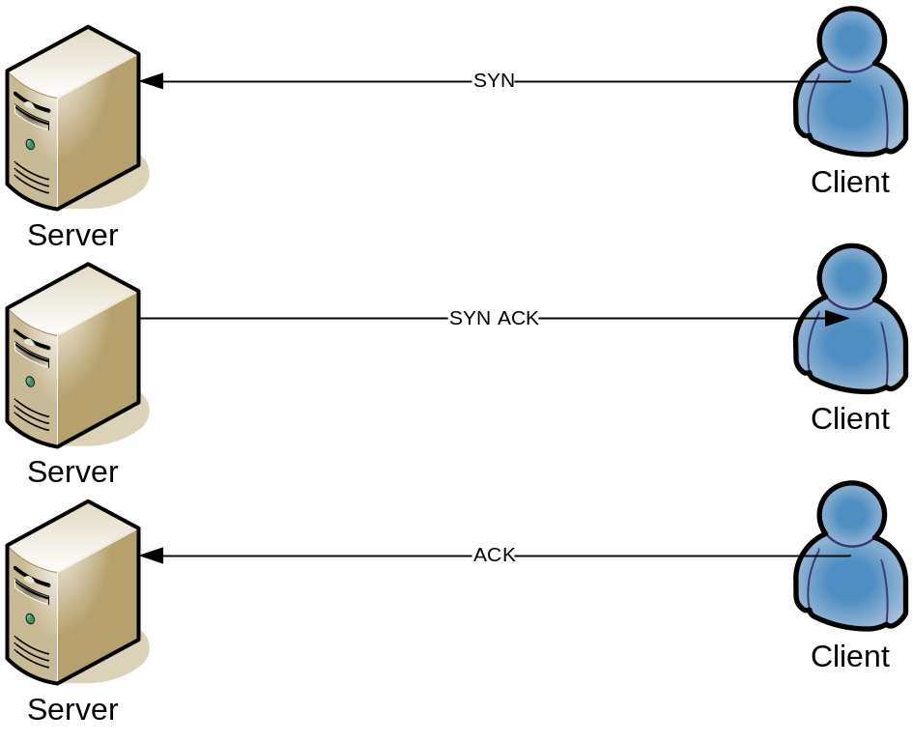
Figure 1 – Three way handshake

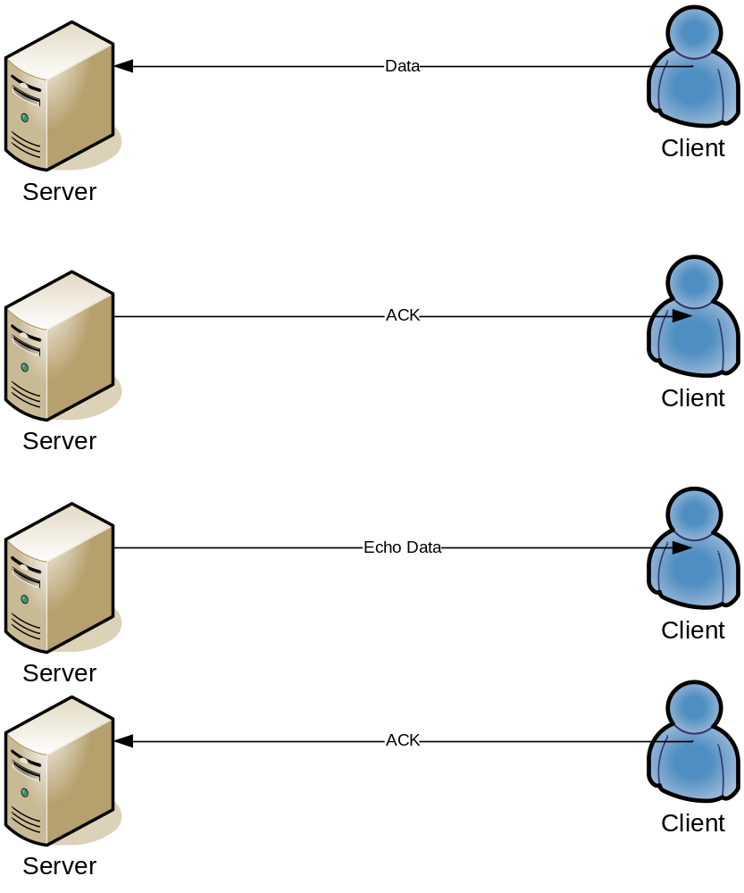
Figure 2 – Simplified view of how the echo server interacts with the client
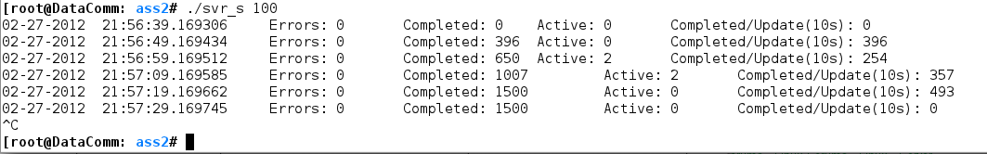
Figure 3 - Sample output of the server’s looping child thread.

Header
This header file contains the globals used in all 4 c programs. To change the number of seconds between each server report, change the value of RECORDTIME.

Client
A simple client program that attempts to connect to a given server. Once connected, the client will send a user defined string as data. It will also listen for the same data to be echo’d back from the server. There isn’t much advanced coding in here so there’s a chance that the client could hang if the server “forgets” about the connection. This could be solved by implementing heart beats.

Script
A bash script that runs the client program 20000 times. Use this script to stress test the servers. Reference figure 4 to see what the script output looks like. If the output is too cluttered with the iteration counts, then you can comment out the line of code under clnt.c lines 117 and 127 then recompile using make.
116 printf("Sending large string to %s - ", hp->h_name);
126 printf("Receiving large string - %i\n", i+1);

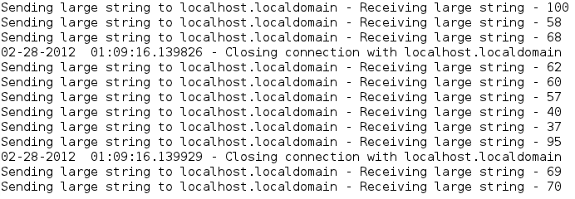
Figure 4 - Sample output from the client. The value is the current iteration for that client process.

Multi-threaded Servers
Multi-threaded servers are easy to code but really dangerous the run. Without setting rules and checking for the correct errors, you could quickly run into problems, such as the server’s performance dropping. The multi-threaded server was implemented so that every accepted client connection would spawn a new child thread which would handle all the data echoing. This runs fine with a few clients but can quickly slow down when the number increases. Figure 5 demonstrates a simple example of how the threads are used.
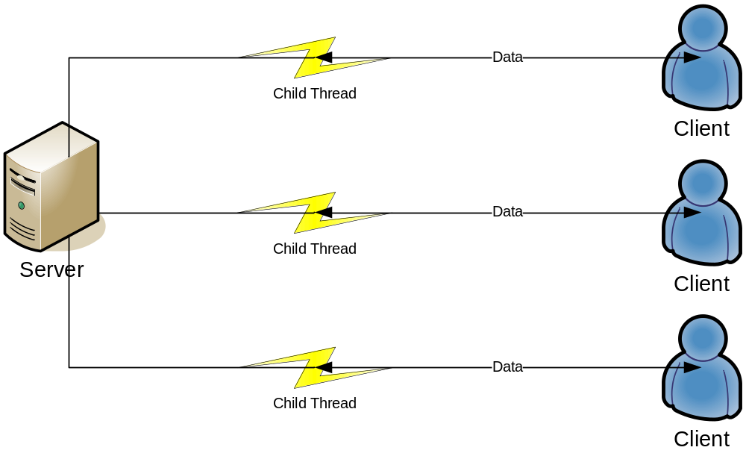
Figure 5 – Multi-thread server spawning multiple child threads to handle each client

Select
The select server listens for client connection requests. It will establish connections with the clients and periodically check for any clients that have data sent. The server will receive the data then echo it back. This process repeats just like the multi-threaded server. Reference figure 6 to see how select searches for clients with data.
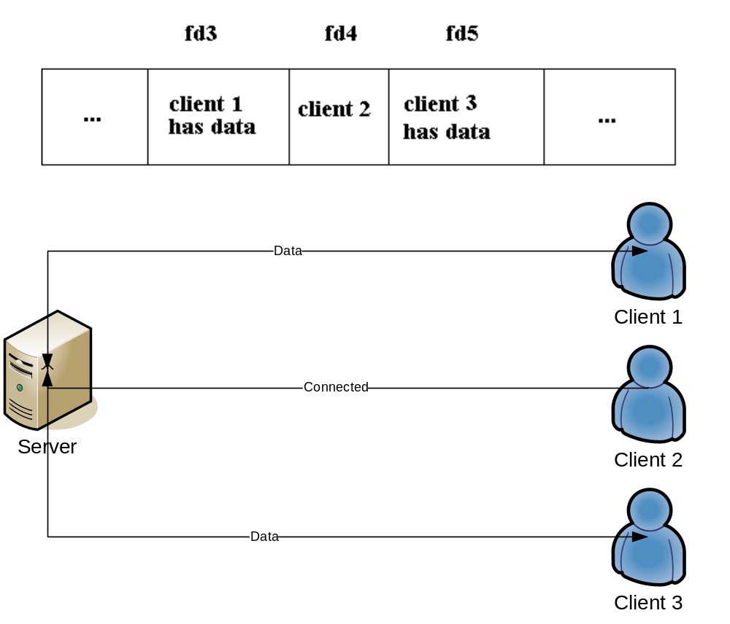
Figure 6 – How the select server handles clients

Epoll
Epoll is the modern way to handle network programming because of how efficient it is with multiple connections hammering it with data. It’s an edge-triggered call which basically means it notifies you when changes are made. The epoll server is designed similarly to the select server only it does not crash and handles many more client connections with higher efficiency.

Testing
I tested all three servers with 2 simple tests as well as a stress test. Netstat was used during all these tests to see if the connections were accurate. The first two tests sent 1000 clients from 2 computers to the server with X number of iteration loops and Y length of the data string. The time it took to complete, and missing connections (connections that weren’t closed and aren’t making any progress) will be documented as well as the highest number of active connections and the number of completed connections if it crashed. The graphs in the figures below represent packets/second.

Results

Light Tests

Multi-Thread
 | 100 iterations and 5 length data | 100 iterations and 500 length data
Time taken to complete all connections | 20 seconds with 1446 completed | 20 seconds with 1406 completed
Missing connections | 554 | 594
If crashed: number of completed connections | NA | NA
Highest active connections | 2000 | 2000

Select
 | 100 iterations and 5 length data | 100 iterations and 500 length data
Time taken to complete all connections | 30 seconds with 1020 connections | Crashed once. 20 seconds on second attempt with 1025 connections
Missing connections | 980 | 975
If crashed: number of completed connections | NA | Crashed right away first time. None completed that time.
Highest active connections | 1025 | 1108

Epoll
 | 100 iterations and 5 length data | 100 iterations and 500 length data
Time taken to complete all connections | 20 seconds with 1909 connections | 20 seconds with 1916 connections
Missing connections | 91 | 84
If crashed: number of completed connections | NA | NA
Highest active connections | 1510 | 1076

Figures 7 to 12 display the packet activity on the server for each test in their respective order.
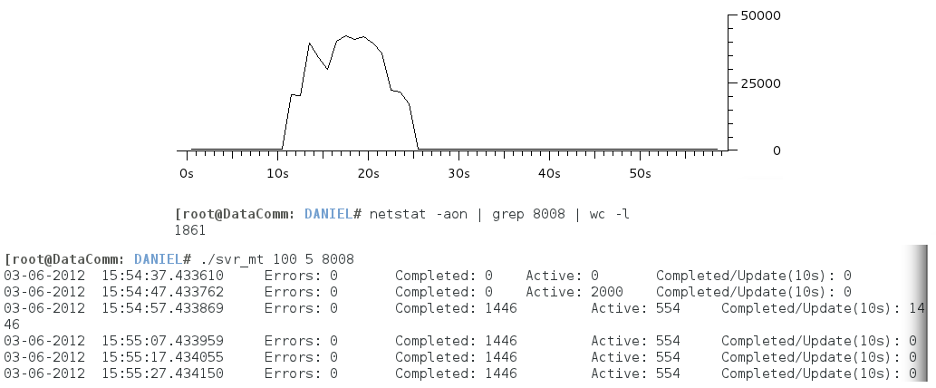
Figure 7 – Light test #1 on the multithread server

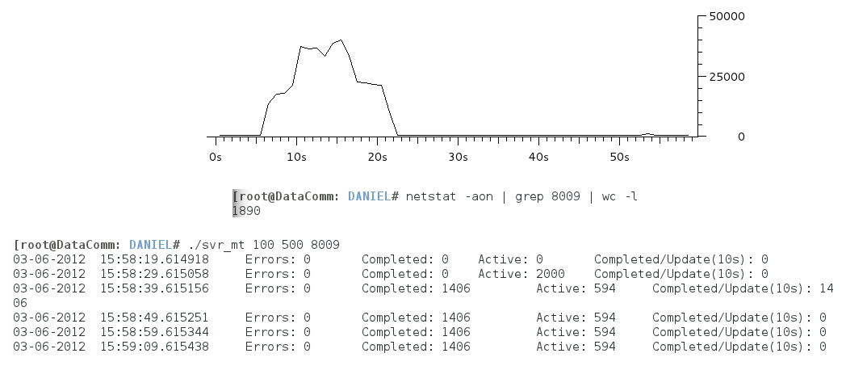
Figure 8 - Light test #2 on the multithread server
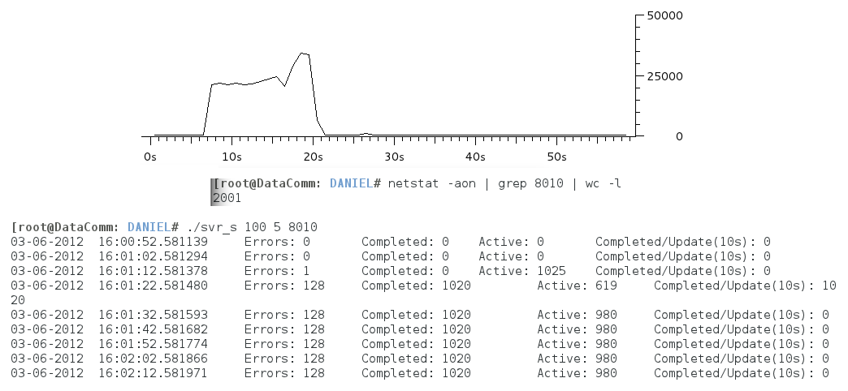
Figure 9 - Light test #1 on the select server

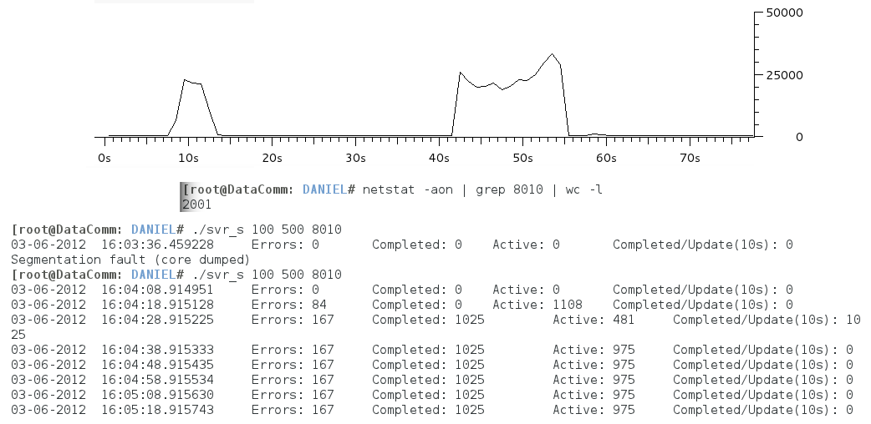
Figure 10 - Light test #2 on the select server
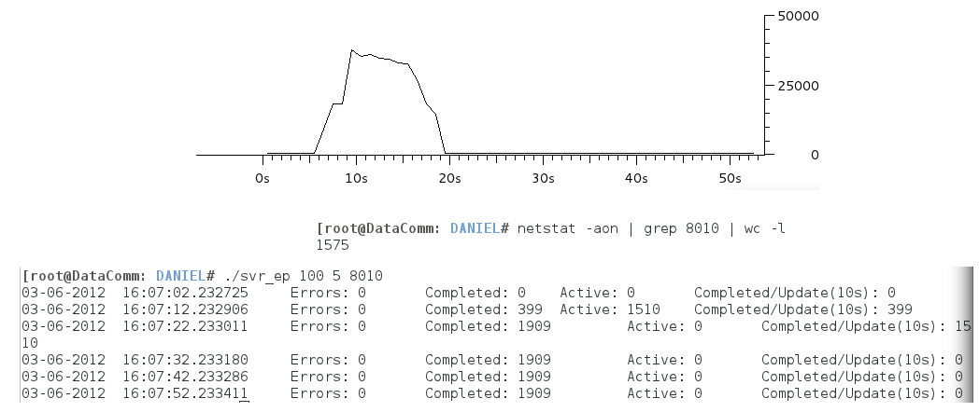
Figure 11 - Light test #1 on the epoll server

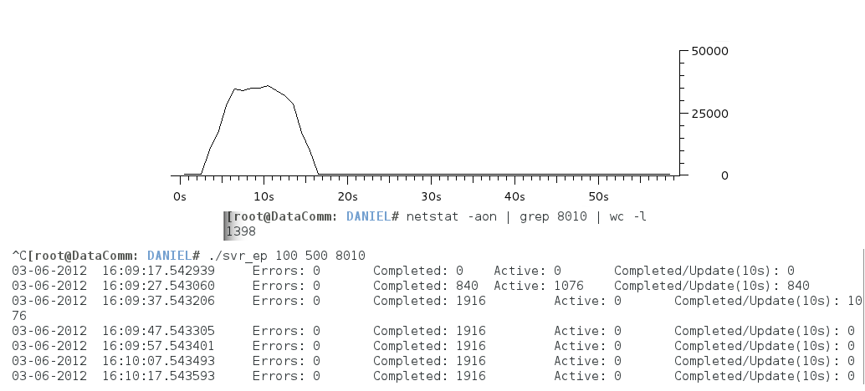
Figure 12 - Light test #2 on the epoll server

Stress Test
The stress test had each computer sending 20,000 clients to the server requesting 1000 echo iterations of a 1000 length string.

Multi-thread
The multi-threaded server was handling this the worst. It would accept all connections and work with all of them but it ate up all of the computer’s memory. It was so bad that I couldn’t even use “killall svr_mt” because the system couldn’t allocate the memory to do so. No graph because, again, the system couldn’t allocate the memory to capture packets.
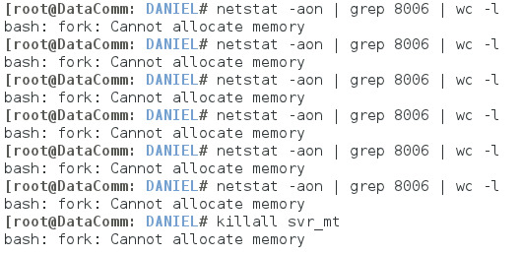
Figure 13 – Stress test done on muti-threaded server

Select
Select also did poorly. Half the time it would crash and the other half it could only have a max of 1699 active connections to work with. It was extremely slow and took minutes because any of the connections finished their iterations. Every client connection attempt after the first 1699 was declined by the server.
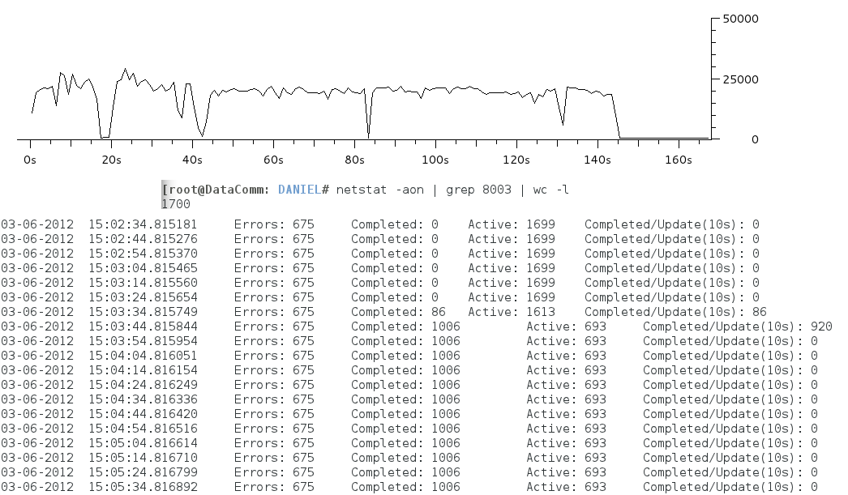
Figure 14 – Stress test done on select server

Epoll
Epoll was the champion of the servers used. Not only did it handle up to 30,000+ connections at once, it would complete the iterations with around 137 connections every 10 seconds. The server wasn’t receiving any loss of performance or slowdown so epoll is the obvious winner out of the 3.
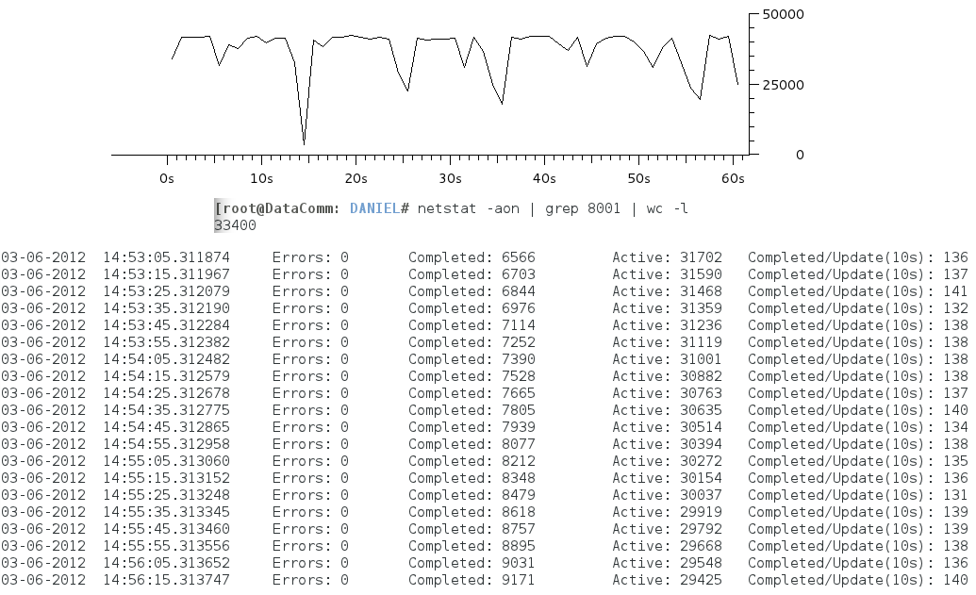
Figure 15 – Stress test done on epoll server

Conclusions
The epoll server was the most efficient server out of the three. Multi-threading just seems so dangerous by today’s standards and select is restricted by the kernel. As explained in the documents on milliways, multi-threading can’t keep up with today’s hardware, high speed networks and heavy loads. Epoll is able to perform more effectively than select because of the way its algorithm is coded.

Instructions to Run Programs
To run the programs you must first be using a Linux machine. You’ll then need to compile all the source code. This can be done by using the makefile. In order to compile these files you much have a C compiler as well as the GMP developer library. If you are using Fedora then you can easily install this library with the following command.
$ yum install gmp-devel

It’s a good idea to reset the iptables on the datacomm room computers in case a firewall is currently running.
$ iptables –X
$ iptables –F

For better results you should also set the ulimit to a value higher than it’s default: 1024.
$ ulimit –n 60000

To compile the code you must use the following makefile command.
$ make

You can run the servers with these commands. 1000 is the number of times the data will be echo’d back and forth from the server and the client. 5000 is the length of the string sent. Both of these values must match the clients. Press CTRL+C to stop the server. Please note that the select server may crash when mass clients attempt to connect. It won’t always crash though so keep trying until it works.
$ ./svr_mt 1000 5000
$ ./svr_s 1000 5000
$ ./svr_ep 1000 5000

After one of the servers are running, you can run the client program to test the connection. localhost will only work if you’re testing the server and client on the same computer. Otherwise you will need to put in the server’s ip address. The last argument is the size of the data that will be sent. Using 1 will send “a”, using 5 will send “aaaaa”, and so on.
$ ./clnt 192.168.0.11 1000 5000

You can also run the bash script file that will send a large amount of client requests from the same machine. It is currently scripted to run the client 20000 times each time you run it. You will need to modify the ip address of the server for this script to work properly.
$ sh clntscript.sh

An easy way to stop all the clients is to use the following linux command:
$ killall clnt

Netstat is a handy linux tool to use to see the activity on ports. Change 7001 to whatever port you’re using.
$ netstat -aon | grep 7001 | wc -l

References

Websites
In order to compile the code you will need to have the GMP developer library installed on your Linux machine.
- GMP Website: http://gmplib.org/
I used code from the following online source.
- http://milliways.bcit.ca/c8005/

Files available on disk
- DanielSmith_Assignment02.doc
- clnt.c
- clntscript.sh
- header.h
- Makefile
- svr_ep.c
- svr_mt.c
- svr_s.c

