DEPARTMENT OF COMPUTER SCIENCE & ENGINEERING
PROJECT SYNOPSIS — ACADEMIC CAPSTONE / MAJOR PROJECT
Design and Simulation of a Hierarchical Multi-Agent AI System for Intelligent Group Elevator Dispatching in Multi-Zone High-Rise Buildings
Project Team Members:  • Divyanshu Yadav (Lead Researcher & System Architect)  • Viraj & Co-developer (Core Algorithm & Simulation Engineering)  • Vaibhav (Documentation, Technical Writing & Quality Assurance) | Supervision & Track:  • Supervisor: [Faculty Guide / Dr. / Prof.]  • Domain: Multi-Agent RL, Distributed Systems & Simulation  • Platform: Python 3.10+, PyTorch, SimPy, Pygame
1. INTRODUCTION & MOTIVATION
In modern multi-storey buildings, vertical transportation accounts for 5% to 15% of total building electrical energy and represents a critical bottleneck. Conventional Elevator Group Control Systems (EGCS) rely almost exclusively on static, deterministic dispatching heuristics (e.g., Nearest Car/ETA, Full Collective, or LOOK/SCAN). These rigid rules fail under non-stationary stochastic passenger surges—particularly morning Up-Peak, evening Down-Peak, and lunchtime Inter-Floor mobility. Crucially, static heuristics cause elevator bunching (cars shadowing one another along the same trajectory, starving other floors) and cannot anticipate demand under partial observability. This project develops an intelligent Group Elevator Controller utilizing a Hierarchical Multi-Agent System (H-MAS) combined with Multi-Agent Reinforcement Learning (MARL / MAPPO) and proactive idle parking to minimize passenger wait times, journey times, and empty car travel.
2. PROBLEM STATEMENT & MATHEMATICAL FORMULATION
Given an N-floor building serviced by M independent elevator cars under a traditional Two-Button Hall-Call Interface (UP / DOWN):
1. Partial Observability: When a passenger pushes the UP/DOWN button at floor i, the destination floor and passenger count remain strictly unknown until the elevator arrives and the passenger boards.
2. Elevator Bunching Mitigation: Preventing trailing cars from following the leader and wasting energy on redundant stops.
3. Multi-Objective Optimization: Formulated as min_π [ w1·AWT + w2·AJT + w3·StarvationPenalty + w4·EnergyIndex ], balancing waiting times, in-transit travel, starvation ceilings, and energy wear.
3. PROPOSED SYSTEM ARCHITECTURE (HIERARCHICAL MULTI-AGENT)
The project decouples global macro-allocation from local motion execution through a two-tier Hierarchical Multi-Agent framework:
• Tier 1: Central Dispatcher Agent (Macro Level): Tracks global state tensor S_t (positions, velocities, load factors ρ_m = p_m/P_max, active hall call wait times). Uses MAPPO / Centralized Critic + ETA cost allocator with load-saturation penalty and proactive idle-car parking.
• Tier 2: Autonomous Car Agents (Micro Level — M Cars): Operates a localized 7-State Kinematic FSM (IDLE → ACCEL → CRUISE → DECEL → DOOR_OPEN → SERVICING → DOOR_CLOSE), managing internal car calls, dynamic LOOK sweeps, and adaptive door dwell times.
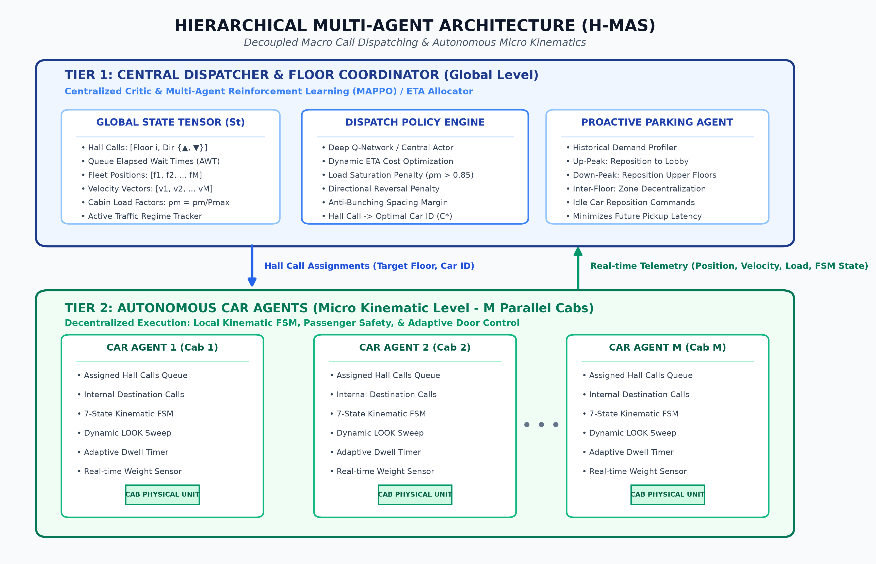
Figure 1: Hierarchical Multi-Agent Architecture (H-MAS) with Tier-1 Dispatcher and Tier-2 Autonomous Car Agents
4. SYSTEM WORKFLOW: HOW ALL COMPONENTS WORK TOGETHER
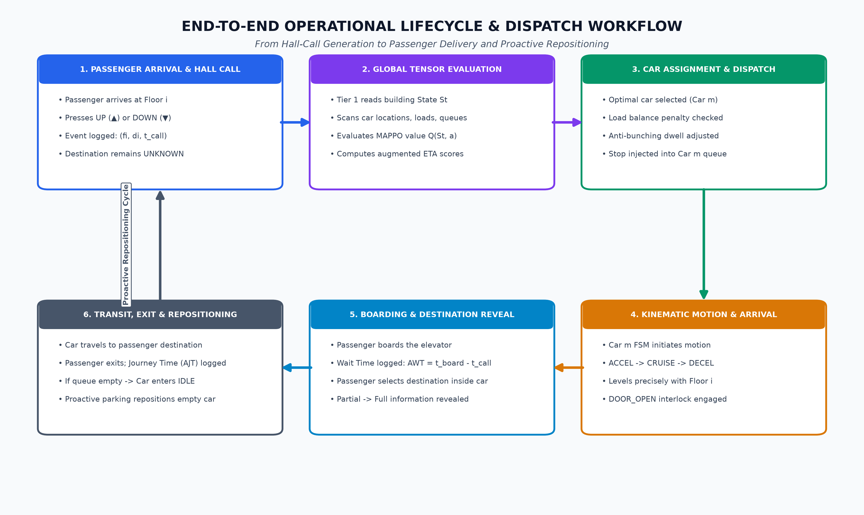
Figure 2: End-to-End Operational Lifecycle from Hall Call Generation to Boarding, Delivery, and Repositioning
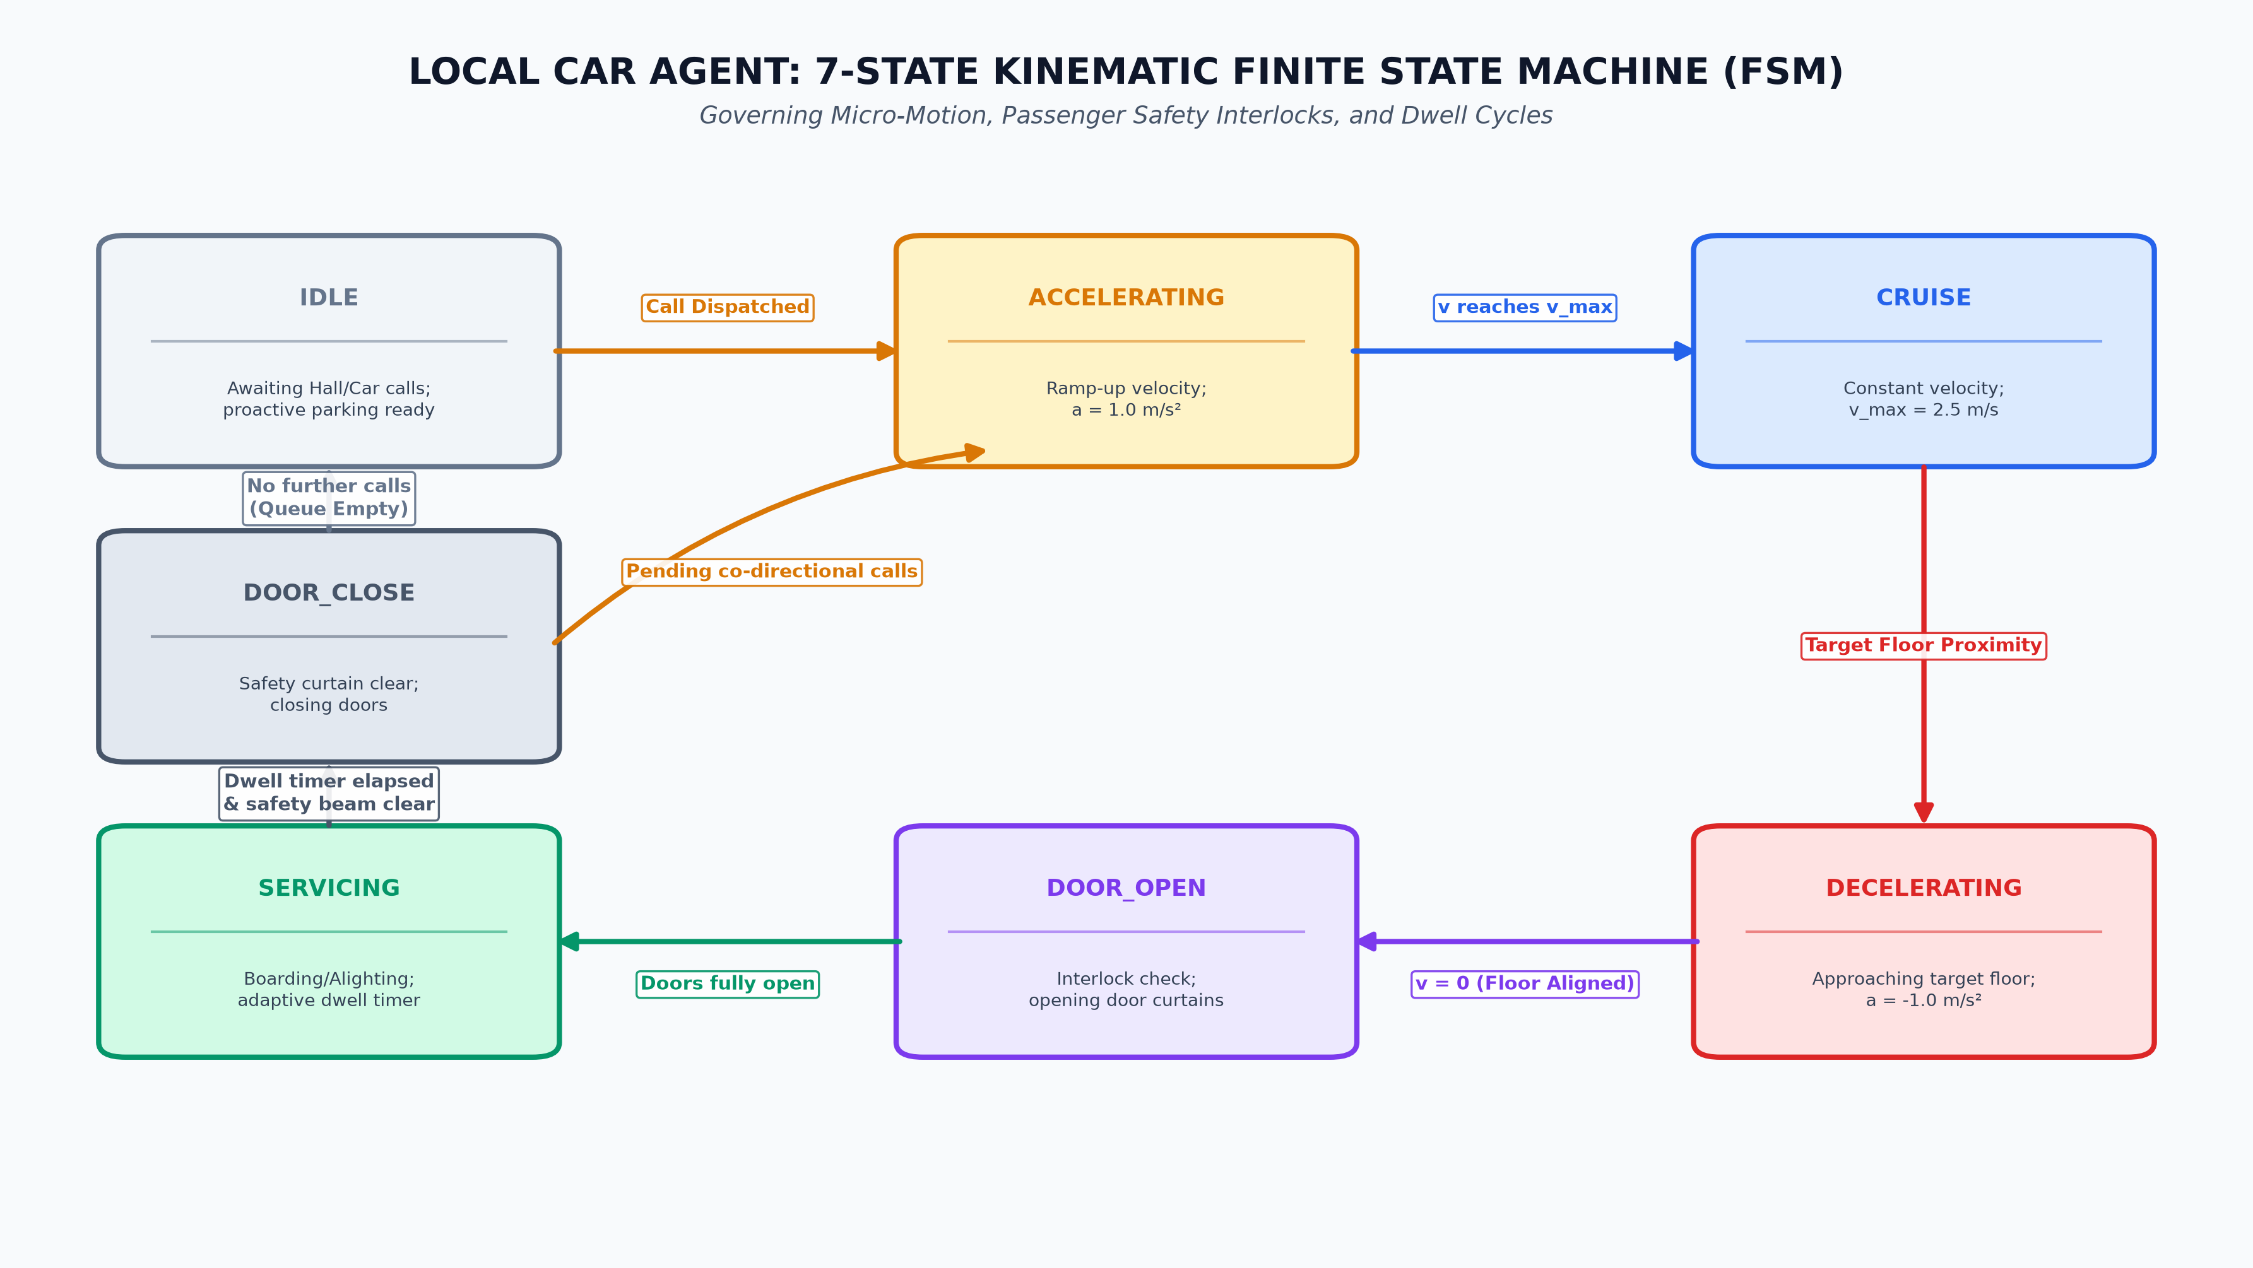
Figure 3: Car Agent 7-State Kinematic Finite State Machine (FSM) Transition Model
5. TRAFFIC PROFILES, PYGAME DASHBOARD & BENCHMARKING
• Traffic Profiles: Evaluates non-stationary Poisson arrivals across Up-Peak (80% lobby to upper), Down-Peak (80% upper to lobby), and Inter-Floor (uniform pairs) regimes.
• Pygame 2D Graphical Dashboard: Real-time animated multi-shaft visualizer showing cabin coordinates, directional passenger queues, cabin load bars, and live streaming HUD telemetry (AWT, AJT, energy index). Parameter configurations allow dynamic scaling (N = 10 to 30+ floors, M = 2 to 8 cars).
• Expected Targets vs. Baselines (LOOK/Collective): 20%-30% lower AWT, 15%-25% lower AJT, zero passenger starvation (<180s cap), and 15% lower energy wear.
6. PROJECT IMPLEMENTATION ROADMAP & TEAM RESPONSIBILITIES
Phase | Milestones / Deliverables | Timeline | Assigned Lead
Phase 1 | Kinematic modeling, FSM state formulation, formal synopsis approval | Weeks 1–2 | Divyanshu & Team
Phase 2 | SimPy simulation engine, traffic Poisson generators, baseline heuristics | Weeks 3–5 | Viraj & Co-dev
Phase 3 | Tier-1 MARL Coordinator (MAPPO), Tier-2 FSM, and Proactive Parking Policy | Weeks 6–8 | Divyanshu & Viraj
Phase 4 | Pygame 2D interactive dashboard, live telemetry HUD, stress benchmarking | Weeks 9–12 | Vaibhav & Team

