Lecture 7
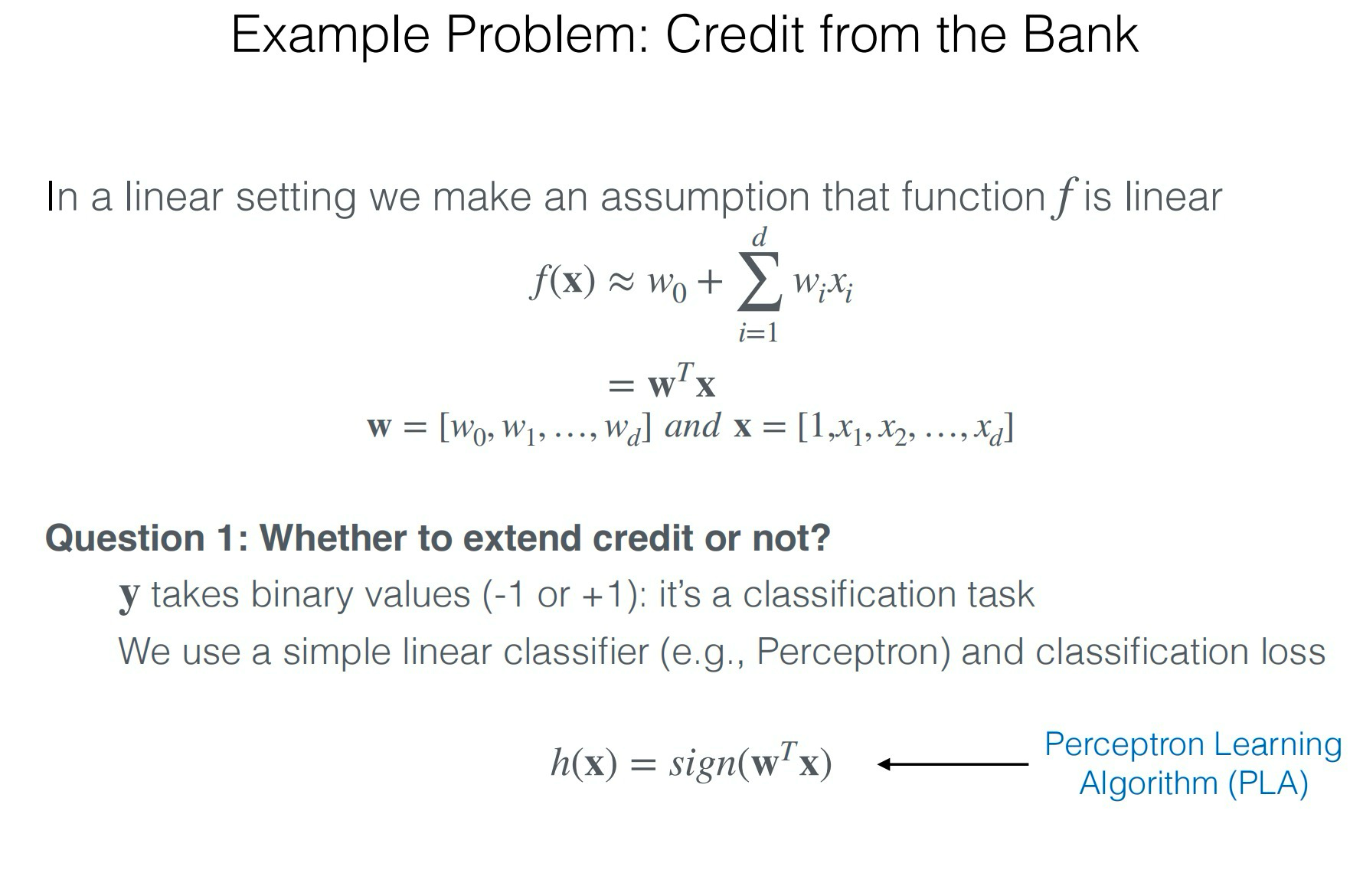
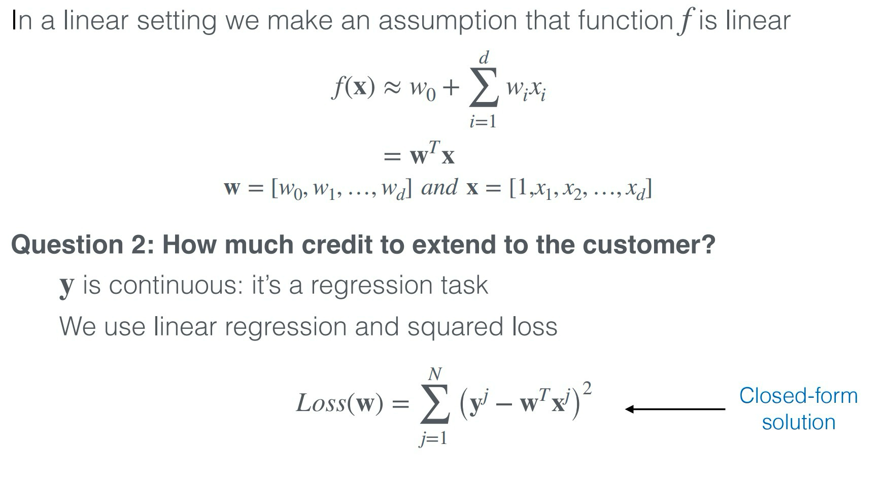
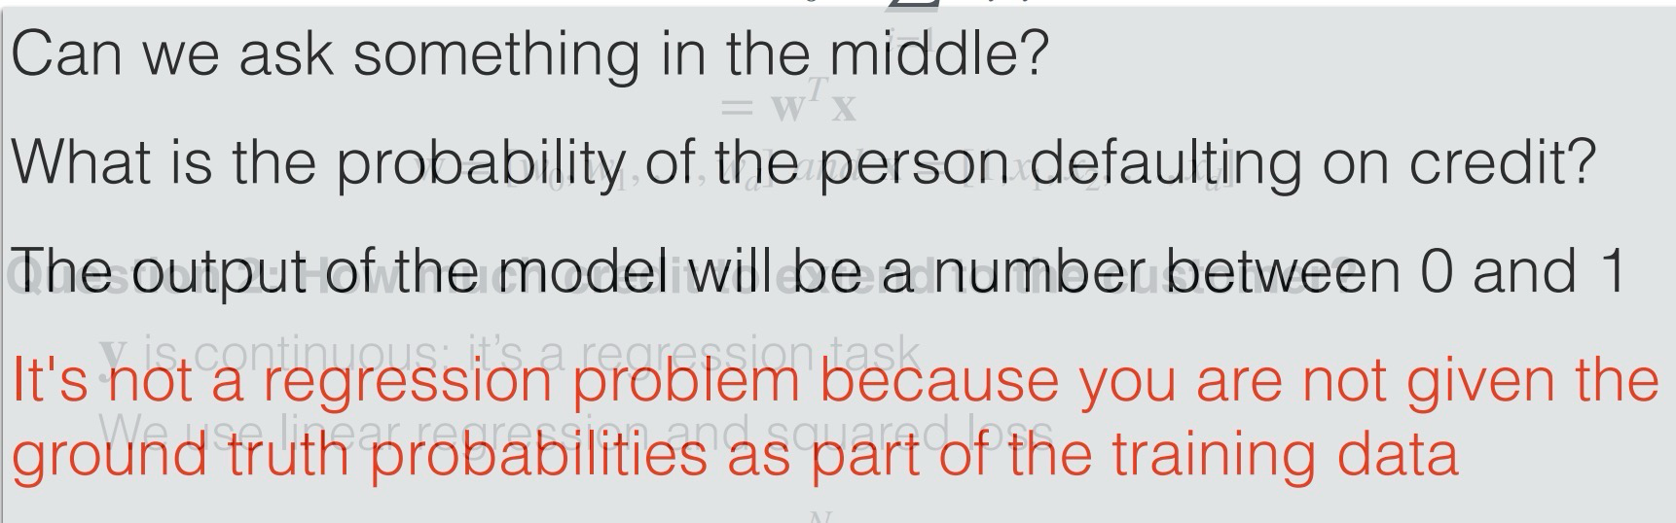
All you are given is whether a person defaulted on the loan or not

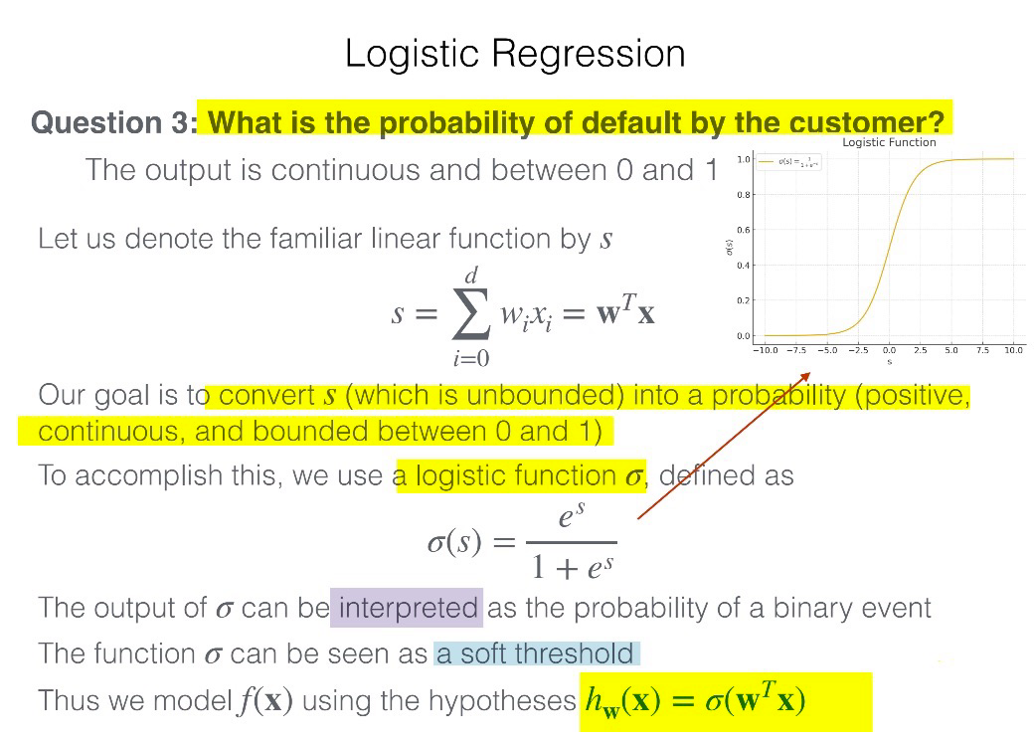

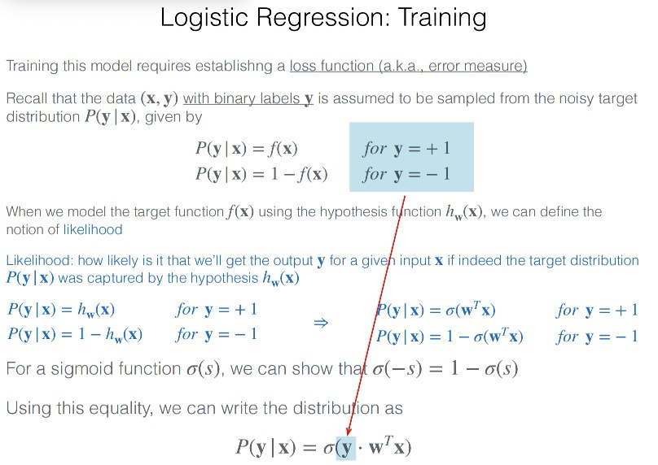
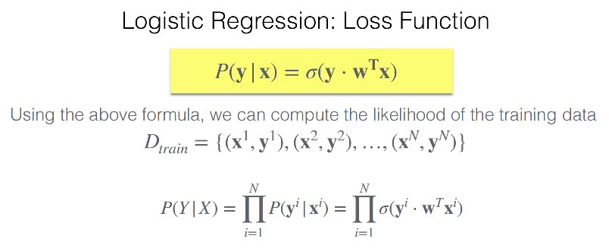
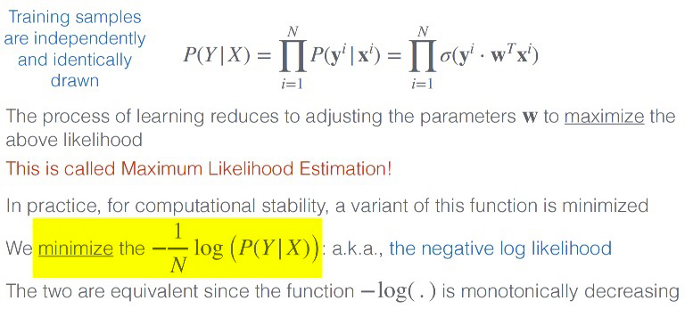
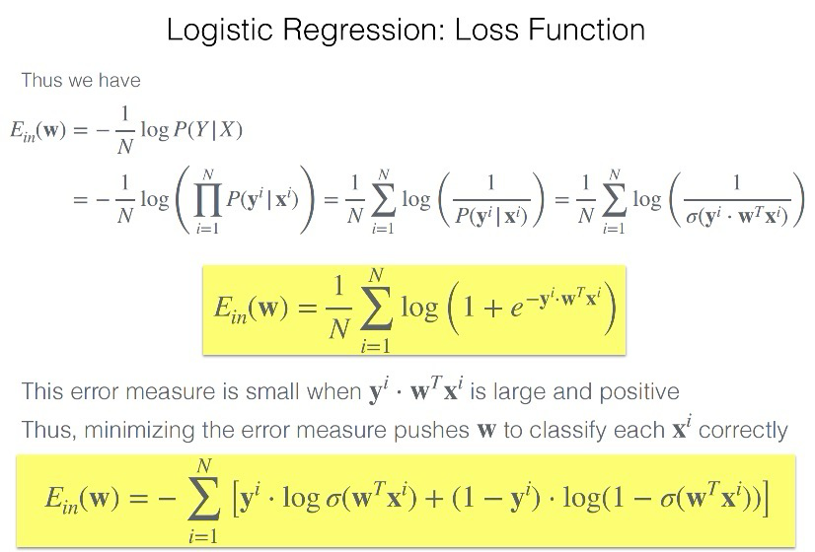
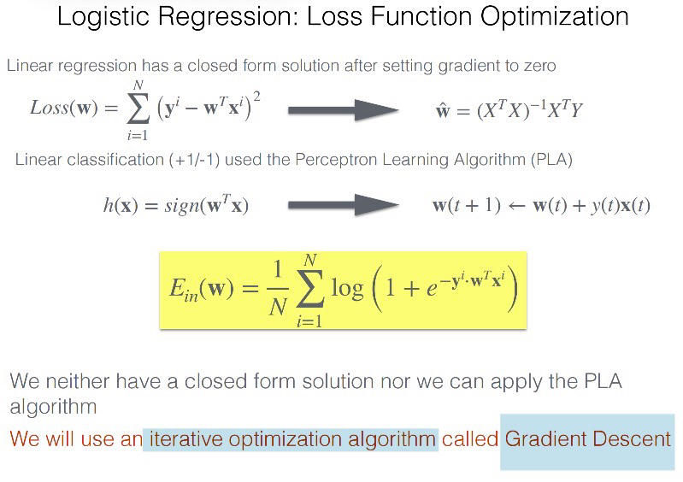
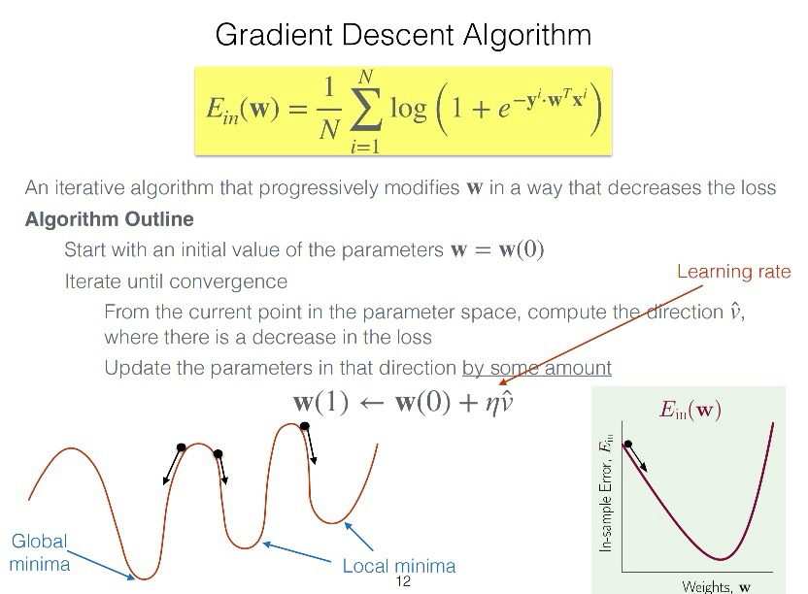

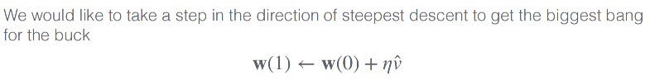
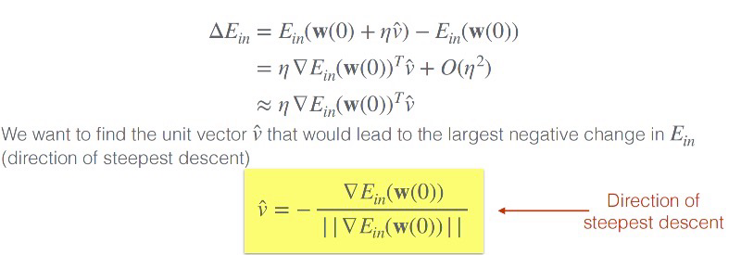
(unit vector after divided by its mode)

So it’s called a fixed learning rate algorithm because the scaling factor η\etaη controlling how far we move along the gradient is constant, even though the actual step length naturally varies with the gradient’s size.

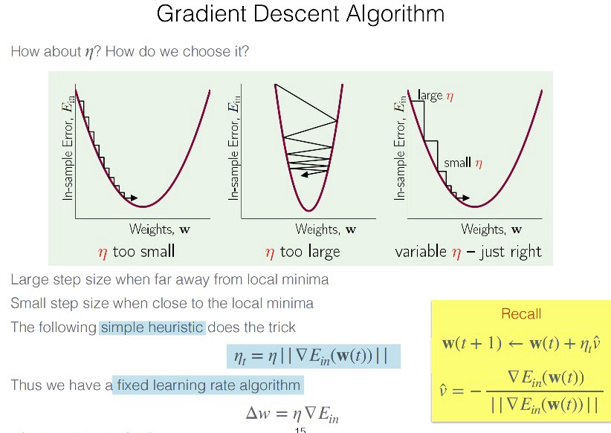
Three kinds of gradient descent:

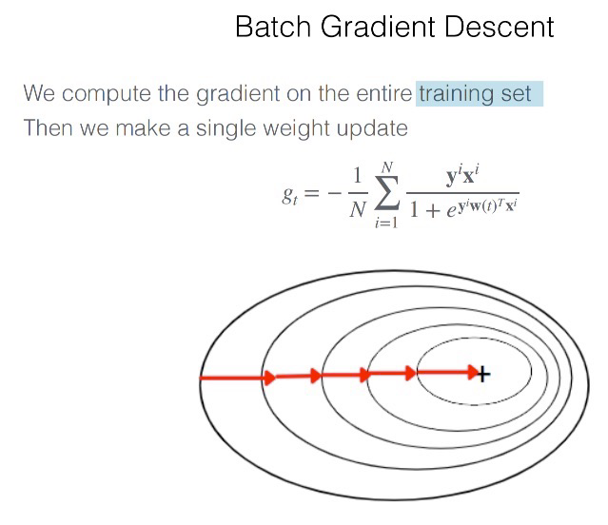
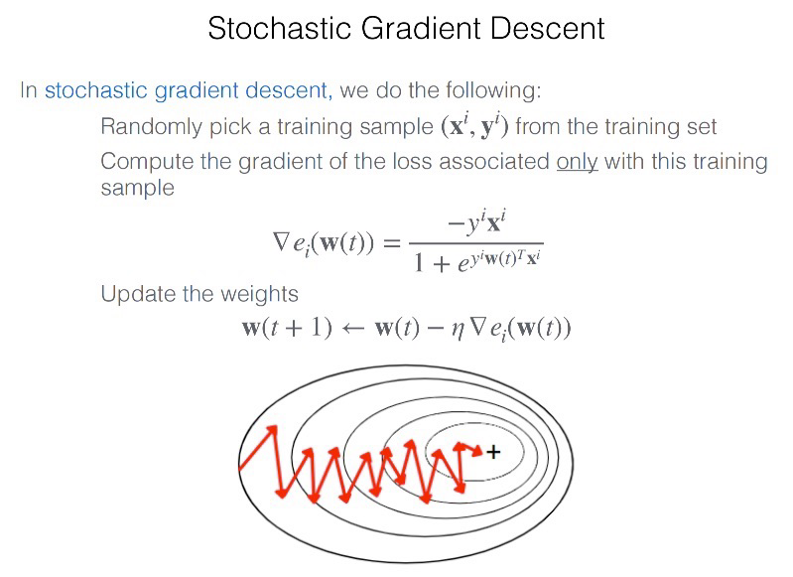
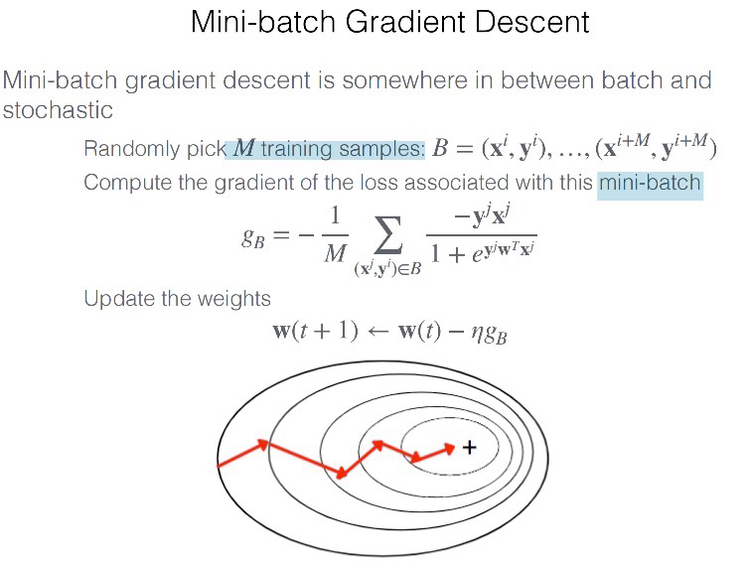

Algorithm | Gradient computed using | Update frequency | Typical use case
Batch Gradient Descent | Entire training set (all ( N ) samples) | Once per epoch | Stable but slow for large data
Stochastic Gradient Descent (SGD) | Single randomly chosen sample | Every sample | Fast but noisy updates
Mini-Batch Gradient Descent | Small subset (batch) of samples | Many updates per epoch | Common modern practice (balance between stability and speed)
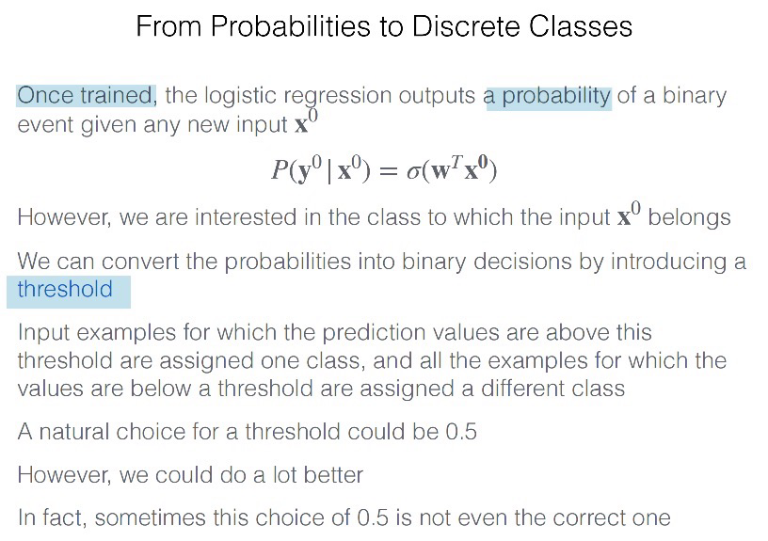

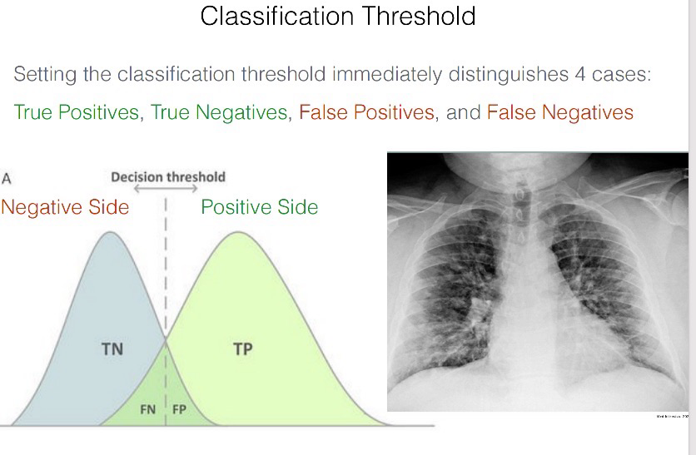
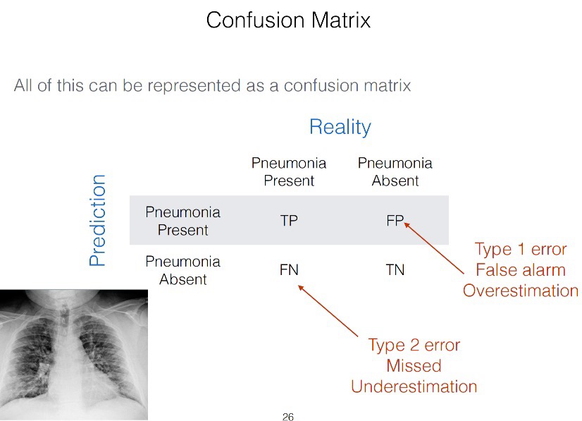
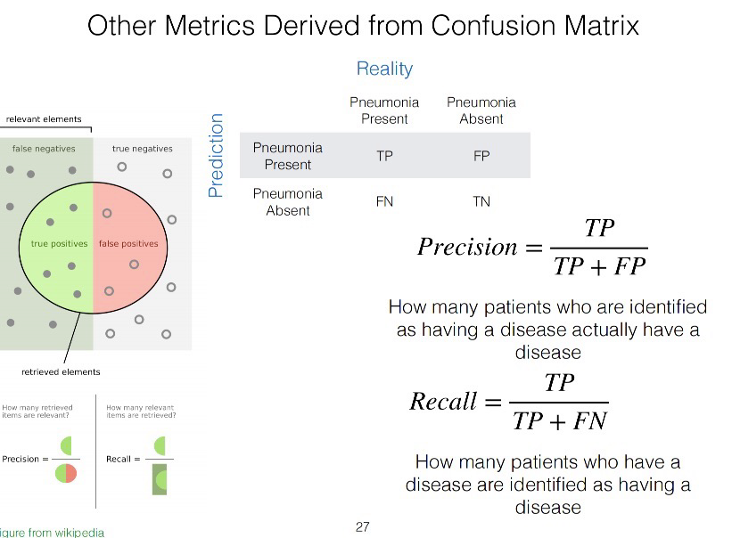
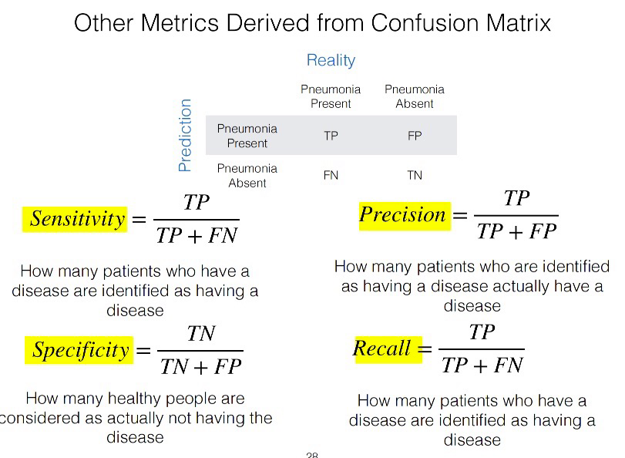
Accuracy is defined as the proportion of examples in the test set that
are correctly classified
Why isn’t the classification accuracy sufficient?
Example :
Assume I build a machine-learning model that detects Pneumothorax
from x-rays of the chest
I claim that my model is 99.9% accurate
Would you pay me to buy this model?
It depends on the prevalence rate of the disease
In general, we need more sophisticated ways to measure the model’s
performance

