Basic Requirements

1. Implement Cartogram

Implement a cartogram that communicates the winning percentage of the candidates, but also gives us some geospatial context. In the cartogram, each state is represented by a square of equal size; the squares are placed so that they correspond to their position on a map. By using equal-sized squares, we ensure that all state results are equally readable.

How do we lay these tiles out? Assume that you are given a matrix. where each cell corresponds to a tile. Some tiles are filled in (the states), others are not (i.e., remain white). Color-code the states either red or blue based on the winning party for that state, and display the abbreviation of the state and the number of its electoral votes.

1. Implement Hovering

On hover, display a tool tip having information such as the state name, the number of electoral votes for the state, and also the name of the nominee, number of votes won and vote percentage for each party with respect to a given state, as shown in the screenshot below.

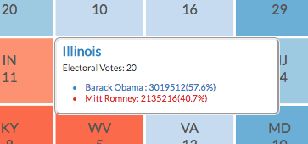

1. Implement Color-coding

Color-code the tiles by win percentage using an appropriate color scale. We will also create a legend associated with the chart, as shown in the screenshot below.

