Mesa — API Testing SOP (Postman) — Assignment Step 6
A step-by-step procedure for testing every Mesa backend endpoint and capturing the evidence required for report §6.1 (request collections + responses) and §6.2 (exported collection link). The screenshots embedded below are the actual responses captured against the running backend.
What you will produce. One screenshot per endpoint showing the request and its response/status, covering success and error paths (200, 201, 400, 401, 403, 409); a saved collection; and the collection exported into the repo for §6.2.

1. Prerequisites
Item | Detail
Backend running | http://localhost:5001 (cd backend → npm run dev), database seeded (node seed.js)
A REST client | Postman (assignment tool) — or Thunder Client in VS Code, used for the captures below
Collection files | postman/Mesa.postman_collection.json + postman/Mesa.local.postman_environment.json
Seed logins | admin@mesa.test / admin1234 · diner@mesa.test / diner1234

2. Set up Postman
- Install Postman from postman.com/downloads and open it (sign in to enable cloud sync — optional).
- Create a workspace (e.g. 'Mesa'), or use the default.
- Import → Files → select postman/Mesa.postman_collection.json AND postman/Mesa.local.postman_environment.json.
- Top-right environment dropdown → choose 'Mesa — Local' so {{baseUrl}} resolves to http://localhost:5001.
The imported collection already contains every request below with test scripts attached, so you can either run requests one-by-one (this SOP) or run the whole collection at once (section 6).

3. Authenticate first (get a JWT)
Most endpoints require a Bearer token. Get one by logging in, then reuse it in the Authorization header of later requests.
POST {{baseUrl}}/api/auth/login
Headers: Content-Type: application/json
Body (raw JSON):
{ "email": "diner@mesa.test", "password": "diner1234" }
Tests tab — assert success and save the token to an environment variable:
pm.test("Status code is 200", () => pm.response.to.have.status(200));
const json = pm.response.json();
pm.test("Returns a JWT", () => pm.expect(json).to.have.property("token"));
if (json.token) pm.environment.set("jwt_token", json.token);
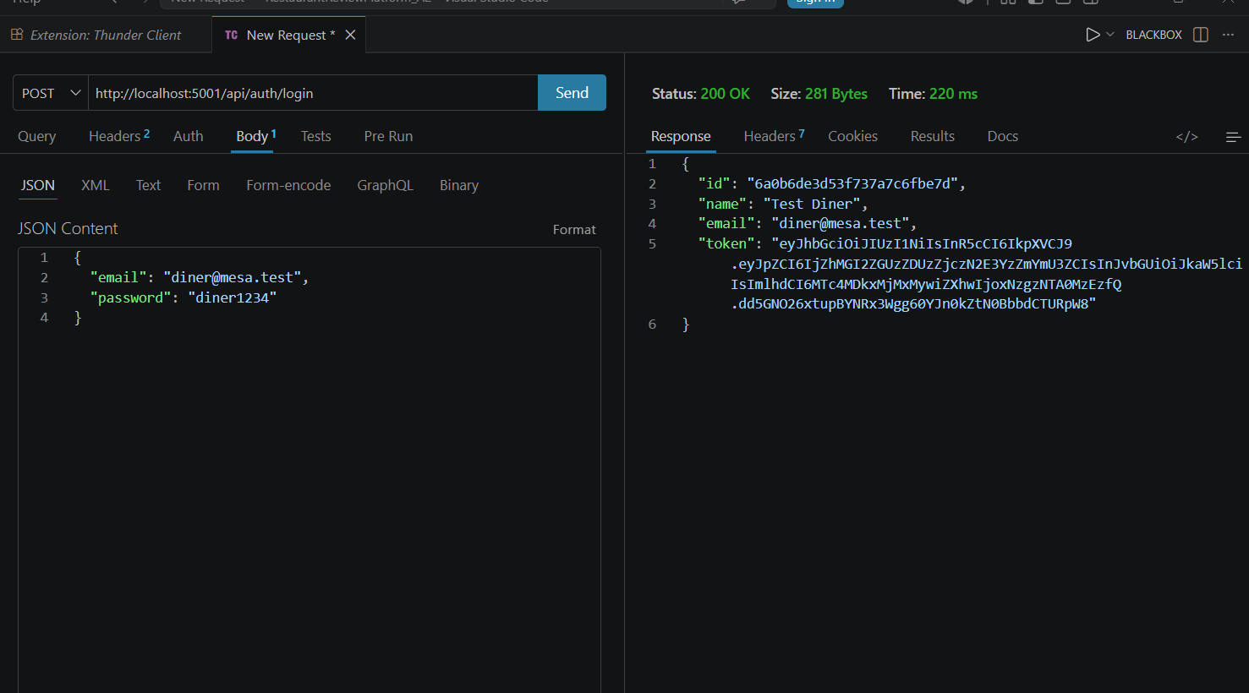
Step 3 — POST /api/auth/login → 200 OK with a JWT. Save the token as {{jwt_token}}.

4. Test each endpoint (success paths)

4.1 List restaurants — GET (public)
GET {{baseUrl}}/api/restaurants
Expected: 200 OK with a paginated payload ({ items, page, total, totalPages }).
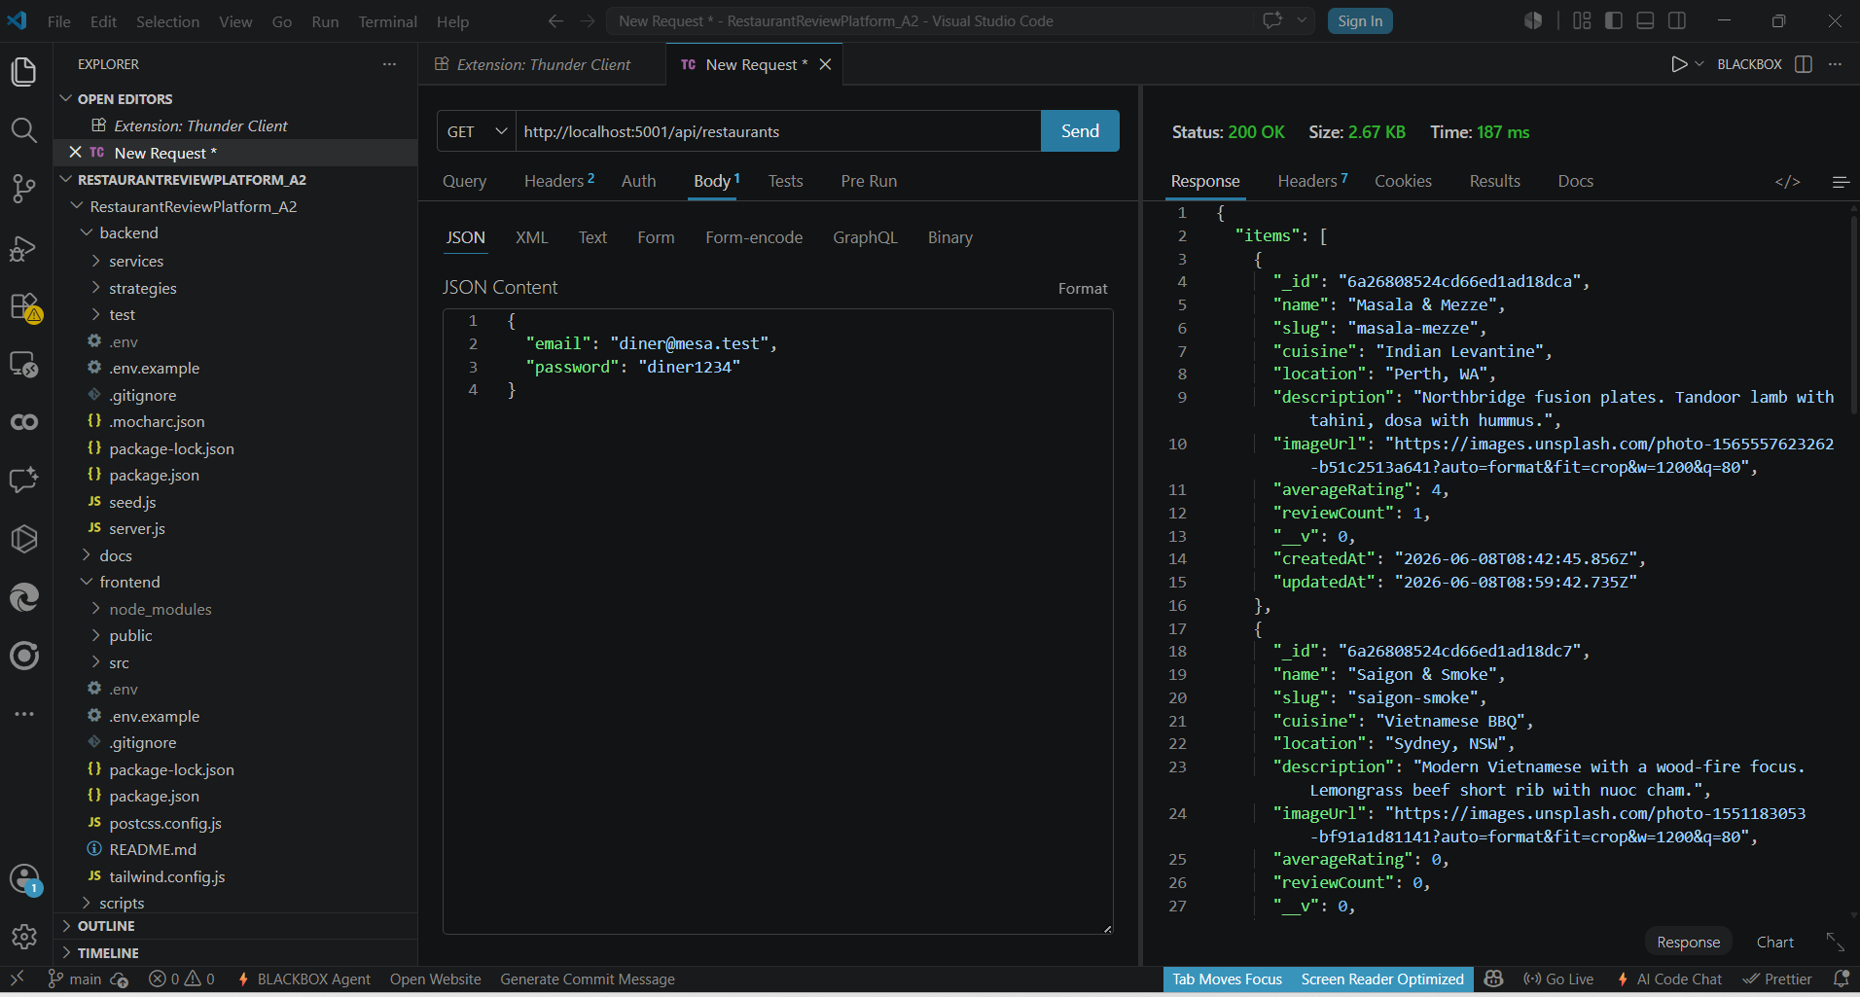
GET /api/restaurants → 200 OK returning the catalogue.

4.2 Create a review — POST (authenticated diner)
POST {{baseUrl}}/api/restaurants/<restaurantId>/reviews
Headers: Content-Type: application/json
Authorization: Bearer {{jwt_token}}
Body: { "rating": 5, "text": "Great via Postman" }
Expected: 201 Created with the new review document.
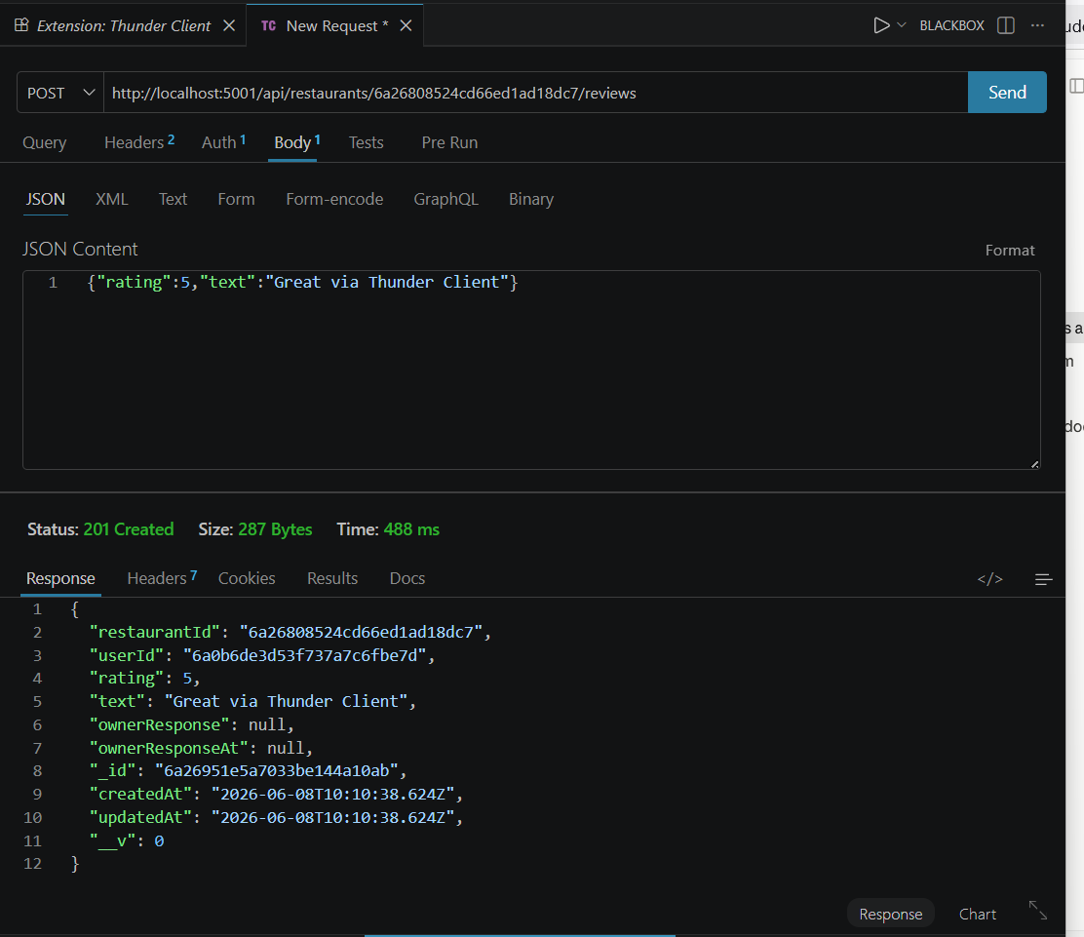
POST /api/restaurants/:id/reviews with Bearer token → 201 Created.

5. Test the error paths (this is what earns the marks)
Good API testing proves the endpoint handles bad input and unauthorised access correctly — not just the happy path.

5.1 No token → 401
Repeat the create-review request but remove the Authorization header.
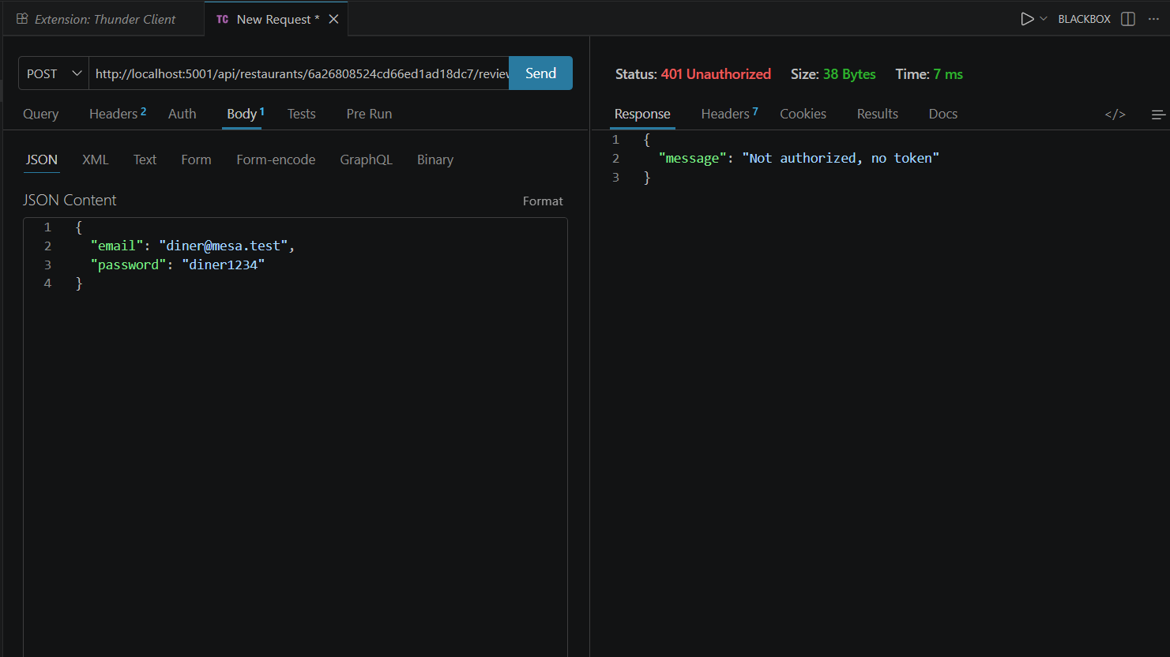
POST review without a token → 401 Unauthorized ('Not authorized, no token').

5.2 Wrong password → 401
POST /api/auth/login with a valid email but a wrong password.
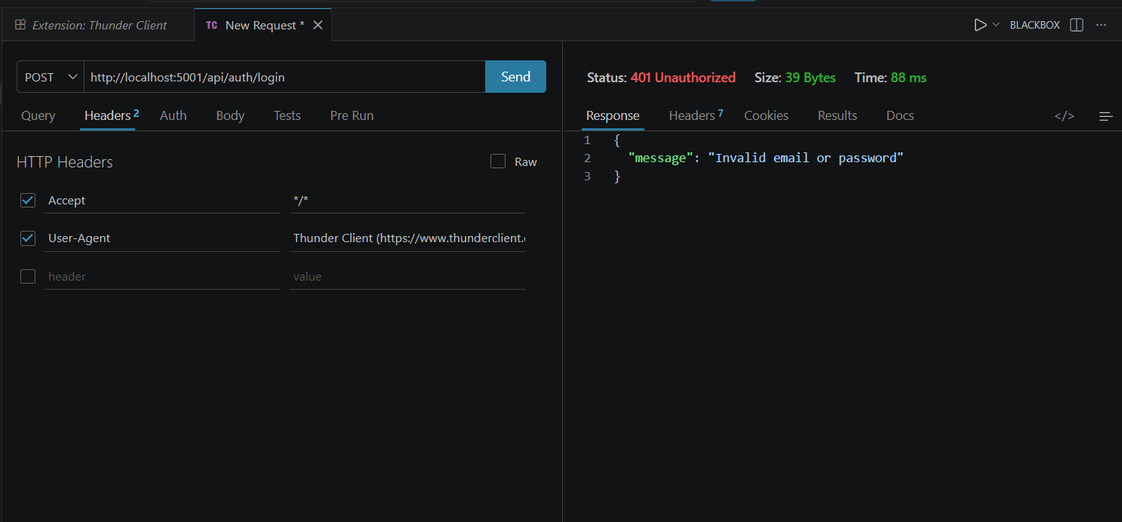
Login with a wrong password → 401 Unauthorized ('Invalid email or password').

5.3 Missing fields → 400
POST a review with an empty body {} (validation via the Chain of Responsibility).
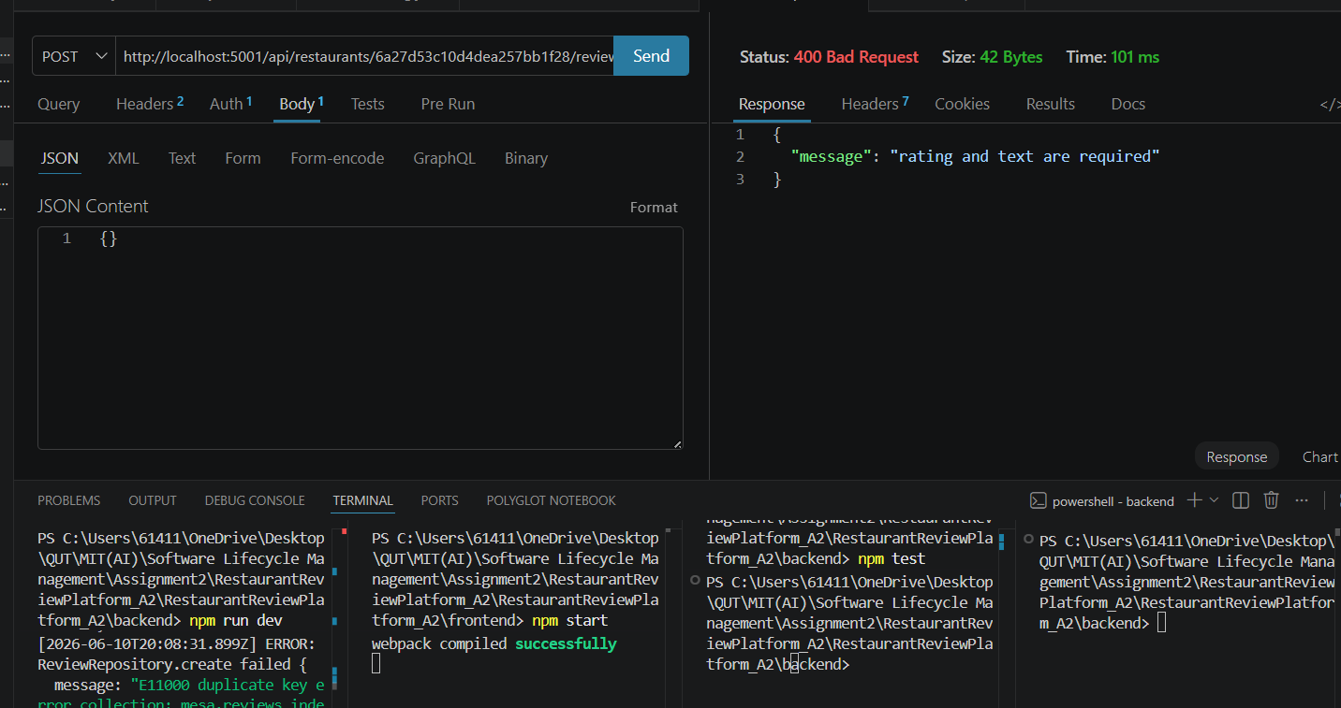
POST review with an empty body → 400 Bad Request ('rating and text are required').

5.4 Duplicate review → 409
POST the same review twice as the same diner (one review per diner per restaurant).
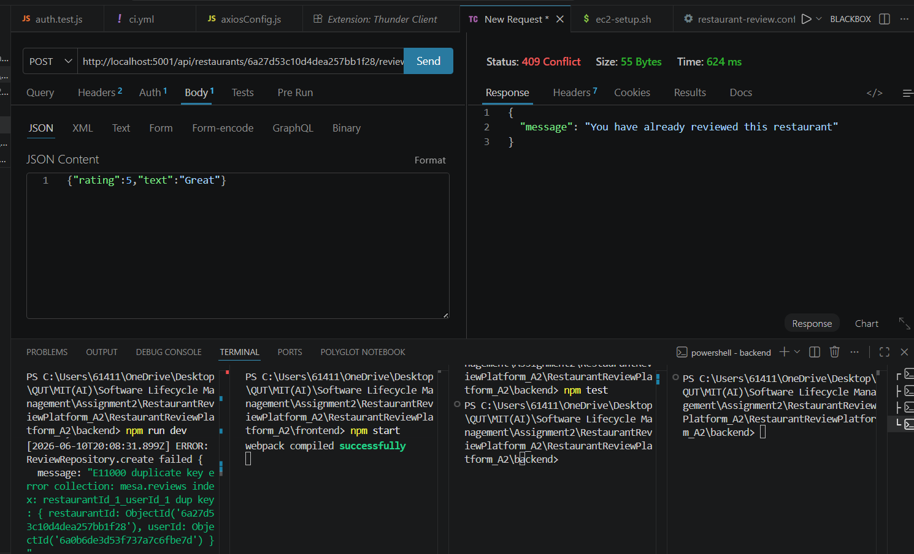
Duplicate review → 409 Conflict; backend log shows the E11000 unique-index error.

5.5 Diner creates a restaurant → 403
POST /api/restaurants while authenticated as a diner (the admin-only role guard / Proxy).
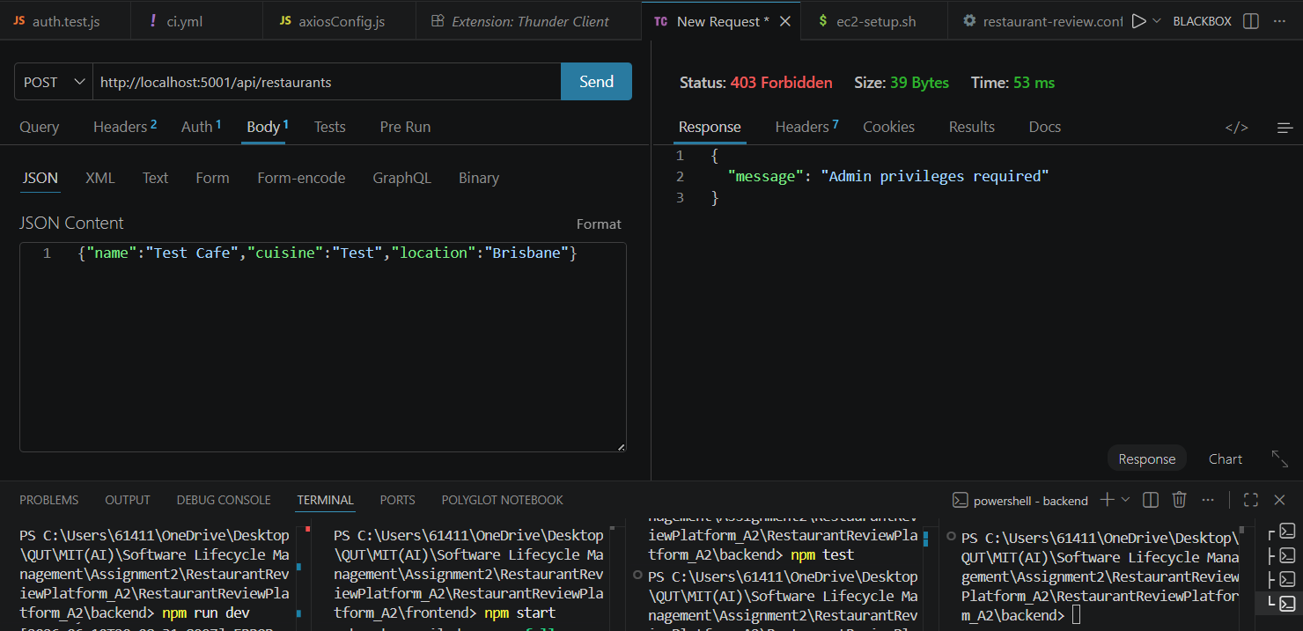
POST /api/restaurants as a diner → 403 Forbidden ('Admin privileges required').

6. Run the whole collection at once
Postman Collection Runner: open the collection → Run → Run Mesa. Every request's tests show pass/fail in one report — screenshot this for §6.1.
Headless (Newman), CI-friendly:
npm install -g newman
newman run postman/Mesa.postman_collection.json \
-e postman/Mesa.local.postman_environment.json \
--reporters cli,html --reporter-html-export postman/newman-report.html

7. Export the collection and push it (§6.2)
- Postman: collection ⋯ menu → Export → Collection v2.1 → save into the repo's postman/ folder.
- Commit and push it so the marker has the exported file and a GitHub link.
git add postman/Mesa.postman_collection.json
git commit -m "test(api): export Postman collection for A2 §6.2"
git push
In §6.2 of the report, paste the GitHub link to postman/Mesa.postman_collection.json.

8. Test-case table (for §6.1)
Test ID | Method & endpoint | Input | Expected | Actual
TC-01 | POST /api/auth/login | valid diner creds | 200 + JWT | 200 + JWT ✓
TC-02 | GET /api/restaurants | — | 200 + items[] | 200 ✓
TC-03 | POST /restaurants/:id/reviews | Bearer + valid body | 201 Created | 201 ✓
TC-04 | POST /restaurants/:id/reviews | no token | 401 | 401 ✓
TC-05 | POST /api/auth/login | wrong password | 401 | 401 ✓
TC-06 | POST /restaurants/:id/reviews | empty body {} | 400 | 400 ✓
TC-07 | POST /restaurants/:id/reviews | duplicate review | 409 | 409 ✓
TC-08 | POST /api/restaurants | diner token | 403 | 403 ✓

