Mesa — API Testing, Step by Step (with explanations)
This walkthrough shows exactly how to test every Mesa backend endpoint in a REST client (Thunder Client or Postman) and capture the six results the assignment needs: 200, 201, 400, 401, 403 and 409. Each step says what to set, what you should see, and why it happens.

First, the four ideas you need
- A request has four parts: a METHOD (GET/POST), a URL, optional HEADERS, and an optional BODY (JSON).
- METHOD matters: GET reads data; POST creates data. Using GET where POST is needed just reads — it never creates.
- A TOKEN (JWT) is your 'wristband'. You get it by logging in, and you present it on protected requests via Auth → Bearer. No/!invalid wristband = 401.
- STATUS CODES tell you the outcome: 2xx = success; 4xx = something about YOUR request (400 bad input, 401 not logged in, 403 not allowed, 404 not found, 409 conflict); 5xx = server error.
Golden rule. The token goes in the Auth → Bearer box. The JSON (e.g. the review) goes in the Body → JSON box. Swapping these two is the #1 cause of a confusing 401.

Before you start
Make sure the backend is running. In the backend folder:
npm run dev # you should see: Server running on port 5001
Everything below talks to http://localhost:5001. Seed logins: diner@mesa.test / diner1234 (normal user) and admin@mesa.test / admin1234 (admin).

Step 1 — Log in to get your token → 200
- New Request → method POST.
- URL: http://localhost:5001/api/auth/login
- Body tab → JSON → paste the credentials below.
- Send.
{ "email": "diner@mesa.test", "password": "diner1234" }
Why this happens. The server checks the email + password against the database. They are correct, so it returns 200 OK and a token (the long "eyJ…" string). Copy that token — you will paste it into later requests. It is the only place the token comes from.
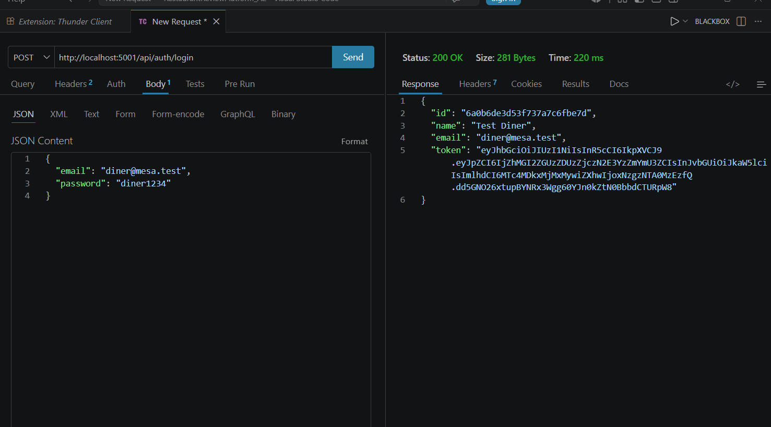
Step 1 — POST /api/auth/login → 200 OK with a JWT token in the response.

Step 2 — Get a real restaurant ID → 200
- New Request → method GET.
- URL: http://localhost:5001/api/restaurants
- Send (no body, no token needed).
- In the response, copy any restaurant's "_id" value.
Why this happens. This endpoint is public, so it returns 200 OK and the list of restaurants. You need a real _id from this list for the next step — you cannot make one up, because the server looks it up in the database.
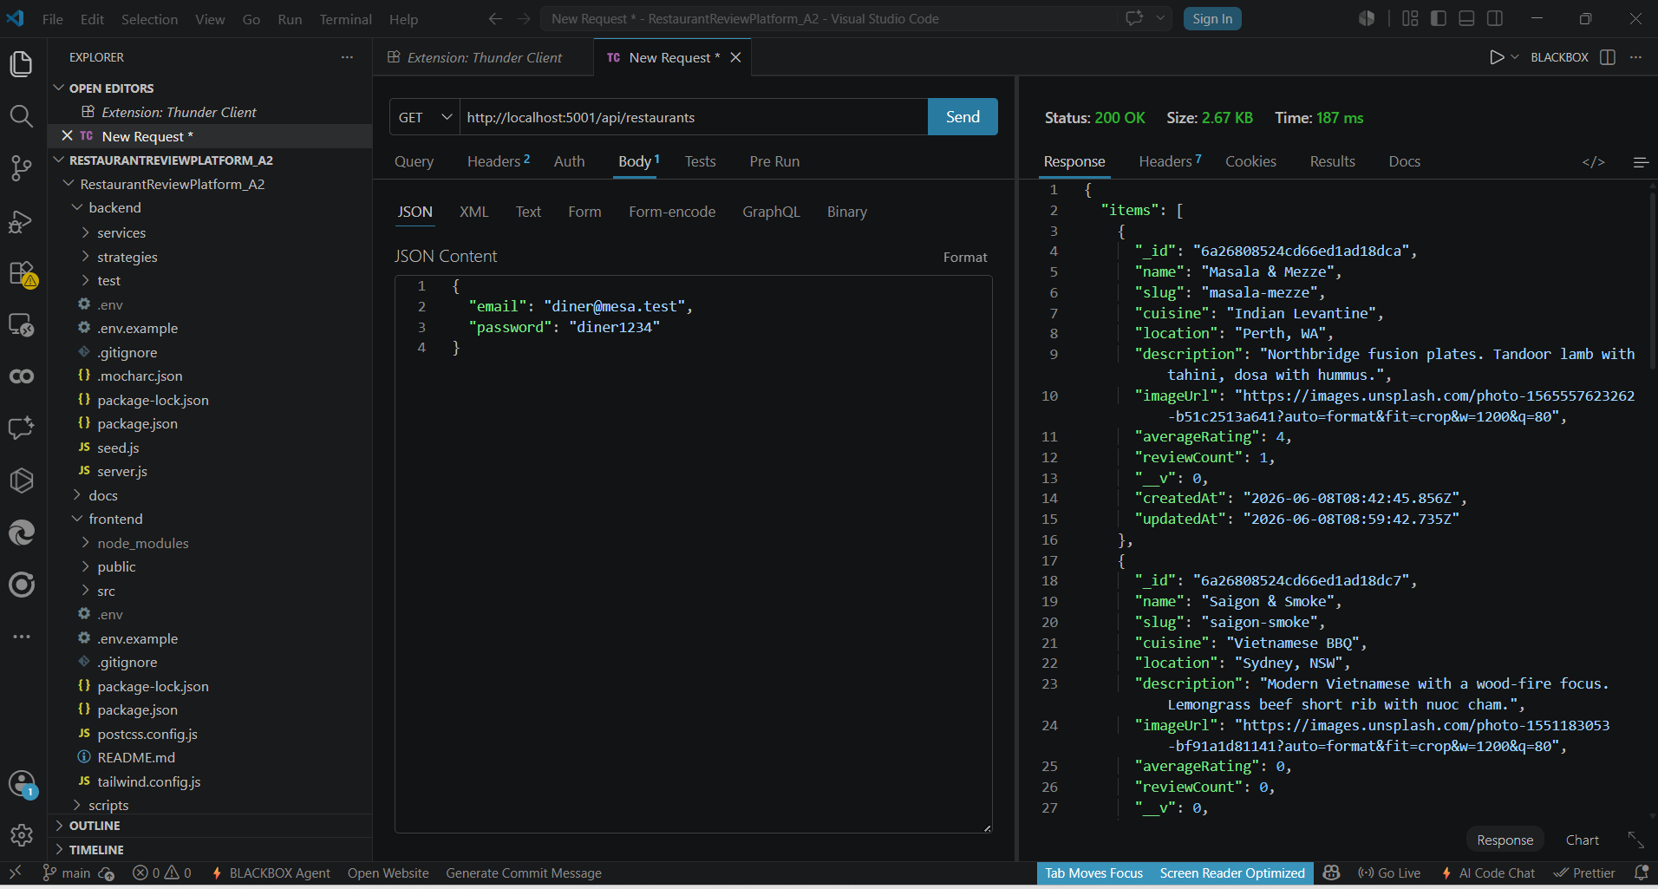
Step 2 — GET /api/restaurants → 200 OK; copy an item's _id.

Step 3 — Create a review → 201
- New Request → method POST.
- URL: http://localhost:5001/api/restaurants/<the _id you copied>/reviews
- Auth tab → Bearer → paste your eyJ… token.
- Body tab → JSON → the review below.
- Send.
{ "rating": 5, "text": "Great via Postman" }
Why this happens. POST means 'create'. The token proves you are a logged-in diner, and the body supplies the review. The server saves it and returns 201 Created with the new review document. (One review per diner per restaurant — if you already reviewed this one, you will get 409 instead; just use a different restaurant's _id.)
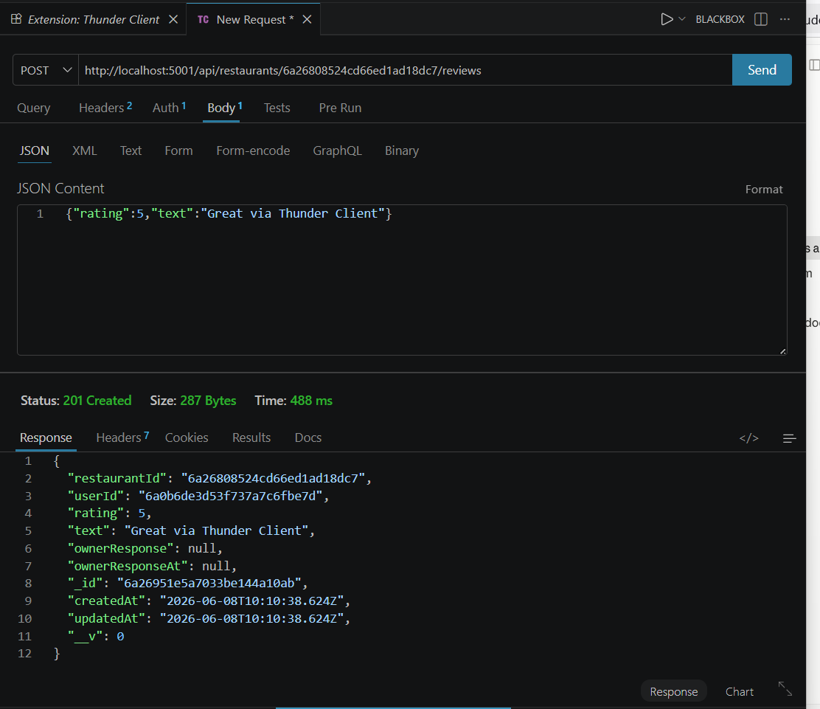
Step 3 — POST /api/restaurants/:id/reviews with Bearer token → 201 Created.

The error cases (this is what earns the marks)
Good API testing proves the endpoint also rejects bad requests correctly. Each case below is a small change to the Step 3 request.

Step 4 — No token → 401
Change: Auth tab → click None (remove the Bearer token). Then Send.
Why this happens. The create-review route is protected. With no token, the server cannot tell who you are, so it refuses with 401 Unauthorized — 'Not authorized, no token'. (If you instead see 'token failed', a token WAS sent but was invalid — often the JSON body was pasted into the Bearer box by mistake.)
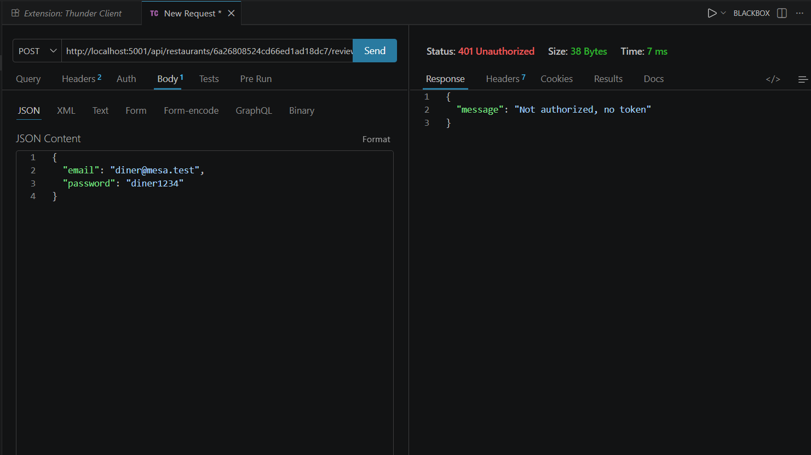
Step 4 — POST review without a token → 401 Unauthorized.

Step 5 — Wrong password → 401
Go back to the login request (Step 1) and change the password to something wrong, e.g. "nope". Send.
Why this happens. The credentials do not match, so authentication fails with 401 Unauthorized — 'Invalid email or password'. This is the login endpoint refusing a bad sign-in.
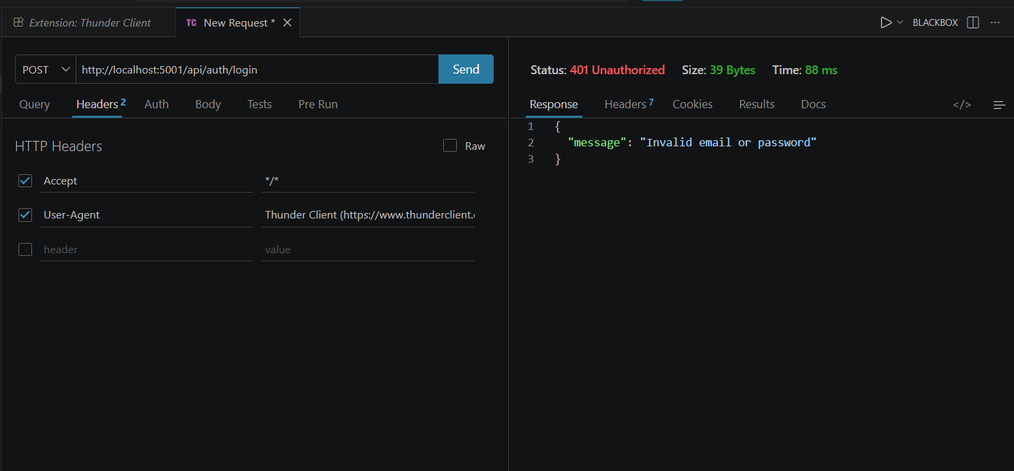
Step 5 — Login with a wrong password → 401 Unauthorized.

Step 6 — Missing fields → 400
Back on the create-review request, put the token back, then change Body → JSON to an empty object:
{}
Why this happens. Before saving, the server validates the input. There is no rating and no text, so it rejects the request with 400 Bad Request — 'rating and text are required'. 400 always means 'your input is malformed or incomplete'.
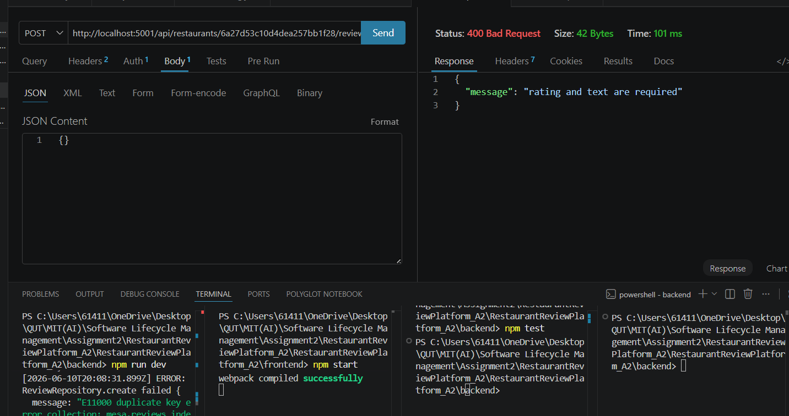
Step 6 — POST review with an empty body → 400 Bad Request.

Step 7 — Duplicate review → 409
Restore the body to a valid review and POST it twice to the SAME restaurant as the same diner.
Why this happens. A diner may only review a restaurant once (enforced by a unique index in the database). The second attempt collides with the first, so the server returns 409 Conflict — 'You have already reviewed this restaurant'. 409 means 'this clashes with something that already exists'.
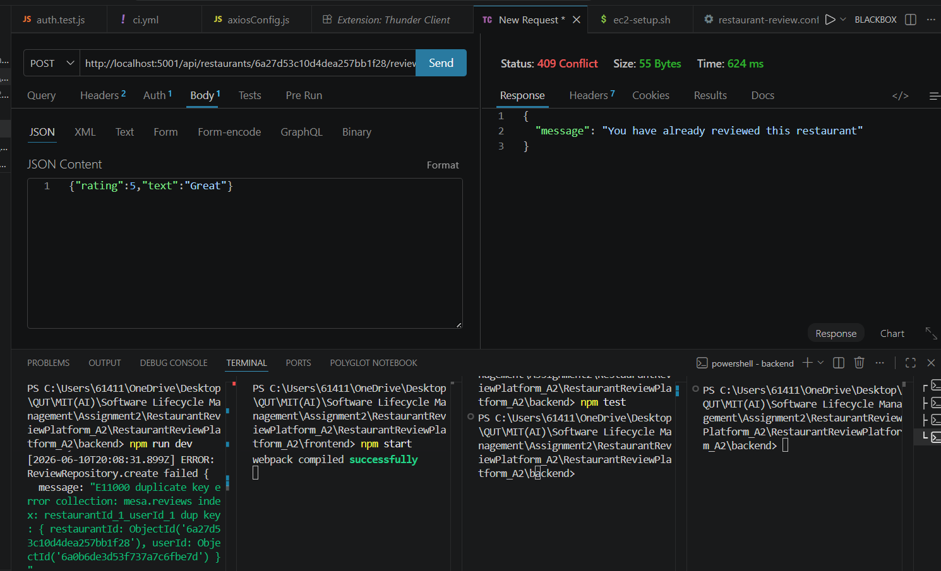
Step 7 — Duplicate review → 409 Conflict (backend log shows the E11000 unique-index error).

Step 8 — A diner tries an admin action → 403
- Method POST.
- URL: http://localhost:5001/api/restaurants (note: no /reviews, no id)
- Keep the diner Bearer token.
- Body → JSON: the restaurant below. Send.
{ "name": "Test Cafe", "cuisine": "Test", "location": "Brisbane" }
Why this happens. Creating a restaurant is admin-only. The diner IS logged in (so it is not 401), but is not allowed to do this, so the role guard returns 403 Forbidden — 'Admin privileges required'. The difference: 401 = 'who are you?', 403 = 'I know who you are, but you can't do this'.
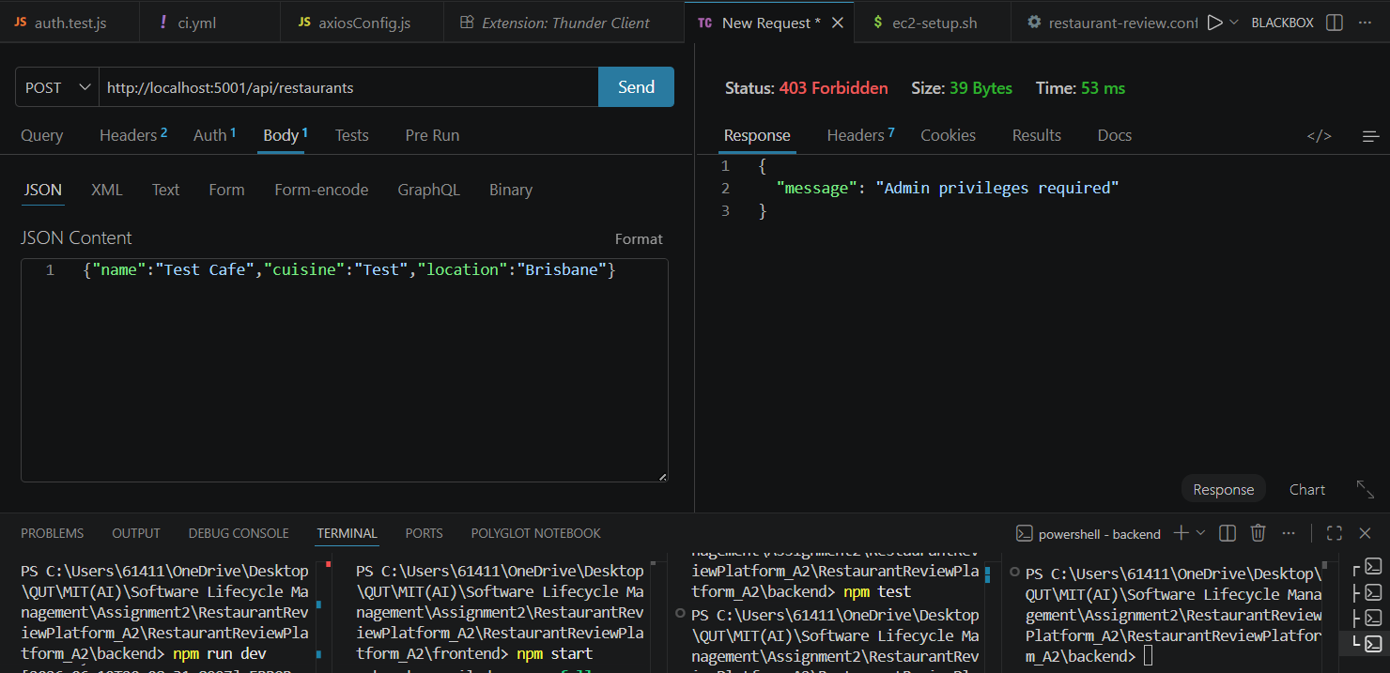
Step 8 — POST /api/restaurants as a diner → 403 Forbidden.

Common mistakes (and the status they cause)
You see… | It means… | Fix
401 'token failed' | A token was sent but is invalid — usually the JSON body was pasted into the Bearer box | Put only the eyJ… token in Auth → Bearer; put JSON in Body
401 'no token' | No Authorization header at all | Auth → Bearer → paste the token
200 with [] | You used GET on the reviews URL (that just lists reviews) | Switch the method to POST to create
404 'Restaurant not found' | The id in the URL is not a real restaurant | Copy a real _id from GET /api/restaurants
409 'already reviewed' | This diner already reviewed this restaurant | Use a different restaurant's _id

Test-case table (paste this into report §6.1)
Test ID | Method & endpoint | Input | Expected | Actual
TC-01 | POST /api/auth/login | valid diner creds | 200 + JWT | 200 + JWT ✓
TC-02 | GET /api/restaurants | — | 200 + items[] | 200 ✓
TC-03 | POST /restaurants/:id/reviews | Bearer + valid body | 201 Created | 201 ✓
TC-04 | POST /restaurants/:id/reviews | no token | 401 | 401 ✓
TC-05 | POST /api/auth/login | wrong password | 401 | 401 ✓
TC-06 | POST /restaurants/:id/reviews | empty body {} | 400 | 400 ✓
TC-07 | POST /restaurants/:id/reviews | duplicate review | 409 | 409 ✓
TC-08 | POST /api/restaurants | diner token | 403 | 403 ✓

Finally — export the collection for §6.2
- Thunder Client: Collections panel → your collection → ⋯ menu → Export.
- Save the exported JSON into the repo (e.g. docs/A2/ or postman/).
- Commit and push it, then paste the GitHub link to that file into report §6.2.
git add postman/
git commit -m "test(api): export API collection for A2 §6.2"
git push

