Mesa — AWS EC2 Redeploy & Evidence Capture SOP
How to bring the live deployment back online after the EC2 instance has been stopped/restarted, and re-capture the IP-specific report evidence — all in a single session.
Why this is needed. Stopping and starting an EC2 instance (without an Elastic IP) assigns a new public IP each time, and the pm2 app processes do not auto-start unless configured to. The Mesa frontend calls its API same-origin (the IP is not hard-coded), so the app keeps working at whatever IP the instance has — but the report text and the two IP-specific screenshots (§7.2 pm2 status, §7.4 live app) must be refreshed.
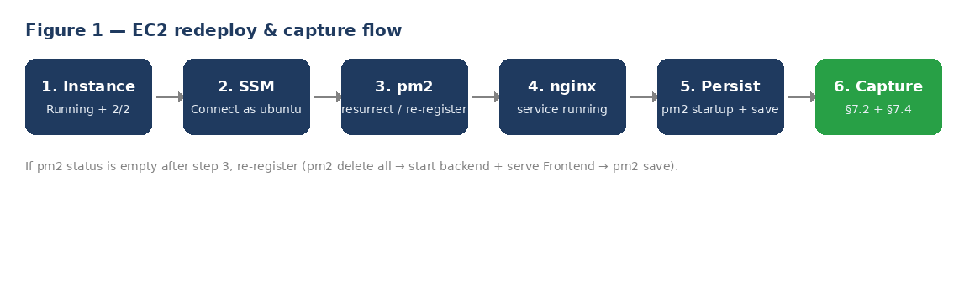

Prerequisites
Item | Where / how
AWS Console access | EC2 dashboard + Systems Manager (SSM) Session Manager
Instance's current public IPv4 | EC2 → Instances → select instance → Details
Your current home IP | Browse to checkip.amazonaws.com
Report + Part C document | Open for editing the IP references / screenshots
Demo login | diner@mesa.test / diner1234

This SOP uses the current live IP 3.27.208.40 (matches the report and Part C). If the instance is stopped/started again it will get a NEW IP — substitute it everywhere below and in the report before capturing.

Part 0 — Update report references to the new IP
If the public IP changed since the last submission, update every reference before capturing, so the document and screenshots agree.
- In the report and Part C, find every occurrence of any OLD IP and replace it with the current one (3.27.208.40).
- Double-check §7 (CI/CD) and any 'Live deployment' / Part C URL lines.

Part A — Bring the app back online at the new IP

A1. Confirm the instance is ready
EC2 → Instances. Wait until the instance shows Running with 2/2 status checks passed. If it says 'Initializing', give it ~1 minute and refresh (↻).

A2. Connect via SSM Session Manager
Select the instance → Connect → Session Manager → Connect. Then switch to the app user:
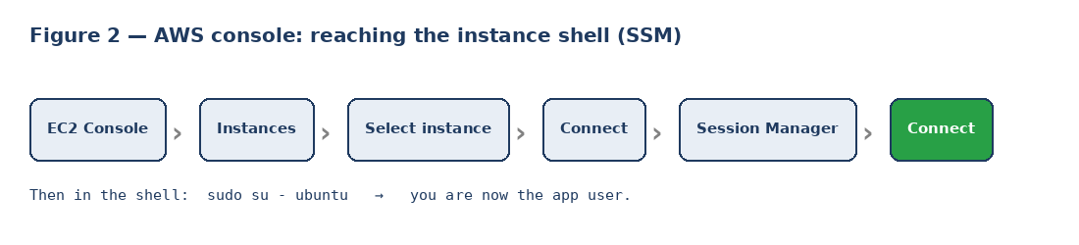
sudo su - ubuntu

A3. Restore the pm2 processes
First try restoring the saved process list:
pm2 resurrect # restores the saved backend + Frontend processes
pm2 status
If pm2 status shows backend + Frontend online, you are done with this step. If it is empty or errored, re-register from scratch:
pm2 delete all
cd ~/actions-runner/_work/restaurant-review-platform/restaurant-review-platform
cd backend && pm2 start npm --name backend -- start && cd ..
pm2 serve frontend/build 3000 --name Frontend --spa
pm2 save
pm2 status
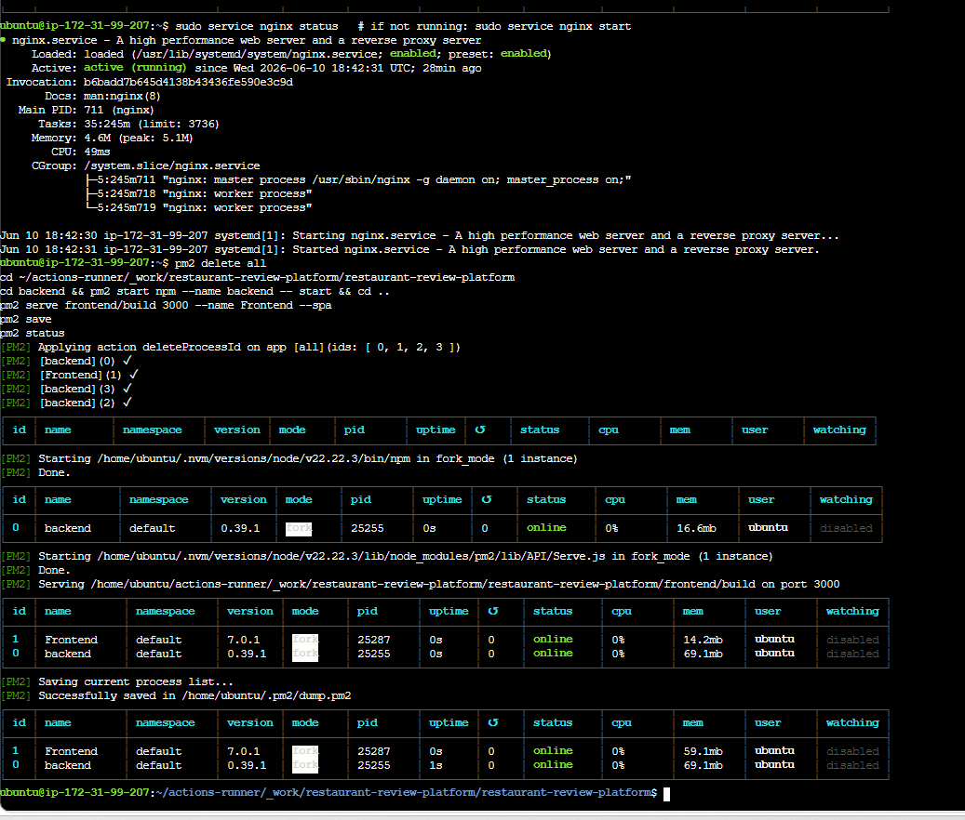
Figure 3 — §7.2 evidence (from the report): nginx running, processes re-registered, backend + Frontend both online. Your own capture should look like this.

A4. Confirm nginx is running
sudo service nginx status # if not running: sudo service nginx start

A5. Make pm2 auto-start on reboot (do this once)
So a future instance restart does not drop the app processes:
pm2 startup systemd # then copy-run the 'sudo ...' line it prints
pm2 save

Part B — Capture the 2 IP-specific screenshots
These are the only screenshots affected by the IP change.
- §7.2 — screenshot a clean `pm2 status` showing backend + Frontend both online.
- §7.4 — open http://3.27.208.40/ in the browser, log in (diner@mesa.test / diner1234), and screenshot the running app with the new IP visible in the address bar.
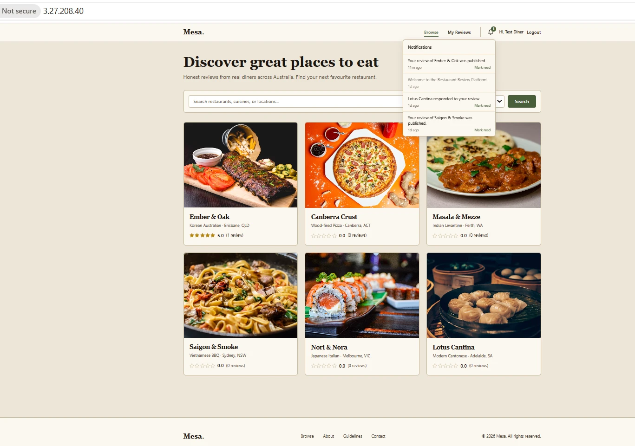
Figure 4 — §7.4 evidence (from the report): the app home at http://3.27.208.40/ with the public IP visible in the address bar (top-left).
If http://3.27.208.40/ does not load: your home IP may have changed when your PC/router restarted — the security group only allows your IP. Check checkip.amazonaws.com; if it differs from the rule, re-add it (see Troubleshooting).

Part C — Already captured — do NOT redo
These do not depend on the IP and are already embedded in the report:
- §7.1 — ci.yml configuration
- §7.3 — GitHub Actions run green
- §5.1 — unit tests passing, 49 passing (existing screenshot is fine)
- §6 — Postman evidence
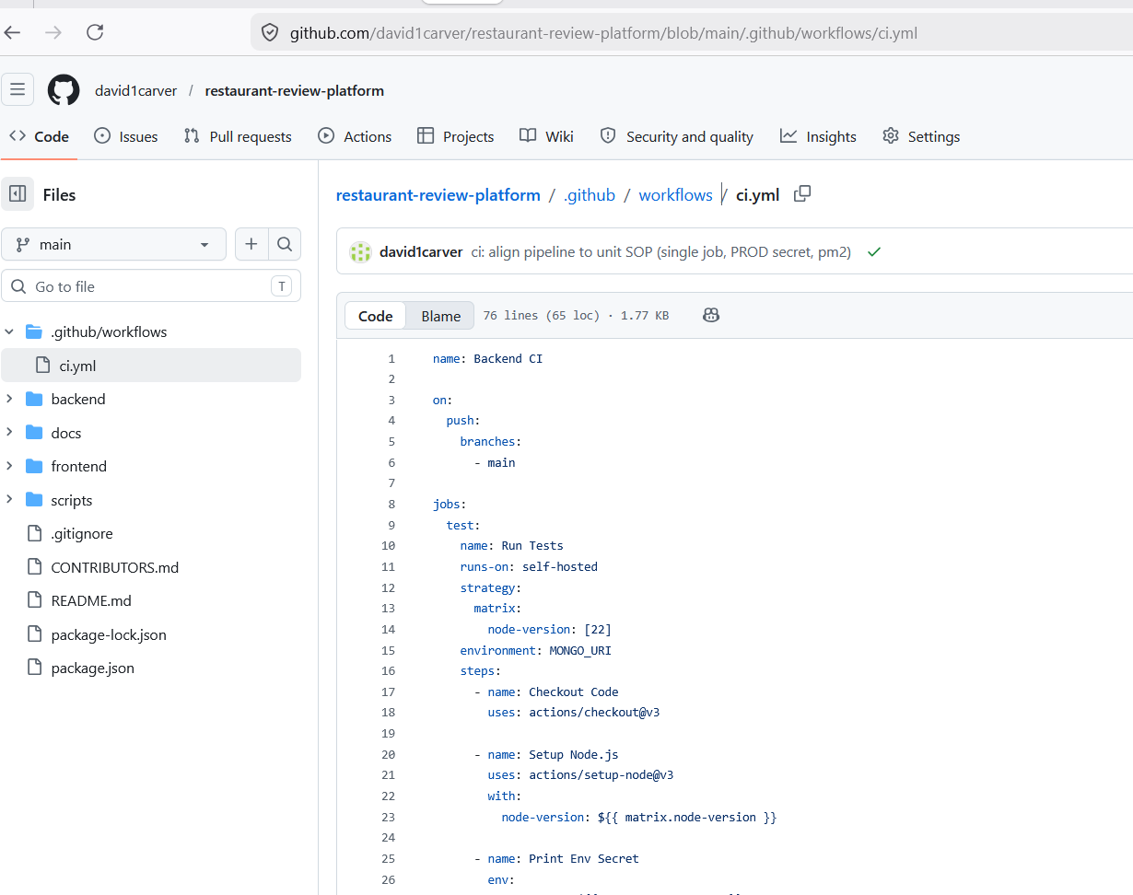
§7.1 — the CI/CD workflow file (ci.yml), already in the report.
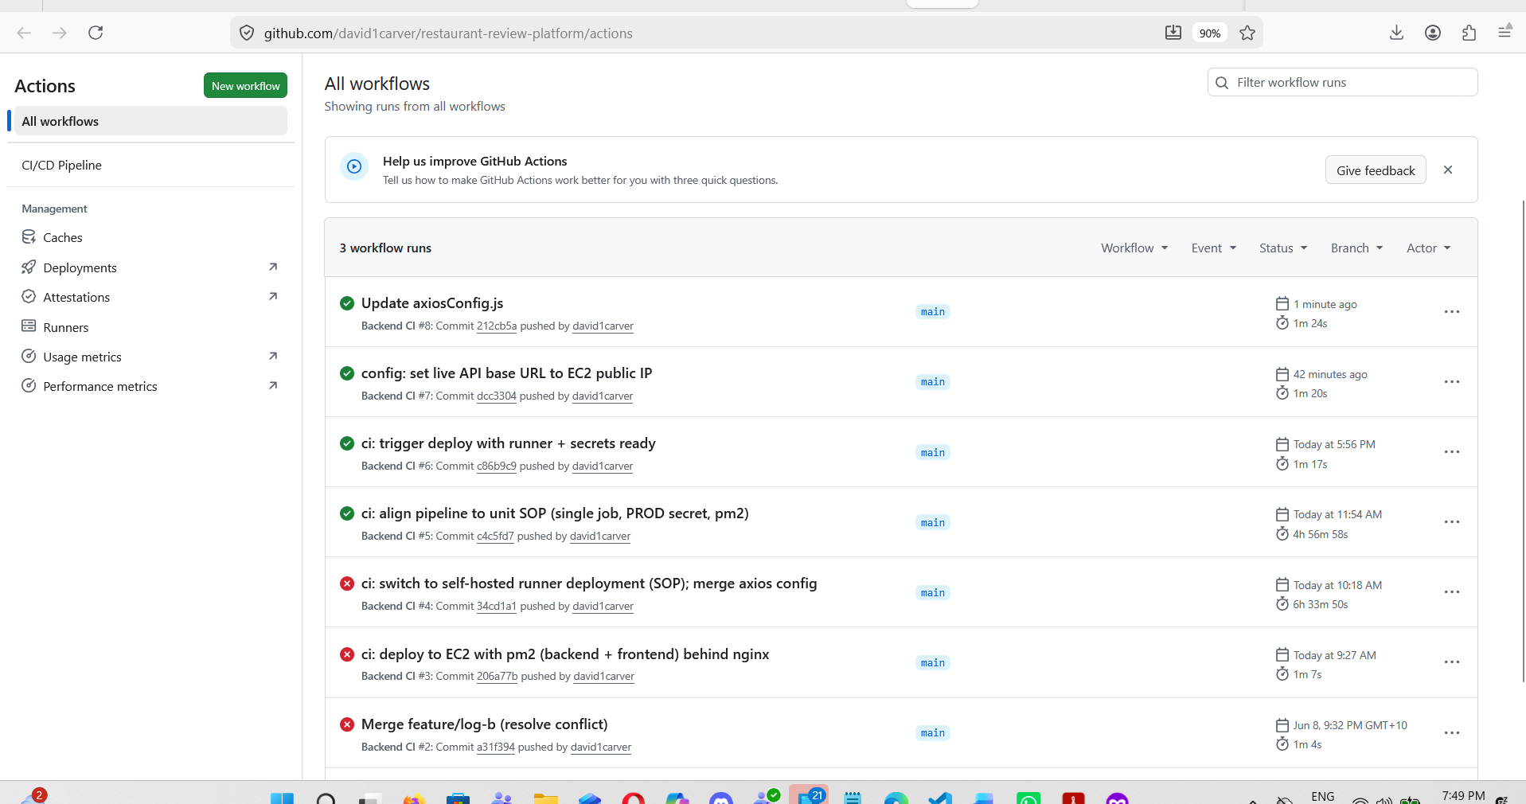
§7.3 — the GitHub Actions run passing, already in the report.

Part D — Capture and submit in ONE session
Important. Because a stop/start hands out a new IP, capture the Part B screenshots and submit in the same working session. If you stop the instance again before submitting, the IP will change and the screenshots/report references will no longer match.
Permanent fix (recommended): allocate an Elastic IP and associate it with the instance so the public IP never changes. See Troubleshooting.

Troubleshooting

App URL will not load
Almost always the security group no longer allows your current home IP.
- Browse to checkip.amazonaws.com to get your current IP.
- EC2 → Security Groups → the instance's group → Inbound rules → Edit.
- Update the HTTP (port 80) rule's source to your current IP (or My IP), save.

pm2 status is empty after resurrect
Re-register the processes using the A3 'pm2 delete all' block, then pm2 save.

Stop the IP churn permanently (Elastic IP)
- EC2 → Elastic IPs → Allocate Elastic IP address.
- Select it → Actions → Associate → choose the instance.
- Update the report/Part C to the Elastic IP once — it will not change again.

Quick reference (run inside SSM, as ubuntu)
sudo su - ubuntu
pm2 resurrect && pm2 status
# if empty:
pm2 delete all
cd ~/actions-runner/_work/restaurant-review-platform/restaurant-review-platform
cd backend && pm2 start npm --name backend -- start && cd ..
pm2 serve frontend/build 3000 --name Frontend --spa
pm2 save && pm2 status
sudo service nginx status # start if needed
pm2 startup systemd # run the printed sudo line, then: pm2 save
# Then capture: §7.2 pm2 status | §7.4 http://3.27.208.40/ logged in

