IFQ636 A2 — Video Presentation Script (10 minutes)
Project: Mesa Restaurant Review Platform. Live: http://3.27.208.40/ Repo: github.com/david1carver/restaurant-review-platform
Roles & direction: D = David (Anrio) Carver — app, design patterns/OOP, CI/CD & deployment. C = Cameron Bruce — unit testing, API testing. Read the quoted lines aloud; the red “SHOW” lines (and the images below them) are what to share on screen. Pre-open every tab and pre-log-in so there is no dead air. Keep the EC2 instance running.

0:00–0:40 — Intro (both on camera)
David: “Hi, I’m David Carver.”
Cameron: “And I’m Cameron Bruce. This is our IFQ636 Assignment 2, Mesa, a Restaurant Review Platform.”
David: “For A2 we re-architected the backend around object-oriented design and eight design patterns, added a new Notifications feature, expanded unit testing, added Postman API testing, and built a CI/CD pipeline that auto-deploys to AWS EC2. It’s live right now.”
▶ SHOW the live app in the browser — address bar http://3.27.208.40/ (this exact screen):
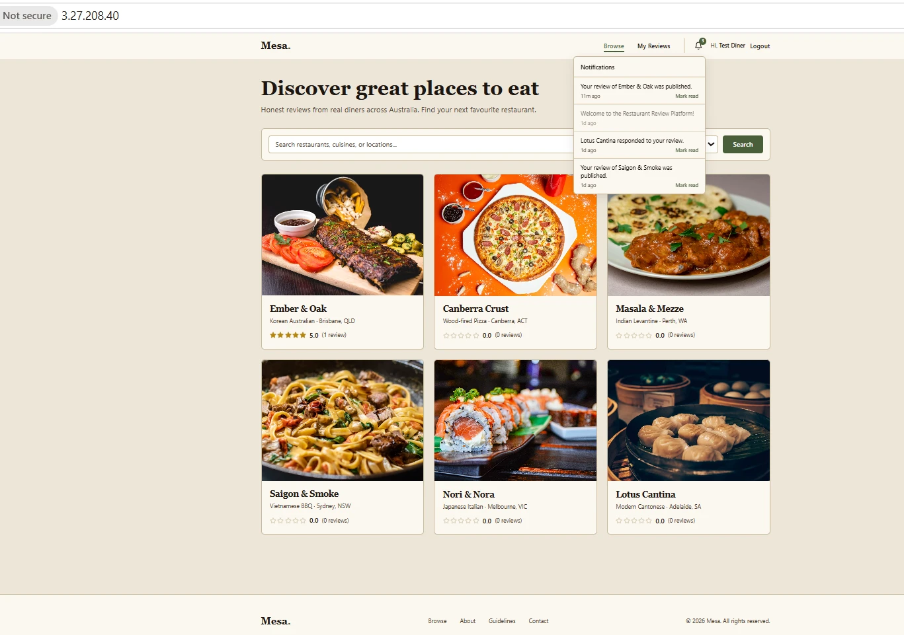
On screen: the live app home at http://3.27.208.40/ — public IP visible top-left.

0:40–2:20 — Live application demo (David)
David: “This is the public catalogue, six restaurants, searchable and filterable by cuisine.”
David: “I’ll log in as a diner and post a five-star review of Ember & Oak.”
David: “Watch two things happen from one action: the average rating updates to 5.0, and a notification appears in the bell, that’s the Observer pattern firing. I’ll show that in the code shortly.”
▶ SHOW post a review live, then open the notifications bell (as pictured): rating 5.0 + “Your review of Ember & Oak was published”.
David: “If I try to review the same restaurant again, the API rejects it — one review per diner. And as an admin I can moderate reviews and manage restaurants.”
Demo live in the browser; the screen above already shows the 5.0 review and the open notifications dropdown — narrate over it.

2:20–4:30, Design patterns & OOP (David, in VS Code), biggest rubric weight, slow down
David: “Here is the backend. We applied eight patterns — the rubric needs seven.”
▶ SHOW the architecture diagram (the eight patterns + the request flow):
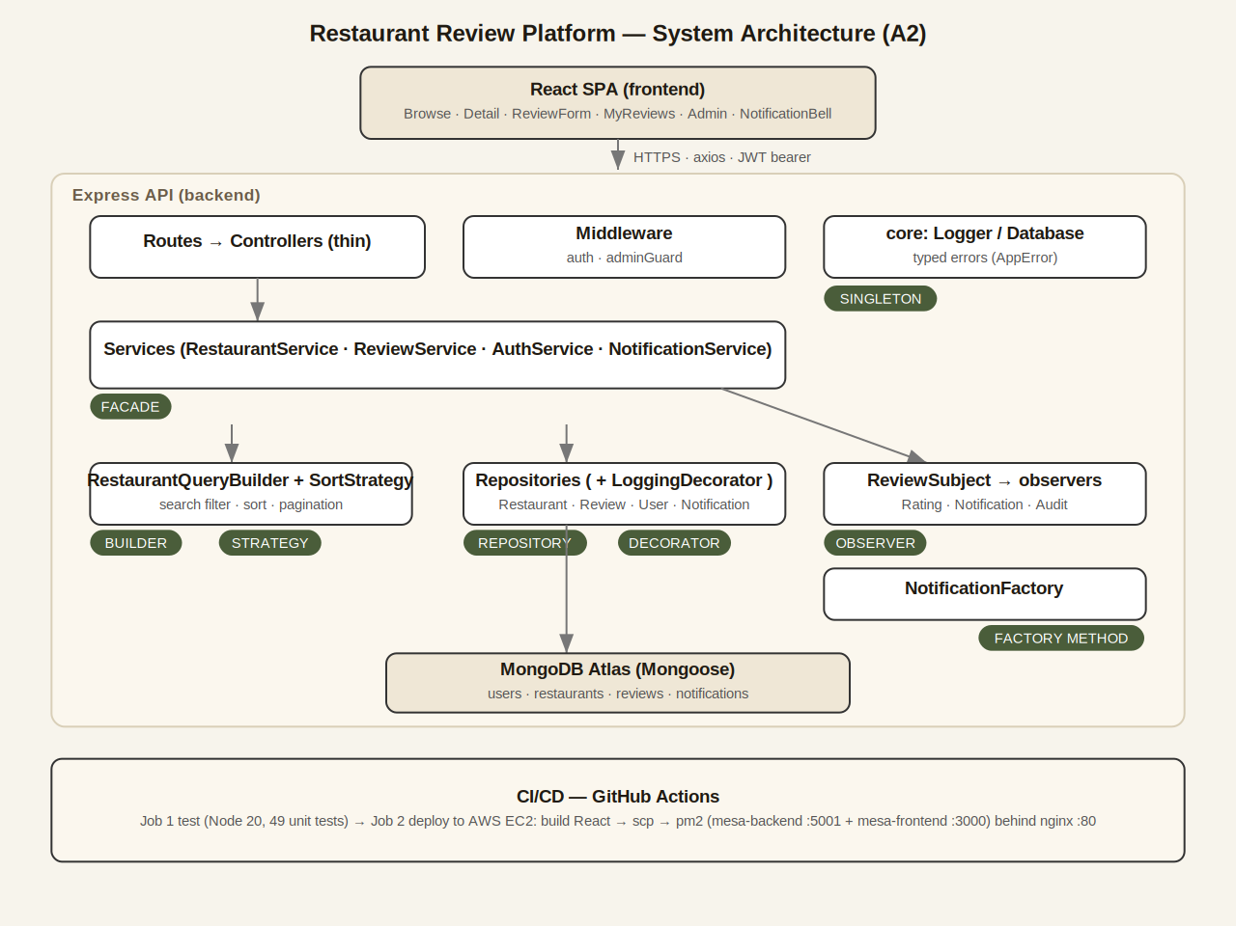
On screen: the system architecture — eight design patterns and the request flow.
David: “Singleton, core/Logger and core/Database. Repository, BaseRepository. Decorator via a Proxy, LoggingRepositoryDecorator. Façade, ReviewService. Builder, RestaurantQueryBuilder. Strategy, SortStrategy. Factory Method, NotificationFactory. Observer, ReviewSubject fanning out to Rating, Notification and Audit observers.”
David: “When a review is posted: controller → Service (Facade) → Repository wrapped by the Logging Decorator → ReviewSubject notifies the observers, one recomputes the rating, one uses the Factory to build a notification, one writes an audit log through the Singleton logger.”
David: “On OOP: private hash fields give encapsulation; the abstract SortStrategy throws if instantiated directly, abstraction; the concrete strategies and observers use inheritance; and every observer exposes the same update method, polymorphism.”
▶ SHOW open 2–3 files live in VS Code: events/ReviewSubject.js, services/ReviewService.js, strategies/SortStrategy.js, point at the pattern in each.

4:30–6:00 — Unit testing (Cameron, terminal)
Cameron: “I handled testing. We use Mocha, Chai and Sinon — pure unit tests, no database; the Mongoose calls are stubbed.”
Cameron: “Running npm test, 49 tests pass.”
▶ SHOW run “npm test” live, and/or this result:
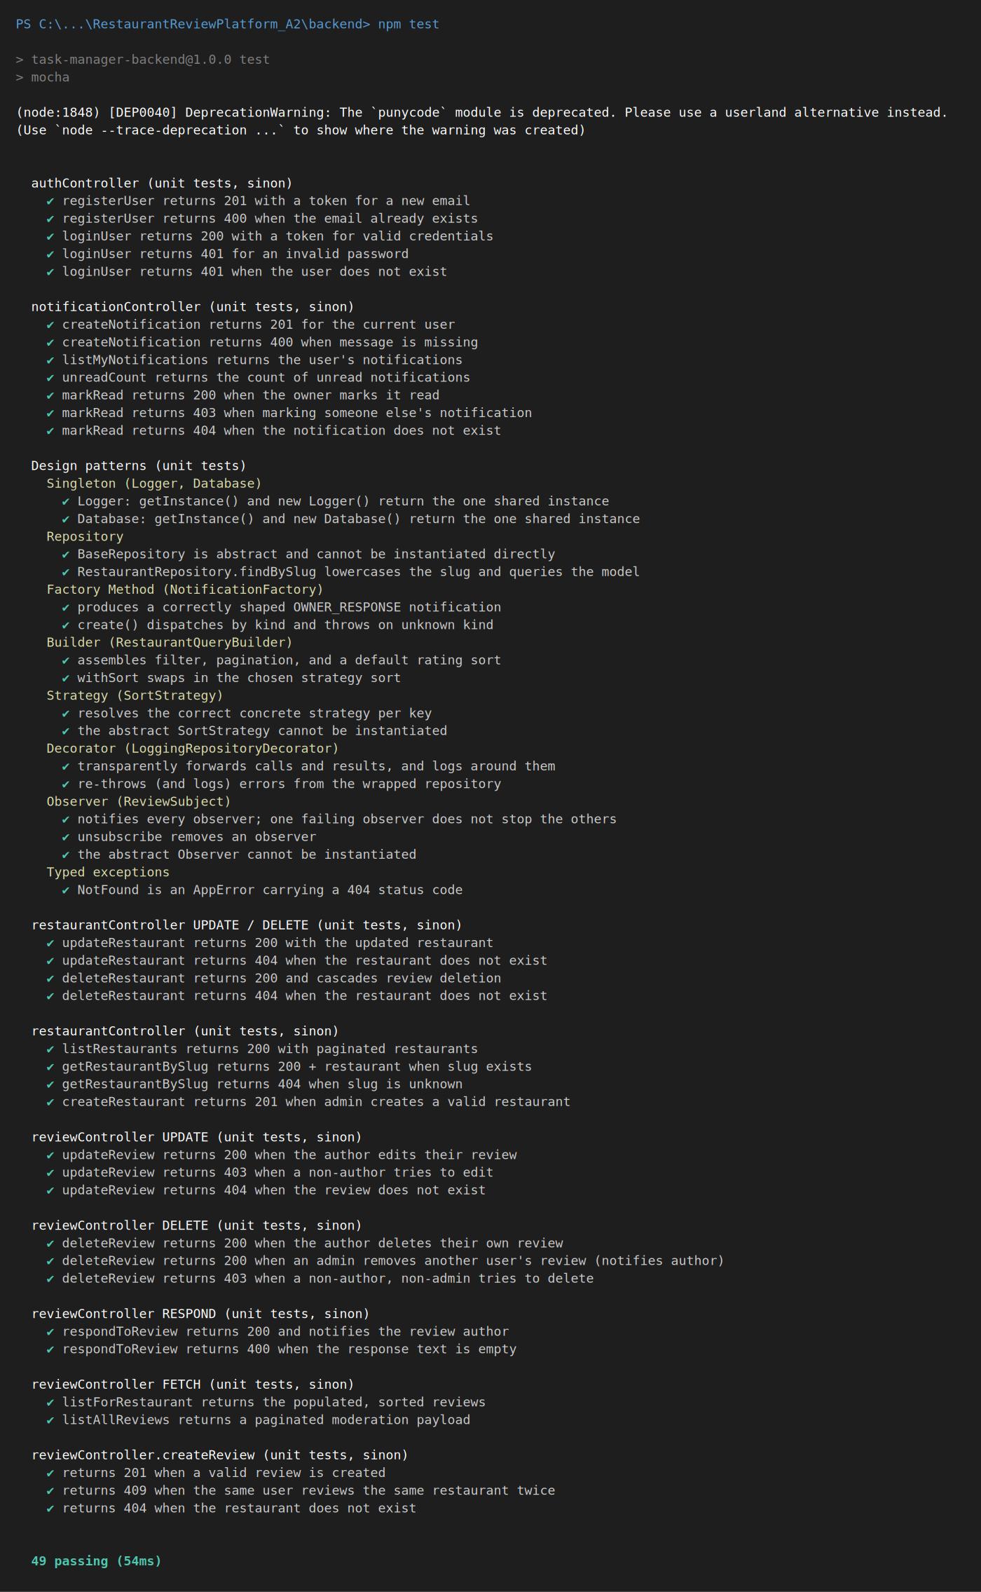
On screen: npm test — 49 passing.
Cameron: “For example, createReview returns 201 on success and 409 on a duplicate, and a pattern test verifies the Observer fans out correctly. Every backend function — create, fetch, update, delete — has a case in our test-case table.”

6:00–7:15 — API testing (Cameron, Thunder Client / Postman)
Cameron: “I verified every endpoint and its error handling. Login returns 200 and a JWT; creating a review returns 201; sending it again returns 409.”
▶ SHOW the 409 duplicate response (note the backend log shows the database unique-index error too):
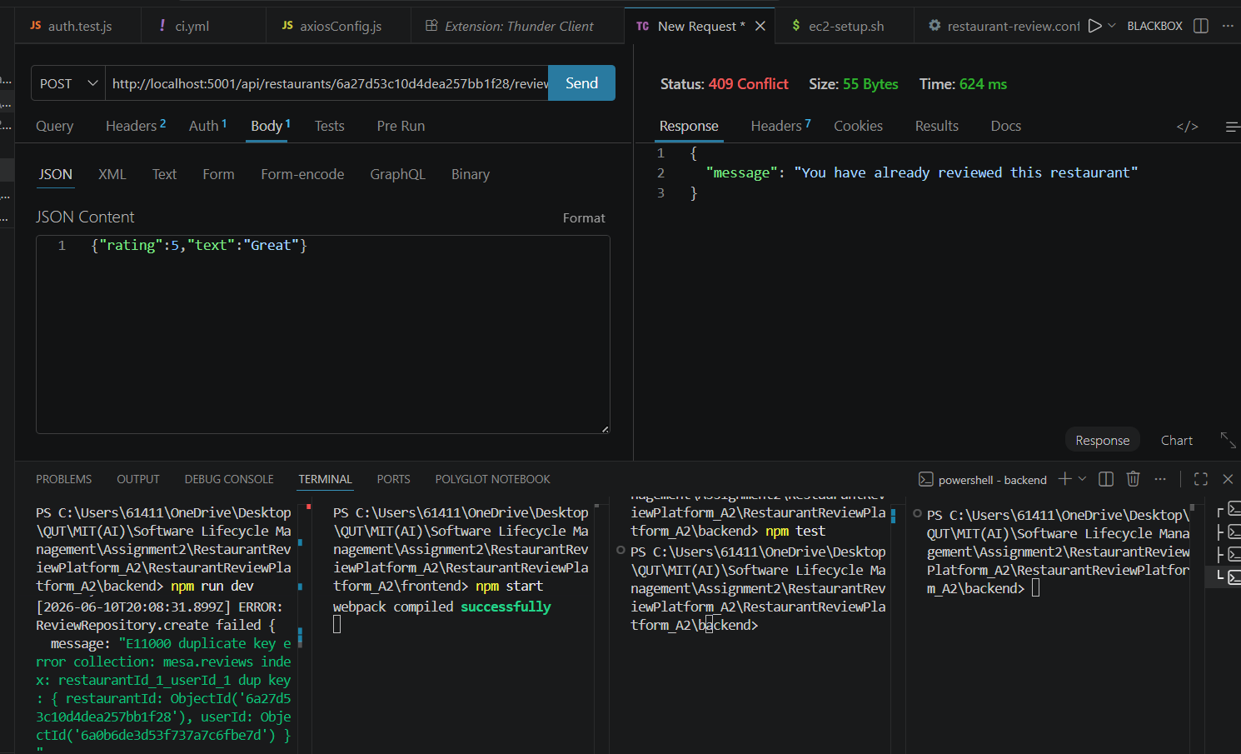
On screen: 409 Conflict — duplicate review (backend log shows the E11000 unique-index error).
Cameron: “Posting without a token returns 401; missing fields returns 400; and a diner trying to create a restaurant returns 403 — the role guard.”
▶ SHOW the 403 role-guard response:
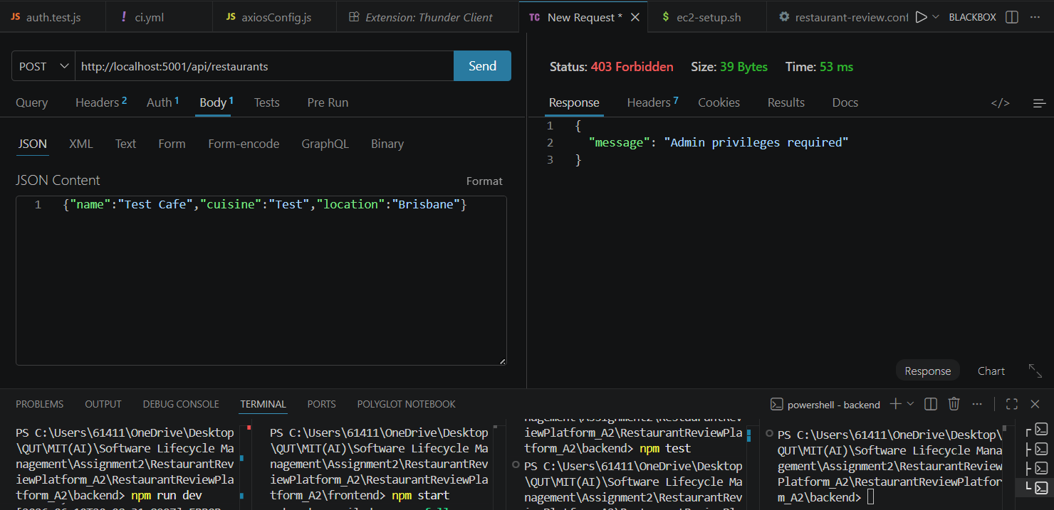
On screen: 403 Forbidden — 'Admin privileges required' (the role guard).
Cameron: “The full collection is exported in the repo under docs/A2.”

7:15–9:00 — CI/CD & deployment (David)
David: “Deployment is fully automated by a GitHub Actions self-hosted runner installed on the EC2 instance. On every push to main it installs deps, builds the frontend, runs the unit tests, writes the production .env from a secret, then restarts the app under pm2.”
▶ SHOW LIVE — open .github/workflows/ci.yml on GitHub (name: Backend CI, runs-on: self-hosted). (live on screen — no slide)
▶ SHOW LIVE — the Actions tab showing green runs, and Settings → Actions → Runners showing the runner Idle. (live on screen — no slide)
David: “On the server, pm2 shows the backend and frontend both online.”
▶ SHOW the pm2 status table (backend + Frontend online):
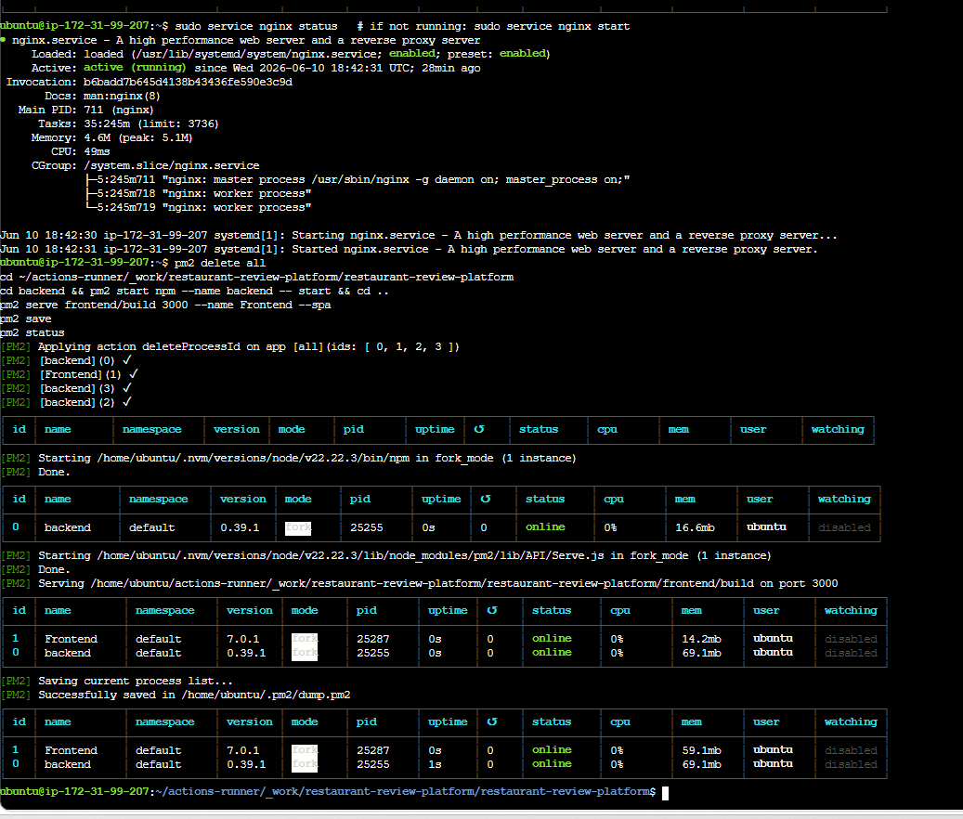
On screen: pm2 status — backend + Frontend both online.
David: “nginx serves the React build on port 80 and proxies /api to the backend. To prove the loop I’ll push a small change, the run goes green, and the live site updates.”
▶ SHOW LIVE — push a tiny change to main → Actions goes green → refresh http://3.27.208.40/. (live on screen — no slide)

9:00–9:40 — Team collaboration (both)
Cameron: “We used GitHub with a feature-branch workflow — feature branches, pull requests, code reviews, and two resolved merge conflicts.”
▶ SHOW LIVE — Insights → Contributors (commits per member), the branch list, a reviewed pull request, and a resolved merge-conflict commit. (live on screen — no slide)
Cameron records this part after he has done his commits/PR/review/merge-conflicts from his own account.

9:40–10:00 — Wrap (both)
David: “So: an OOP, pattern-based backend; a new notifications feature; 49 unit tests; full API testing; and a live, auto-deployed app.”
Cameron: “Thanks for watching.”

Recording checklist
- One continuous screen recording (OBS / Zoom / Xbox Game Bar Win+G); mic on.
- Pre-open: live site (logged in), VS Code (backend), GitHub Actions + Runners, the test terminal, Thunder Client.
- Keep the EC2 instance RUNNING the whole time (a stop/start changes the public IP).
- If the live site flashes a 502 right after a push, wait ~10s and refresh (pm2 restarting).
- Both members must speak and screen-share their own parts (markers verify each member demonstrates their work).
- Upload via Canvas Studio (one member submits to Assignment 2: Video submission).

