IFQ636 A2 — Cameron: Standard Operating Procedure (with expected screenshots)
Repository: github.com/david1carver/restaurant-review-platform
Goal: produce REAL GitHub activity from your own account — commits, a pull request, a code review, and your half of two merge conflicts. That is exactly what the marker checks for. Do every step from your own machine and GitHub login. Each step shows what you should EXPECT to see (green) and what to CAPTURE (red) to send to David. ~2-3 hours.

Step 0 — Set up (once)
- Accept the collaborator invite (your GitHub: blueskyex19) from your GitHub email/notifications.
- Install Node 18/20, Git, VS Code.
Clone and set your identity so commits are attributed to YOU:
git clone https://github.com/david1carver/restaurant-review-platform.git
cd restaurant-review-platform
git config user.name "Cameron Bruce"
git config user.email "cambruce223@gmail.com"
Create backend/.env (paste the MONGO_URI and JWT_SECRET David sent you), then test:
MONGO_URI=<from David>
JWT_SECRET=<from David>
PORT=5001
cd backend
npm install
npm test
Expected: the terminal ends with "49 passing" (green), like this:
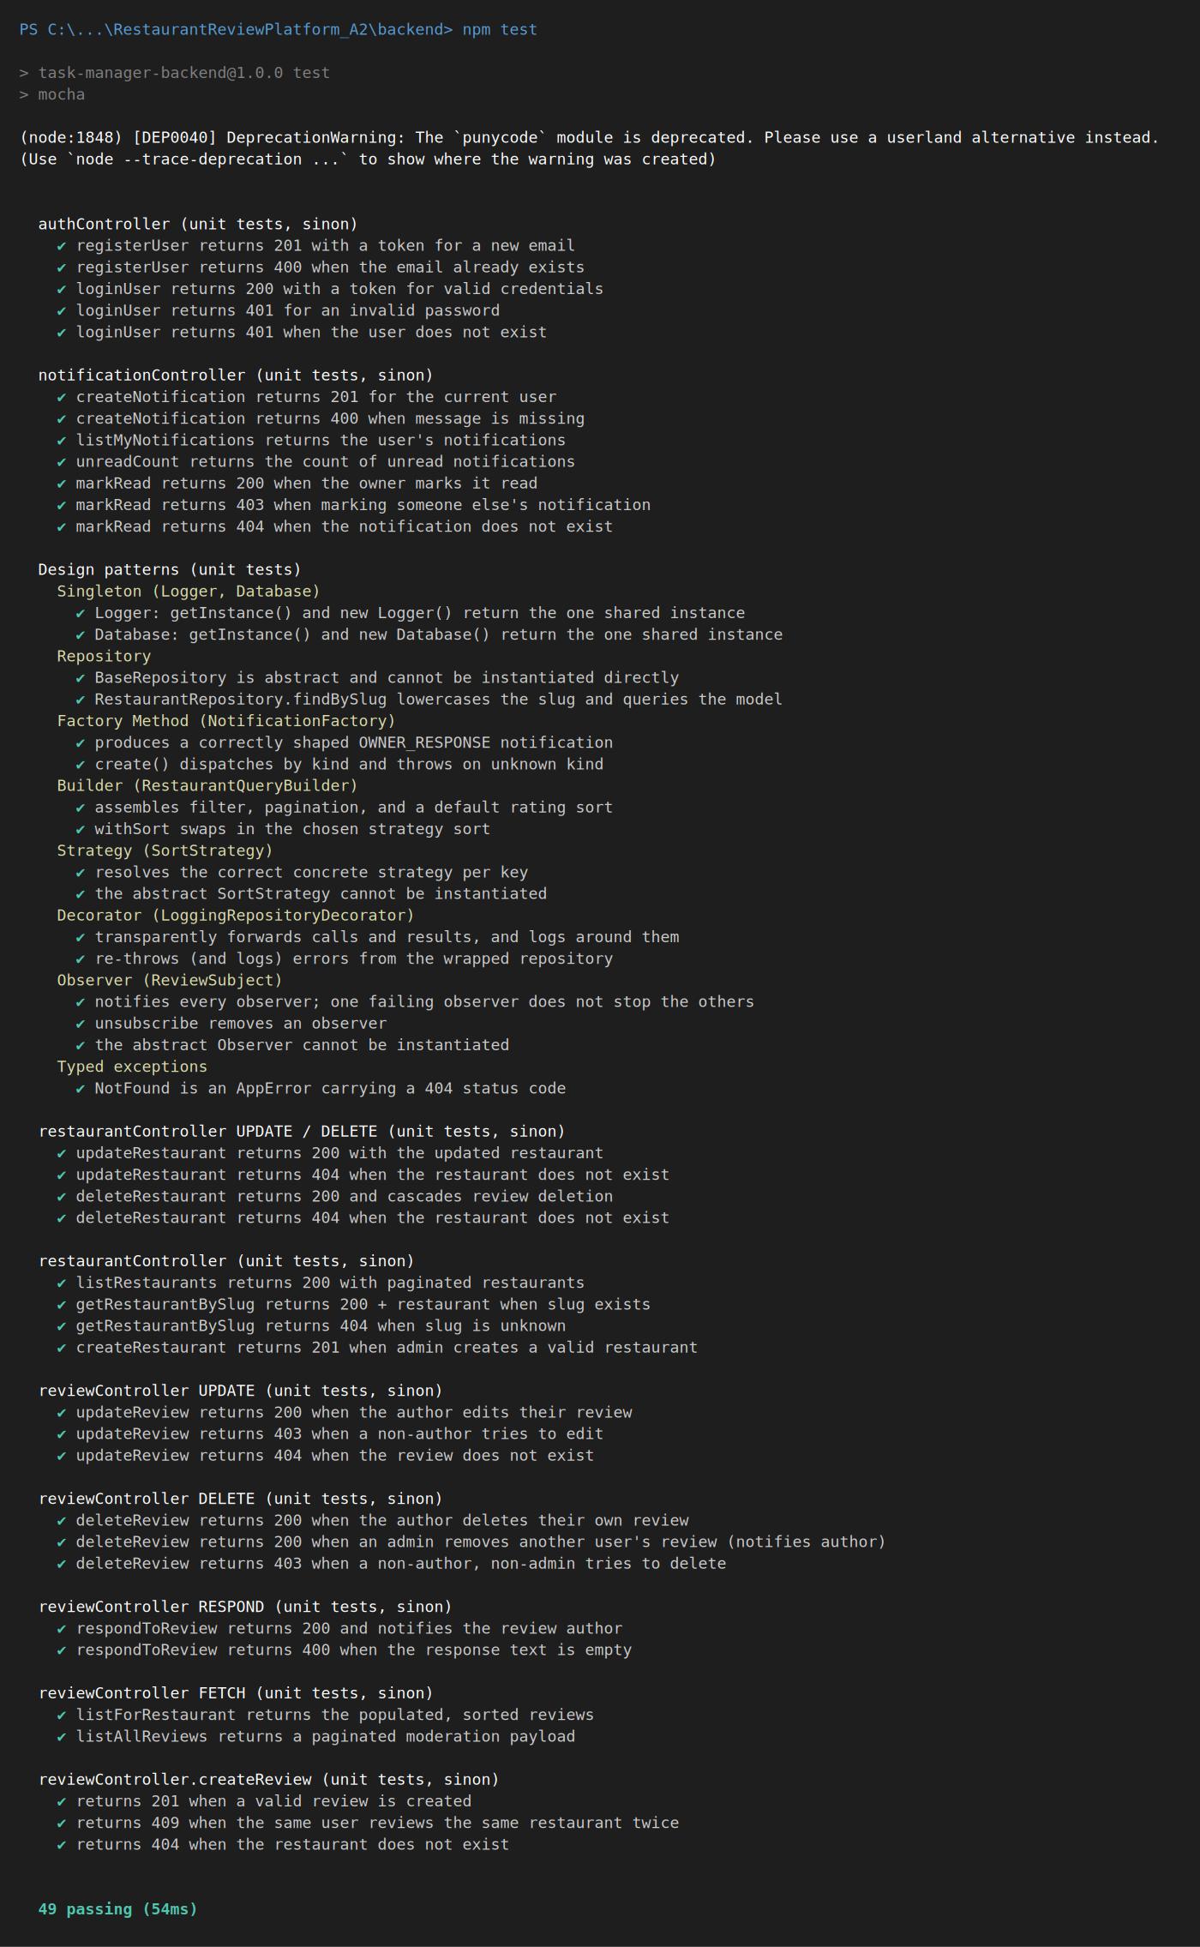
CAPTURE: this "49 passing" terminal.

Step 1 — Commit #1: add a unit test
Create backend/test/profile.test.js (paste the code David provided in Cameron_StepByStep.docx), then:
npm test # expect: 52 passing
git checkout -b feature/profile-tests
git add backend/test/profile.test.js
git commit -m "test: add unit tests for the user profile endpoints"
git push -u origin feature/profile-tests
On GitHub, click "Compare & pull request" then "Create pull request".
Expected: a Pull Request like the example below (your branch, your commit):
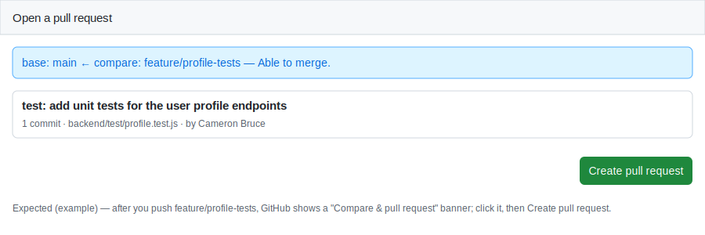
CAPTURE: your open Pull Request page.

Step 2 — Review David's pull request
Repo -> Pull requests -> open David's PR -> Files changed -> Review changes -> add a comment -> Approve -> Submit review.
Expected: your approving review appears on the PR, like this:
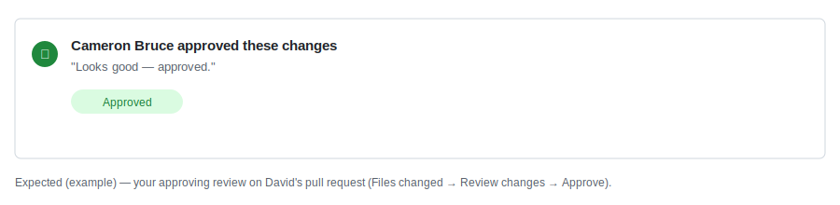
CAPTURE: your approved review on David's PR.

Step 3 — The two merge conflicts (you do "branch B")
David does "branch A" first and tells you "go". Then you create your branch with your own line on the same file:
git fetch origin
git checkout main
git checkout -b conflict/contrib-b
# add your line to CONTRIBUTORS.md
git add CONTRIBUTORS.md
git commit -m "docs: add Cameron to CONTRIBUTORS"
git push -u origin conflict/contrib-b
Open the PR -> GitHub shows "This branch has conflicts" -> Resolve conflicts. Keep BOTH lines and delete the marker lines:
Expected: the Resolve-conflicts editor, like this:
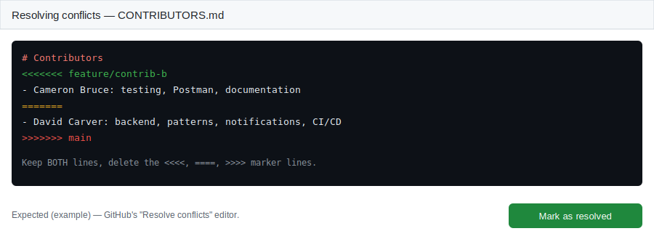
Then Mark as resolved -> Commit merge -> Merge pull request. Repeat for the second conflict on docs/A2/meeting-log.md (branch conflict/log-b).
CAPTURE: each "Resolve conflicts" screen (both conflicts).

Step 4 — API testing (Thunder Client / Postman)
Start the backend (npm run dev). Log in to get a token (POST /api/auth/login), then test the error paths with the Bearer token in the Auth tab.
Expected: a duplicate review returns 409 Conflict:
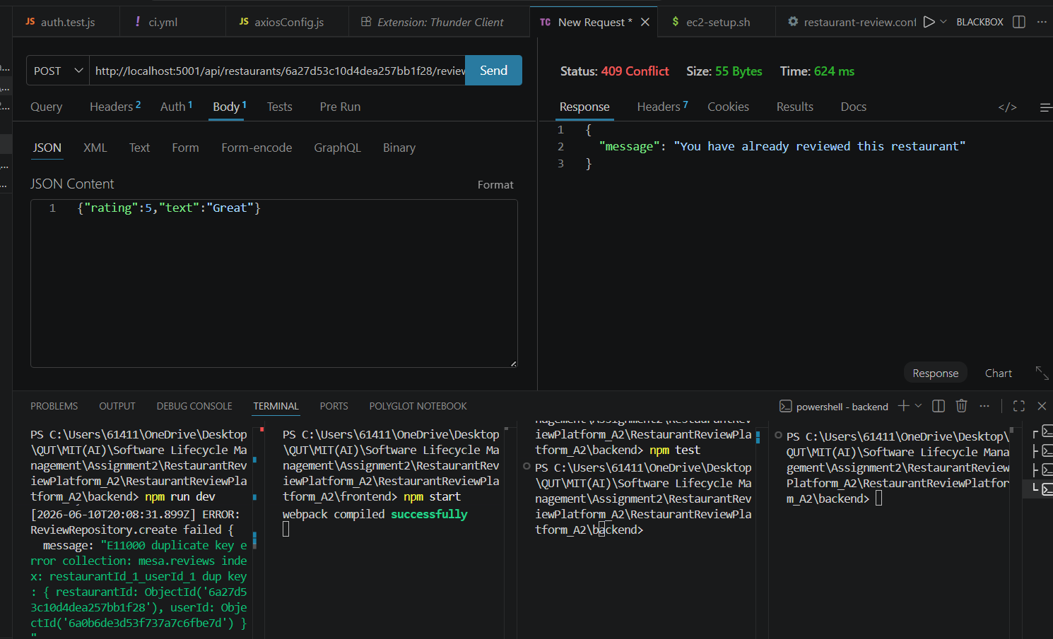
Expected: a diner creating a restaurant returns 403 Forbidden:
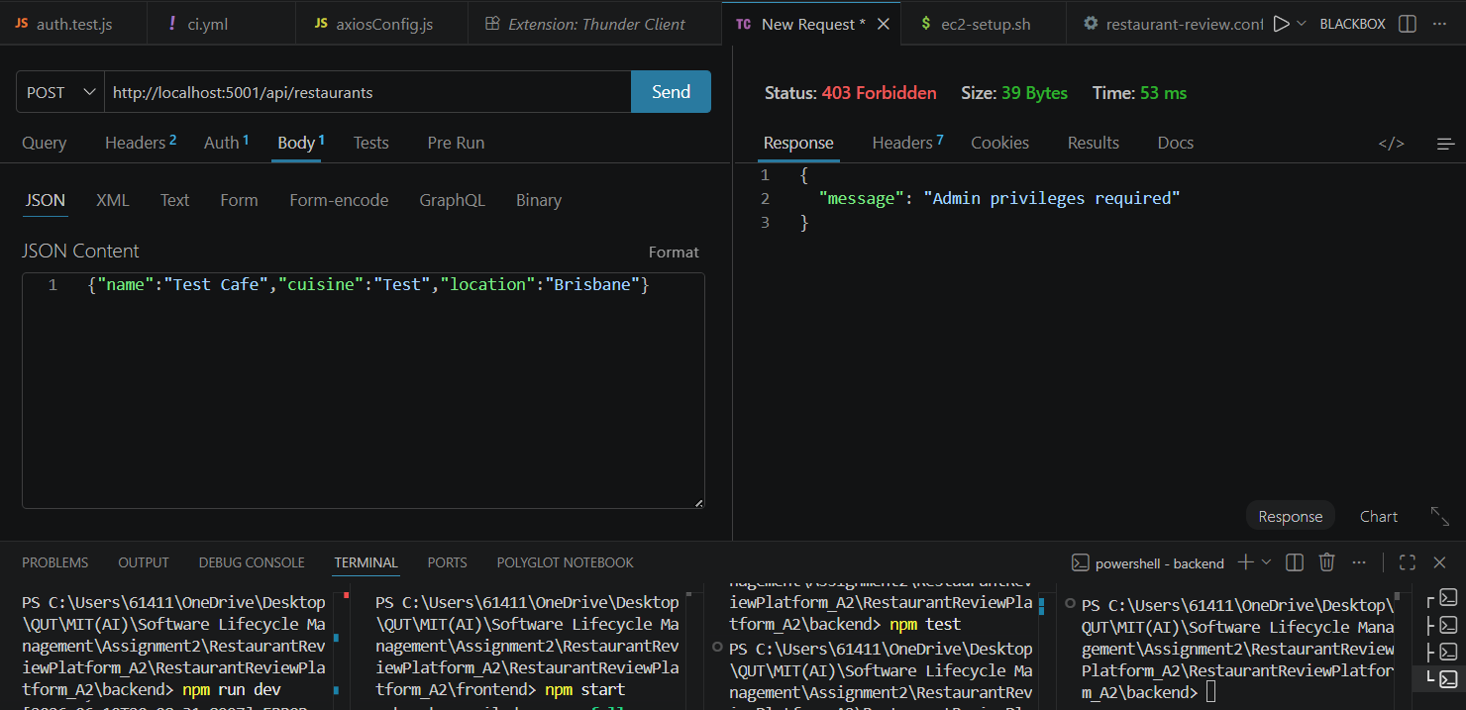
CAPTURE: the 409 and 403 responses.

Step 5 — Send David
- Your student ID: N11315423 (already on the cover/Part C).
- All CAPTURE screenshots above: 49 passing, your PR, your review, both conflict-resolve screens, 409 + 403.
- GitHub -> Insights -> Contributors graph + the branch list (for report section 4.2).
- A one-line description of what you did (for section 4.1 and Part C).
- Sign Part C and suggest a couple of meeting dates.
- Your video parts: demo the unit tests (npm test) and the API testing.

Screenshot checklist
- [ ] 49 passing (terminal)
- [ ] your Pull Request
- [ ] your approving review on David's PR
- [ ] conflict 1 resolve screen
- [ ] conflict 2 resolve screen
- [ ] Insights -> Contributors + branch list
- [ ] API 409 (duplicate)
- [ ] API 403 (diner creating restaurant)
Note: the images marked "Expected (example)" are illustrations of what the GitHub screens look like — your real screens will show your own name/branches. Capture YOUR versions to send David.

