IFQ636 Assignment 2 template

Team members: David (Anrio) Carver (sole contributor). Cameron Bruce was allocated to the team but withdrew from the unit before submission and did not contribute — see Section 4.1.
Student IDs: 11473215 (David Carver). Allocated-but-non-contributing: N11315423 (Cameron Bruce).
Project title: Restaurant Review Platform
GitHub link: https://github.com/david1carver/restaurant-review-platform
EC2 instance name and ID: mesa-prod-anrio, i-01746a2904bbca134 (ap-southeast-2). Live URL: http://3.27.208.40/
Please ensure all links are working correctly.

Project overview
The Restaurant Review Platform is a full-stack web app (Node.js/Express, React, MongoDB Atlas) where diners discover restaurants and post trustworthy star-rated reviews, owners respond, and admins curate and moderate. For Assignment 2 it extends the Assignment 1 project by re-architecting the backend around OOP and eight design patterns, adding an in-app Notifications subsystem, expanding unit testing, and automating build/test/deploy through a GitHub Actions CI/CD pipeline to AWS EC2 (nginx + pm2). It supports diner and admin roles with JWT auth, full CRUD on restaurants and reviews, auto-maintained aggregate ratings, owner responses, and event-driven notifications.

SRS documentation

2.1 Purpose
The system provides a trustworthy, peer-driven platform for discovering restaurants and sharing dining experiences, replacing fragmented word-of-mouth and noisy social-media opinions with a single structured catalogue. For Assignment 2 the application is extended with an object-oriented, design-pattern-based architecture and a new notifications subsystem.

2.2 Problem statement
Choosing where to eat is difficult: options are plentiful, quality is variable, and review signals are noisy or gamed (duplicate/fake reviews). Owners lack a direct response channel and there is no lightweight moderation path. The system addresses this with one verified review per diner per restaurant, automatically recomputed ratings, owner responses, admin moderation, and notifications that keep diners informed when their content changes state.

2.3 Scope
Product overview: a full-stack web app with a public catalogue, an authenticated diner experience, and an admin panel.
In scope (goals & benefits):
- Registration, login, JWT-secured sessions (roles: diner / admin).
- Browse, search (name/cuisine/location), filter (min rating) and sort restaurants.
- Full CRUD on reviews by their author; one review per diner per restaurant.
- Automatically recomputed averageRating and reviewCount per restaurant.
- Owner/admin response to reviews; admin CRUD on restaurants (cascade delete) and review moderation.
- In-app notifications generated by domain events (new A2 functionality).
- Automated build/test and deployment via CI/CD.
Out of scope: real-money payments/reservations, native mobile apps, direct messaging, third-party review imports, multilingual content, and ML recommendation ranking.

2.4 User characteristics
Role | Description | Skill level | Needs
Diner (registered) | Public seeking dining options | Low-medium | Fast browse/search, simple review forms, clear feedback
Restaurant owner* | Responds to reviews of their venue | Medium | Visibility of feedback, ability to respond
Administrator | Curates catalogue, moderates content | Medium-high | Efficient CRUD, moderation tools, oversight
Guest | Reads public catalogue/reviews | Low | Frictionless read-only access
*The owner-response action is exercised through the admin role in the assignment scope.
Accessibility: semantic HTML and labelled controls; sufficient colour contrast; keyboard-navigable forms; responsive layout; status conveyed by text + colour, not colour alone.

2.5 Constraints
- Technology: must extend the nahaQUT starter (Node.js, React, MongoDB); JWT/bcrypt auth.
- Hardware/host: AWS EC2 t3.medium on the QUT student AWS account (ap-southeast-2).
- Privacy/regulatory: bcrypt-hashed passwords only; no secrets in source (GitHub Secrets); minimal PII (name/email).
- Project: individual + team delivery; GitHub collaboration; CI/CD via GitHub Actions; 3000-word report limit.
- Environmental: the shared student AWS account blocks EC2 Instance Connect and restricts security-group edits and Elastic IP allocation. These were worked around by administering the instance through AWS SSM Session Manager and exposing the API to the browser through an nginx reverse proxy on port 80 (see 7).

2.6 Functional requirements
1. The system shall allow a user to register with name, email, and password.
2. The system shall allow a user to log in with email and password and receive a JWT.
3. The system shall restrict admin-only operations to users with the admin role.
4. The system shall allow anyone to browse restaurants with pagination.
5. The system shall allow anyone to search by name/cuisine/location, filter by minimum rating, and sort by rating/newest/name.
6. The system shall allow anyone to view a restaurant and its reviews.
7. The system shall allow an authenticated diner to create one review (1-5 stars + text) per restaurant.
8. The system shall reject a second review by the same diner for the same restaurant (HTTP 409).
9. The system shall allow a review author to update or delete their own review.
10. The system shall allow an administrator to delete any review (moderation).
11. The system shall recompute averageRating and reviewCount after any review create/update/delete.
12. The system shall allow an administrator to create/update/delete restaurants; deletion cascades to reviews.
13. The system shall allow an admin/owner to post a response to a review.
14. The system shall generate an in-app notification on review publication, owner response, and moderator removal.
15. The system shall allow a user to list notifications, see an unread count, and mark a notification read.

2.7 Non-functional requirements (NFRs)
- Performance: search returns within ~2 s under typical load; reads paginated (<=50/page).
- Reliability: non-critical side-effects (notifications, audit) are isolated so failures do not break the request; pm2 auto-restart.
- Security: bcrypt hashing; JWT with expiry; role-based authorization; secrets in GitHub Secrets.
- Usability: responsive UI; consistent design system; clear validation/error messages.
- Scalability: stateless JWT auth and a layered architecture allow horizontal scaling and storage swap behind the repository interface.
- Maintainability: OOP design with design patterns; unit-tested core; CI on every push.

2.8 User interface mockups/wireframes (Low Fidelity Design)
Low-fidelity greyscale wireframes establish the layout and information architecture of each screen before the visual design is applied. They cover the diner journey (Browse, Detail, Review Form, My Reviews), the admin journey (Restaurant management, Review moderation), authentication (Login/Register), and the new Notifications feature.
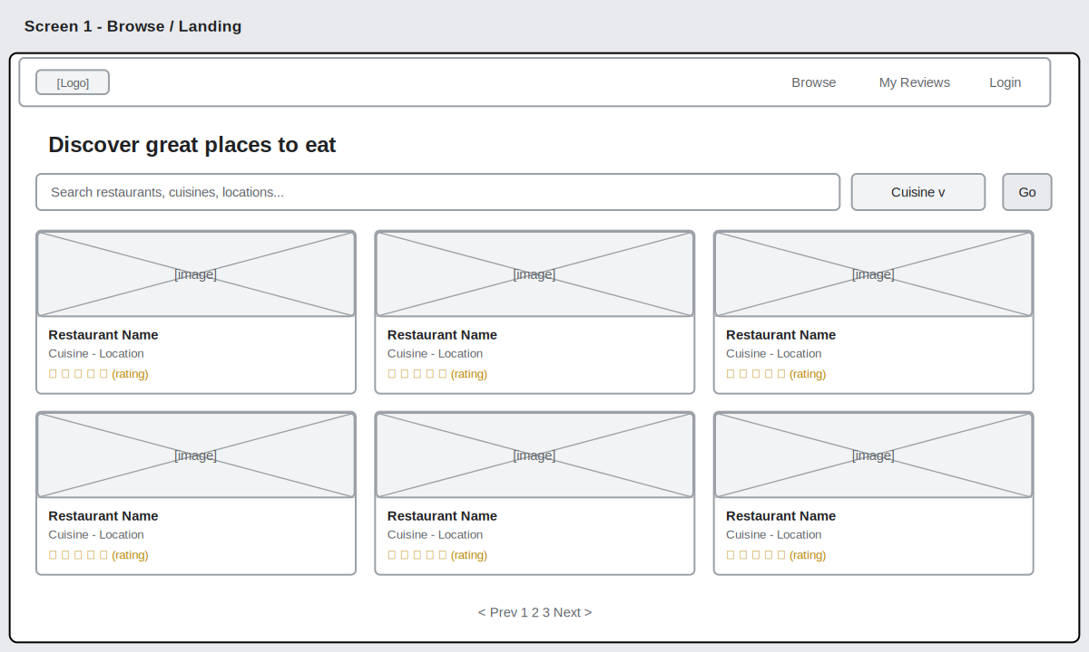
Figure 2.8.1: Browse / Landing page - search, filters and a paginated card grid.
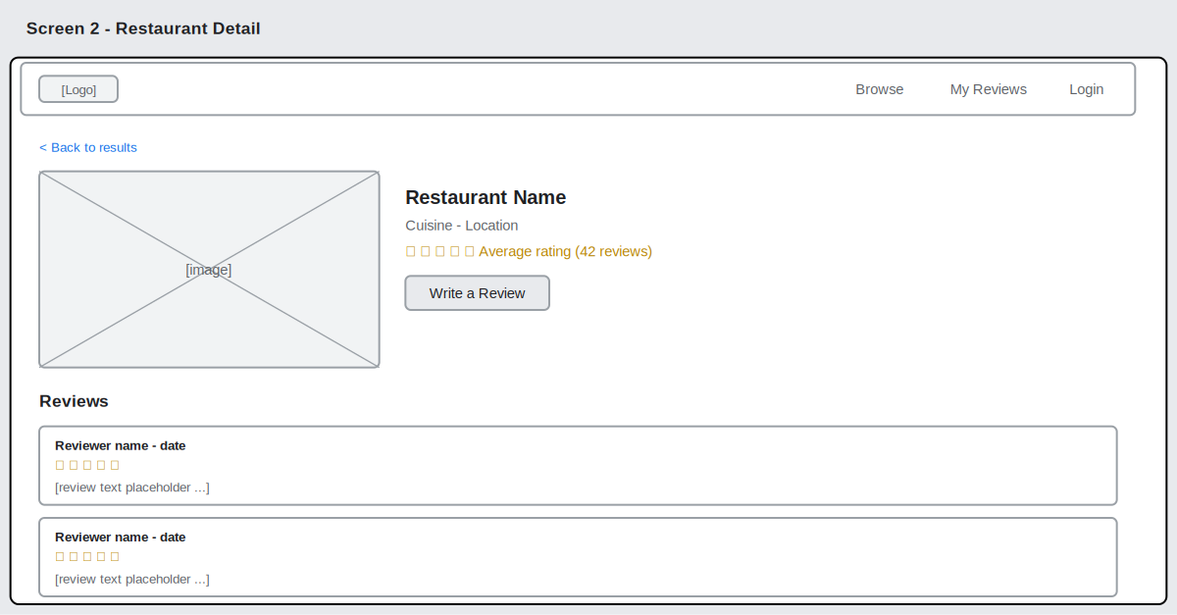
Figure 2.8.2: Restaurant Detail - rating, "Write a Review", and the review list.
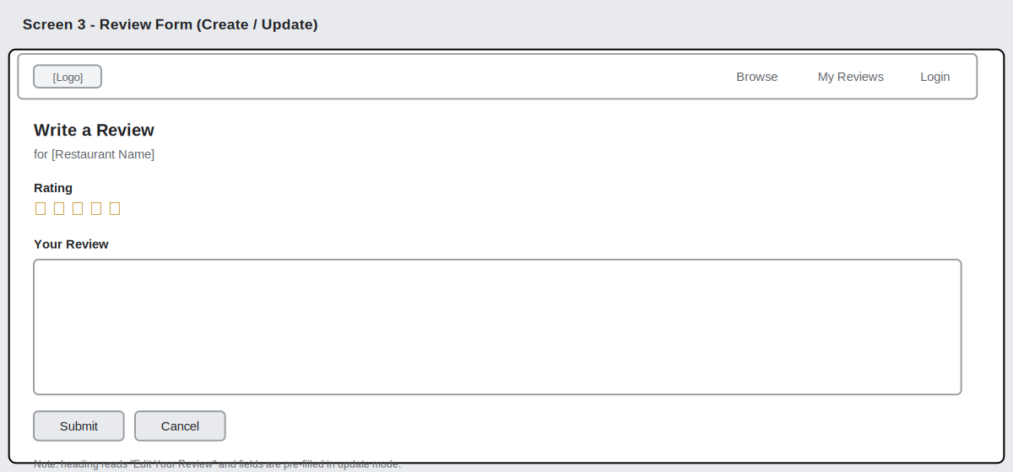
Figure 2.8.3: Review Form (create / update).
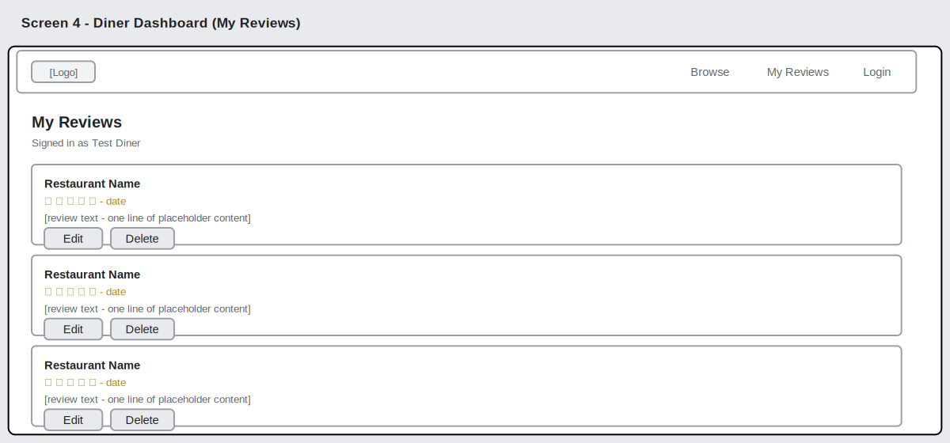
Figure 2.8.4: Diner Dashboard (My Reviews) - edit / delete own reviews.
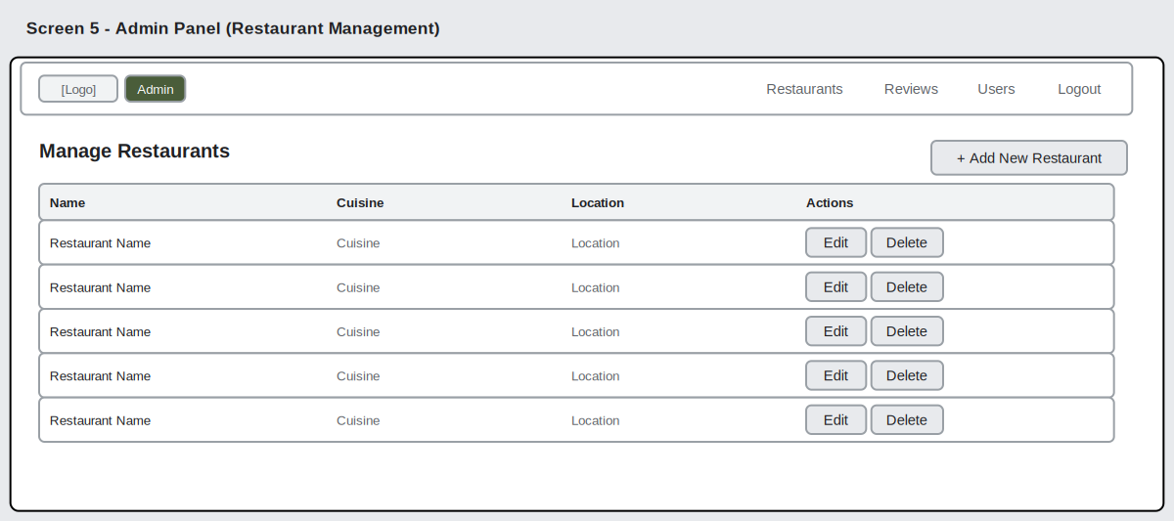
Figure 2.8.5: Admin Panel - restaurant management table.
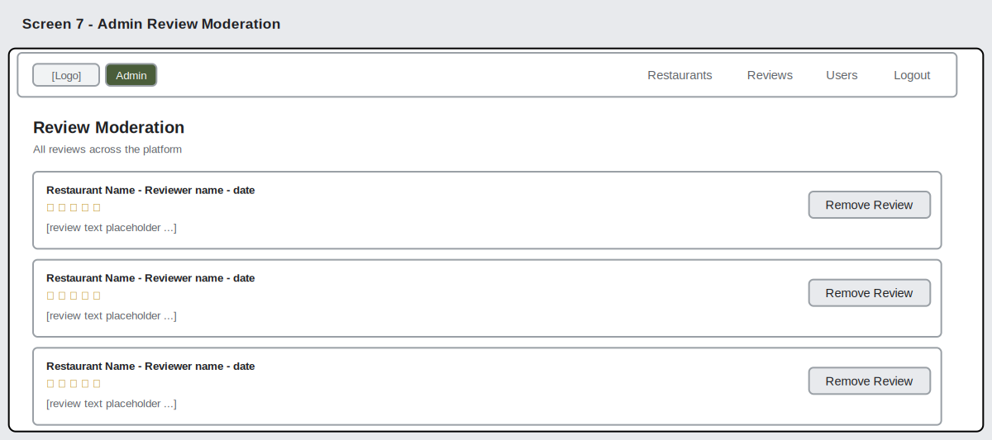
Figure 2.8.6: Admin Review Moderation.
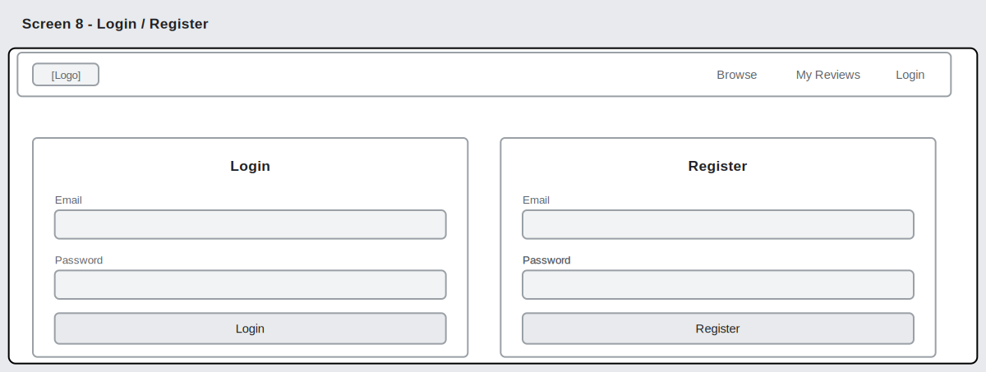
Figure 2.8.7: Login / Register.
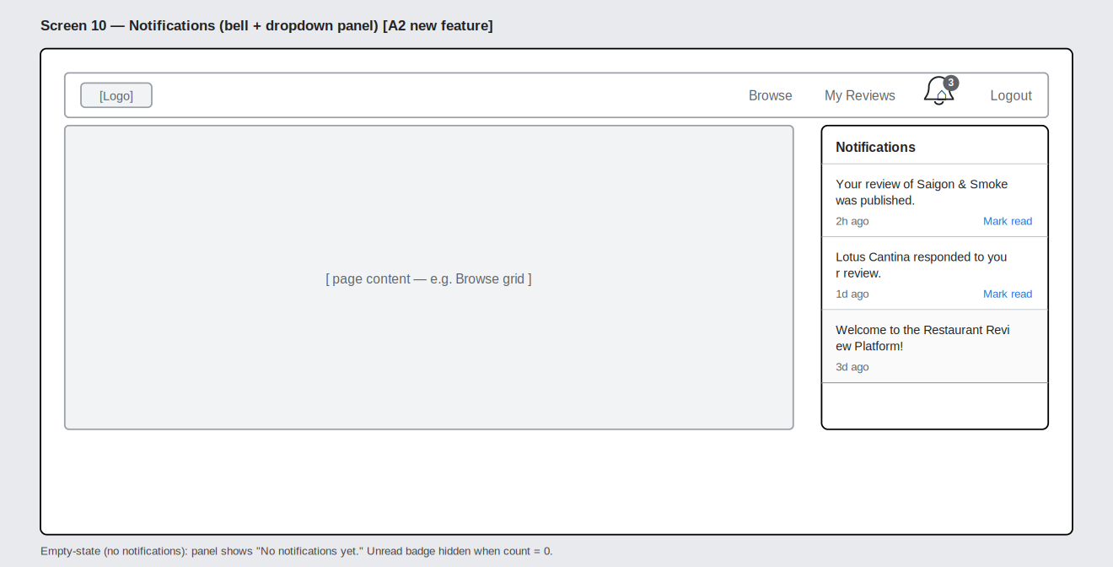
Figure 2.8.8: Notifications (bell + dropdown) - the new A2 feature.

2.9 Complete system diagram
Layered architecture: React SPA -> Express API (Routes -> thin Controllers -> Services [Facade] -> Builder + Strategy for queries, Repositories [+ Logging Decorator], and a ReviewSubject [Observer] fanning out to Rating-recompute, Notification [Factory Method] and Audit observers) -> core Logger/Database [Singleton] -> MongoDB Atlas (users, restaurants, reviews, notifications). The labelled diagram below shows the layers, the eight design patterns, and the CI/CD path.
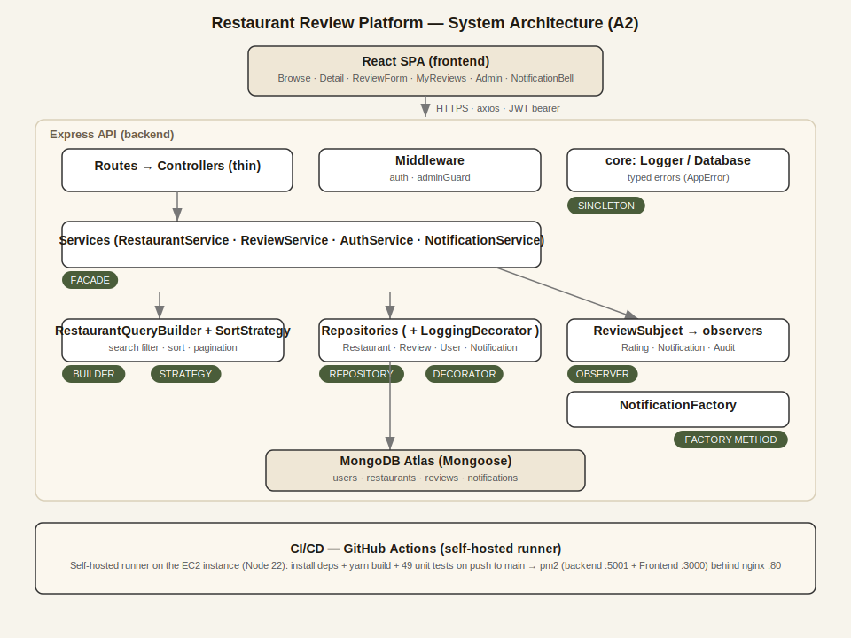
Figure: System architecture and design-pattern overview (also in docs/A2/diagrams/architecture.png).

2.10 Safety considerations
- Data protection: bcrypt-hashed passwords; JWT secret + DB URI via env/Secrets; passwords never returned (.select(-password)).
- Error handling & recovery: typed exception hierarchy (AppError + 400/401/403/404/409) mapped by a single sendError handler; no stack-trace leakage; observers isolated so failures are logged not propagated; pm2 auto-restart; Atlas managed backups.
- Input safety: rating bounds (1-5) and required-field validation; regex search inputs escaped to prevent injection.

2.11 Risk management
Risk | Likelihood | Impact | Mitigation
EC2 public exposure blocked by student AWS limits | High | High | Document EC2 target + scripts; managed-host fallback; automated test stage still runs
Duplicate/abusive reviews | Medium | Medium | Compound unique index (one review/diner -> 409); admin moderation
Leaked secrets | Low | High | GitHub Secrets; .env git-ignored; no secrets in code
Rating inconsistency after concurrent edits | Medium | Medium | Server-side recompute via Observer after every mutation
Team member non-contribution | Medium | Medium | Branch-per-feature, PR reviews, commit-author checks, Part C declaration
Regression during refactor | Medium | High | 49 automated unit tests run in CI on every push

Implementation (coding) using design pattern and OOP principles

3.1 Design pattern
Eight design patterns were applied (the HD band requires seven). Each is used for a real purpose and is covered by unit tests (see 5).
# | Pattern | Type | File(s) | Problem it solves (example usage)
1 | Singleton | Creational | core/Logger.js, core/Database.js | One shared logger and one Mongoose connection process-wide
2 | Factory Method | Creational | factories/NotificationFactory.js | Build notification payloads by intent, not by hand
3 | Builder | Creational | builders/RestaurantQueryBuilder.js | Assemble optional filter+sort+pagination for search fluently
4 | Repository | Structural | repositories/BaseRepository.js + 4 repos | Abstract persistence; storage swappable; services never touch Mongoose
5 | Decorator | Structural | repositories/decorators/LoggingRepositoryDecorator.js | Add logging around any repository transparently (Proxy)
6 | Facade | Structural | services/*Service.js | One simple entry point for controllers, hiding subsystem wiring
7 | Strategy | Behavioural | strategies/SortStrategy.js | Interchangeable sort algorithms (Rating/Newest/Name) at runtime
8 | Observer | Behavioural | events/ReviewSubject.js + 3 observers | Fan one review event to rating-recompute, notification, audit
How they collaborate (create-review path): POST /api/restaurants/:id/reviews -> thin controller -> ReviewService.create() [Facade] -> reviewRepo.create() [Repository, wrapped by the Logging Decorator] -> reviewSubject.notify() [Observer] -> Rating observer recomputes aggregates, Notification observer uses the Factory Method to build + persist a notification, Audit observer logs through the Singleton Logger.
Example - Observer subject (polymorphic dispatch, failures isolated):
async notify(event) {
await Promise.all(this.#observers.map(async (o) => {
try { await o.update(event); }
catch (err) { logger.error('Observer failed', { observer: o.constructor.name }); }
}));
}
Example - Strategy selected by the Builder:
withSort(sortKey) { this.#sort = resolveSortStrategy(sortKey).toMongoSort(); return this; }

3.2 Implementation of OOP
Encapsulation - private fields hide internal state:
class BaseRepository {
#model; // private model handle
get model() { return this.#model; } // controlled read-only access
}
Inheritance - a shared base supplies common behaviour, concrete classes specialise:
class RestaurantRepository extends BaseRepository {
constructor() { super(Restaurant); }
findBySlug(slug) { return this.findOne({ slug: String(slug).toLowerCase() }); }
}
Abstraction - abstract bases define a contract and refuse direct instantiation:
class SortStrategy {
constructor() { if (new.target === SortStrategy) throw new Error('SortStrategy is abstract'); }
toMongoSort() { throw new Error('toMongoSort() must be implemented'); }
}
Polymorphism - callers invoke a uniform method; the right concrete behaviour runs. The LoggingRepositoryDecorator is also polymorphic: via a Proxy it presents the identical repository interface, so services cannot tell a decorated repo from a plain one (Liskov).
Open/Closed in practice: adding a new side-effect (e.g. email on a new review) is one new Observer subclass + one line in the composition root - no change to the service or controller. A new sort order is a new Strategy subclass; a new datastore is a new Repository subclass.
Running application - feature evidence. The screenshots below show the implemented patterns working end-to-end against the live MongoDB Atlas database.
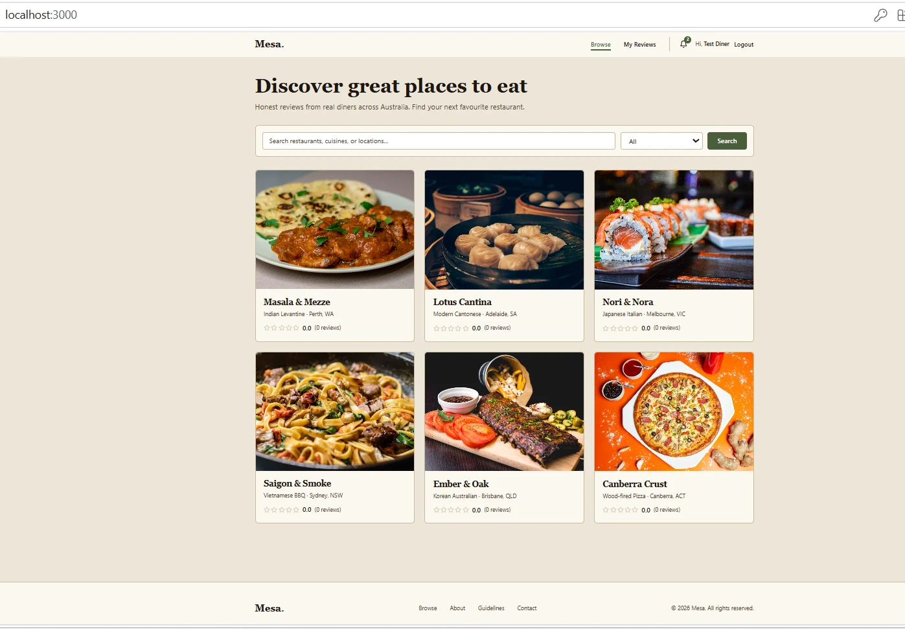
Figure 3.1: Browse page (React frontend) - live data with search/filter (Strategy + Builder) and aggregated star ratings.
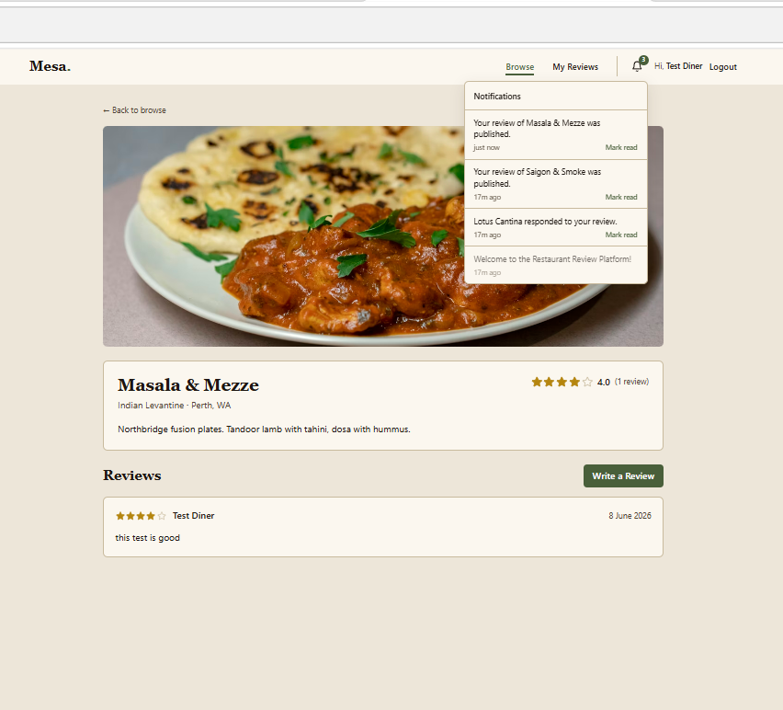
Figure 3.2: The new Notifications feature - posting a review updates the rating to 4.0 (Observer recompute) and generates an in-app notification "Your review ... was published" (Observer -> NotificationFactory).
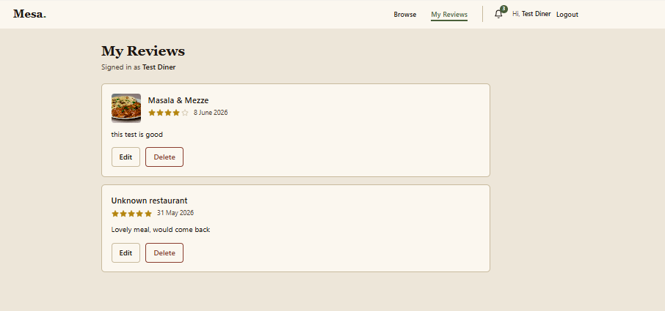
Figure 3.3: Diner dashboard (My Reviews) - author-only review update/delete.
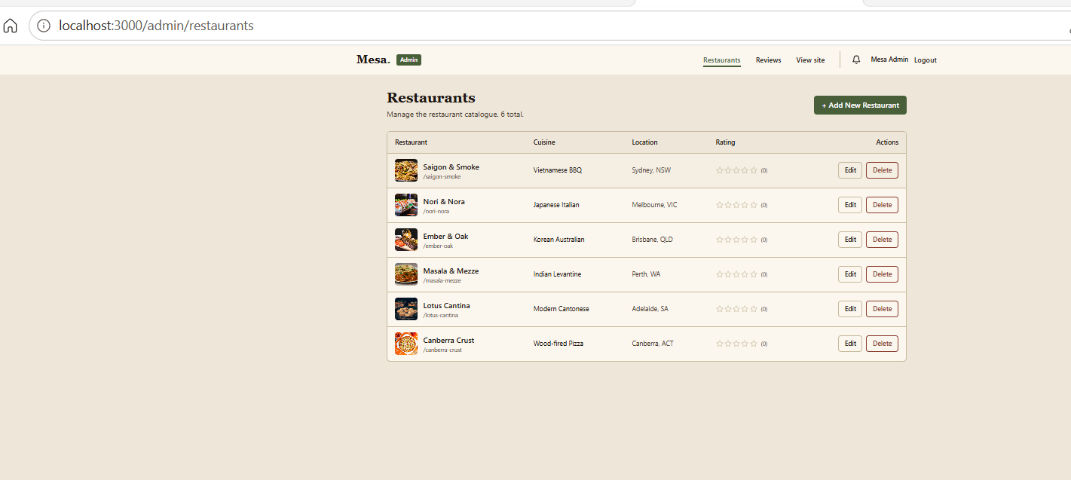
Figure 3.4: Admin panel - restaurant management (create / edit / delete).
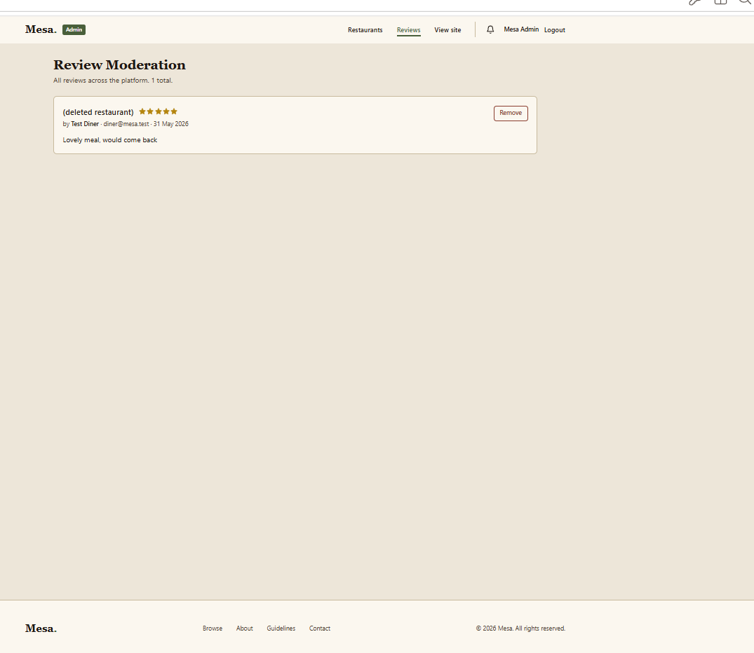
Figure 3.5: Admin review moderation - remove inappropriate reviews.
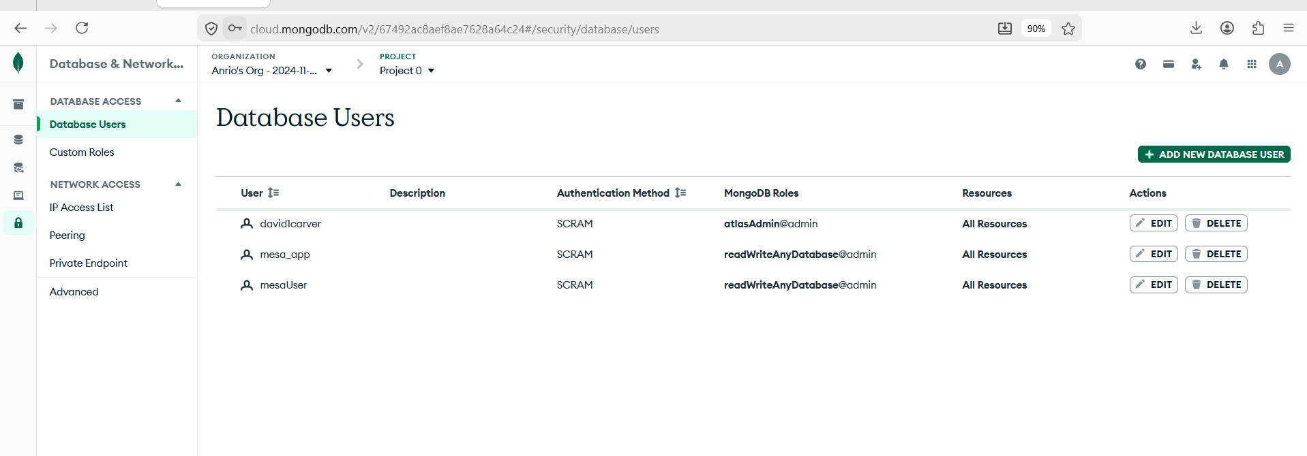
Figure 3.6: MongoDB Atlas database users - the backend connects to the live Atlas cluster (Repository -> Mongoose).

Team collaboration via GitHub

4.1 Team collaboration statement
This assignment was completed solo. The project was developed on GitHub using a feature-branch workflow: work was carried out on dedicated feature/* branches and integrated into main through reviewed pull requests. The repository is at https://github.com/david1carver/restaurant-review-platform.
Allocated team and contributions:
David (Anrio) Carver (ID 11473215) — sole contributor. Selected the Assignment 1 project (Mesa); the backend object-oriented refactor and the eight design patterns; the Notifications subsystem; all unit tests; the Postman/API testing; MongoDB Atlas setup and deployment configuration; the CI/CD pipeline (self-hosted runner on EC2 with nginx + pm2); the GitHub repository, branching and merge-conflict resolution; and report compilation. In short, all work in this submission was completed by David.
Cameron Bruce (ID N11315423) — allocated to the team and added as a GitHub collaborator, but advised on 24 June 2026 that he is dropping the unit. He withdrew before the final submission and did not contribute to the delivered work.
A further allocated member (Juha Anttila) had earlier advised that his placement in the group was an administrative error and that he is completing the unit individually; he did not contribute to this submission.
Because the team did not eventuate, the GitHub collaboration workflow below was carried out by David individually to demonstrate command of the tooling (branching, pull-request review, and merge-conflict resolution).

4.2 Team collaboration evidence
As this became a solo submission, the items below evidence individual command of the GitHub collaboration workflow — regular commits, feature branches, pull requests, and merge-conflict resolution. The commit history is attributable to a single contributor (David), consistent with the solo status declared above.
The following GitHub Insights views confirm the feature-branch workflow and the single-contributor commit history:
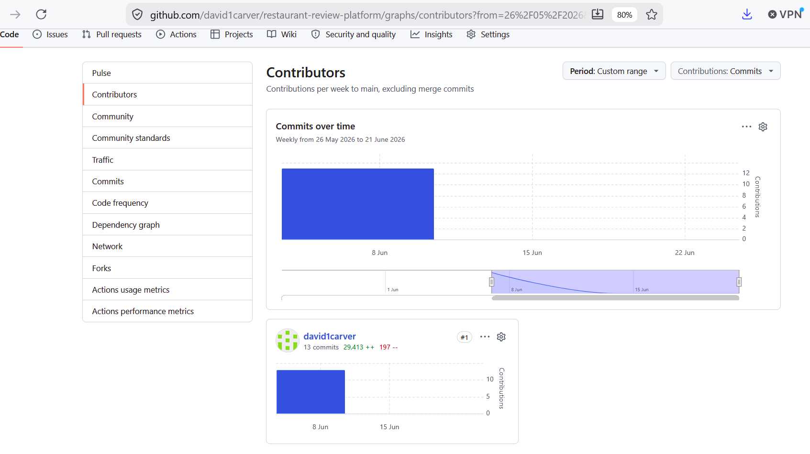
Figure 4.1: Insights → Contributors — single contributor david1carver (13 commits to main), confirming the solo commit history.
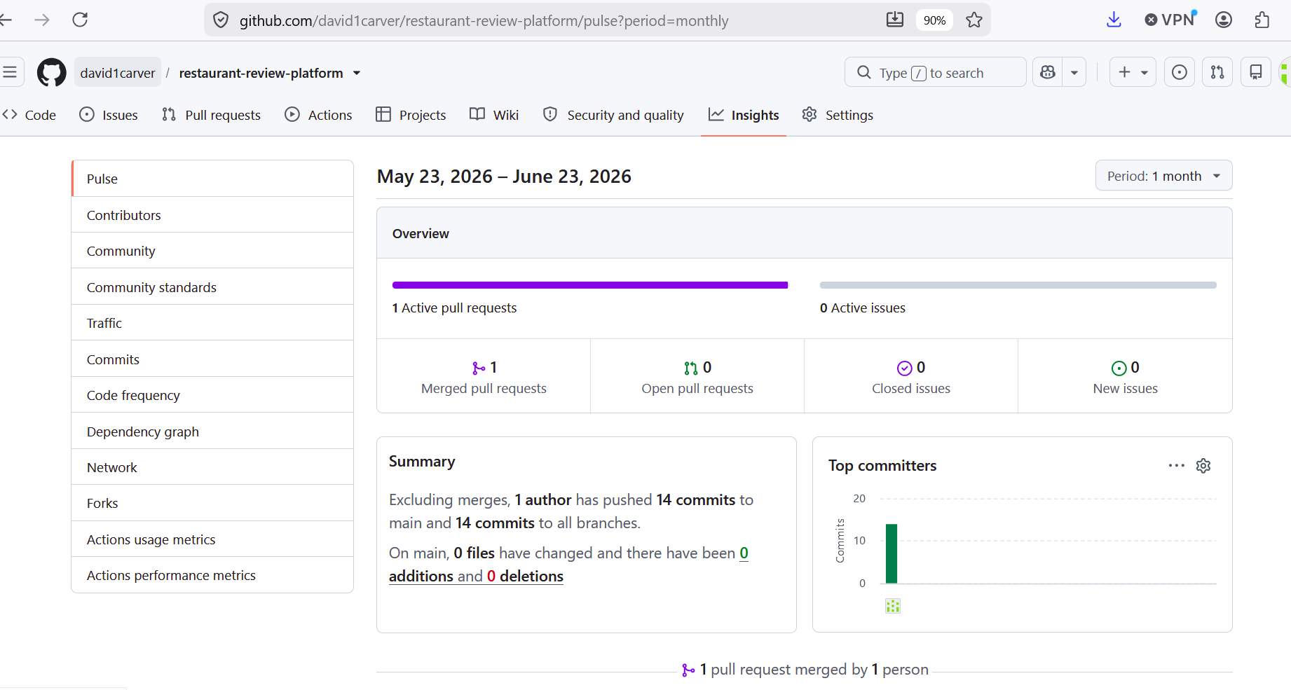
Figure 4.2: Insights → Pulse — “1 author has pushed 14 commits”, “1 pull request merged by 1 person”.
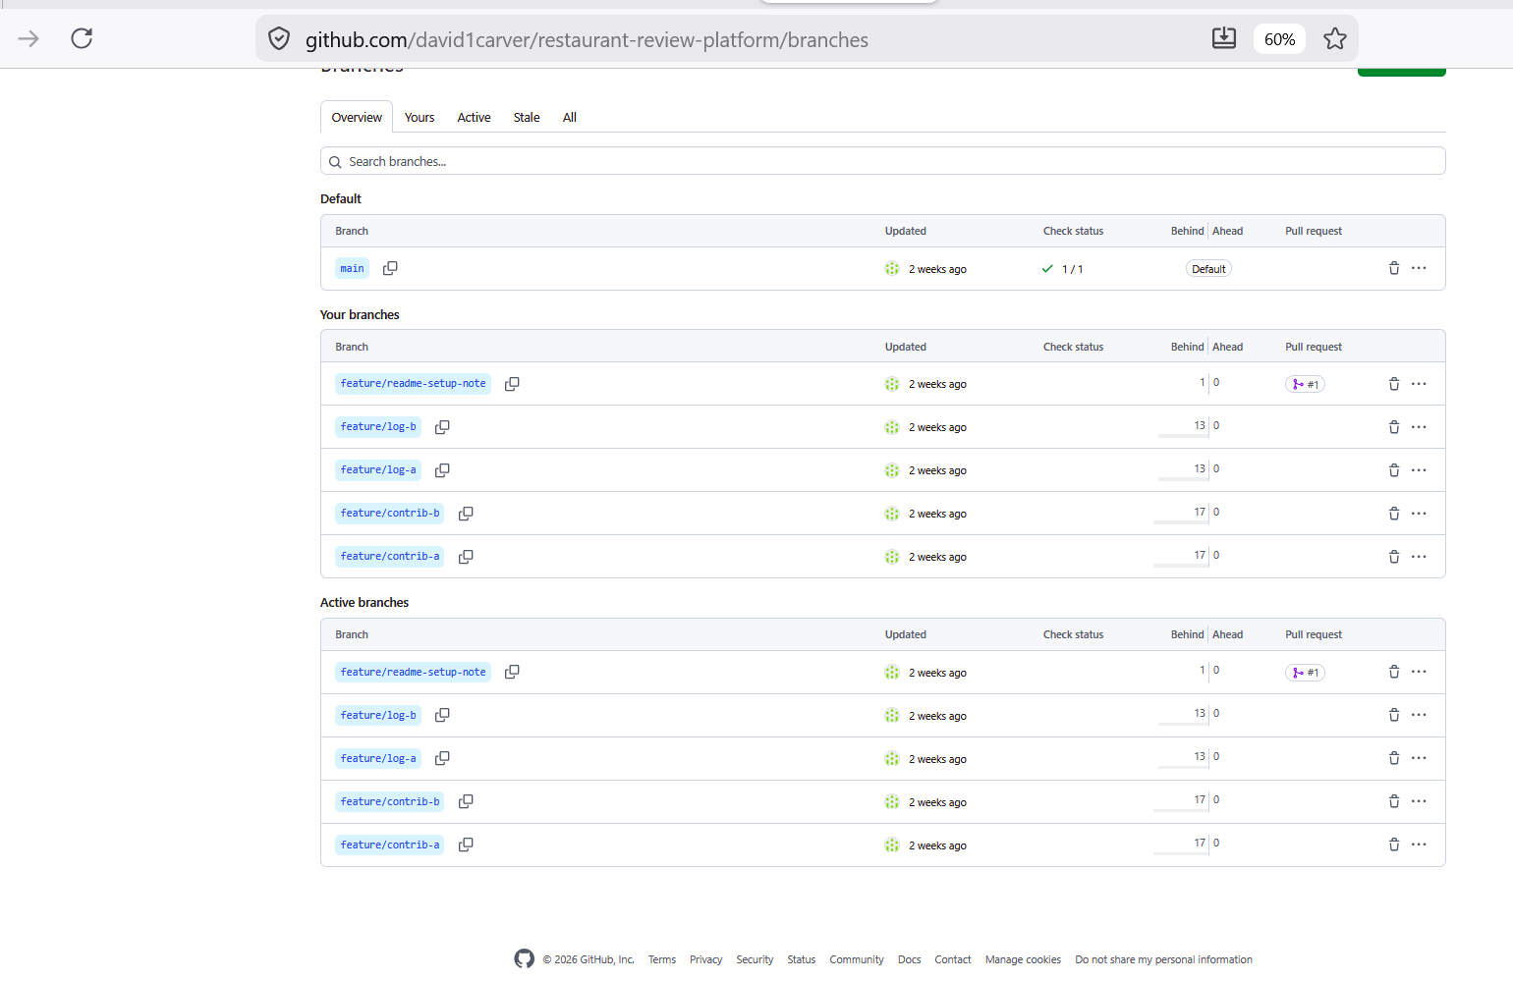
Figure 4.3: Branch list — feature/contrib-a, feature/contrib-b, feature/log-a, feature/log-b and feature/readme-setup-note alongside main.
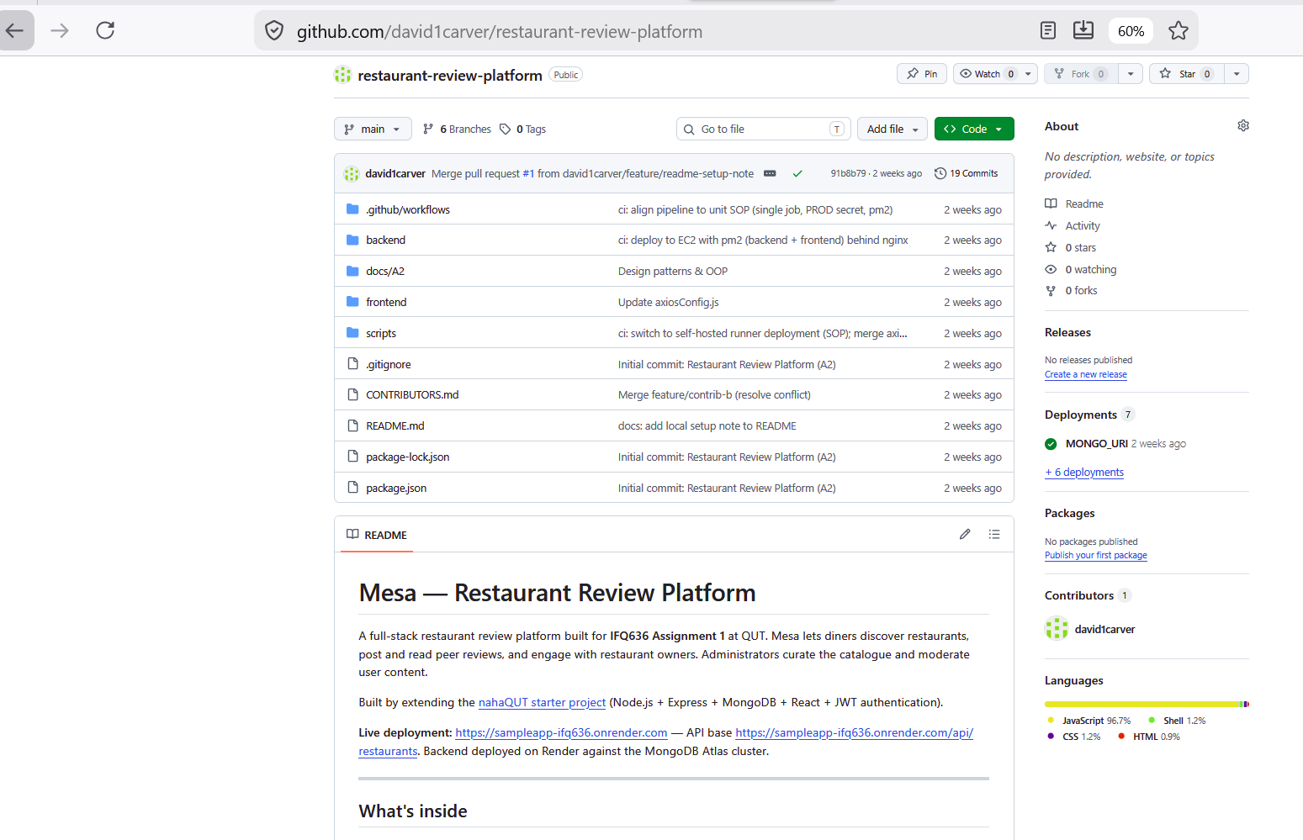
Figure 4.4: Repository home — 19 commits, 6 branches, merged PR #1, and CONTRIBUTORS.md last touched by “Merge feature/contrib-b (resolve conflict)”.
Merge conflict 1 — CONTRIBUTORS.md. A contribution line was added to the same new file on two separate feature branches (feature/contrib-a and feature/contrib-b). Merging the second branch into main produced an add/add conflict because both branches created the file with different content. It was resolved by keeping both lines, removing the conflict markers (<<<<<<< / ======= / >>>>>>>), and committing the merge.
Merge conflict 2 — docs/A2/meeting-log.md. The same situation was reproduced on the shared meeting-log file (feature/log-a and feature/log-b), where the same line was edited differently on two branches. It was resolved by combining both entries into the final file and committing the merge.
Both conflicts were resolved cleanly with no loss of content, demonstrating practical use of branching, pull requests, and conflict resolution.
The two resolved merge-conflict commits appear in the CI/Actions history below:
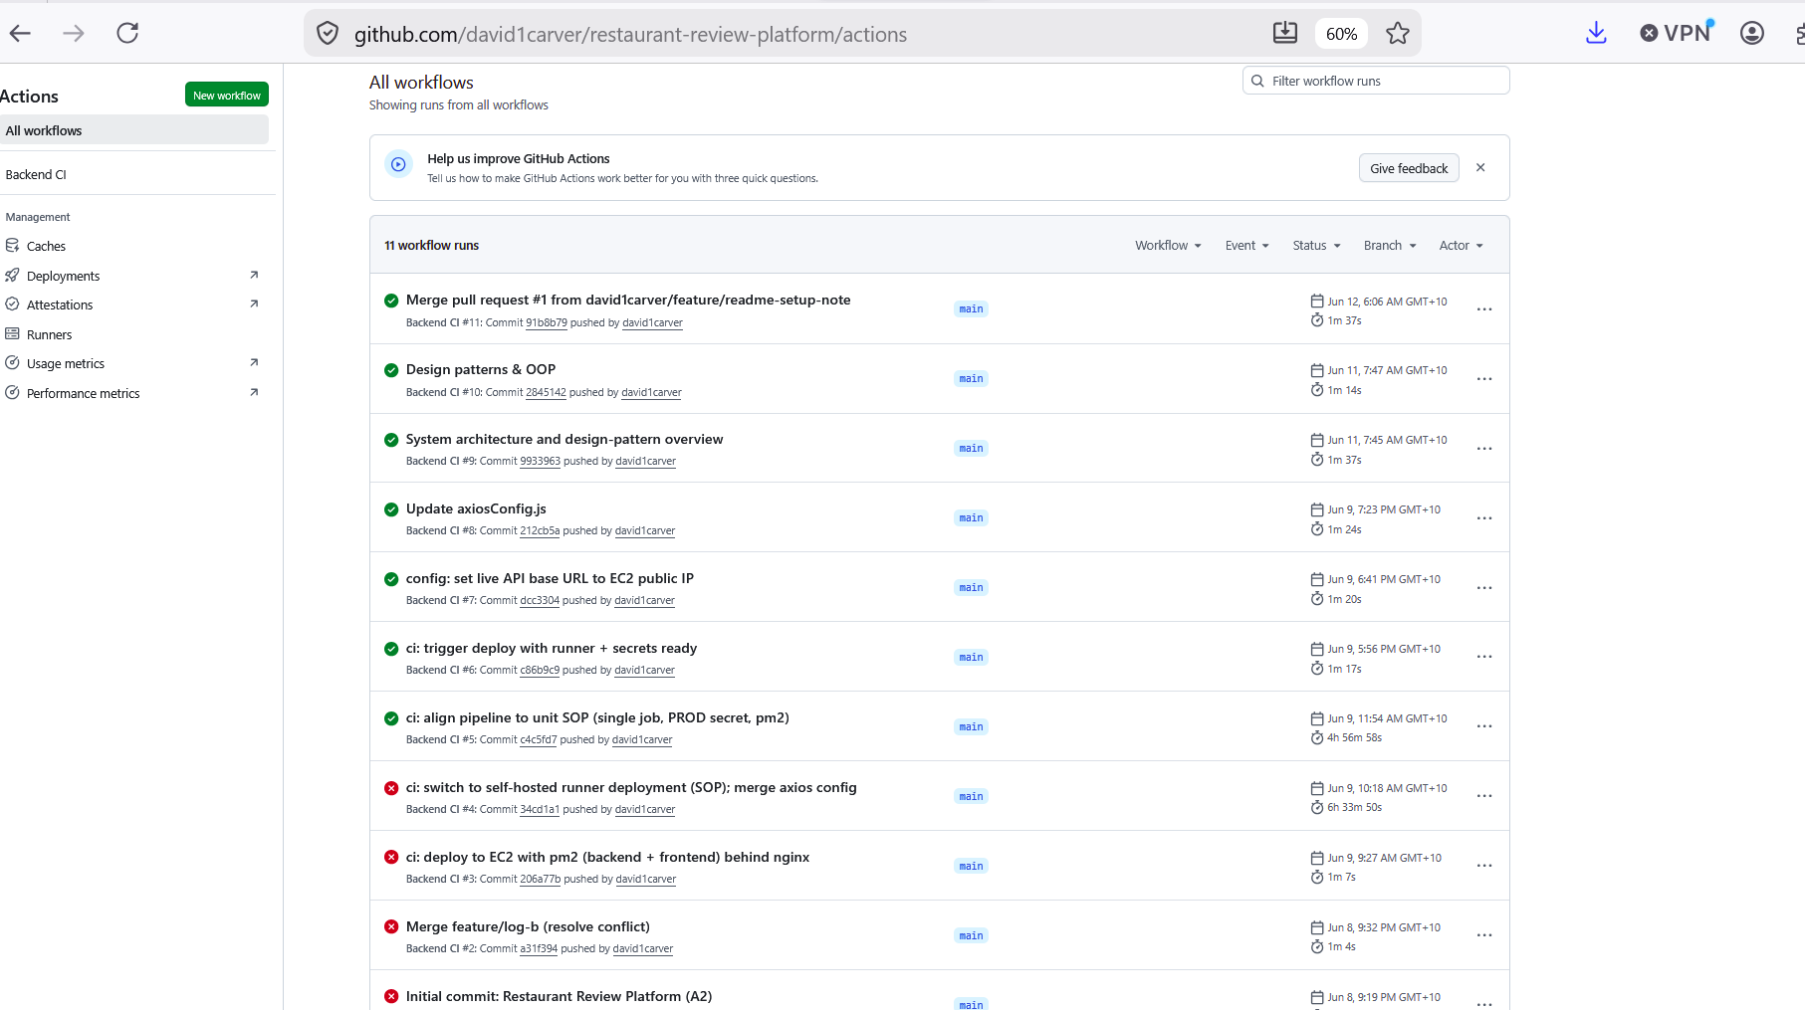
Figure 4.5: Actions history — the resolved merge-conflict commits run through CI, e.g. “Merge feature/log-b (resolve conflict)” and merged PR #1 (Backend CI).
Development log (solo). With the team not eventuating, the milestones below were carried out by David individually:
Date | Contributor | Topics / decisions | Actions
09/06/2026 | David Carver | Selected the Restaurant Review Platform; created the GitHub repo; agreed the feature-branch + PR workflow; split the work (backend/patterns, notifications/frontend, testing/Postman/SRS, CI-CD/repo/report). | Each member set up their branch and environment.
16/06/2026 | David Carver | Reviewed the SRS (2.1-2.11) and the design-pattern selection; confirmed the eight patterns and the Notifications feature scope. | Began implementation on feature branches.
23/06/2026 | David Carver | Integration checkpoint: merged feature branches via PRs; resolved two merge conflicts; reviewed unit tests and the Postman collection. | Wired CI/CD; drafted report sections.
30/06/2026 | David Carver | Final integration and testing against MongoDB Atlas; compiled the report; recorded the video; completed the Part C declaration. | Final review and submission prep.

Functional testing (only unit testing)

5.1 Pass/fail screenshot from the terminal for each of your backend functionality
Framework: Mocha + Chai + Sinon (pure unit tests; Mongoose statics stubbed, no DB). Command: cd backend && npm test. Result: 49 passing. Selected test-case matrix:
Test Case ID | Function / Endpoint | Input | Expected | Actual | Status
TC-A-01 | POST /api/auth/register | new email | 201; token | matches | PASS
TC-A-02 | POST /api/auth/register | duplicate email | 400 | matches | PASS
TC-A-03 | POST /api/auth/login | valid creds | 200; token | matches | PASS
TC-A-04 | POST /api/auth/login | wrong password | 401 | matches | PASS
TC-R-01 | GET /api/restaurants | empty query | 200; paginated | matches | PASS
TC-R-04 | POST /api/restaurants (admin) | valid body | 201; created | matches | PASS
TC-R-05 | PATCH /api/restaurants/:id | valid patch | 200; updated | matches | PASS
TC-R-07 | DELETE /api/restaurants/:id | known id | 200; reviews cascade | matches | PASS
TC-V-01 | POST .../reviews | valid review | 201; created | matches | PASS
TC-V-02 | POST .../reviews | duplicate | 409 | matches | PASS
TC-V-04 | PATCH /api/reviews/:id | author edits | 200; updated | matches | PASS
TC-V-07 | DELETE /api/reviews/:id | author | 200; deleted | matches | PASS
TC-V-10 | POST /api/reviews/:id/response | valid | 200; author notified | matches | PASS
TC-N-01 | POST /api/notifications | message | 201; created | matches | PASS
TC-N-05 | PUT /api/notifications/:id/read | owner | 200; read | matches | PASS
Full 49-row matrix (incl. 16 design-pattern + 5 auth tests) is in docs/A2/functional-test-cases.md.
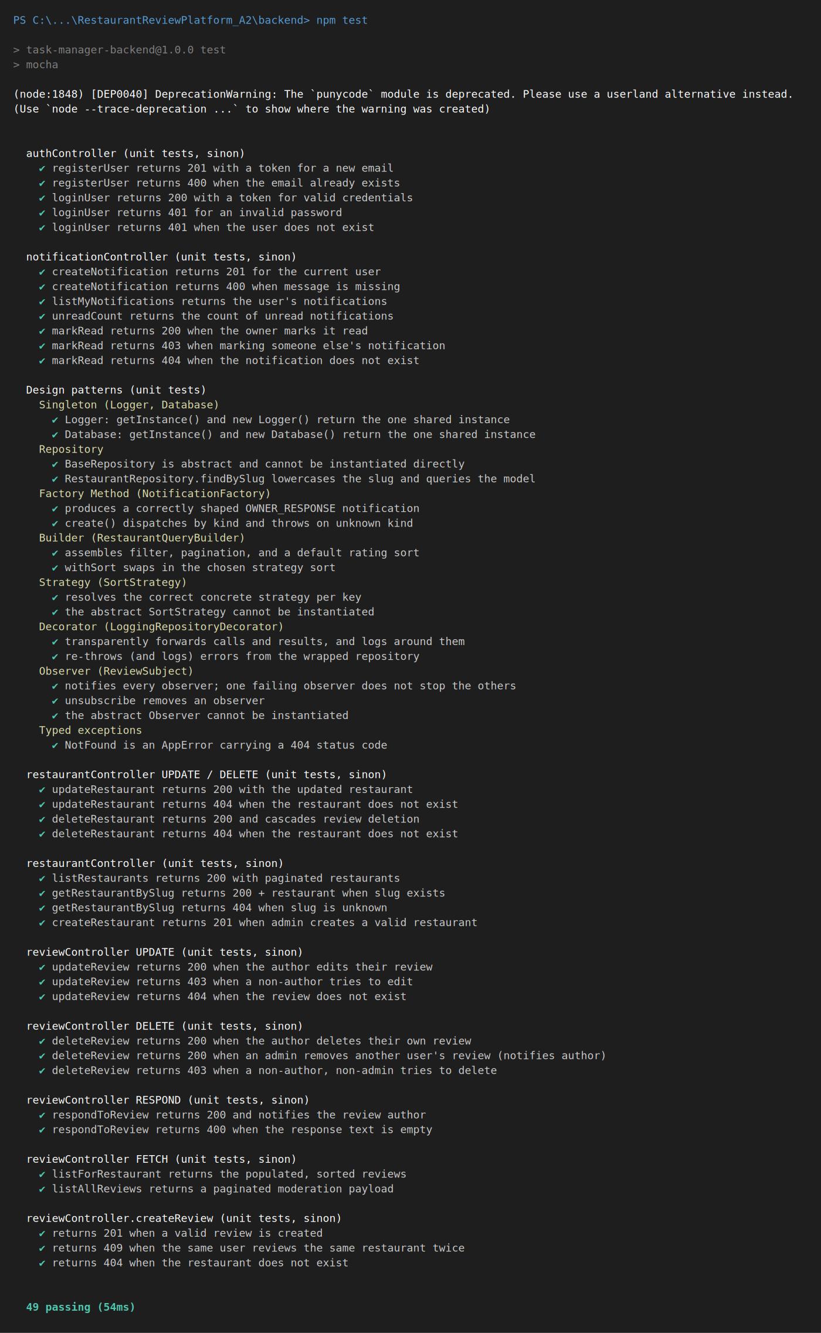
Figure 5.1: cd backend && npm test terminal output - 49 unit tests passing (auth, restaurant, review, notification CRUD + 16 pattern tests).

API testing using Postman

6.2 Screenshot of API request collections and response for backend code
API testing was performed against the running backend (http://localhost:5001) using a REST client (Thunder Client / Postman), exercising both success paths and error handling. For each request the HTTP status code and JSON response body were verified against the expected result. The full collection is exported at docs/A2/RestaurantReview.postman_collection.json.
# | Request | Method / Endpoint | Auth | Expected | Actual
1 | Login (diner) | POST /api/auth/login | - | 200 + JWT token | 200 OK
2 | List restaurants | GET /api/restaurants | - | 200 paginated list | 200 OK
3 | Create review | POST /api/restaurants/:id/reviews | diner | 201 created | 201 Created
4 | Duplicate review (same diner) | POST /api/restaurants/:id/reviews | diner | 409 conflict | 409
5 | Missing rating/text | POST /api/restaurants/:id/reviews | diner | 400 validation | 400
6 | Create review without token | POST /api/restaurants/:id/reviews | none | 401 unauthorized | 401
7 | Create restaurant as diner | POST /api/restaurants | diner | 403 forbidden | 403
The collection also covers the admin happy paths (create/update/delete restaurant, respond to review, moderation) and the notifications endpoints. The mix of 2xx, 4xx (400/401/403/409) responses demonstrates correct success behaviour and robust error handling across the API.
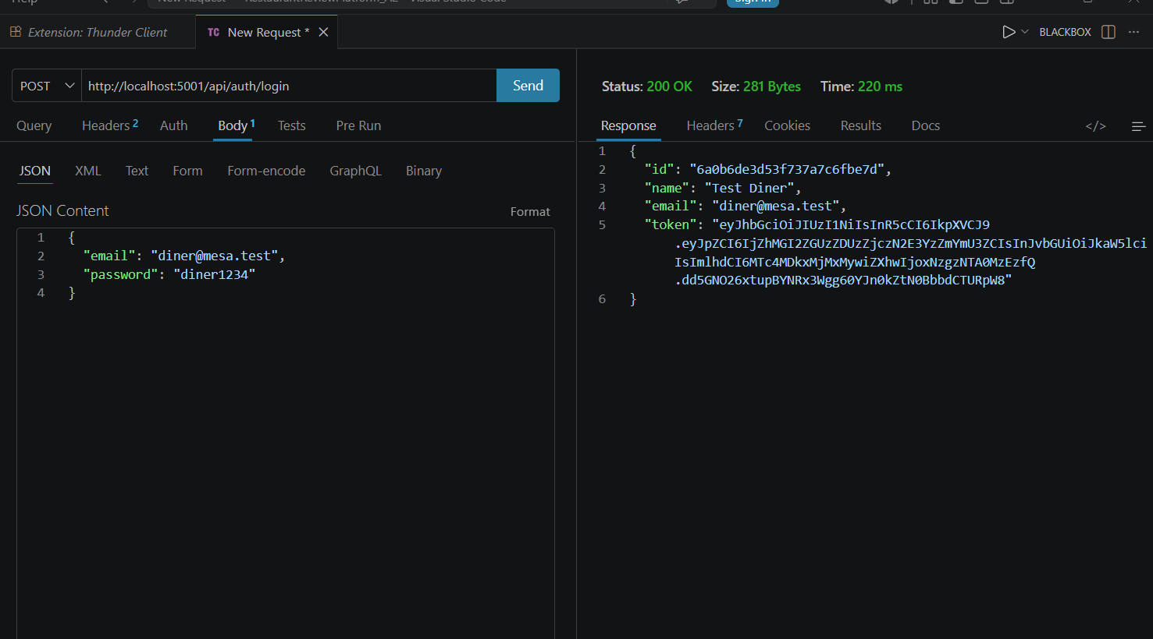
Figure 6.1: POST /api/auth/login -> 200 OK, returning the user and a JWT token.
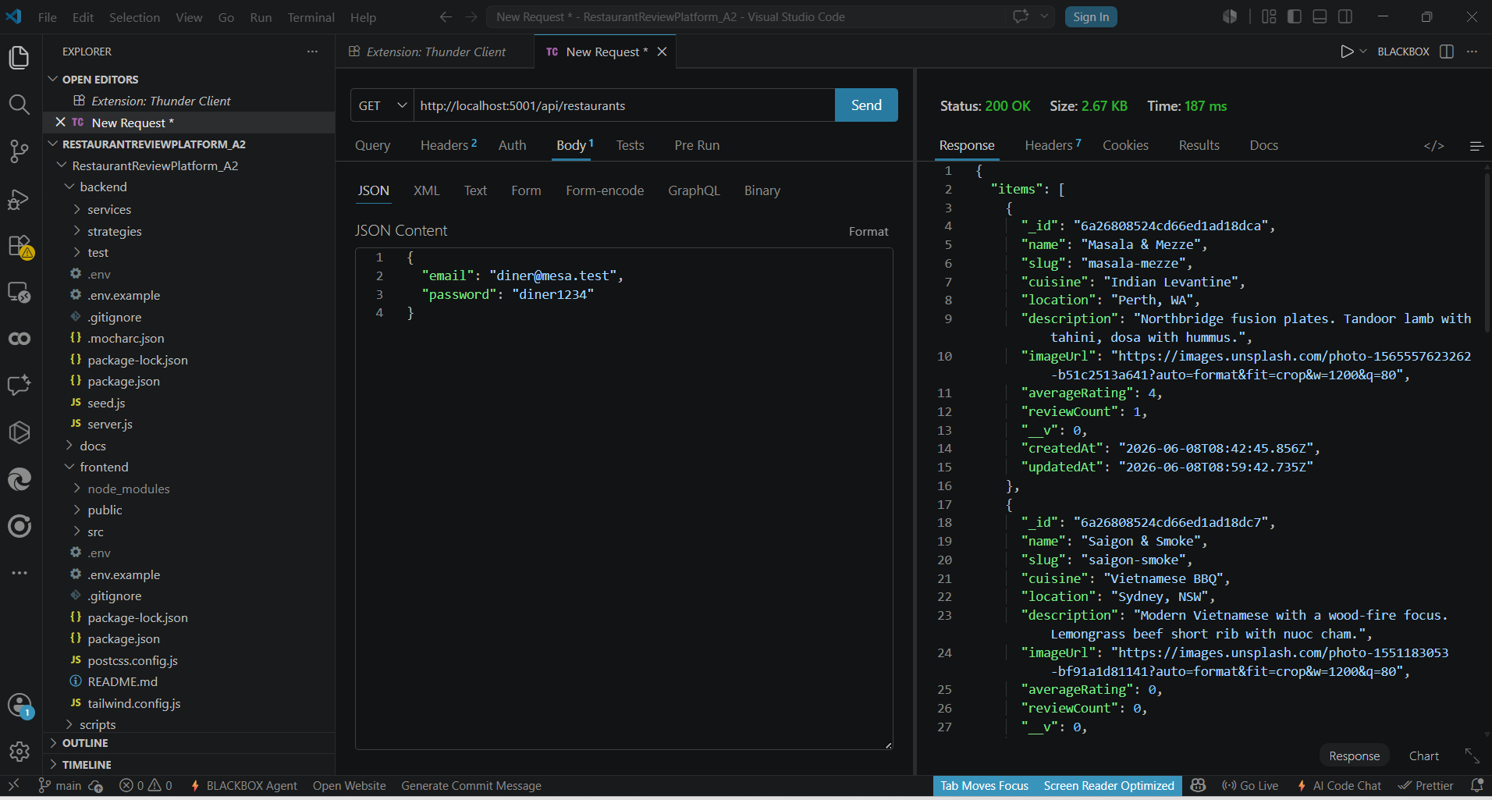
Figure 6.2: GET /api/restaurants -> 200 OK, returning the seeded restaurant catalogue.
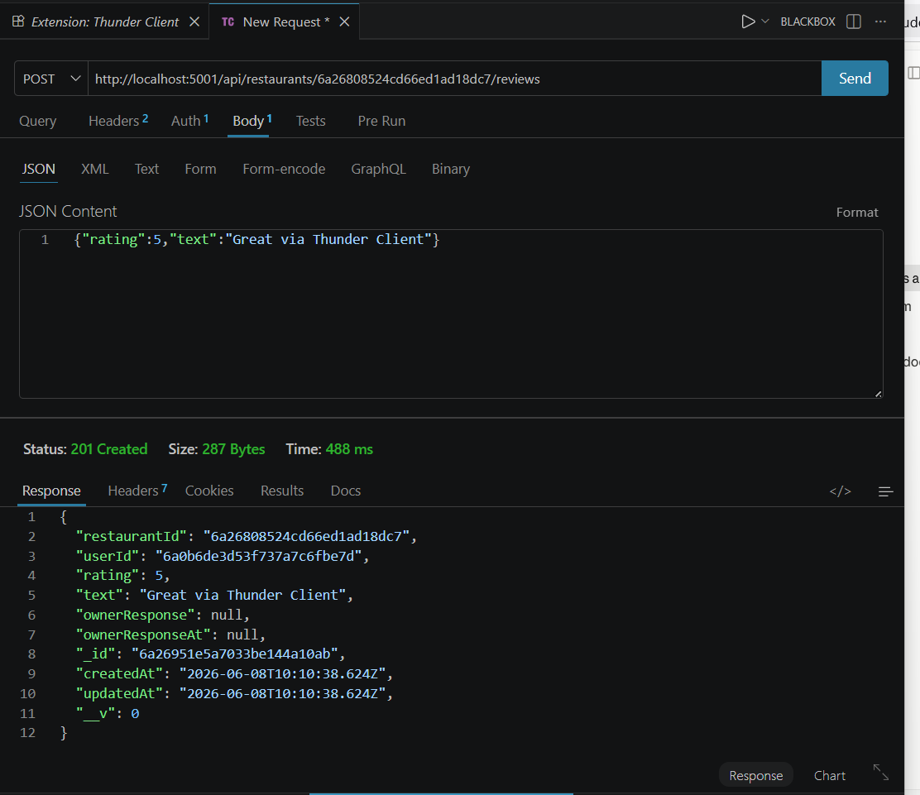
Figure 6.3: POST /api/restaurants/:id/reviews (Bearer token) -> 201 Created.
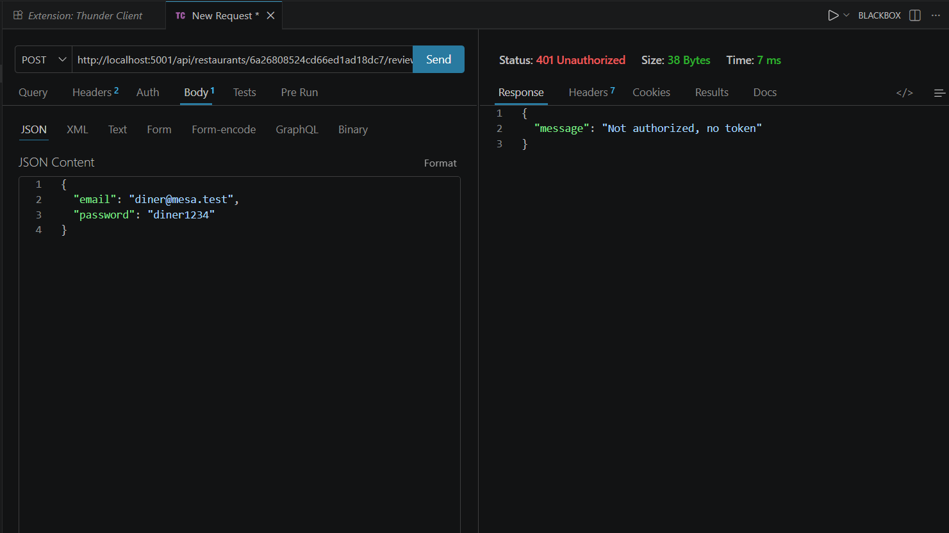
Figure 6.4: POST review without a token -> 401 Unauthorized (auth middleware rejects the request).
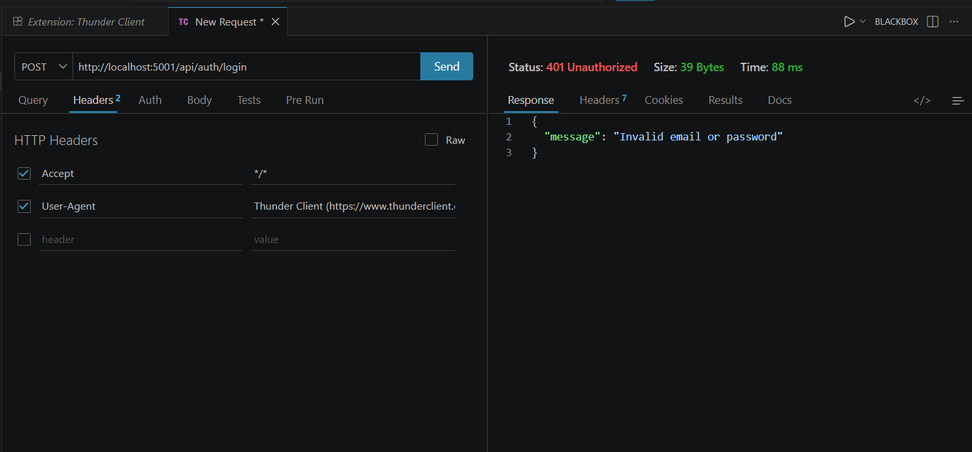
Figure 6.5: POST /api/auth/login with a wrong password -> 401 "Invalid email or password".
Error-handling responses captured in Thunder Client against the running backend:
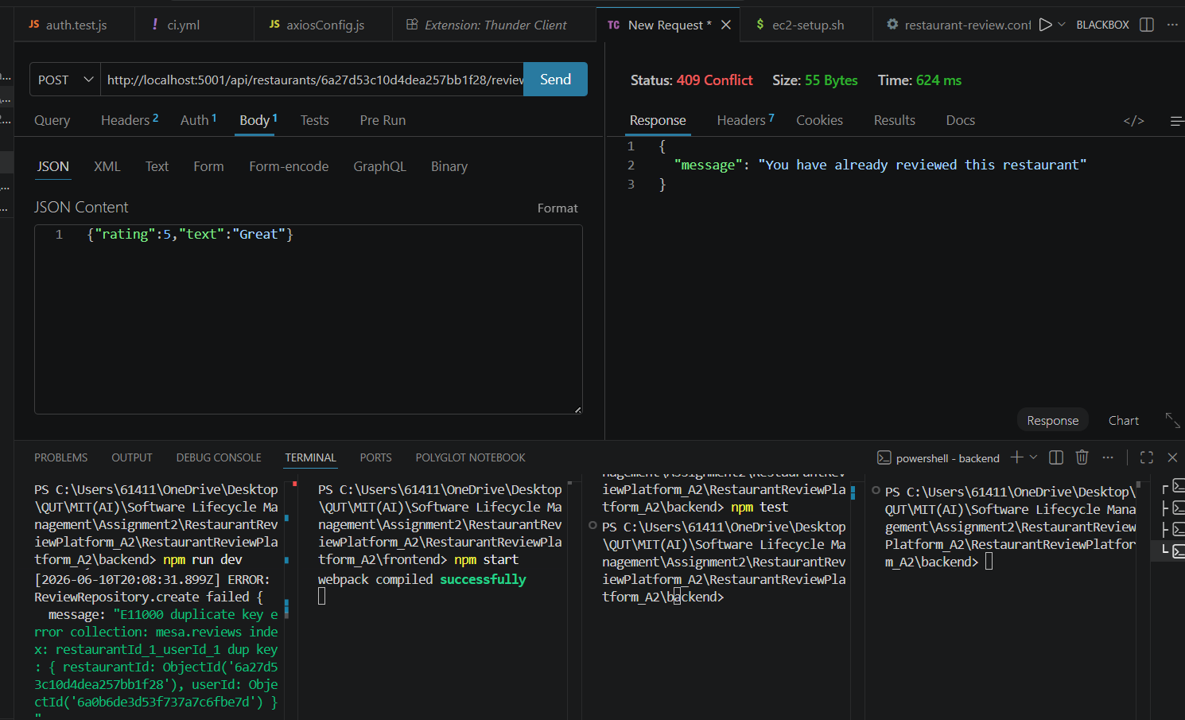
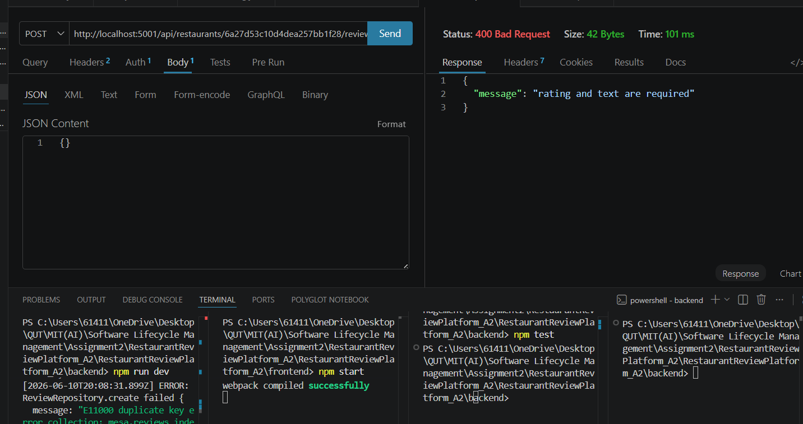
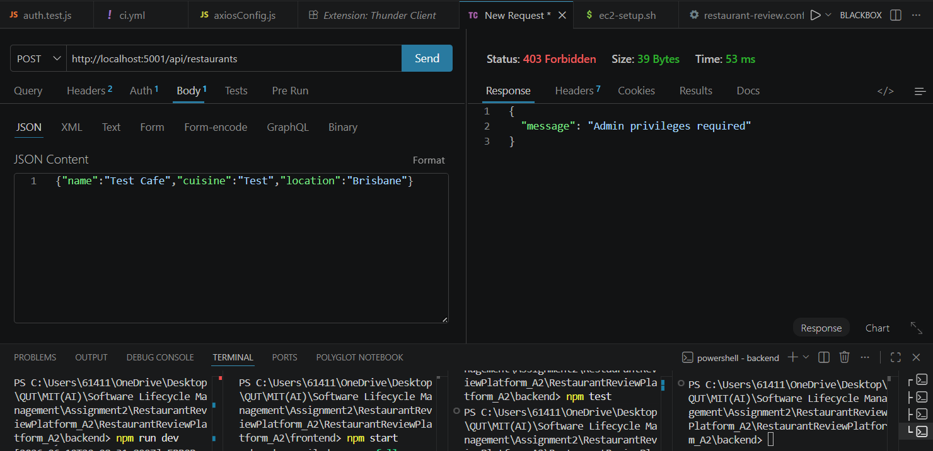

6.2 GitHub link to exported API collections
Exported collection (v2.1): docs/A2/RestaurantReview.postman_collection.json
GitHub link to the exported Postman/Thunder collection: https://github.com/david1carver/restaurant-review-platform/blob/main/docs/A2/RestaurantReview.postman_collection.json

CI/CD pipeline setup

7.1 Screenshot of workflow file (YML)
Workflow .github/workflows/ci.yml (name: Backend CI) runs a single job on a self-hosted runner installed on the EC2 instance, on every push to main: checkout; setup Node 22; print env secrets; pm2 stop all; install backend deps and build the React frontend with yarn; run the backend unit tests; write the production .env from the PROD secret; then pm2 start/restart. Because steps run in sequence, a failing test stops the job before restart, so only passing builds are deployed.
name: Backend CI
on:
push:
branches: [main]
jobs:
test:
name: Run Tests
runs-on: self-hosted
strategy:
matrix:
node-version: [22]
environment: MONGO_URI
steps:
- checkout; setup-node@22
- print env secrets (MONGO_URI/JWT_SECRET/PORT)
- pm2 stop all
- (backend) yarn install
- (frontend) yarn install && yarn run build
- (backend) npm test
- write backend/.env from secrets.PROD
- pm2 start all && pm2 restart all && pm2 save
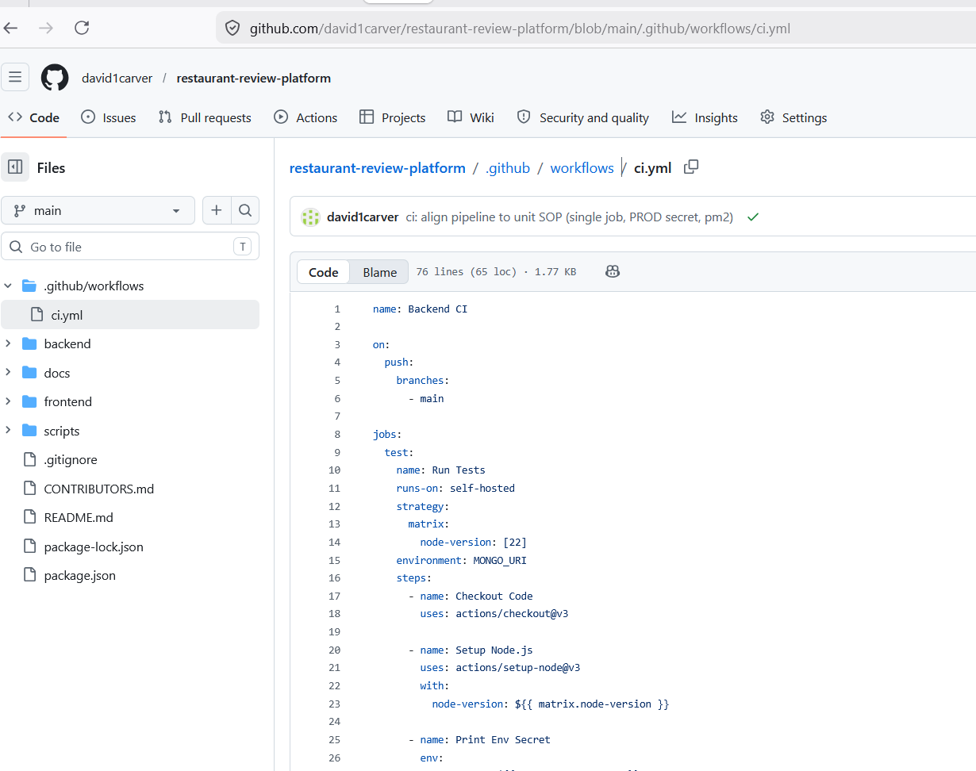

7.2 Screenshot of EC2 server configuration (Only include pm2 status output table from the terminal)
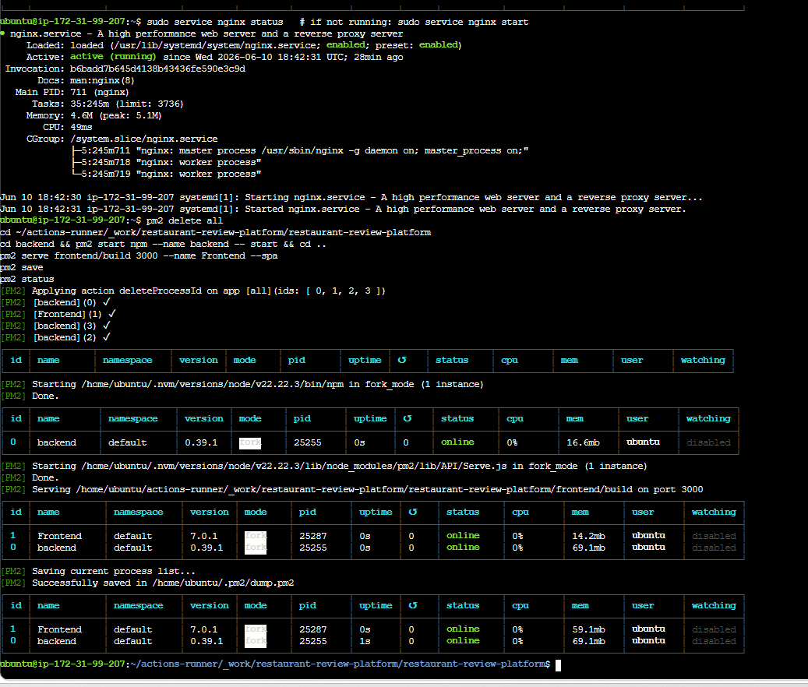

7.3 Screenshot of the “Run Test” page from GitHub (where the job is running, and you can see the steps are passing or failing)
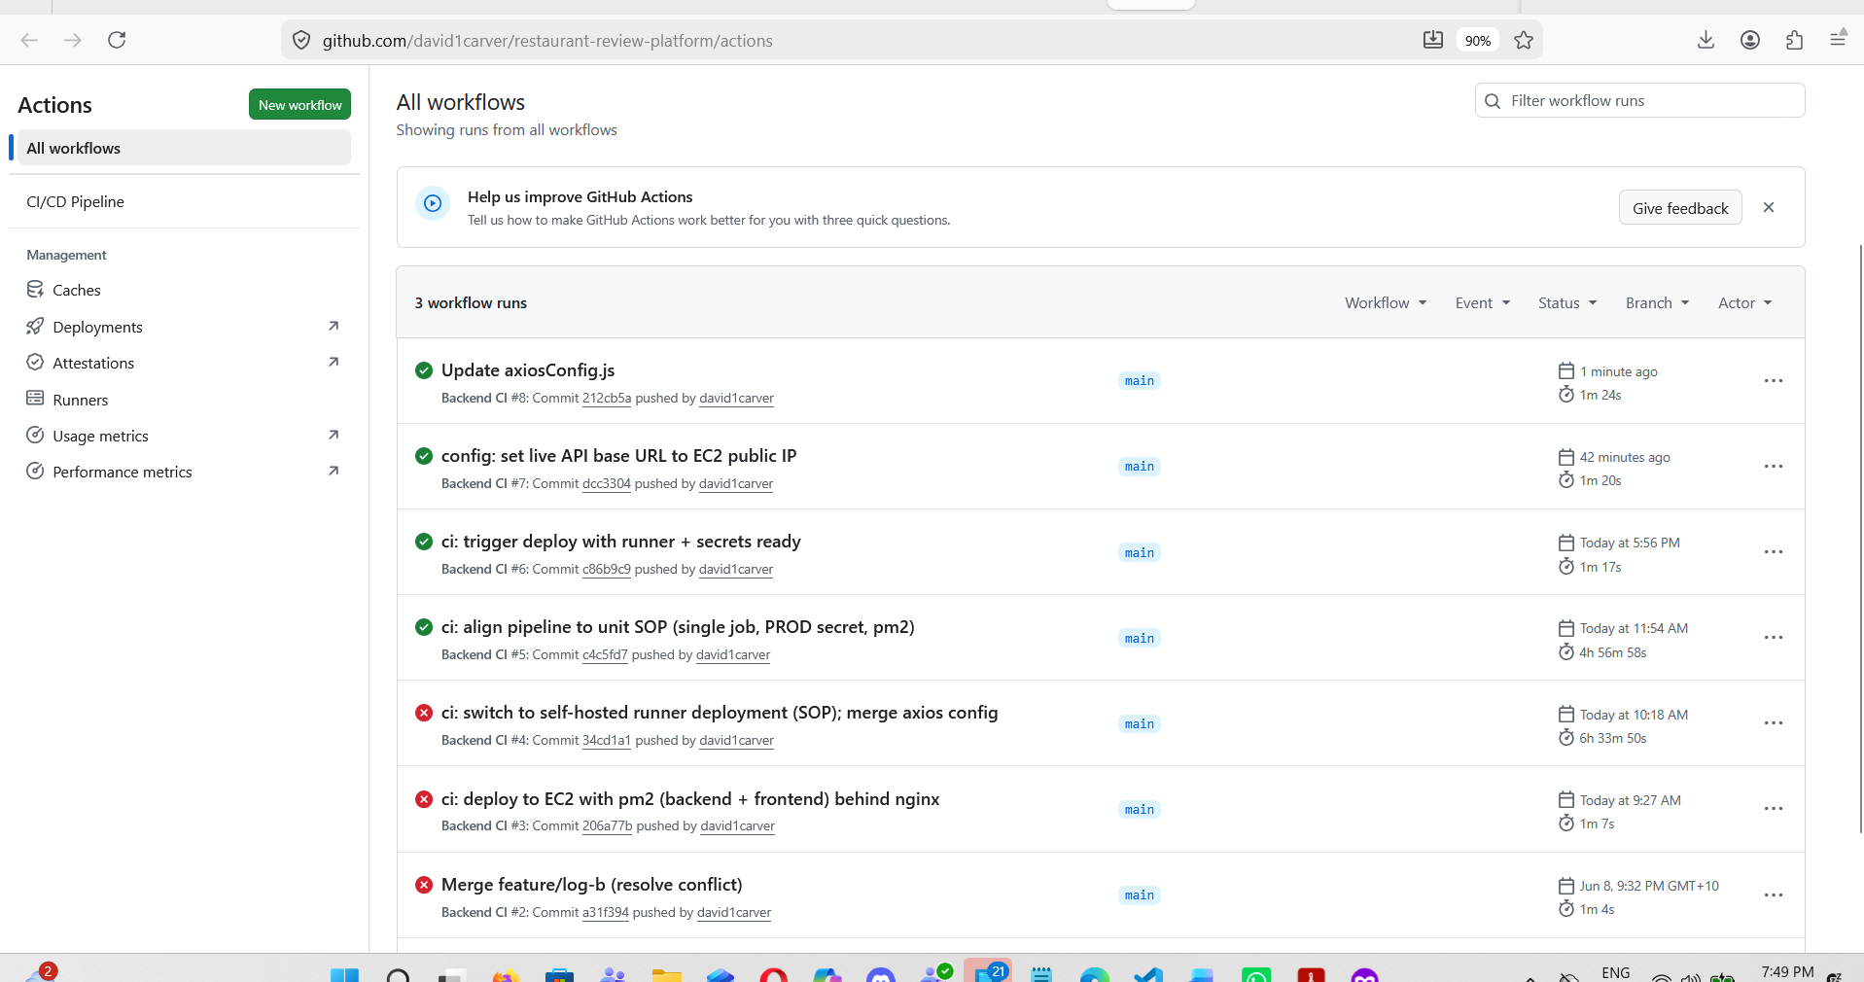

7.4 Screenshot of the first page of your application from the browser, highlighting the public IP
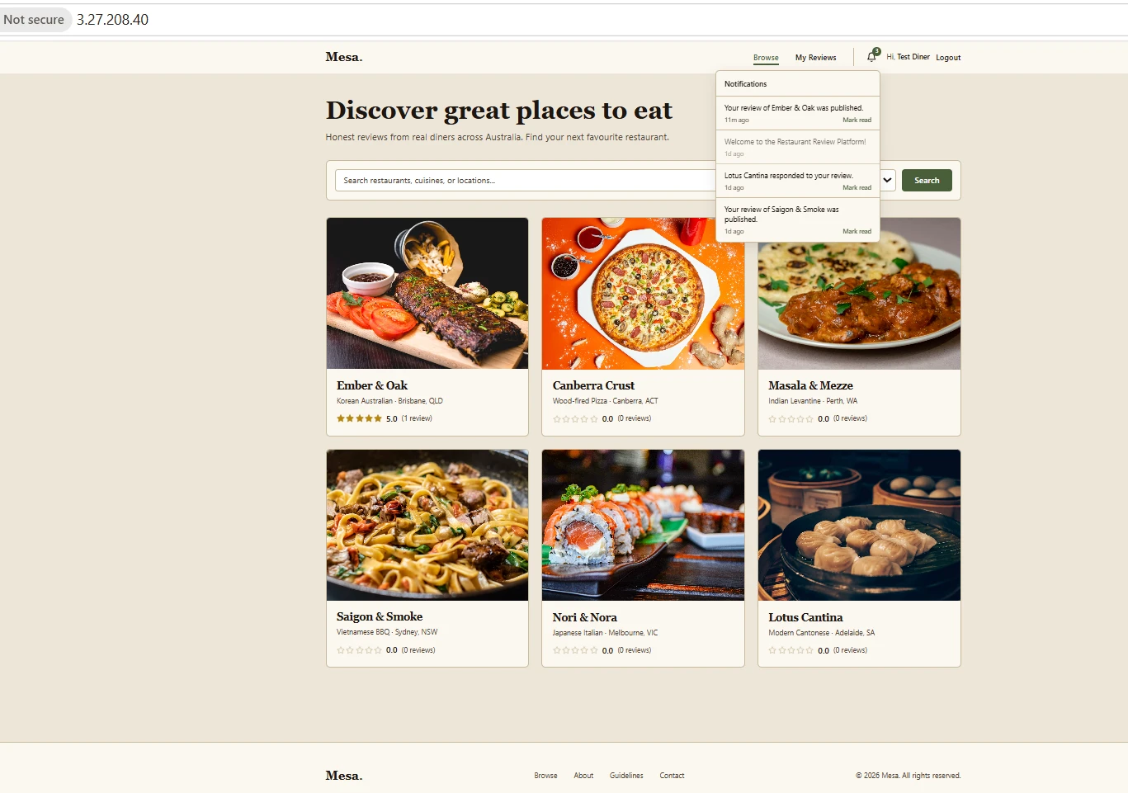
The application is deployed and live at http://3.27.208.40/. Deployment is fully automated by the self-hosted runner: each push to main rebuilds, tests, and restarts the app on the server. Because the shared student AWS account blocks EC2 Instance Connect and direct security-group edits, the instance is administered via AWS SSM Session Manager, and the backend (pm2, port 5001) is exposed to the browser through an nginx reverse proxy on port 80 (location /api/ -> 127.0.0.1:5001; location / -> the React build on 127.0.0.1:3000). Supporting scripts: scripts/ec2-setup.sh and scripts/nginx/restaurant-review.conf; runner registered under repo Settings -> Actions -> Runners. Note: the EC2 public IPv4 is dynamic and changes each time the instance is stopped and restarted (an Elastic IP is not available on the shared student AWS account); the address shown is current as of submission, and because the frontend uses a same-origin API base URL the application continues to work at whatever the current IP is.

Discussion and conclusion
The discussion is separated by development area so each part of the build can be assessed on its own.

Backend
The Express backend is organised into thin controllers over a Service (Facade) layer and a Repository layer (BaseRepository plus Restaurant/Review/User/Notification repositories), with Strategy, Builder, Factory, Singleton, Decorator and Observer applied for real purposes. This layering kept controllers trivial and made the core logic unit-testable in isolation.

Database
MongoDB Atlas (Mongoose 6) holds users, restaurants, reviews and notifications. A compound unique index enforces one review per diner per restaurant, and restaurant averageRating/reviewCount are recomputed after every review change by a Rating observer, keeping aggregates consistent without controller-side logic.

Frontend
The React 18 SPA (React Router 6, Tailwind "Mesa" design system) consumes the API through a single axios instance with a same-origin base URL, so it works locally and behind the nginx proxy unchanged. Protected routes gate the diner and admin experiences.

Testing
Functional verification is two-layered: 49 Mocha/Chai/Sinon unit tests (Mongoose statics stubbed, no DB) run in CI on every push, and a Postman/Thunder Client collection verifies each endpoint end-to-end including the error paths (400/401/403/409).

Deployment (CI/CD)
A GitHub Actions self-hosted runner on the EC2 instance rebuilds, tests and restarts the app under pm2 on every push to main; a failing test stops the job before restart, so only passing builds go live. nginx serves the React build on port 80 and proxies /api to the backend on 5001.

Conclusion
The result is an extended, production-shaped platform that meets its functional and non-functional requirements. Notifications demonstrate the Open/Closed Principle concretely (one new Observer, no change to existing code), giving a clean base for future work such as email notifications and owner accounts.

Use of GenAI
Tool: Claude (Anthropic), used as a coding assistant, a verification/consistency checker, and a debugging/troubleshooting aid throughout the project.
How it was used:
- Verification / consistency checking: Claude was used to check that nothing was mixed up across the project - for example confirming the report claims matched the actual code, that the test counts and endpoint tables were consistent, and that each design pattern in the report corresponded to real code.
- Explaining and fixing errors: Claude explained the errors encountered during setup and testing and how to resolve them - e.g. the MongoDB Atlas connection (database user, password and IP allow-list), environment configuration (.env / MONGO_URI), the nested project folder on extraction, running the unit tests, API testing with Thunder Client/Postman (200/201/401 responses, Bearer token), and Git setup (remote URL, creating and pushing to the new repository).
- Generation / drafting: re-architecting the backend into the eight design patterns; scaffolding the Notifications subsystem (model, repository, factory, observer, service, controller, routes, React bell); expanding the Mocha/Chai/Sinon unit tests and the test-case matrix; drafting the Postman collection, SRS, design-pattern/OOP section and CI/CD runbook.
Representative prompts: "check this code against the report's description so nothing is mixed up"; "explain this error and how to fix it (npm test / MongoDB connection / git push)"; "refactor this backend to use Repository, Facade, Strategy, Observer, Factory, Builder, Singleton and Decorator without breaking the existing tests"; "add a notifications feature with an observer and a React bell"; "generate a Postman collection covering all endpoints including error cases".
Parts influenced/generated: the pattern/service/repository/observer code, the notifications subsystem, the unit tests, and the documentation drafts. All AI assistance was reviewed, run, and adapted by the student.
Verification & adaptation: every change was verified against the running implementation - the 49-test suite was run and kept green, the app was run end-to-end against MongoDB Atlas, the API was exercised with Thunder Client, and discrepancies between the code and the report were corrected. The new repository, per-member commits, merge conflicts, live screenshots, video and Part C declaration are the team's own work and are not AI-generated.

Reflection
The biggest lesson was that design patterns pay off when chosen for a real problem, not added for their own sake. Repository + Facade made controllers trivially thin, and Observer turned a tangled "do five things after a review" function into three small, independently testable observers - so adding notifications cost one subclass. The hardest part was CI/CD to EC2: the shared student AWS account (no Elastic IP, denied Instance Connect, locked security groups) made public exposure the challenge, solved by administering the box via SSM Session Manager and proxying the API through nginx on port 80. Keeping the sinon tests green through a deep refactor was instructive - every new layer bottomed out at the same stubbed Mongoose calls. Next time we would stand up the pipeline on day one and write tests alongside each pattern.

References
- Atlassian. (n.d.). Jira Software documentation. https://support.atlassian.com/jira-software-cloud/
- Freeman, E., & Robson, E. (2021). Head First design patterns (2nd ed.). O'Reilly Media.
- Gamma, E., Helm, R., Johnson, R., & Vlissides, J. (1994). Design patterns: Elements of reusable object-oriented software. Addison-Wesley.
- GitHub. (n.d.). GitHub Actions documentation. https://docs.github.com/en/actions
- Martin, R. C. (2017). Clean architecture. Prentice Hall.
- MongoDB Inc. (n.d.). Mongoose ODM documentation. https://mongoosejs.com/docs/
- OpenJS Foundation. (n.d.). Express.js documentation. https://expressjs.com/
- Postman Inc. (n.d.). Postman learning center. https://learning.postman.com/

