SOP — Bring the live deployment back up after an EC2 restart
Use this every time the EC2 instance has been stopped & started (or the app is down). A stop/start gives the instance a NEW public IPv4, so the app needs waking up and the two IP-specific screenshots (7.2 pm2, 7.4 app) need re-taking. Total time ~5 minutes.
Repo: github.com/david1carver/restaurant-review-platform
Instance: mesa-prod-anrio (i-01746a2904bbca134), region ap-southeast-2. EC2 toolchain: Node 22 (nvm), pm2, yarn, nginx.

Step 0 — Start the instance & get the new public IP
- AWS console -> EC2 -> Instances -> select mesa-prod-anrio.
- If it is Stopped: Instance state -> Start instance. Wait for Running + 2/2 checks.
- On the Details tab, copy the new Public IPv4 address (e.g. 3.27.x.x). Write it down — you need it for the report and the 7.4 screenshot.

Step 1 — Connect to the instance
EC2 -> Instances -> select it -> Connect -> SSM Session Manager -> Connect. Then become the ubuntu user:
sudo su - ubuntu

Step 2 — Bring the app back online (pm2)
pm2 resurrect # restores the saved backend + Frontend processes
pm2 status
If pm2 status shows backend AND Frontend online -> go to Step 3.
If it is empty or errored, re-register (one time) from the runner workspace:
pm2 delete all
cd ~/actions-runner/_work/restaurant-review-platform/restaurant-review-platform
cd backend && pm2 start npm --name backend -- start && cd ..
pm2 serve frontend/build 3000 --name Frontend --spa
pm2 save
pm2 status

Step 3 — Make sure nginx is running
sudo service nginx status # if not running: sudo service nginx start

Step 4 — (Once) make pm2 auto-start on reboot
So a future reboot brings the app back automatically:
pm2 startup systemd # copy-run the "sudo ..." line it prints
pm2 save

Step 5 — Verify it is live
curl -s http://localhost:5001/api/health; echo
curl -sI http://localhost:3000 | head -1
Expect {"status":"OK"} and HTTP/1.1 200 OK. Then open http://<new-public-ip>/ in your browser.
⚠ If the site will not load in the browser: your home IP may have changed. Check it at checkip.amazonaws.com and, if different, add it to the EC2 security group inbound rules (SSH 22, HTTP 80, TCP 5001 from your IP).

Step 6 — Re-capture the 2 IP-specific screenshots
- 7.2 — screenshot the clean pm2 status (backend + Frontend online). Expected:
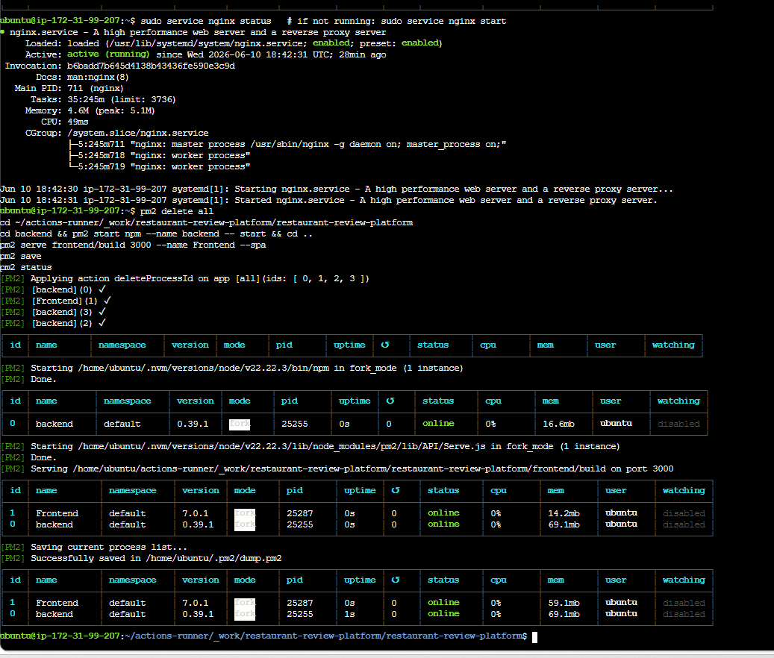
- 7.4 — open http://<new-public-ip>/ , log in (diner@mesa.test / diner1234), and screenshot the Browse page with the new IP visible in the address bar.

Step 7 — Update the IP everywhere it is written
The app code does NOT hard-code the IP (the frontend uses a same-origin API base URL), so no rebuild or push is needed — the app just works at the new IP. Only the written references need updating:
- Report cover (EC2 line + Live URL), section 7 text, and the 7.2 / 7.4 screenshots.
- Part C public URL.
- README live-deployment line (optional).
Find-and-replace the old IP with the new one in the report and Part C, then re-insert the two fresh screenshots into 7.2 and 7.4.

Step 8 — Submit in ONE session
⚠ Because the IP changes on every stop/start, do the final evidence capture, the video recording, and the submission in the SAME session while the instance stays up — otherwise the IP changes again and you repeat Steps 6-7.

Quick reference (the whole thing in 6 commands)
# in SSM, as ubuntu:
sudo su - ubuntu
pm2 resurrect && pm2 status
sudo service nginx start
curl -s http://localhost:5001/api/health; echo
# then: copy new Public IPv4 from the console, update report/Part C, re-take 7.2 + 7.4

