Restaurant Review Platform (Mesa) — Technical Build & Deploy Guide (IFQ636 A2)
A complete, reproducible walkthrough of how this project was built, tested, and deployed. Follow the steps in order; every command can be copied as-is. Code is shown in monospace; the explanatory text is size 12.
Repository: github.com/david1carver/restaurant-review-platform
Live deployment: http://3.27.208.40/
Stack: Node.js + Express + Mongoose 6 (MongoDB Atlas), React 18 + Tailwind, JWT auth. Infra: AWS EC2 (Ubuntu, t3.medium), nginx, pm2, GitHub Actions self-hosted runner.

0. Prerequisites
- Node.js 18 or 20 (local dev) — nodejs.org
- Git — git-scm.com
- VS Code (with the Thunder Client extension for API testing)
- A MongoDB Atlas account (free M0 cluster)
- A GitHub account
- An AWS account (for the live deployment — this project used the QUT student account)

1. Get the project running locally
Clone the repository and install the backend:
git clone https://github.com/david1carver/restaurant-review-platform.git
cd restaurant-review-platform/backend
npm install
Create backend/.env (use your own Atlas connection string and a random secret):
MONGO_URI=mongodb+srv://<user>:<password>@<cluster>.mongodb.net/mesa?retryWrites=true&w=majority
JWT_SECRET=<a-long-random-string>
PORT=5001
Seed the database (6 restaurants, demo users, notifications), then start the backend:
node seed.js
npm run dev # backend on http://localhost:5001
In a second terminal, start the frontend:
cd ../frontend
npm install
npm start # http://localhost:3000
Demo logins: diner@mesa.test / diner1234 and admin@mesa.test / admin1234. The running app:
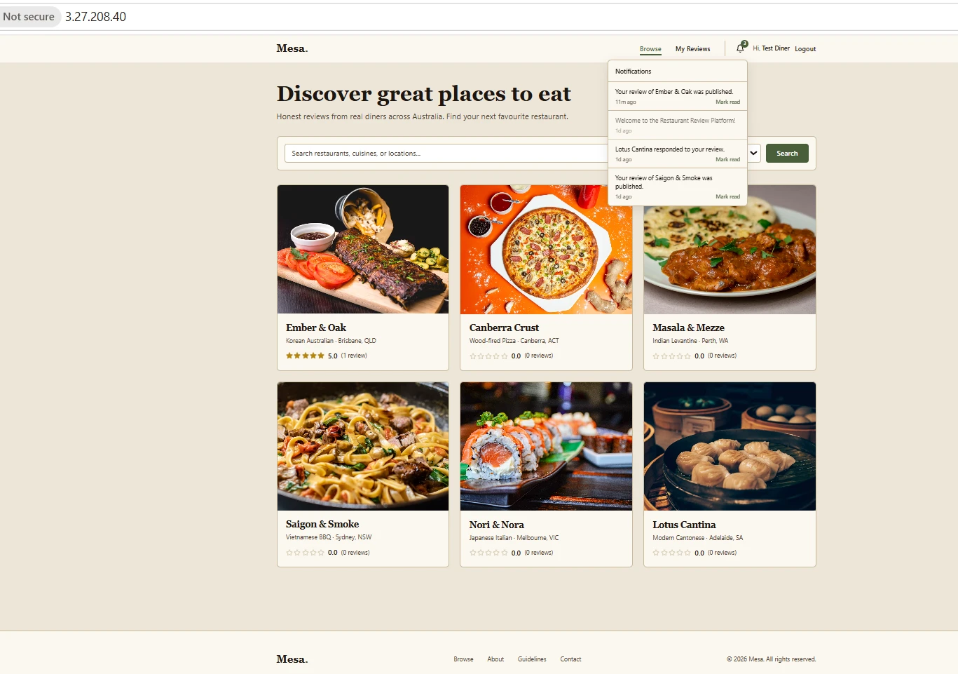

2. Backend architecture — OOP and the eight design patterns
The backend is layered so each pattern solves a real problem. The diagram below shows the layers and the eight patterns.
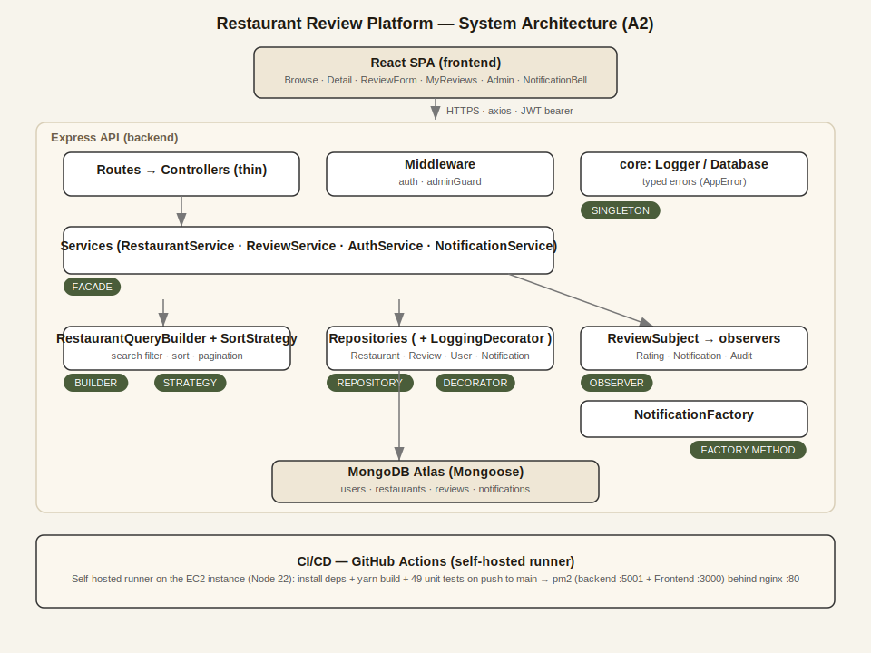
- Singleton — core/Logger.js, core/Database.js (one shared instance).
- Repository — repositories/BaseRepository.js (+ Restaurant/Review/User/Notification).
- Decorator (via a Proxy) — repositories/decorators/LoggingRepositoryDecorator.js.
- Facade — services/ReviewService.js, services/RestaurantService.js.
- Builder — builders/RestaurantQueryBuilder.js.
- Strategy — strategies/SortStrategy.js (abstract base + concrete sorts).
- Factory Method — factories/NotificationFactory.js.
- Observer — events/ReviewSubject.js + observers/ (Rating, Notification, Audit).
Create-review flow: controller (thin) -> ReviewService [Facade] -> reviewRepo.create() [Repository, wrapped by the Logging Decorator] -> reviewSubject.notify() [Observer] -> the Rating observer recomputes the average, the Notification observer uses the Factory to build a notification, and the Audit observer logs through the Singleton logger.
OOP: encapsulation via #private fields; abstraction via abstract base classes that throw if instantiated directly; inheritance in the Strategy/Observer subclasses; polymorphism via a uniform update() / toMongoSort() method.

3. Unit testing (Mocha + Chai + Sinon)
Tests are pure unit tests — Mongoose statics are stubbed, so no database is needed. Run them with:
cd backend
npm test # expected: 49 passing
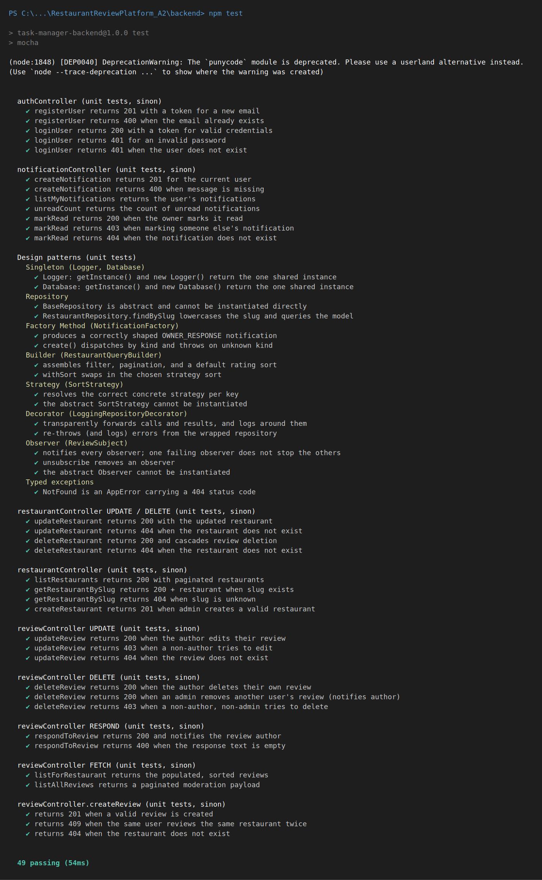

4. MongoDB Atlas setup
- Create a free M0 cluster (region Sydney ap-southeast-2).
- Database Access -> add a user (e.g. mesaUser) with readWrite.
- Network Access -> IP Access List -> add 0.0.0.0/0 (so the EC2 instance can connect).
- Copy the connection string into MONGO_URI in backend/.env (and later into the CI PROD secret).

5. GitHub repository and collaboration
Create the repo on GitHub and push. Use a feature-branch workflow: each member works on feature/* branches and integrates via pull requests with code review.
git init
git add .
git commit -m "Initial commit: Restaurant Review Platform (A2)"
git branch -M main
git remote add origin https://github.com/<you>/restaurant-review-platform.git
git push -u origin main

5.1 Cameron Bruce — collaboration tasks (TO BE COMPLETED)
[This section is Cameron's contribution and will be filled in once he has completed it from his own GitHub account. Until then it is marked in red as outstanding.]
- Accept the repository collaborator invite (GitHub username: blueskyex19).
- On his machine: git config user.name "Cameron Bruce"; git config user.email "cambruce223@gmail.com".
- Add a unit test (backend/test/profile.test.js), push feature/profile-tests, open a Pull Request (52 passing).
- Review David's pull request (approve with a comment).
- Resolve the two merge conflicts (CONTRIBUTORS.md and docs/A2/meeting-log.md) on his "branch B" after David completes "branch A".
- Capture screenshots: 49 passing, his PR, his review, both conflict-resolve screens, Insights -> Contributors graph.

6. CI/CD — deploy to AWS EC2 with a self-hosted runner
The pipeline (.github/workflows/ci.yml, name: Backend CI) runs on a GitHub Actions self-hosted runner installed on the EC2 instance. On every push to main it installs deps, builds the frontend with yarn, runs the unit tests, writes the production .env from a secret, then restarts the app under pm2.

6.1 Launch the EC2 instance
- AWS console -> region Asia Pacific (Sydney) ap-southeast-2 -> EC2 -> Launch instances.
- Ubuntu Server 22.04 LTS, type t3.medium (the React build needs the RAM).
- Create a key pair (.pem). Network: a public subnet, allow SSH (22), HTTP (80) and TCP 5001.
- Launch, then note the Public IPv4 address (this is dynamic and changes on stop/start).

6.2 Connect and install the toolchain (on the instance)
Connect via AWS SSM Session Manager (EC2 -> Connect -> SSM Session Manager), then become the ubuntu user and install Node 22, pm2, yarn and nginx:
sudo su - ubuntu
sudo apt-get update && sudo apt-get install -y nginx curl git
curl -o- https://raw.githubusercontent.com/nvm-sh/nvm/v0.39.1/install.sh | bash
source ~/.bashrc
nvm install 22
npm install -g pm2 yarn
for t in node npm npx pm2 yarn; do sudo ln -sf "$(command -v $t)" /usr/local/bin/$t; done
Configure nginx to serve the app on port 80 and proxy /api to the backend:
sudo tee /etc/nginx/sites-available/default > /dev/null <<NGINX
server {
listen 80;
server_name _;
location /api/ { proxy_pass http://localhost:5001; proxy_set_header Host \$host; }
location / { proxy_pass http://localhost:3000; proxy_set_header Host \$host; }
}
NGINX
sudo nginx -t && sudo service nginx restart

6.3 Install the GitHub self-hosted runner
On GitHub: repo -> Settings -> Actions -> Runners -> New self-hosted runner -> Linux/x64. Copy the Download and Configure commands into the EC2 terminal, run all EXCEPT ./run.sh, then install it as a service:
sudo ./svc.sh install
sudo ./svc.sh start
sudo ./svc.sh status # active (running)

6.4 Add the GitHub secrets
- Create a GitHub Environment named MONGO_URI with secrets MONGO_URI, JWT_SECRET, PORT (used by the print/test steps).
- Create a repository secret PROD containing the full production .env (MONGO_URI / JWT_SECRET / PORT lines).

6.5 First deploy + register pm2
Push to main to trigger the workflow (it builds the project in the runner workspace). Then register the pm2 processes once, pointing at that workspace:
cd ~/actions-runner/_work/restaurant-review-platform/restaurant-review-platform
cd backend && pm2 start npm --name backend -- start && cd ..
pm2 serve frontend/build 3000 --name Frontend --spa
pm2 save
pm2 startup systemd # run the sudo ... line it prints, then: pm2 save
pm2 status should show backend and Frontend both online:
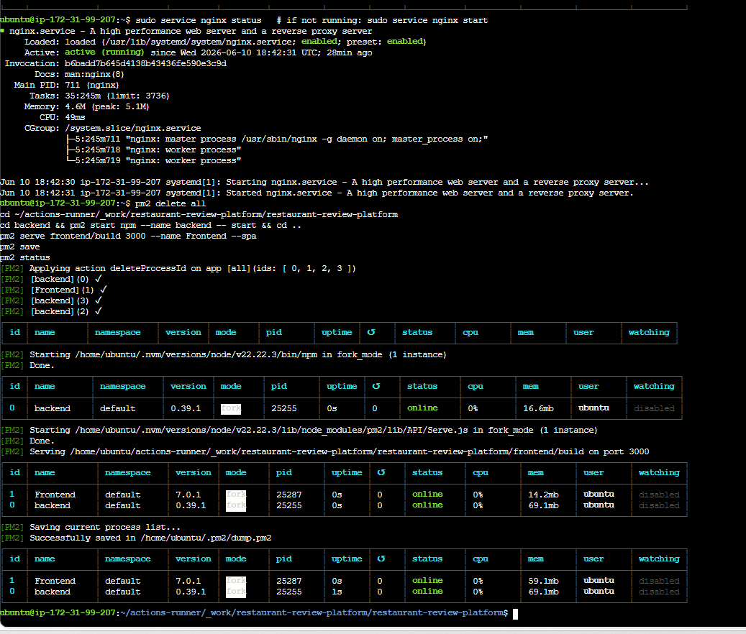
The app is then live at http://<public-ip>/. Because the frontend uses a same-origin API base URL, it keeps working even when the public IP changes.

7. API testing (Thunder Client / Postman)
With the backend running, log in to get a JWT, then test each endpoint. Set the Method, URL, Body (JSON) and Auth (Bearer token).
- POST /api/auth/login -> 200 + token
- GET /api/restaurants -> 200 (copy a restaurant _id)
- POST /api/restaurants/:id/reviews (Bearer) {"rating":5,"text":"Great"} -> 201
- Send it again -> 409 (one review per diner)
- Body {} -> 400 (validation)
- No token -> 401
- POST /api/restaurants as a diner -> 403 (role guard)
Examples of the error-handling responses:
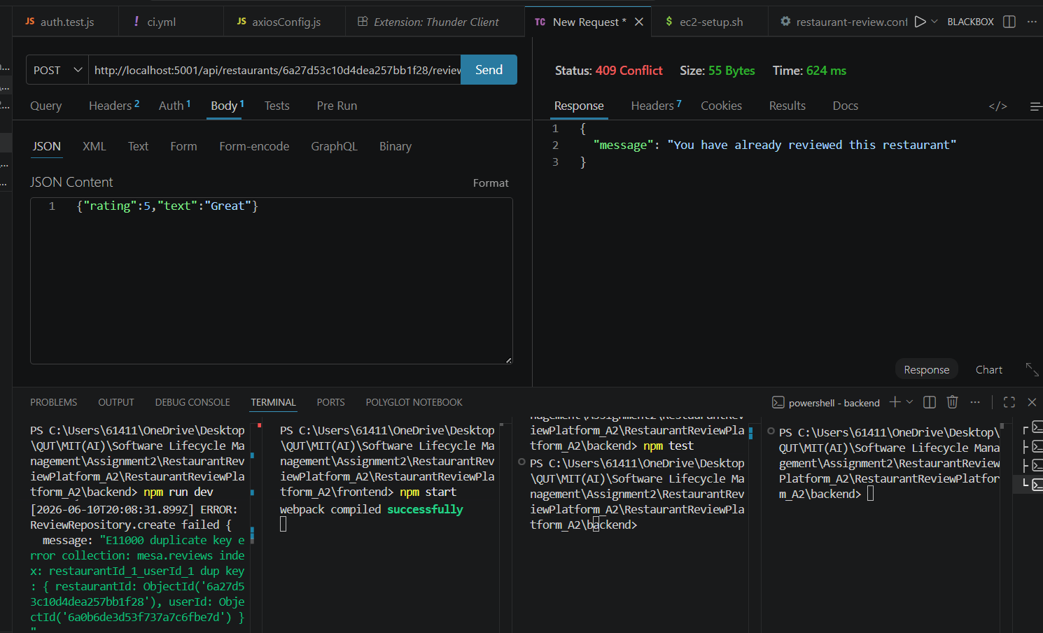
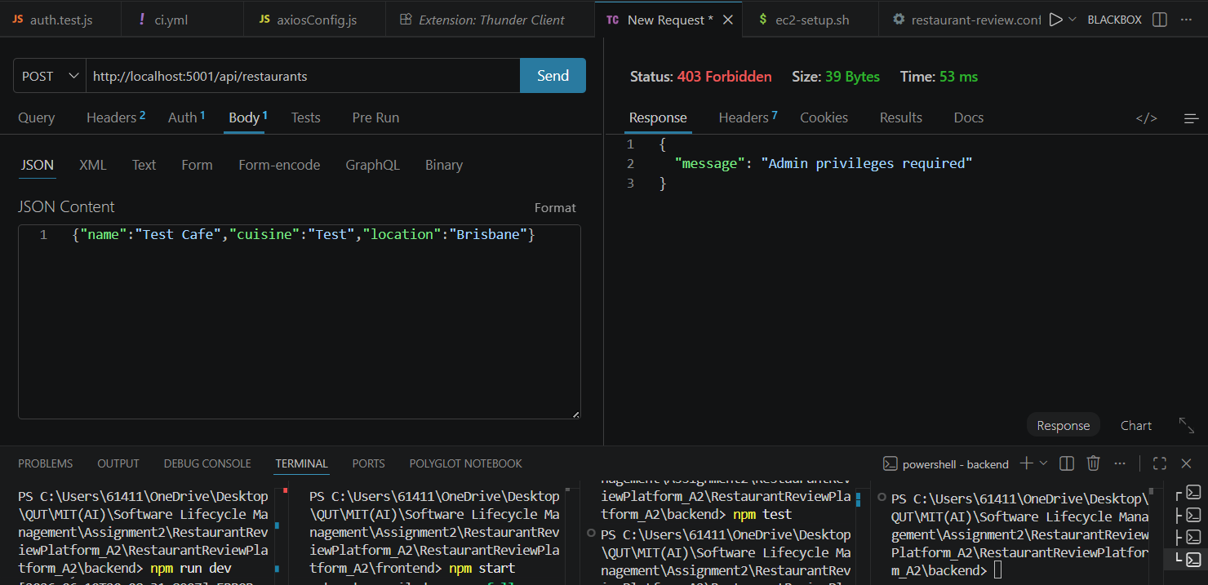

8. Notes
- The EC2 public IPv4 is dynamic and changes on stop/start (no Elastic IP on the student account); capture evidence and submit in one session.
- If the live site shows a brief 502 right after a deploy, wait ~10s and refresh (pm2 restarting).
- Keep the instance running through evidence capture and the video recording.

