IFQ636 A2 — Video Storyboard (10 min) with on-screen visuals
Project: Mesa Restaurant Review Platform. Live: http://3.27.208.40/ Repo: github.com/david1carver/restaurant-review-platform
Solo presentation by David (Anrio) Carver (D). My allocated teammate withdrew from the unit, so all work shown is my own. Read the quoted lines aloud; the ▶ SHOW lines are the on-screen visuals.

0:00–0:40 — Intro (David on camera)
D: “Hi, I’m David Carver. This is my IFQ636 Assignment 2 — Mesa, a Restaurant Review Platform.”
D: “I completed this project solo — my allocated teammate withdrew from the unit, so everything you’ll see is my own work.”
D: “For A2 I re-architected the backend around object-oriented design and eight design patterns, added a new Notifications feature, expanded unit testing, did full API testing, and deployed it live with an automated CI/CD pipeline.”
▶ SHOW: the live app in the browser — address bar http://3.27.208.40/ (this exact screen):
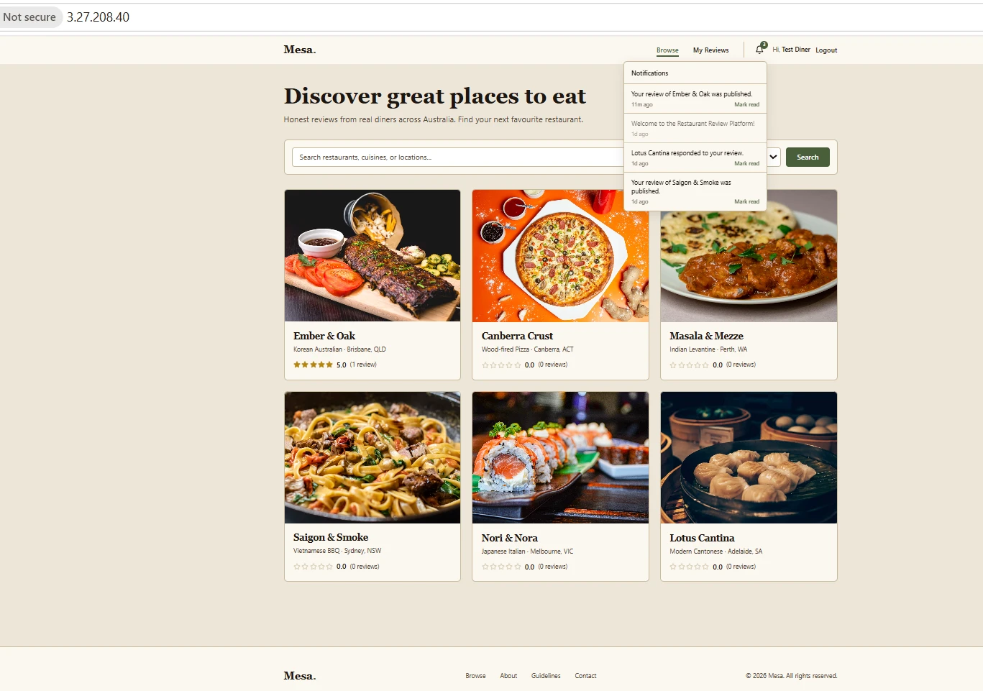

0:40–2:20 — Live application demo (David)
D: “This is the public catalogue — six restaurants, searchable and filterable by cuisine.”
D: “I’ll log in as a diner and post a five-star review of Ember & Oak.”
D: “Watch two things happen from one action: the average rating updates to 5.0, and a notification appears in the bell — that’s the Observer pattern firing. I’ll show that in the code shortly.”
▶ SHOW: post a review live, then open the notifications bell (as pictured): rating 5.0 + “Your review of Ember & Oak was published”.
D: “If I try to review the same restaurant again, the API rejects it — one review per diner. And as an admin I can moderate reviews and manage restaurants.”
Demo live in the browser; the screen above already shows the 5.0 review and the open notifications dropdown — narrate over it.

2:20–2:50 — Design (Figma) (David)
D: “Before the build, the interface was designed in Figma — here are the low-fidelity wireframes and the high-fidelity prototype for the diner and admin journeys.”
▶ SHOW: open the Figma file (or the exported wireframes in docs/A2/wireframes/) — click through 2–3 screens to show the interactive prototype, then cut back to the live app.

2:20–4:30 — Design patterns & OOP (David, in VS Code) — biggest rubric weight, slow down
D: “Here is the backend. I applied eight patterns — the rubric needs seven.”
▶ SHOW: the architecture diagram (the eight patterns + the request flow):
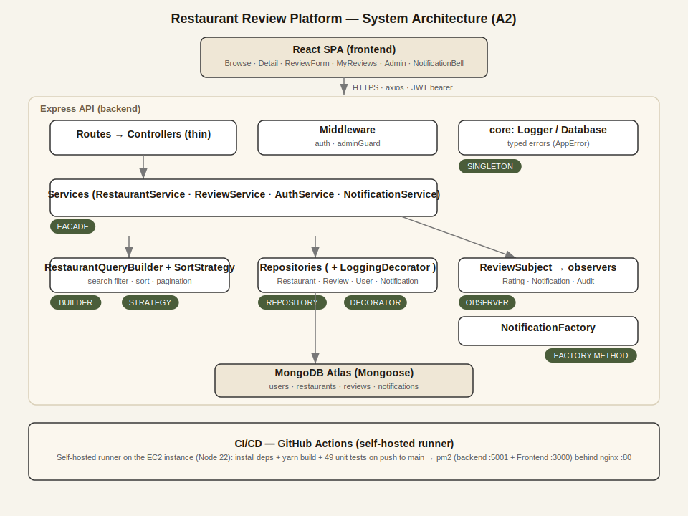
D: “Singleton — core/Logger and core/Database. Repository — BaseRepository. Decorator via a Proxy — LoggingRepositoryDecorator. Facade — ReviewService. Builder — RestaurantQueryBuilder. Strategy — SortStrategy. Factory Method — NotificationFactory. Observer — ReviewSubject fanning out to Rating, Notification and Audit observers.”
D: “When a review is posted: controller → Service (Facade) → Repository wrapped by the Logging Decorator → ReviewSubject notifies the observers — one recomputes the rating, one uses the Factory to build a notification, one writes an audit log through the Singleton logger.”
D: “On OOP: private hash fields give encapsulation; the abstract SortStrategy throws if instantiated directly — abstraction; the concrete strategies and observers use inheritance; and every observer exposes the same update method — polymorphism.”
▶ SHOW: open 2–3 files live in VS Code: events/ReviewSubject.js, services/ReviewService.js, strategies/SortStrategy.js — point at the pattern in each.

4:30–6:00 — Unit testing (David, terminal)
D: “For testing I use Mocha, Chai and Sinon — pure unit tests, no database; the Mongoose calls are stubbed.”
D: “Running npm test — 49 tests pass.”
▶ SHOW: run “npm test” live, and/or this result:
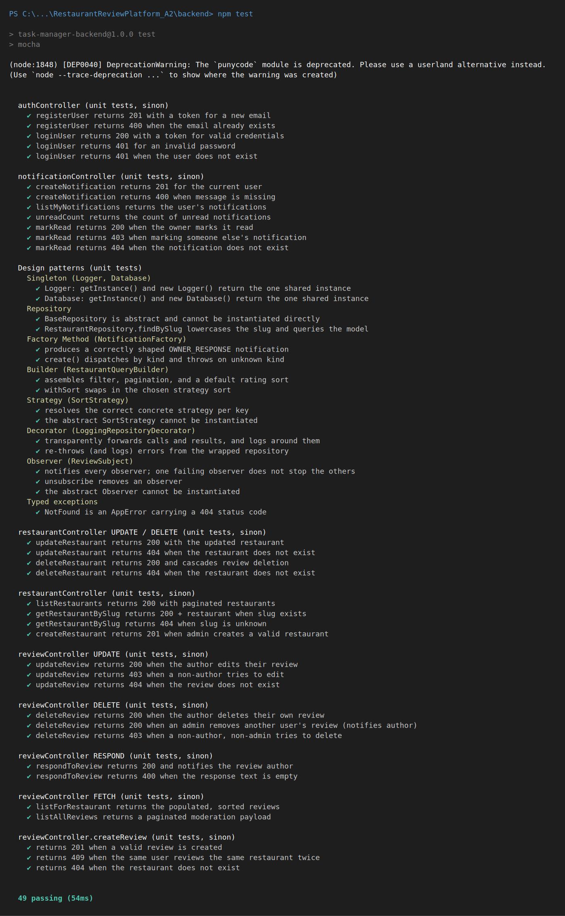
D: “For example, createReview returns 201 on success and 409 on a duplicate, and a pattern test verifies the Observer fans out correctly. Every backend function is covered.”

6:00–7:15 — API testing (David, Thunder Client / Postman)
D: “I verified every endpoint and its error handling. Login returns 200 and a JWT; creating a review returns 201; sending it again returns 409.”
▶ SHOW: the 409 duplicate response (note the backend log shows the database unique-index error too):
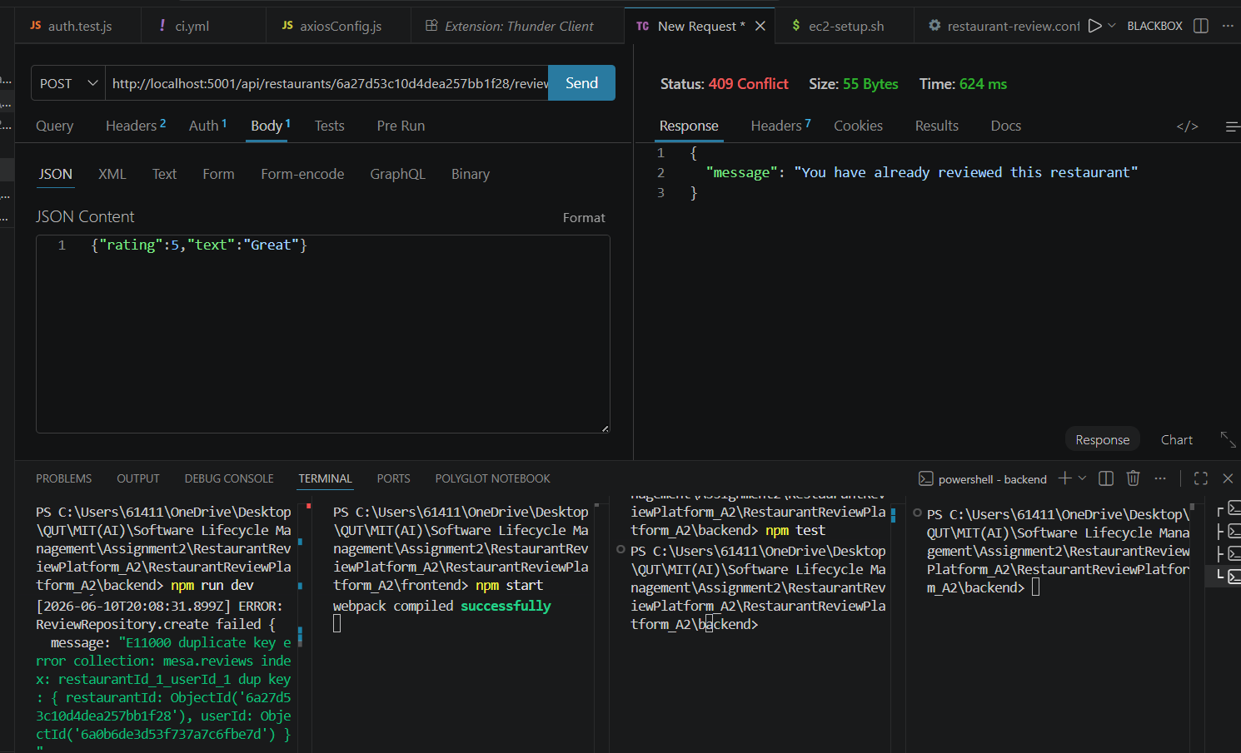
D: “Posting without a token returns 401; missing fields returns 400; and a diner trying to create a restaurant returns 403 — the role guard.”
▶ SHOW: the 403 role-guard response:
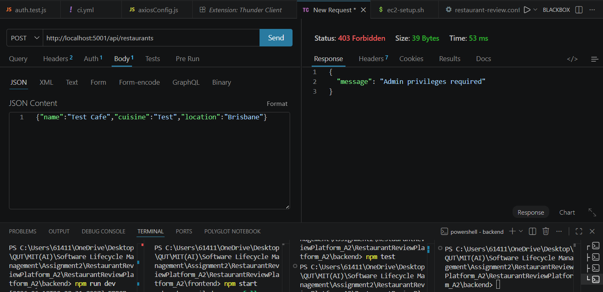
D: “The full collection is exported in the repo under docs/A2.”

7:15–9:00 — CI/CD & deployment (David)
D: “Deployment is fully automated by a GitHub Actions self-hosted runner installed on the EC2 instance. On every push to main it installs deps, builds the frontend, runs the unit tests, writes the production .env from a secret, then restarts the app under pm2.”
▶ SHOW: LIVE — open .github/workflows/ci.yml on GitHub (name: Backend CI, runs-on: self-hosted).
▶ SHOW: LIVE — the Actions tab showing green runs, and Settings → Actions → Runners showing the runner Idle.
D: “On the server, pm2 shows the backend and frontend both online.”
▶ SHOW: the pm2 status table (backend + Frontend online):
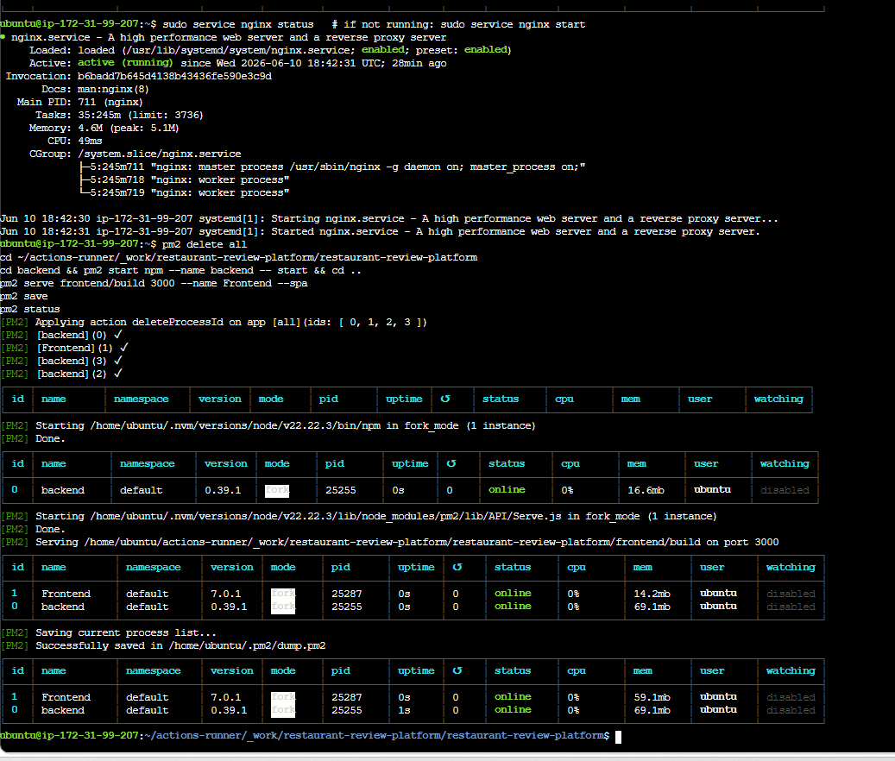
D: “nginx serves the React build on port 80 and proxies /api to the backend. To prove the loop I’ll push a small change, the run goes green, and the live site updates.”
▶ SHOW: LIVE — push a tiny change to main → Actions goes green → refresh http://3.27.208.40/.

9:00–9:40 — GitHub workflow (David)
D: “I used GitHub with a feature-branch workflow — feature branches, pull requests, and two merge conflicts I resolved. As my teammate withdrew, this is an individual demonstration of the collaboration workflow.”
▶ SHOW: LIVE — Insights → Contributors (commit history), the branch list, a pull request, and a resolved merge-conflict commit.
Note: this is a solo demonstration; the commit history is single-contributor.

9:40–10:00 — Wrap (David)
D: “So: an OOP, pattern-based backend; a new notifications feature; 49 unit tests; full API testing; and a live, auto-deployed app.”
D: “Thanks for watching.”

Recording checklist
- One continuous screen recording (OBS / Zoom / Xbox Game Bar Win+G); mic on.
- CAMERA ON — your face must be visible during the recording (Canvas Studio: enable camera in full-screen). This is a stated academic-integrity requirement.
- Pre-open: live site (logged in), VS Code (backend), GitHub Actions + Runners, the test terminal, Thunder Client.
- Keep the EC2 instance RUNNING the whole time (a stop/start changes the public IP).
- If the live site flashes a 502 right after a push, wait ~10s and refresh (pm2 restarting).
- Demonstrate and narrate each part yourself, screen-sharing your own work (the marker verifies the presenter demonstrates the work).
- Upload via Canvas Studio (one member submits to Assignment 2: Video submission).

