Timothy Sjoquist (0822403)

Yen-Ting Chen (1063219)

Lab 2

Problem 1

For problem one, we created two sinusoids, one with a frequency of 2500Hz and the other with a frequency of 5000Hz. We looked at their frequency response which are shown below. The response is normal for the 2500Hz signal, but because of aliasing the second signal appears to have a frequency of 3000Hz. This is so because it is “folding over” meaning as we would increase the frequency of the signal past 4000Hz the frequency response looks like “actual frequency-4000Hz”. Since we put in 5000Hz, the frequency response appears to be 3000Hz. From this part of the lab we learned that aliasing is something that needs to be dealt with when dealing with analog to digital transformations.

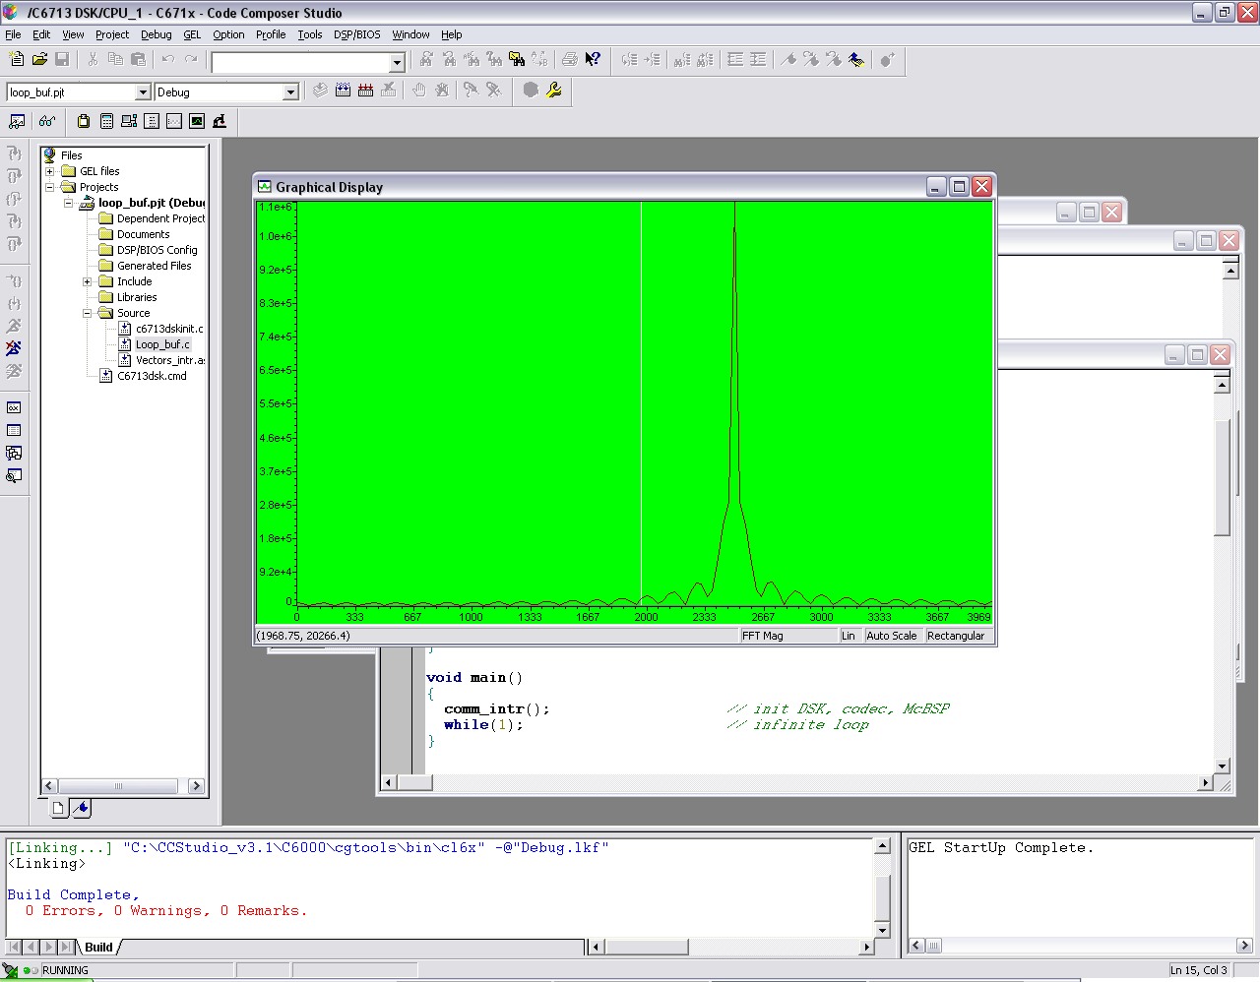

Frequency response of 2500 Hz, first part

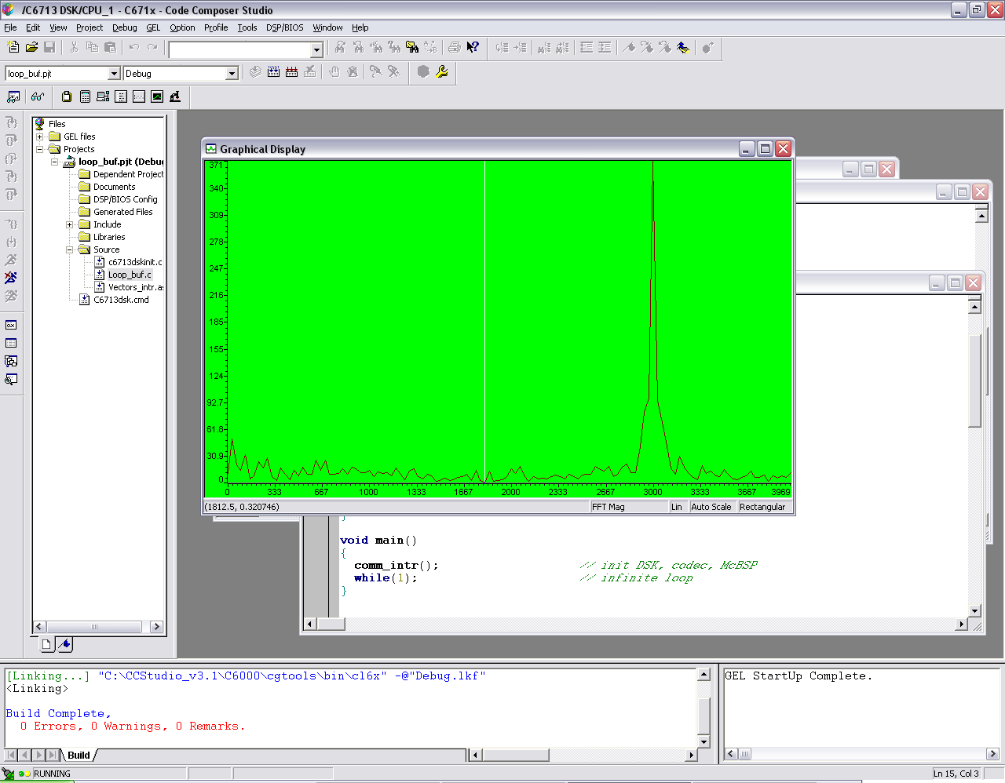

Frequency response of 5000 Hz, first part

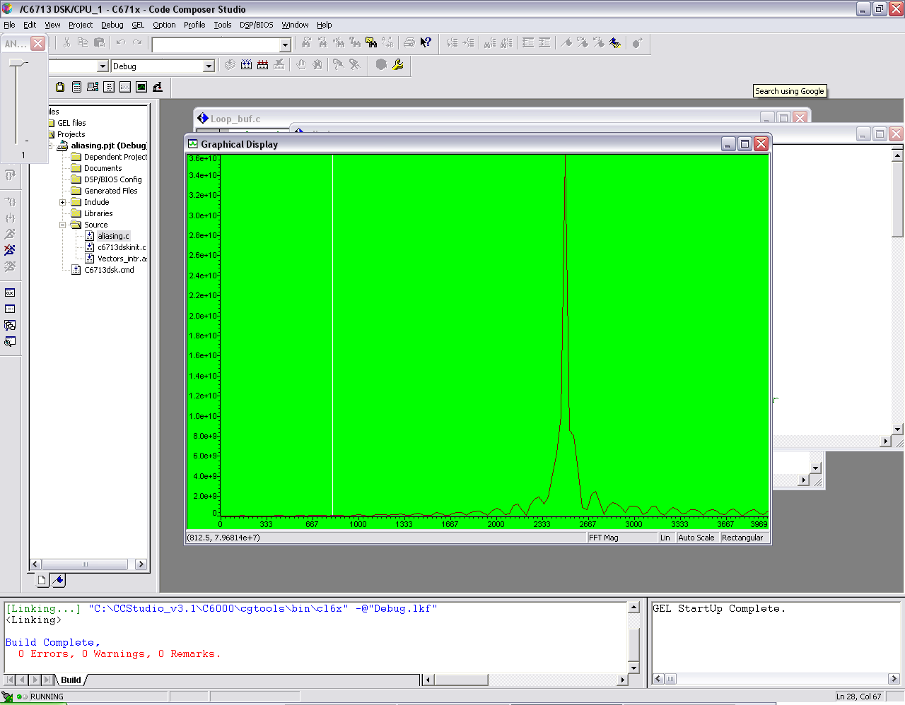

Frequency response of 2500 Hz with no anti-aliasing filter

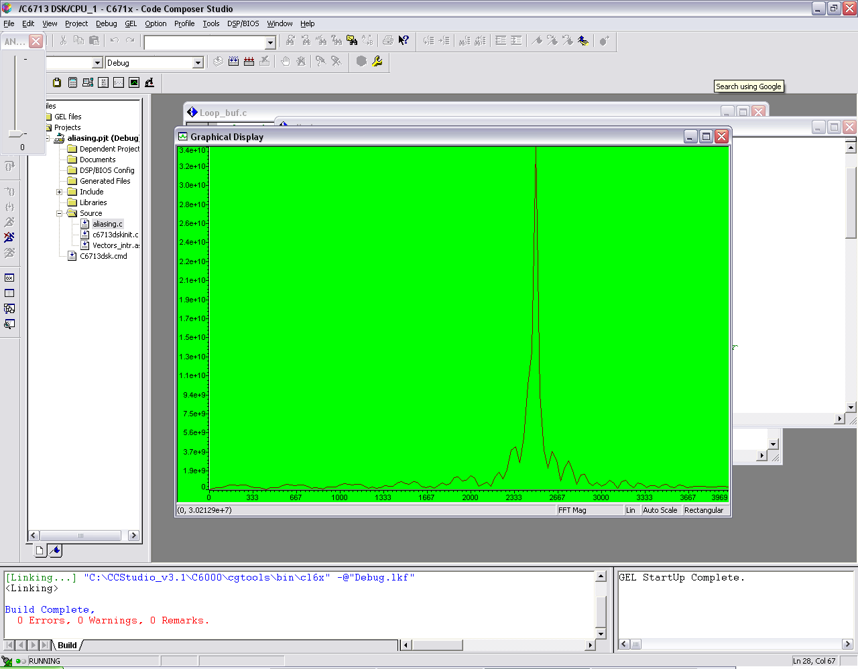

Frequency response of 2500 Hz with anti-aliasing filter

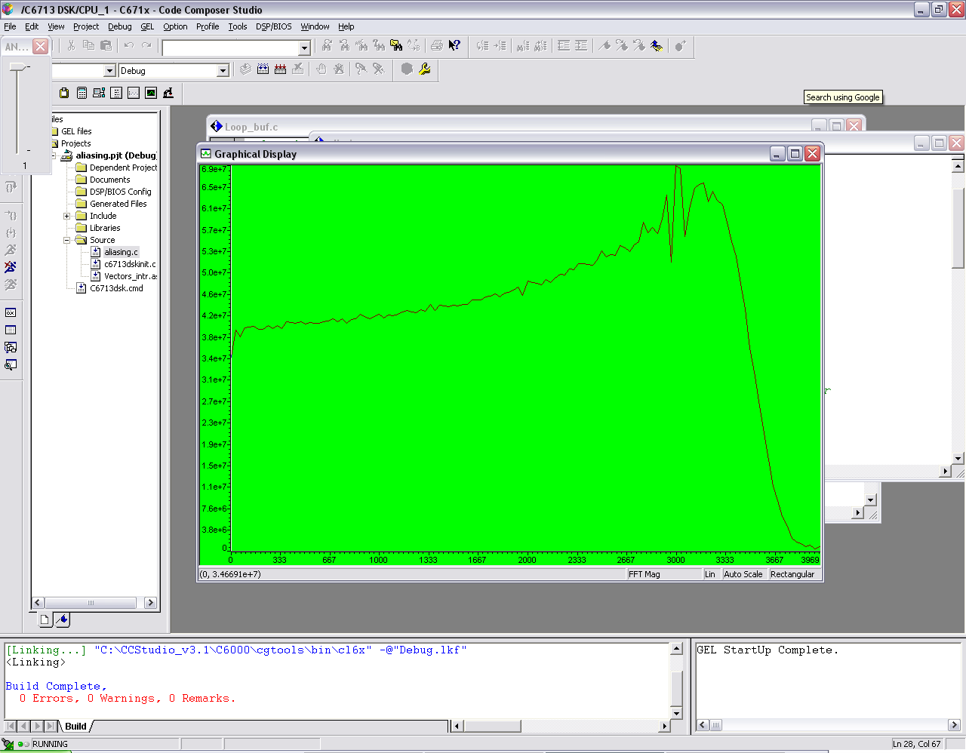

Frequency response of 5000 Hz with no anti-aliasing filter

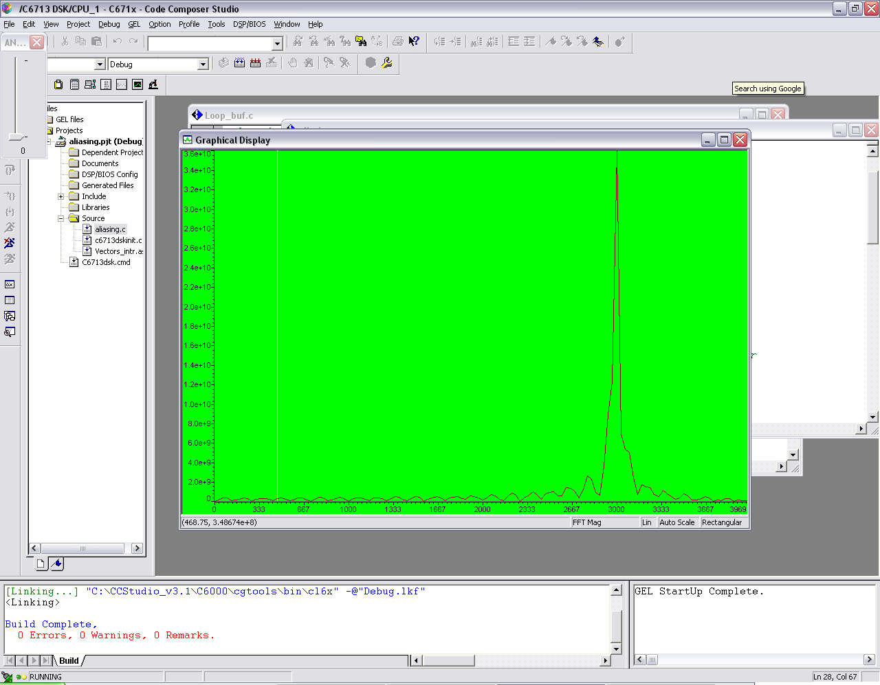

Frequency response of 5000 Hz with anti-aliasing filter

Problem 2

For problem 2 we were to have a line input playing music from the PC sampled at 32KHz and add delay functionality to it. We needed to create sliders to control both gain and the amount of delay for both the left and right channel. To accomplish this we needed to use union(Uint32 uint; short channel[2]), which would allow us to get different data for both the left and right channels. Then we got the data for either the left or the right, and added it to the correct buffer, corresponding to the correct side which allows us to delay the signal. We then outputted the most recent input data added to the data from the buffer to create the delay sound. We could change the amount of delay by changing the bufferlength, a larger buffer means longer delay. To change the gain we simply create a variable gain which is multiplied by the delay factor to change how loud the delay will be. No graphs or tables were required. From this portion of the lab, we learned how to add delay to an input signal for stereo output.

Problem3

For problem 3 we are using a C-callable assembly code to reverse an array of input samples. The c code for this problem should be able to call the reverse assembly on 100 of the input samples and skip another 100 that won’t be reversed. We can look at the time domain data as below to see the reversed relationship between them(Certain samples in the input buffer don’t have reversed relationship with output buffer samples, since the program has a switching function.)

Input buffer:

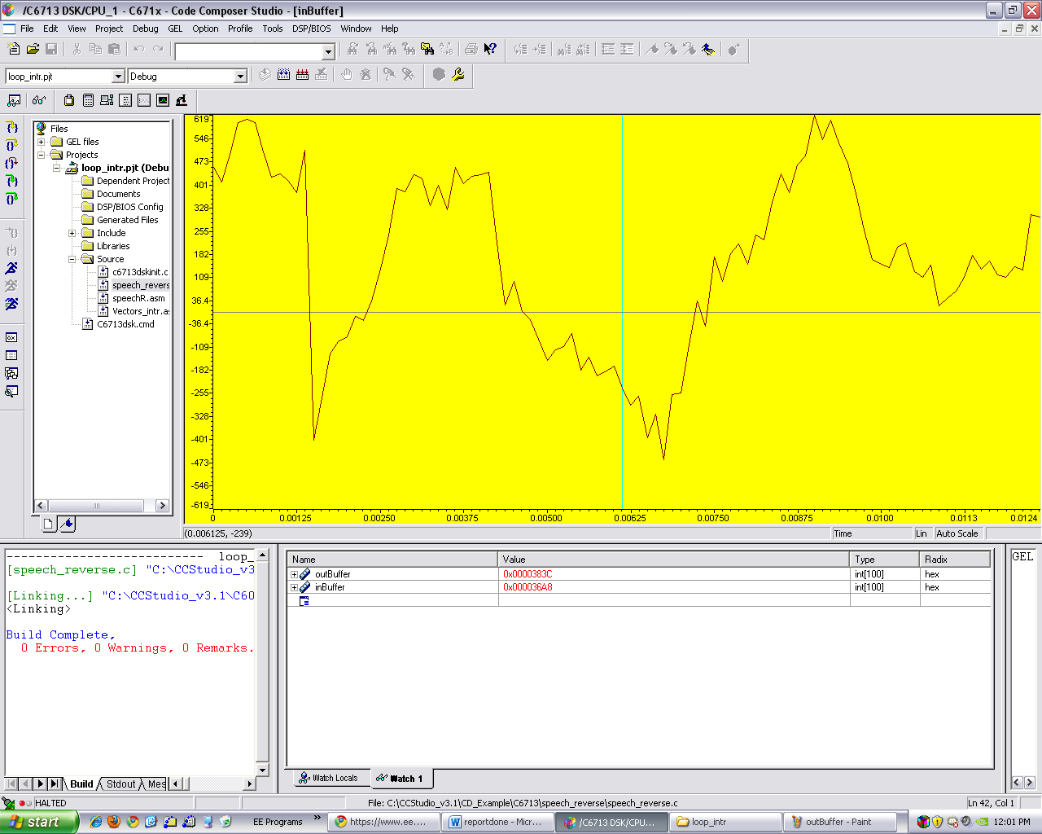

Output buffer:

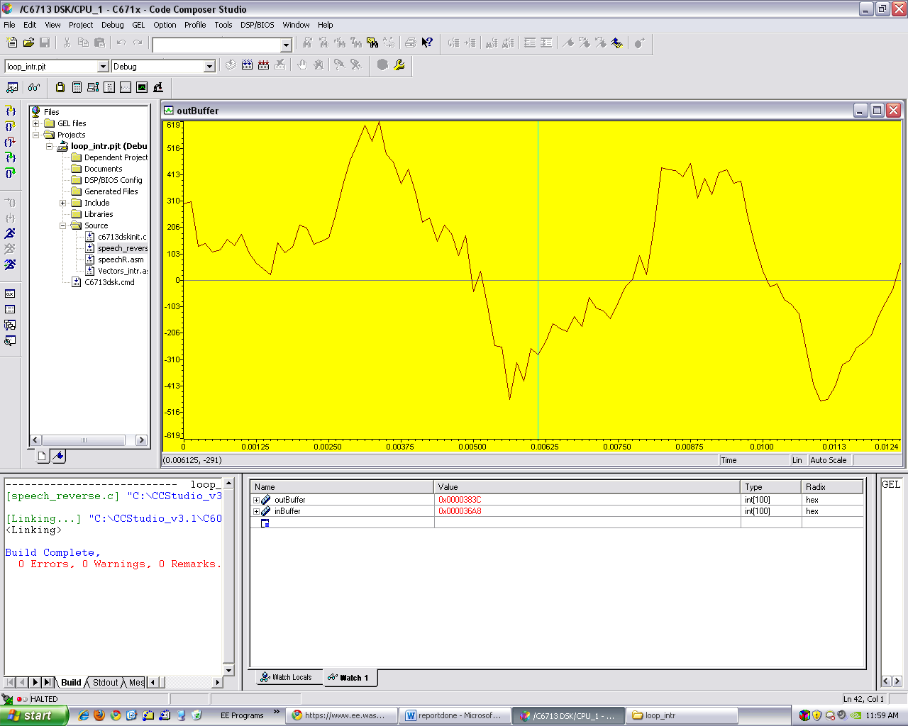

Problem 4

For problem 4 we were to take in stereo music from the PC and either output stereo mix or output the stereo signal without any processing depending on if the switch number one is up or down. To accomplish this, we used the union from Problem 2, so we could output different data for both the Left and Right channels. After we took the input samples from both input_left and input_right, if the switch was up we simply outputted the left data on the left channel and the right data on the right channel. However, if the switch was down, we created a stereo mix by subtracting the left sample data from the right sample data and outputting it on the right channel. For the left channel we added the data from both the right and left inputs and outputted them together. No tables or graphs were required. From this portion of the lab we learned how to create different mixes of output data depending on switch one.

Problem 5

For problem 5 we were to take a stereo music input from the PC and either output it normally or add pseudorandom noise depending on if switch 1 was up or down. In the C program we called an assembly function to generate random noise. Also, we had to implement a slider to control the amplitude of the random noise. The FFT of the random noise in shown below. From the graph we see that there is no predominant frequency in the “random noise” but lots of different values to make up the noise. From this part of the lab, we learned how to introduce random noise and add it to the input signal when needed.

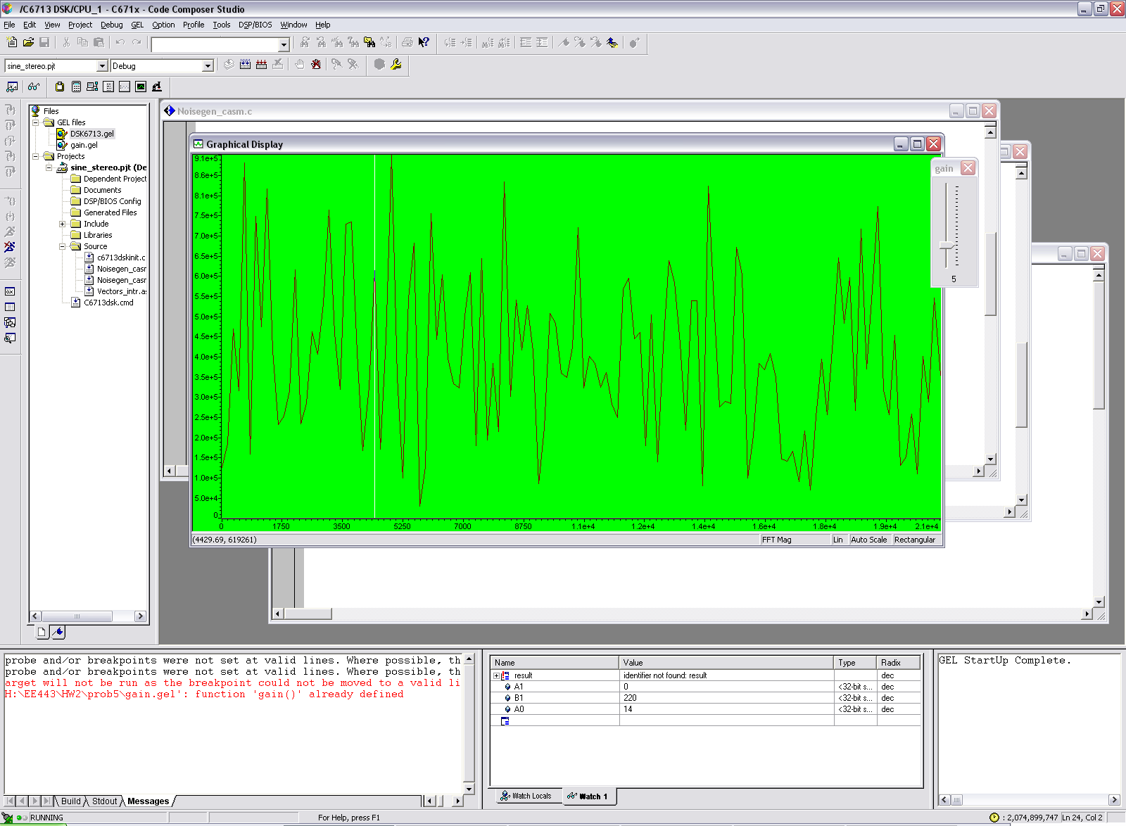

FFT of random noise

Problem 6

For this part of the lab we were required to implement an autocorrelation function of an array of size 20 given as:

$$R\left(k\right)=\sum_{n=0}^{19-k}{x\left(n\right)x(n+k)}$$

We were to implement this in two different versions. First, only using the C language and second using C to call assembly to finish it. Programming this in C simply required a nested for loop accumulating the data into an int. For the next part, we called the assembly function in C to get the correct data in the array. In the assembly function it simply multiplied and added up the values to get the desired result. The results are shown below with the time difference as well. Both sets of code got the correct results, but the C calling assembly version was a lot faster, roughly five times faster. From this portion of the lab we learned that writing optimized assembly code is much faster than having the computer compile the C code for you.

|  |  |
| --- | --- |
| C only (runtime 8911) | C called assembly (runtime 1738) |
| 2870 | 2870 |
| 2660 | 2660 |
| 2451 | 2451 |
| 2244 | 2244 |
| 2040 | 2040 |
| 1840 | 1840 |
| 1645 | 1645 |
| 1456 | 1456 |
| 1274 | 1274 |
| 1100 | 1100 |
| 935 | 935 |
| 780 | 780 |
| 636 | 636 |
| 504 | 504 |
| 385 | 385 |
| 280 | 280 |
| 190 | 190 |
| 116 | 116 |
| 59 | 59 |
| 20 | 20 |

**Problem 1 Code a;**

//loop_buf.c loop program with storage

#include "DSK6713_AIC23.h" // codec support

Uint32 fs=DSK6713_AIC23_FREQ_8KHZ; //set sampling rate

#define DSK6713_AIC23_INPUT_MIC 0x0015

#define DSK6713_AIC23_INPUT_LINE 0x0011

Uint16 inputsource=DSK6713_AIC23_INPUT_LINE; // select input

#define BUFSIZE 512

int buffer[BUFSIZE];

int buf_ptr = 0;

interrupt void c_int11() // interrupt service routine

{

int sample_data;

sample_data = input_left_sample(); // read input sample

buffer[buf_ptr] = sample_data; // store in buffer

if(++buf_ptr >= BUFSIZE) buf_ptr = 0; // update buffer index

output_left_sample(sample_data); // write output sample

return;

}

void main()

{

comm_intr(); // init DSK, codec, McBSP

while(1); // infinite loop

}

**Problem 1 code B:**

//aliasing.c illustration of downsampling, aliasing, upsampling

#include "DSK6713_AIC23.h" //codec support

Uint32 fs=DSK6713_AIC23_FREQ_16KHZ; //set sampling rate

#include "lp6545.cof" //filter coefficients

#define DSK6713_AIC23_INPUT_MIC 0x0015

#define DSK6713_AIC23_INPUT_LINE 0x0011

Uint16 inputsource=DSK6713_AIC23_INPUT_LINE; // select input

#define DISCARD 0

#define SAMPLE 1

short buffer[512];

short flag = DISCARD; //toggles for 2x down-sampling

short indly[N],outdly[N]; //antialias and reconst delay lines

float yn; int i; //filter output, index

short antialiasing = 1; //init for no antialiasing filter

int bufl;

interrupt void c_int11() //ISR

{

indly[0]=(float)(input_left_sample());//new sample to antialias filter

yn = 0.0; //initialize downsampled value

if (flag == DISCARD) flag = SAMPLE; //don't discard at next sampling

else

{

if (antialiasing == 1) //if antialiasing filter desired

{ //compute downsampled value

for (i = 0 ; i < N ; i++) //using LP filter coeffs

yn += (h[i]*indly[i]); //filter is implemented using float

}

else //if filter is bypassed

yn = indly[0]; //downsampled value is input value

flag = DISCARD; //next input value will be discarded

}

for (i = N-1; i > 0; i--)

indly[i] = indly[i-1]; //update input buffer

outdly[0] = (yn); //input to reconst filter

yn = 0.0; //8 kHz sample values and zeros

for (i = 0 ; i < N ; i++) //are filtered at 16 kHz rate

yn += (h[i]*outdly[i]); //by reconstruction lowpass filter

for (i = N-1; i > 0; i--)

outdly[i] = outdly[i-1]; //update delays

buffer[bufl++]=(short)yn;

if(bufl>=512){

bufl=0;

}

output_left_sample((short)yn); //16 kHz rate sample

return; //return from interrupt

}

void main()

{

comm_intr(); //init DSK, codec, McBSP

while(1); //infinite loop

}

**Problem 2 Code:**

//echo_control.c echo with variable delay and feedback

#include "DSK6713_AIC23.h" // codec support

Uint32 fs=DSK6713_AIC23_FREQ_32KHZ; // set sampling rate

#define DSK6713_AIC23_INPUT_MIC 0x0015

#define DSK6713_AIC23_INPUT_LINE 0x0011

Uint16 inputsource=DSK6713_AIC23_INPUT_LINE; // select input

#define MAX_BUF_SIZE 8000 // this sets maximum length of delay

#define LEFT 0

#define RIGHT 1

union {Uint32 uint; short channel[2];} AIC23_data;

float gain = 0.5;

float gain2 = 0.5;

short buflength = 1000;

short buflength2 = 1000;

short buffer[MAX_BUF_SIZE]; // storage for previous samples

short buffer2[MAX_BUF_SIZE];

short input,output,delayed,delayed2,input2;

int i = 0; // index into buffer

interrupt void c_int11() // interrupt service routine

{

input = input_right_sample();

input2= input_left_sample(); // read new input sample from ADC

delayed = buffer[i]; // read delayed value from buffer

delayed2=buffer2[i];

AIC23_data.channel[RIGHT]=input+delayed;

AIC23_data.channel[LEFT]=input2+delayed2; // output sum of input and delayed values

output_sample(AIC23_data.uint);

buffer[i] = input + delayed*gain; // store new input and a fraction

buffer2[i]= input2 + delayed2*gain2; // of the delayed value in buffer

if(++i >= MAX_BUF_SIZE) // test for end of buffer

i = MAX_BUF_SIZE - buflength;

return; // return from ISR

}

void main()

{

for(i=0 ; i<MAX_BUF_SIZE ; i++) // clear buffer

buffer[i] = 0;

comm_intr(); // init DSK, codec, McBSP

while(1); //infinite loop

}

**Problem 3 Code:**

Assembly:

.def _speechR

_speechR:

;A4 - inBuffer input

;B4 - outBuffer input

;A6 - 100

MV .L1 A6,A1; buffer data as bytes.

MPY .M1 A6,4,A6

MV A4,A7

ADD .S2 A6,B4,B4

LDW .D2 *B4--,A0 ;shift A7 to point to the end of inBuffer.

NOP 4

loop

LDW *A7++,A8

NOP 4

STW A8,*B4

NOP 4

[A1] B .S2 loop

LDW *B4--,A0

SUB .S1 A1,1,A1

NOP 3

B B3

NOP 5

.end

C code:

//loop_intr.c loop program using interrupts

#include "DSK6713_AIC23.h" //codec support

Uint32 fs=DSK6713_AIC23_FREQ_8KHZ; //set sampling rate

#define DSK6713_AIC23_INPUT_MIC 0x0015

#define DSK6713_AIC23_INPUT_LINE 0x0011

#define bufSize 100

Uint16 inputsource=DSK6713_AIC23_INPUT_MIC; // select input

int inBuffer[bufSize];

int inBufIndex = 0;

int outBuffer[bufSize];

int outBufIndex = 0;

int isReversed = 0;

int* outPtr;

interrupt void c_int11() //interrupt service routine

{

short sample_data;

sample_data = input_sample(); //input dataL

inBuffer[inBufIndex++] = sample_data;

output_sample(*outPtr++);

if(outBufIndex >= bufSize){outBufIndex = 0;}

if(inBufIndex >= bufSize){

if(isReversed == 0){

speechR(inBuffer,outBuffer,bufSize);

outPtr = &outBuffer[outBufIndex];

}else{

outPtr = &inBuffer[inBufIndex];

}

inBufIndex = 0;

}

return;

}

void main()

{

outPtr = &inBuffer[inBufIndex];

comm_intr(); //init DSK, codec, McBSP

while(1); //infinite loop

}

**Problem 4 Code:**

//sine_stereo Sine generation to both LEFT and RIGHT channels

#include "dsk6713_aic23.h" //codec support

Uint32 fs=DSK6713_AIC23_FREQ_48KHZ; //set sampling rate

#define DSK6713_AIC23_INPUT_MIC 0x0015

#define DSK6713_AIC23_INPUT_LINE 0x0011

Uint16 inputsource=DSK6713_AIC23_INPUT_LINE; // select input

#define LEFT 0

#define RIGHT 1

union {Uint32 uint; short channel[2];} AIC23_data;

#define LOOPLENGTH 8 // size of look up table

short sample_dataL;

short sample_dataR;

//short loopindex = 0; // look up table index

interrupt void c_int11() //interrupt service routine

{

sample_dataL = input_left_sample(); //input data

sample_dataR = input_right_sample();

if(DSK6713_DIP_get(0)==0){

AIC23_data.channel[RIGHT]=sample_dataR-sample_dataL; //for right channel;

AIC23_data.channel[LEFT]=sample_dataR+sample_dataL; //for leftchannel;

}else{

AIC23_data.channel[RIGHT]=sample_dataR;

AIC23_data.channel[LEFT]=sample_dataL;

}

output_sample(AIC23_data.uint); //output to both channels

//if (++loopindex >= LOOPLENGTH)

// loopindex = 0; // check for end of look up table

return;

}

void main()

{

comm_intr(); //init DSK,codec,McBSP

while(1) ; //infinite loop

}

**Problem 5 C Code:**

//Noisegen_casm.c Pseudo-random noise generation calling ASM function

#include "dsk6713_aic23.h" //codec-DSK support file

Uint32 fs=DSK6713_AIC23_FREQ_32KHZ; //set sampling rate

#define DSK6713_AIC23_INPUT_MIC 0x0015

#define DSK6713_AIC23_INPUT_LINE 0x0011

Uint16 inputsource=DSK6713_AIC23_INPUT_LINE; // select mic in

#define LEFT 0

#define RIGHT 1

union {Uint32 uint; short channel[2];} AIC23_data;

short sample_dataL;

short sample_dataR;

int previous_seed;

short gain;

int bufindex;

int x;

int out_buffer[1024];

short pos=32000, neg=-32000; //scaling noise level

interrupt void c_int11()

{

previous_seed = noisefunc(previous_seed); //call ASM function

sample_dataL = input_left_sample(); //input data

sample_dataR = input_right_sample();

AIC23_data.channel[RIGHT]=sample_dataR;

AIC23_data.channel[LEFT]=sample_dataL;

if(DSK6713_DIP_get(0)==1){

output_sample(AIC23_data.uint);

}else{

if(previous_seed & 0x01){

x=pos;

}else{

x=neg;

}

AIC23_data.channel[RIGHT]=sample_dataR+(x*gain)/(350);

AIC23_data.channel[LEFT]=sample_dataL + (x*gain)/(350);

output_sample(AIC23_data.uint);

}

out_buffer[bufindex++]=x;

if(bufindex>=1024) bufindex=0;

}

void main ()

{ bufindex=0;

gain=0;

comm_intr(); //init DSK, codec, McBSP

previous_seed = noisefunc(0x7E521603); //call ASM function

while (1); //infinite loop

}

**Problem 5 assembly code:**

;Noisegen_casmfunc.asm Noise generation C-called function

.def _noisefunc ;ASM function called from C

_noisefunc ZERO A2 ;init A2 for seed manipulation

MV A4,A1 ;seed in A1

SHR A1,17,A1 ;shift right 17->bit 17 to LSB

ADD A1,A2,A2 ;add A1 to A2 => A2

SHR A1,11,A1 ;shift right 11->bit 28 to LSB

ADD A1,A2,A2 ;add again

SHR A1,2,A1 ;shift right 2->bit 30 to LSB

ADD A1,A2,A2 ;

SHR A1,1,A1 ;shift right 1->bit 31 to LSB

ADD A1,A2,A2 ;

AND A2,1,A2 ;Mask LSB of A2

SHL A4,1,A4 ;shift seed left 1

OR A2,A4,A4 ;Put A2 into LSB of A4

B B3 ;return to calling function

NOP 5 ;5 delays for branch

**Problem 6 C code**:

#include <stdio.h>

#define count 20

short x[count]={1,2,3,4,5,6,7,8,9,10,11,12,13,14,15,16,17,18,19,20};

short y[count]={0,0,0,0,0,0,0,0,0,0,0,0,0,0,0,0,0,0,0,0};

short result2[count]={0,0,0,0,0,0,0,0,0,0,0,0,0,0,0,0,0,0,0,0};

main(){

int i,j,k;

for(i=0;i<count;i++){

for(j=0;j<count-i;j++){

y[i]=x[j]*x[i+j]+y[i];

}

}

printf("hello2");

try(x[0],count,&result2);

printf("hello2");

for(k=0;k<count;k++){

printf("Y= %d\n",y[k]);

}

}

**Problem 6 assembly code:**

;Factfunc.asm Assembly function called from C to find factorial

.def _try ;asm function called from C

_try: Mv A4,A7

Mv A6,A4

LDH *A6,A1

SUB B7,B7,B7

Mv B4,B1

Outer:

Mv B4,B0

Mv A7, A9

Mv A7, B9

LDB *B9++[B7],A0

LOOP:

SUB B0,1,B0

[B0] B LOOP

MPY A9,B9,A3

LDB *A9++,A0

LDB *B9++,A0

ADD A3,A1,A1

NOP 1

SUB B1,1,B1

[B1] B Outer

STH A1,*A6++

SUB B4,1,B4

SUB A1,A1,A1

ADD B7,1,B7

NOP 1

B B3 ;return to calling routine

NOP 5 ;five NOPs for delay slots

.end