# Intro to Java Week 5 Coding Assignment

**Screenshots of Code:**

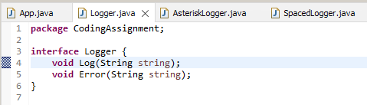

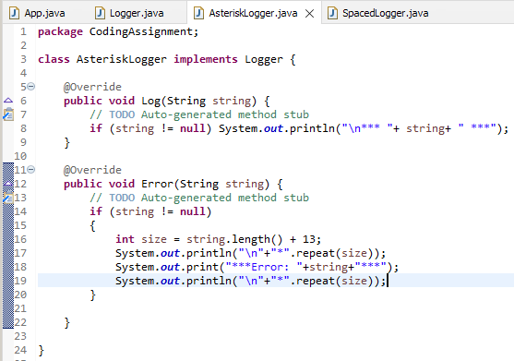

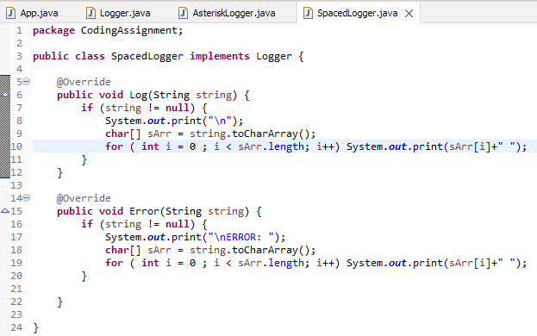

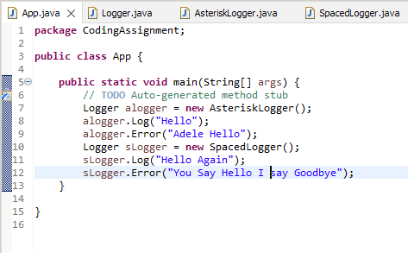

**Screenshots of Running Application:**

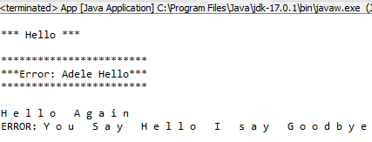

**URL to GitHub Repository:**

**https://github.com/david2joh/Week5.git**