Web API Design with Spring Boot Week 4 Coding Assignment

- Create a new integration test class to test a Jeep order named CreateOrderTest.java. Create this class in src/test/java in the com.promineotech.jeep.controller package.

  - Produce a screenshot of the createOrderBody() method. 
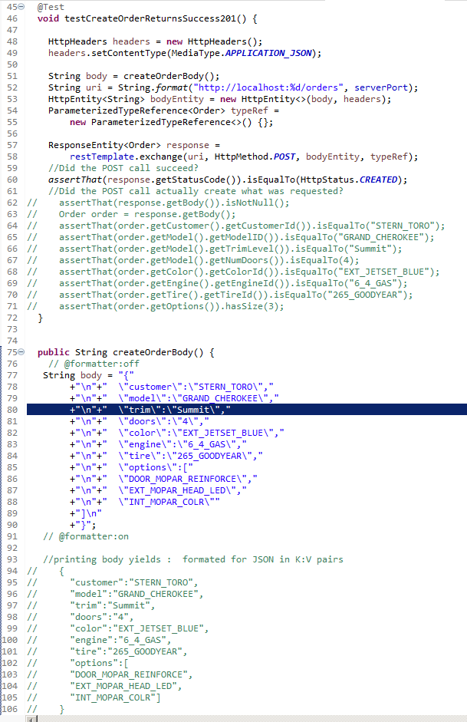

  - Produce a screenshot of the test method.

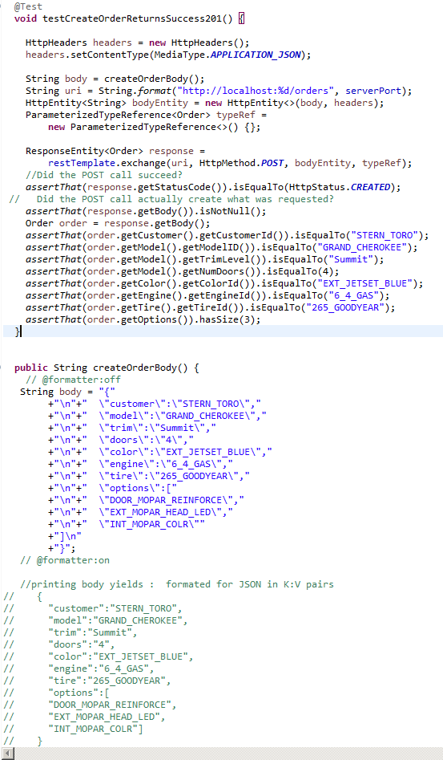

- In the controller sub-package in src/main/java, create an interface named JeepOrderController. Add @RequestMapping("/orders") as a class-level annotation.

  - Produce a screenshot of the finished JeepOrderController interface showing no compile errors.

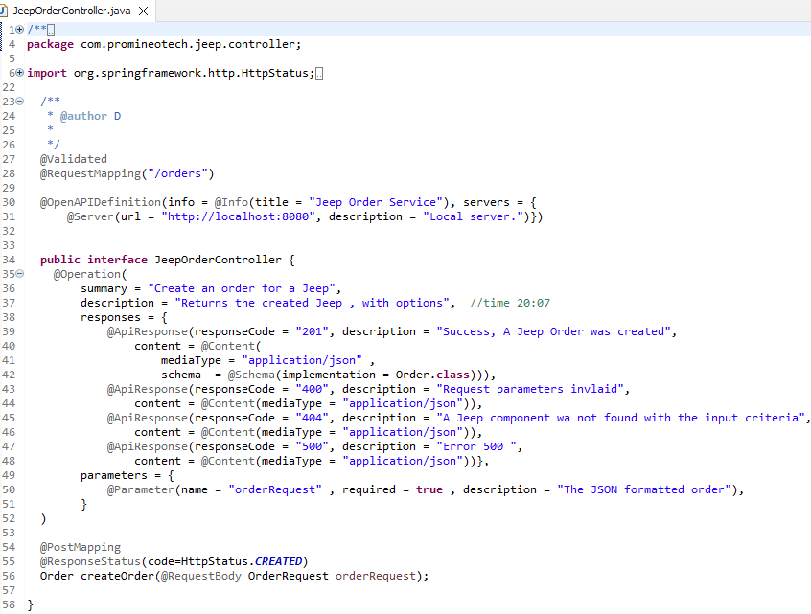

- Create a class that implements JeepOrderController named DefaultJeepOrderController.

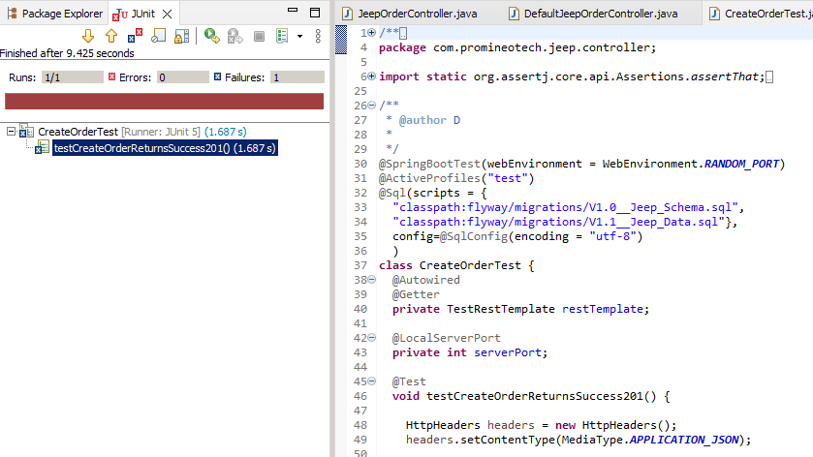
  - Run the test to show a red status bar. Produce a screenshot that shows the test method, the log line, and the red JUnit status bar.

- Add Bean Validation annotations to the OrderRequest class as shown in the video.

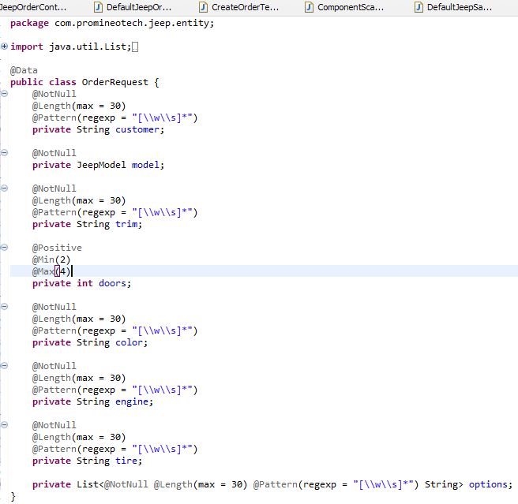
  - Produce a screenshot of this class with the annotations.

- In the jeep.service sub-package, create the empty (no methods yet) order service interface (named JeepOrderService) and implementation (named DefaultJeepOrderService).

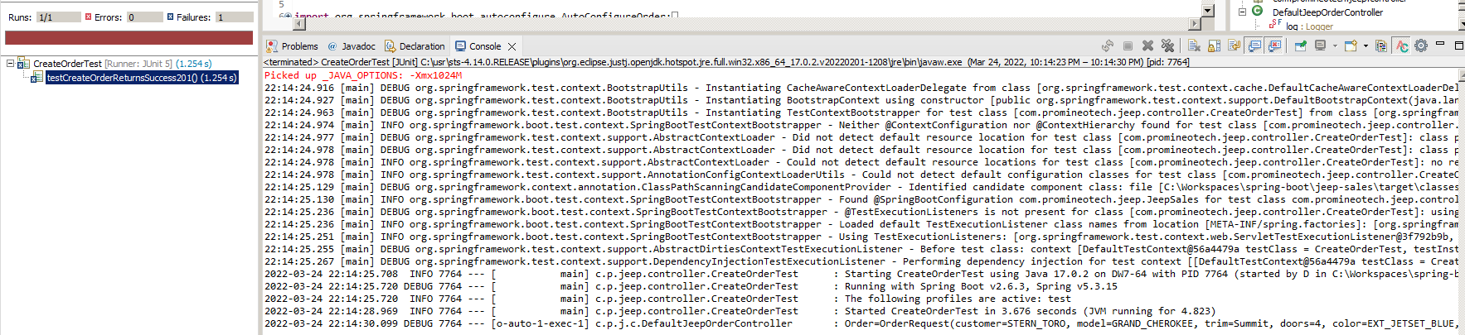
  - Run the test CreateOrderTest again. Produce a screenshot showing that the service layer createOrder method correctly prints the log line in the console. (e.g. prints out the OrderRequest in the console from within the Service Layer).

- In JeepOrderDao.java and DefaultJeepOrderDao.java, add the method:
Order saveOrder(Customer customer, Jeep jeep, Color color, Engine engine, Tire tire, BigDecimal price, List<Option> options);
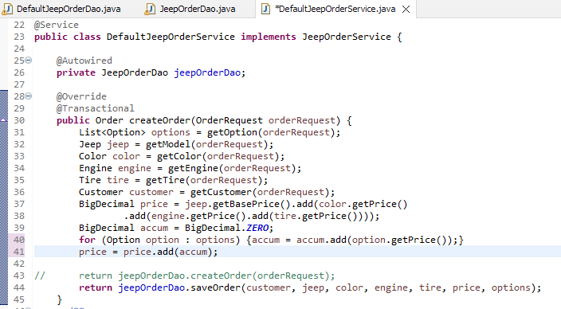
  - Call the jeepOrder.Dao.saveOrder method from the jeepOrderSalesService.createOrder service. Produce a screenshot of the jeepOrderSalesService.createOrder method.
  - Write the implementation of the saveOrder method in the DAO.

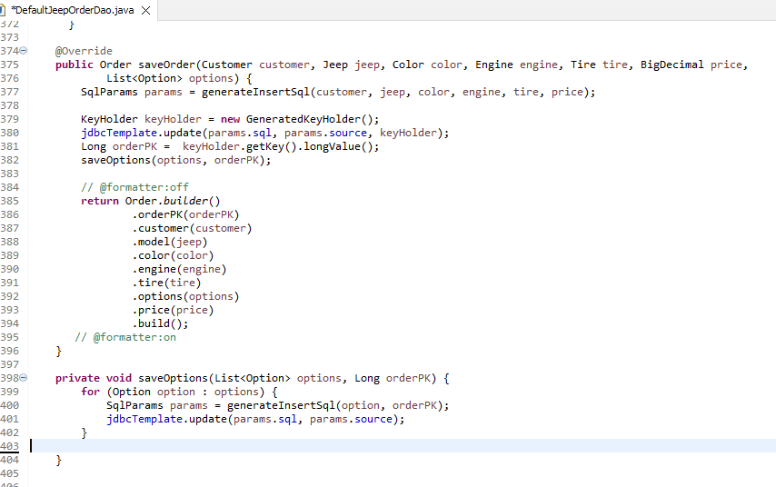
    - Produce a screenshot of the saveOrder method.

  - Run the integration test in CreateOrderTest. Produce a screenshot of the test method that shows the green JUnit status bar, the console output, and the test class.

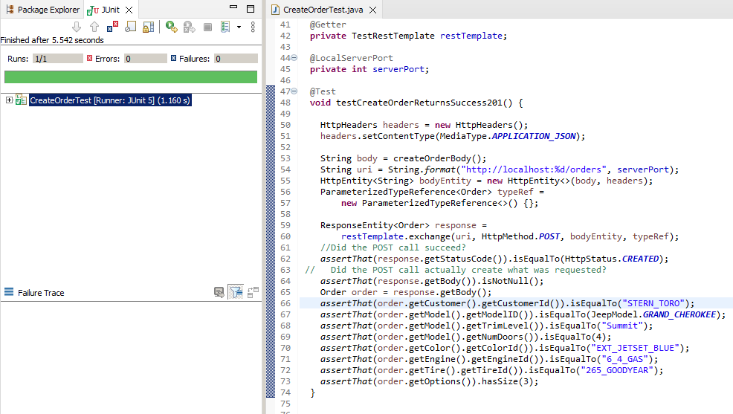

URL to GitHub Repository:
https://github.com/david2joh/nccspringboot/tree/main/Week04

