Web API Design with Spring Boot Week 1 Coding Assignment

  - Produce a screenshot showing the completed test class. 

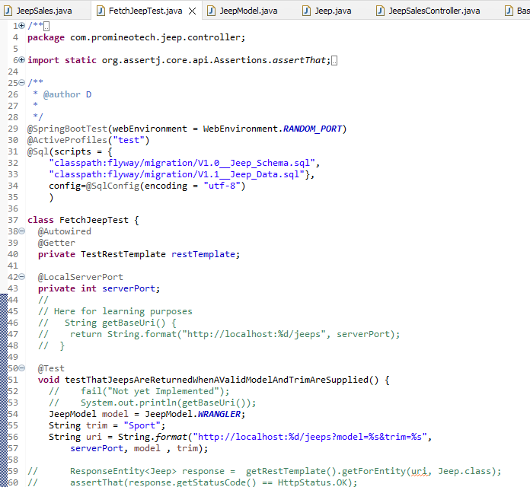

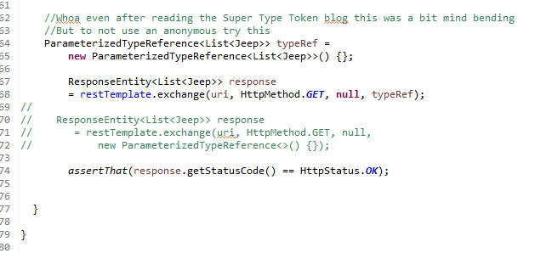

Produce a screenshot showing the interface and OpenAPI documentation.
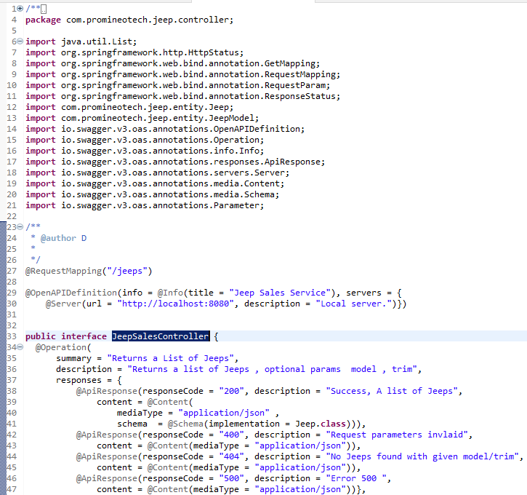
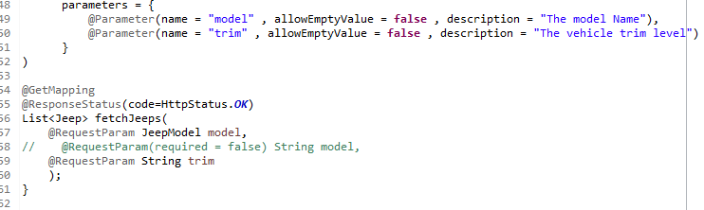
Run the application within the IDE and show the resulting OpenAPI (Swagger) documentation produced in the browser. Produce a screenshot of the documentation showing all four possible outcomes.
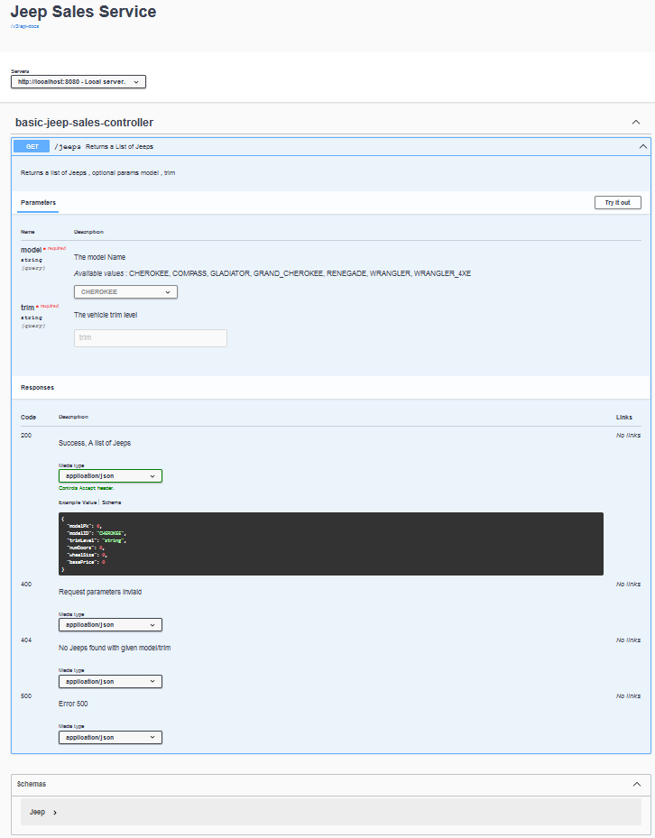

URL to GitHub Repository:
https://github.com/david2joh/springweek1.git

