# Web API Design with Spring Boot Week 2 Coding Assignment

1. 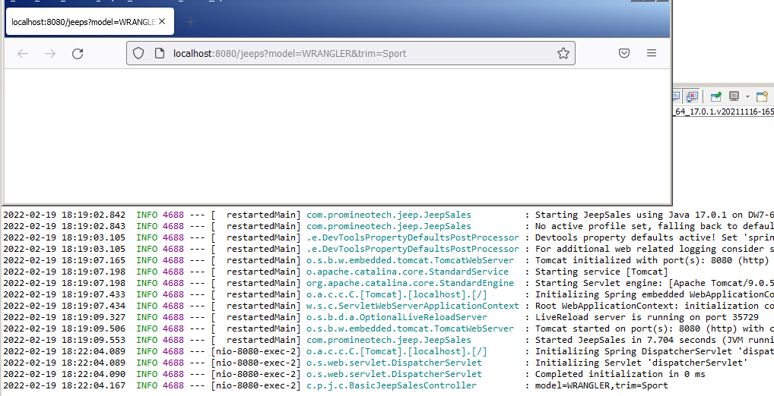Start the application (not an integration test). Use a browser to navigate to the application passing the parameters required for your selected operation. (A browser, used in this manner, sends an HTTP GET request to the server.) Produce a screenshot showing the browser navigation bar and the log statement that is in the IDE console showing that the controller method was reached (as in the video). 
2. 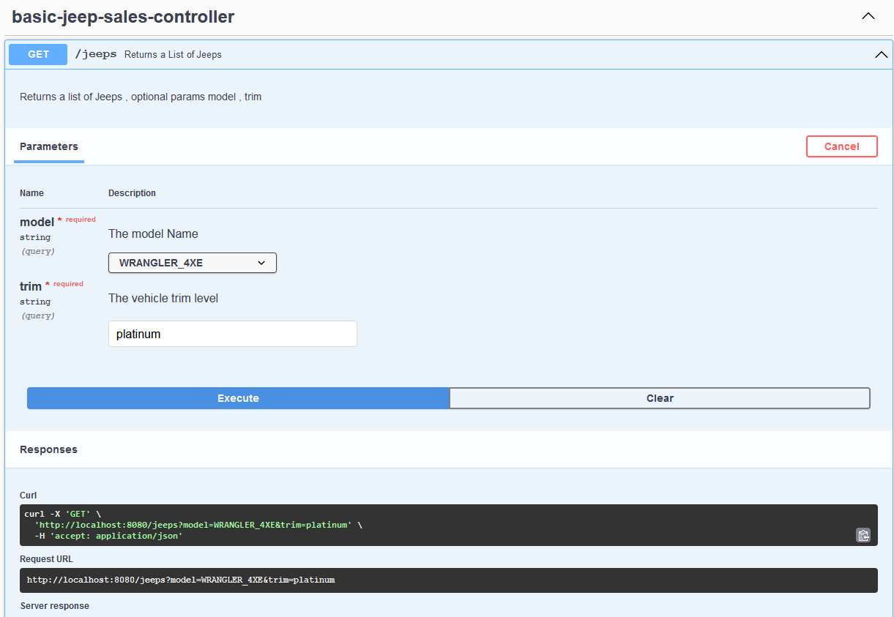With the application still running, use the browser to navigate to the OpenAPI documentation. Use the OpenAPI documentation to send a GET request to the server with a valid model and trim level. (You can get the model and trim from the provided data.sql file.) Produce a screenshot showing the curl command, the request URL, and the response headers. 
3. 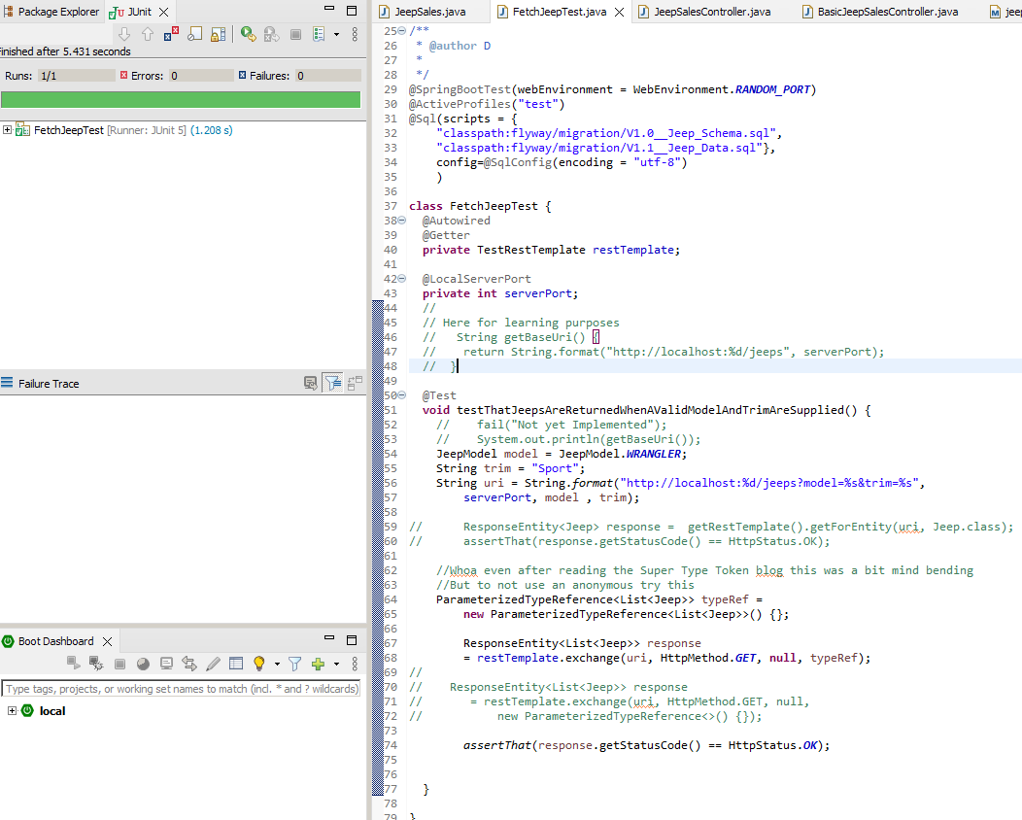Run the integration test and show that the test status is green. Produce a screenshot of the test class and the status bar. 
4. 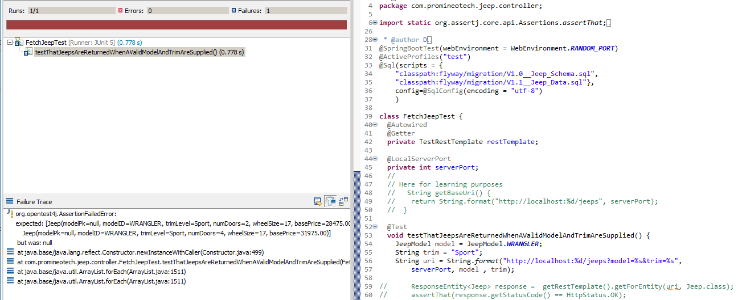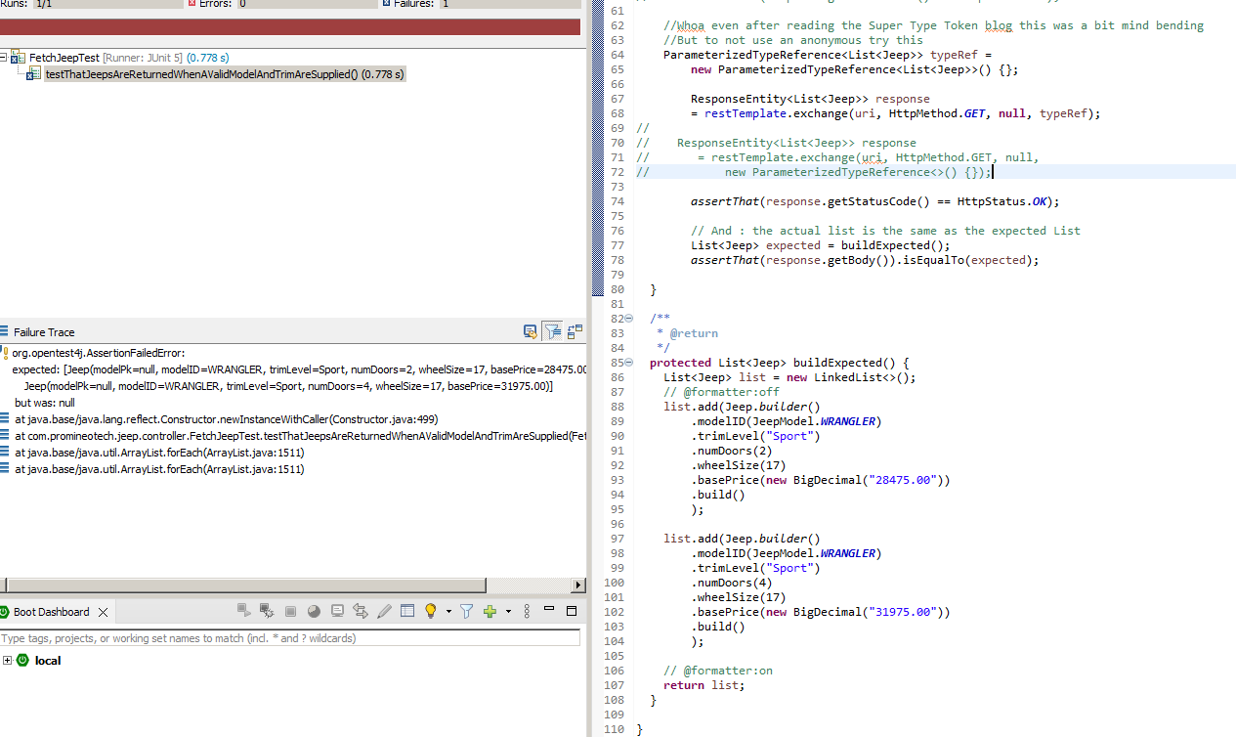The JUnit status bar (should be red).The method returning the expected list of Jeeps. 

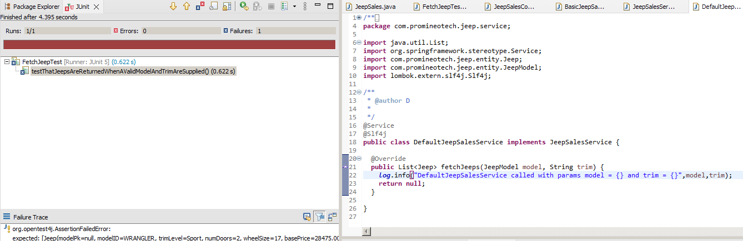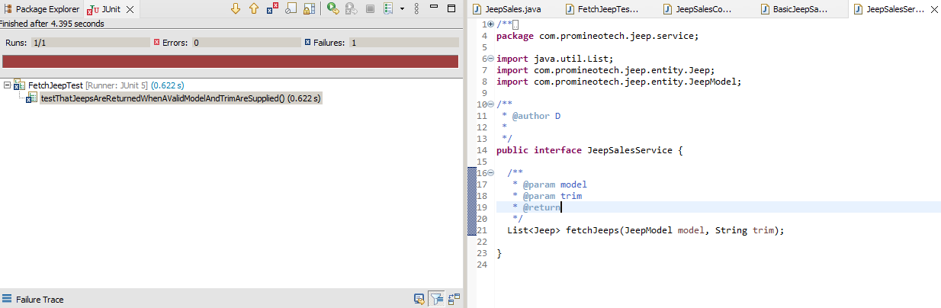Run the test again. Produce a screenshot showing the service class implementation, the log line in the console, and the red status bar.   
  
DefaultJeepSalesService class  
  
  
  
  
  
  
  
JeepSalesService Interface

1. 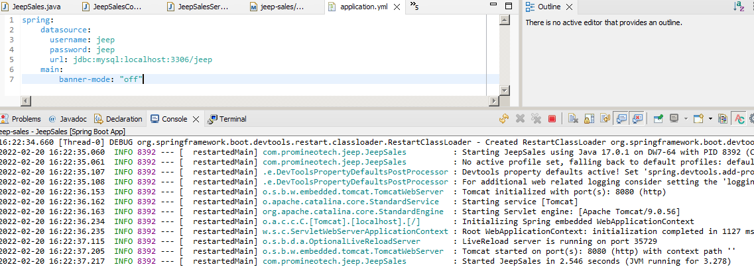Start the application (the real application, not the test). Produce a screenshot that shows application.yaml and the console showing that the application has started with no errors. 

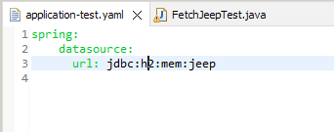Produce a screenshot showing application-test.yaml. 

**URL to GitHub Repository:**

https://github.com/david2joh/springweek2.git