# Web API Design with Spring Boot Week 3 Coding Assignment

1. In the DAO implementation class (DefaultJeepSalesDao):
   1. Add the class-level annotation: @Service.
   2. 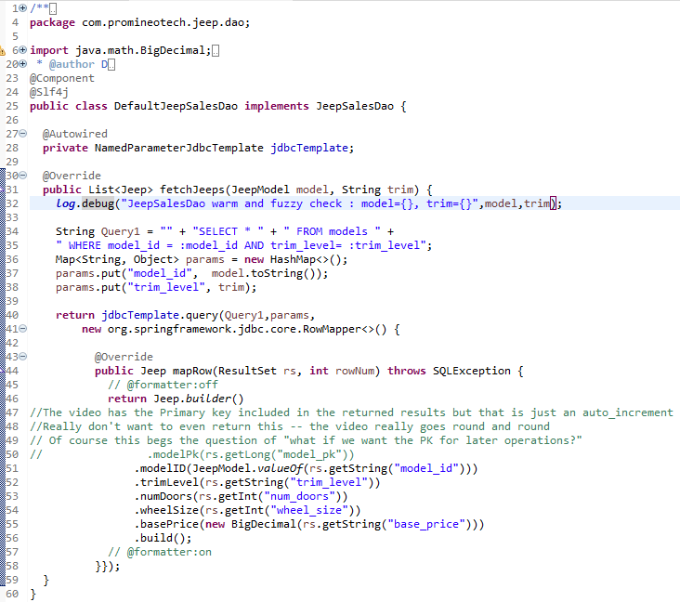Add a log statement in DefaultJeepSalesDao.fetchJeeps() that logs the model and trim level. Run the integration test. Produce a screenshot showing the DAO implementation class and the log line in the IDE's console. 

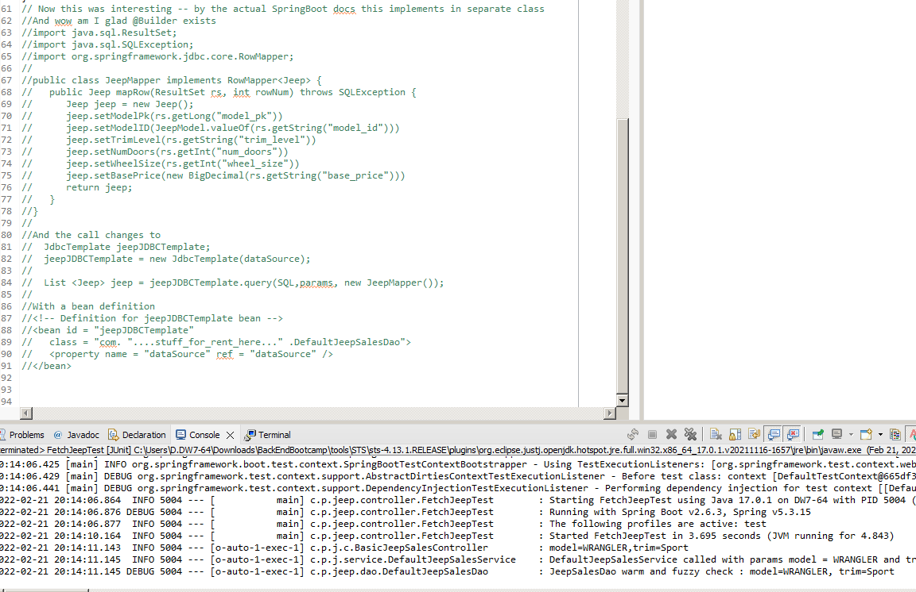

* 1. Call the query method on the NamedParameterJdbcTemplate instance variable to return a list of Jeep model objects. Use a RowMapper to map each row of the result set. Remember to convert modelId to a JeepModel. See the video for details. Produce a screenshot to show the complete method in the implementation class. 

(Student Note : Complete class in screenshots above. Only method call here)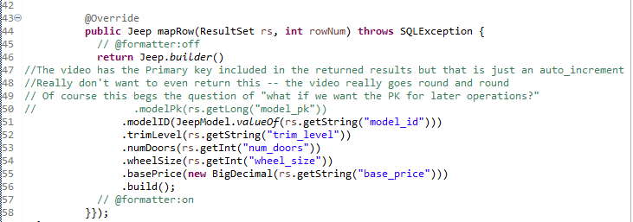

1. 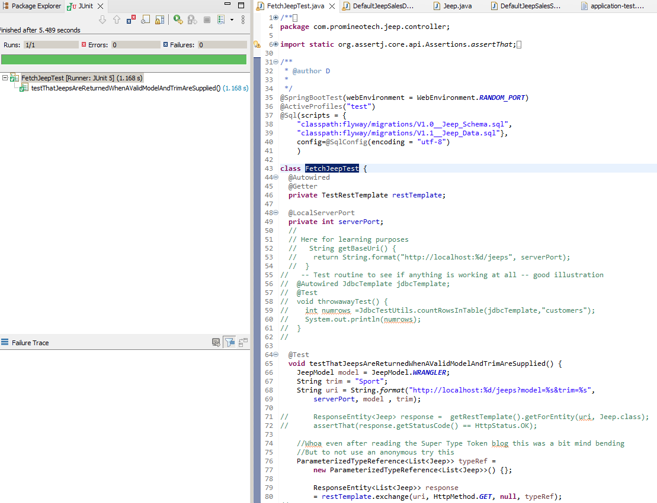Run the test to produce a green status bar. Produce a screenshot showing the test and the green status bar. 

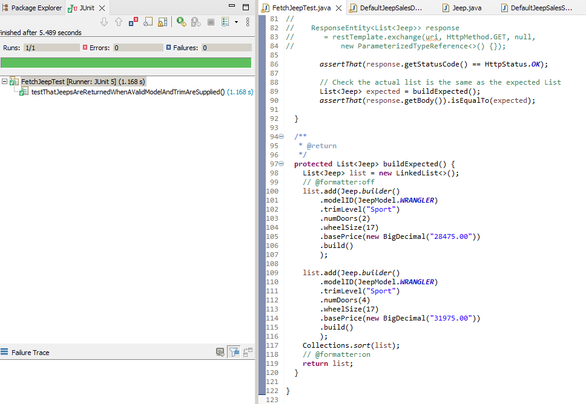

1. **URL to GitHub Repository:**

<https://github.com/david2joh/springweek3.git>