# Relational Databases with MySQL Week 2 Coding Assignment

// Student Note : I’ve placed the query and screenshot of result below the Coding step question

// for clarity versus all together.

**Coding Steps:**

Write queries to address the following business needs.

1. I want to know how many employees with each title were born after 1965-01-01.

select count(e.emp_no), t.title from employees AS e INNER JOIN titles AS t ON e.emp_no = t.emp_no WHERE e.birth_date > '1965-01-01' group by t.title;

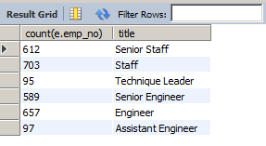

2. I want to know the average salary per title.

select round(avg(s.salary),2) , t.title from salaries AS s INNER JOIN titles AS t on s.emp_no = t.emp_no group by t.title;

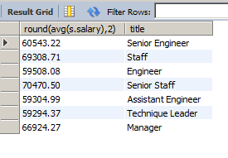

3. How much money was spent on salary for the marketing department between the years 1990 and 1992?

//Student Notes

// 1. ) Both the join query and nested subquery produce an identical result.

SELECT SUM(s.salary) from salaries AS s  
 INNER JOIN dept_emp AS de ON s.emp_no = de.emp_no  
 INNER JOIN departments d ON d.dept_no = de.dept_no   
 WHERE d.dept_name = 'Marketing' AND ( s.from_date > '1990-01-01' and s.to_date < '1992_12_31');

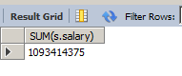

select SUM(salary) from salaries AS s   
 where (emp_no in   
 (select emp_no from dept_emp where dept_no =   
 (select dept_no from departments where dept_name = 'Marketing') ) )  
 AND ( s.from_date > '1990-01-01' and s.to_date < '1992_12_31');

**GIT Hub URL**

https://github.com/david2joh/sqlWeek2.git

**Screenshots of Queries:**

**See above**

**Screenshots of Query Results (only include the last 20 rows):**

**See Above**

**URL to GitHub Repository:**