# Relational Databases with MySQL Week 5 Coding Assignment

**Student Note:**  Only a single table , groceryList, was implement to complete the assignment

The items table and code is included as a learning exercise to be done later.

**Screenshots of Code:**

**SQL commands**

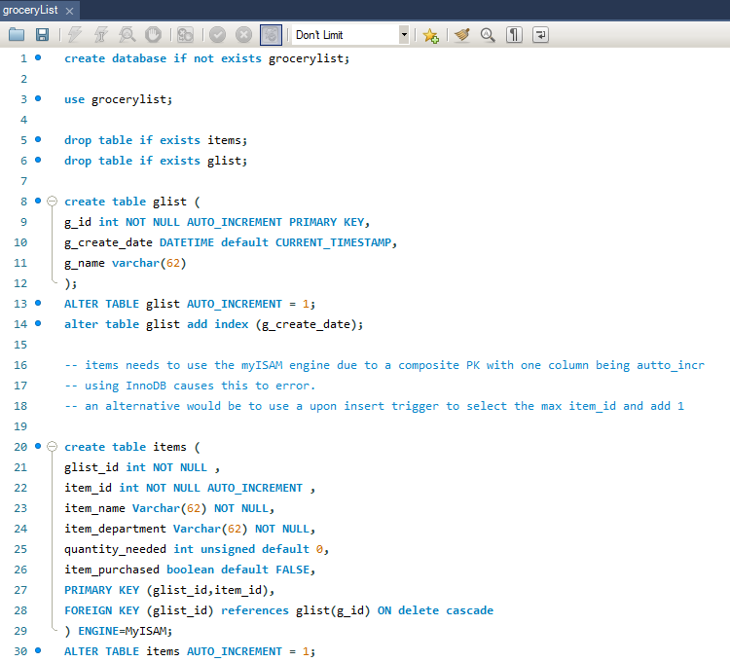

**DBConnection**

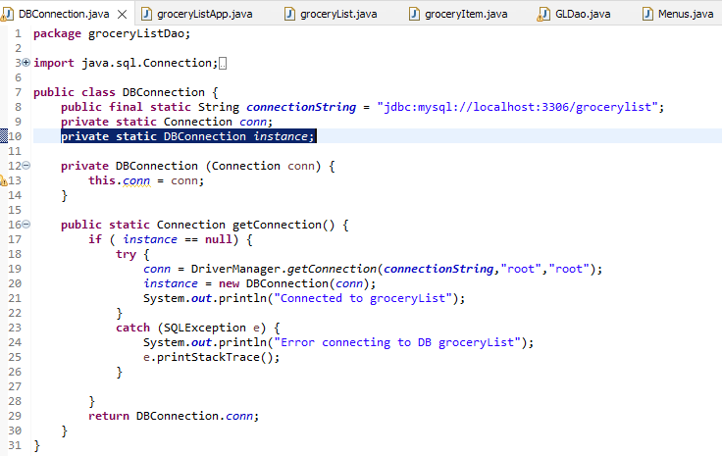

**groceryListApp**

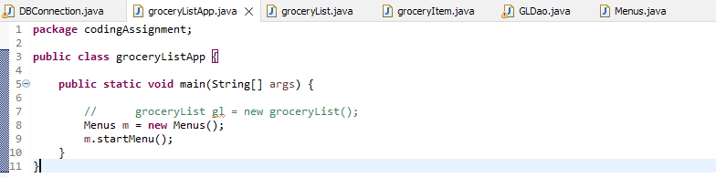

**Menus (part1)**

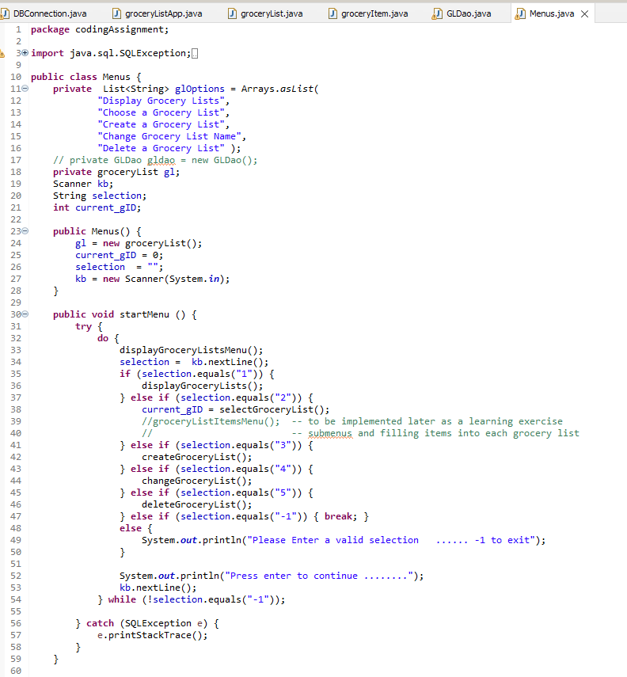

**Menus (part2)**

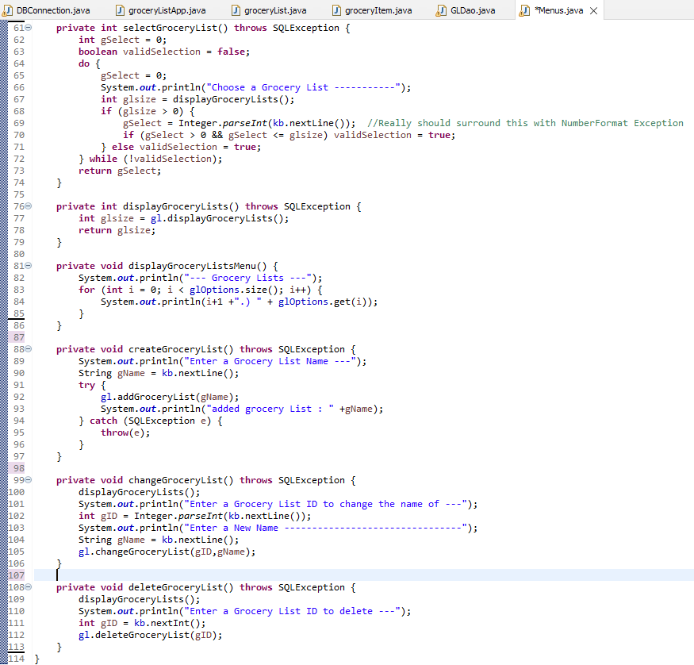

**groceryList**

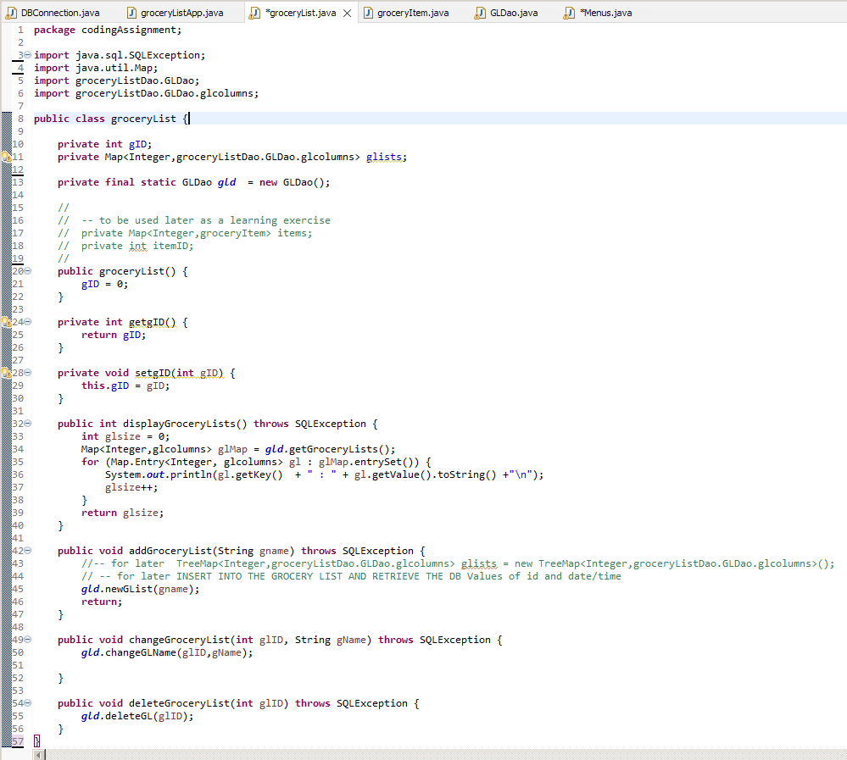

**GLDao (part 1)**

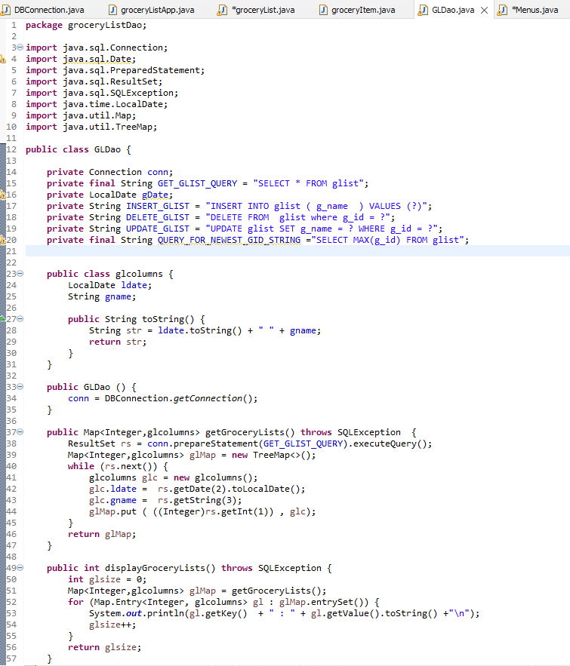

**GLDao (part 2)**

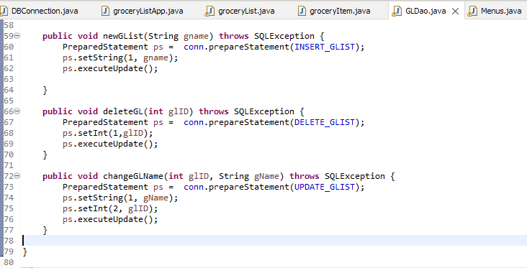

**groceryItem //Stub not currently implemented – kept for practice later**

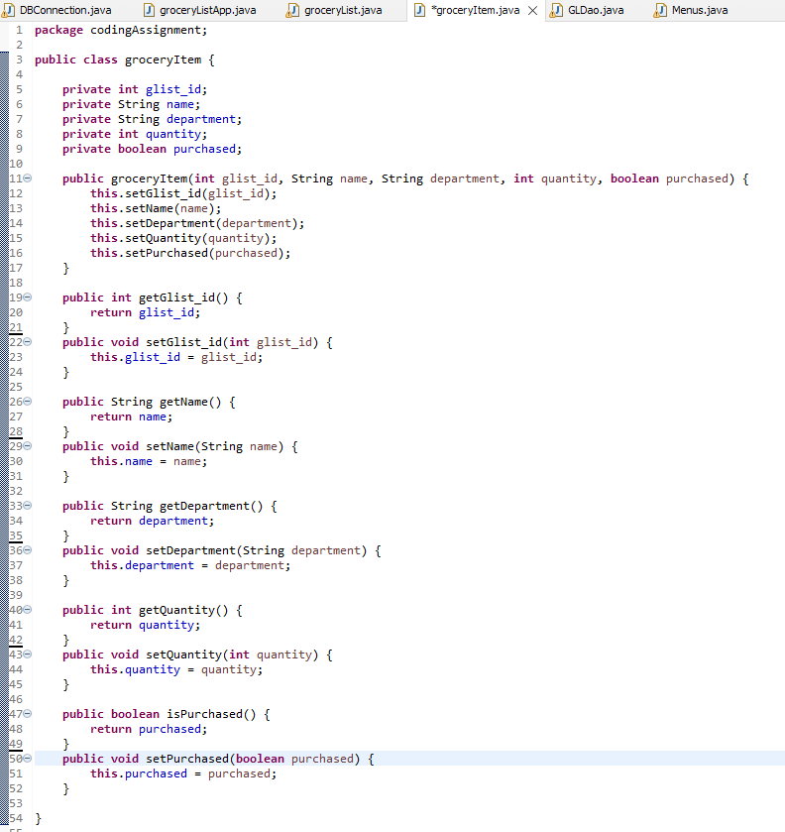

**Screenshots of Running Application:**

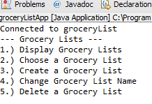

**Display**

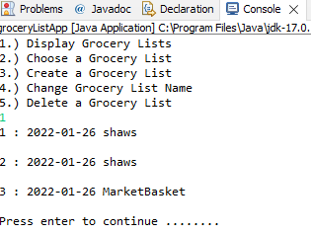

**Create**

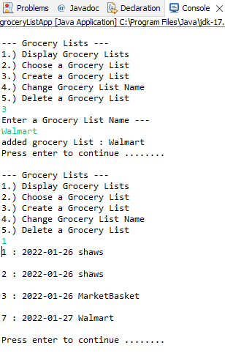

**Update a grocery list name**

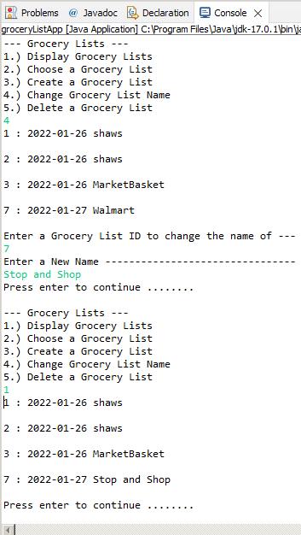

**Delete a Grocery List**

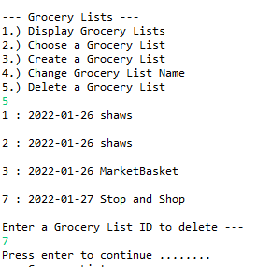

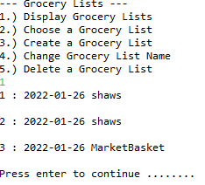

**URL to GitHub Repository:**

https://github.com/david2joh/sqlWeek4.git