# Relational Databases with MySQL Week 5 Coding Assignment

**Screenshots of Code:**

Part 1

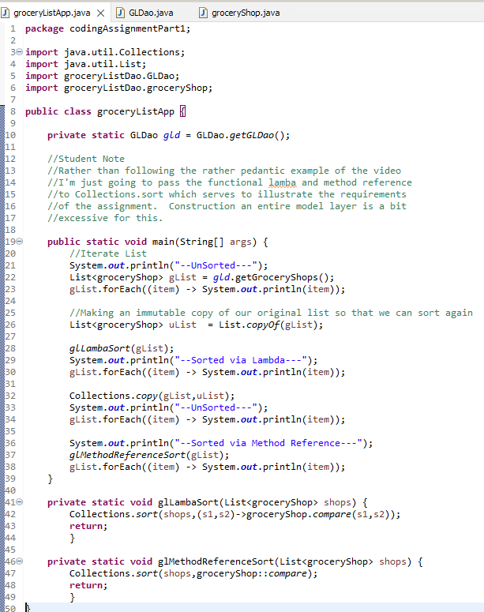

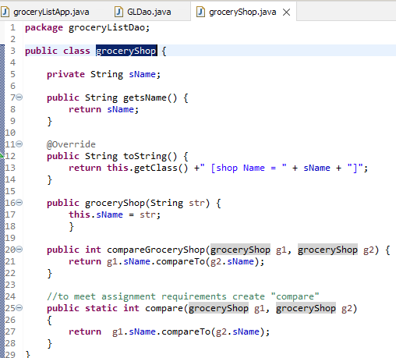

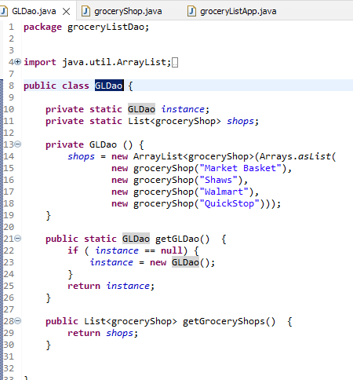

**Screenshots of Running Application Results:**

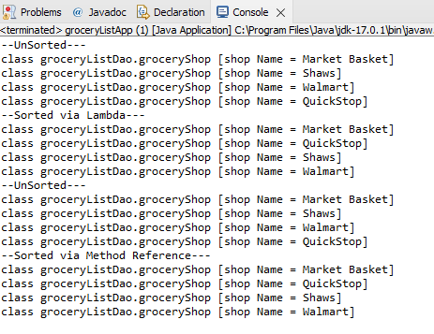

**Screenshots of Code:**

**Part Two**

**//Student Note : Resused the GLDao and groceryShop classes from Part 1**

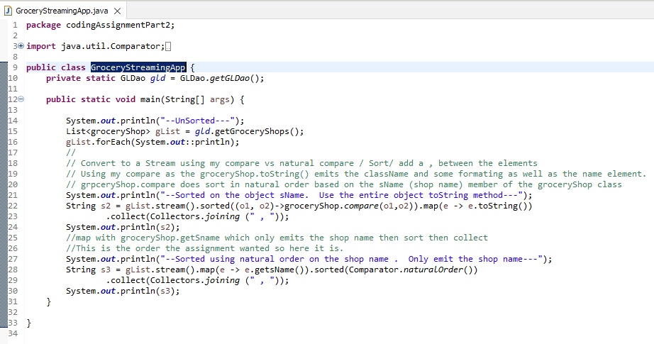

**Screenshots of Running Application Results:**

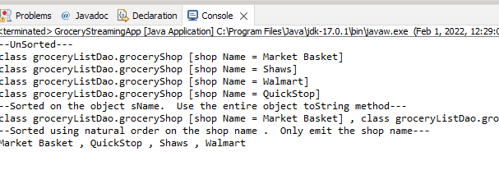

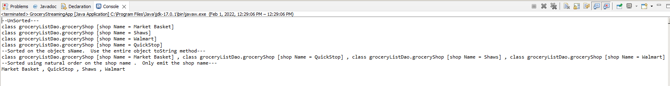

**Screenshots of Code:**

**Part Three**

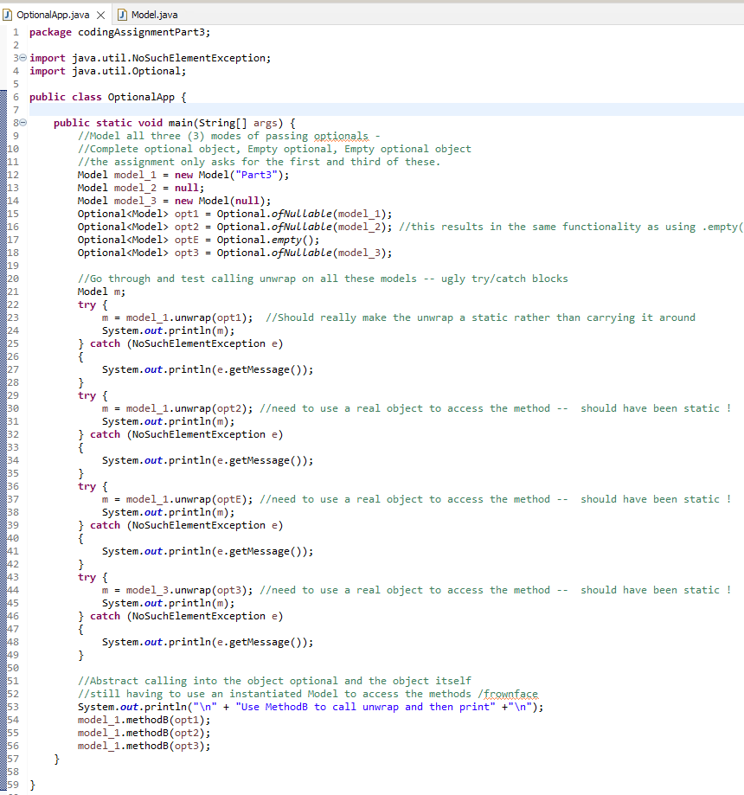

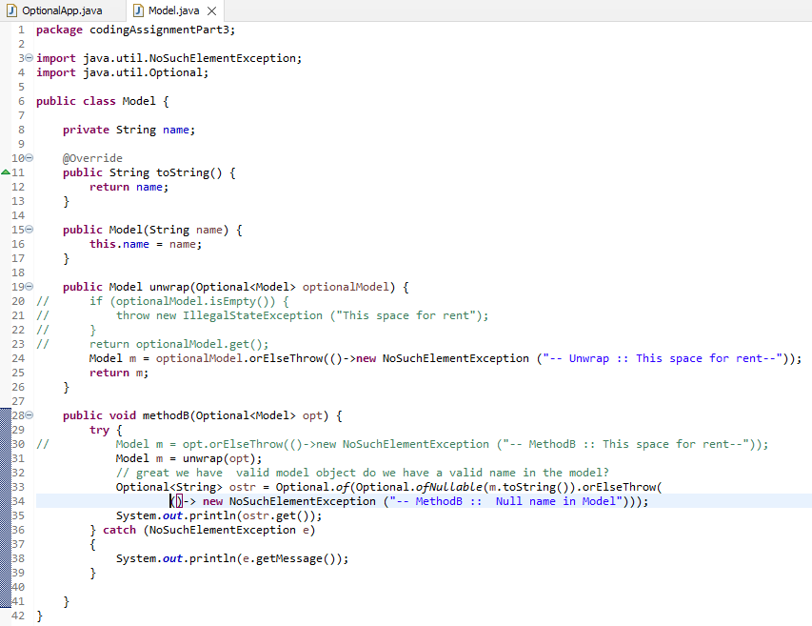**Screenshots of Running Application Results:**

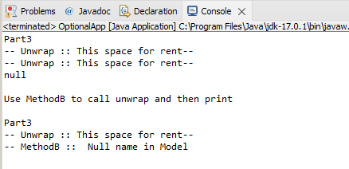

**URL to GitHub Repository:**

**https://github.com/david2joh/sqlWeek5.git**