# Relational Databases with MySQL Week 6 Coding Assignment

**Screenshots of Code**

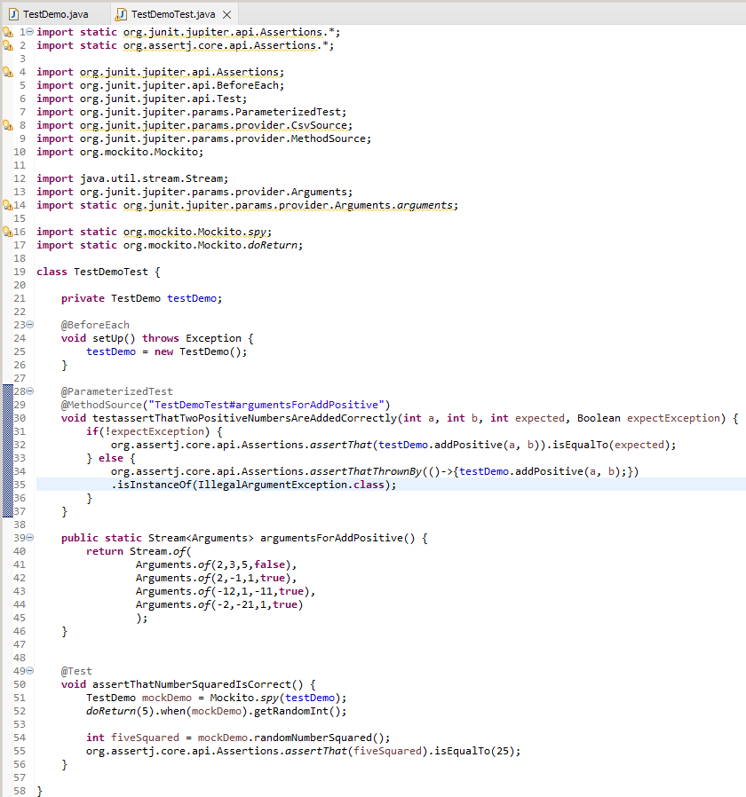

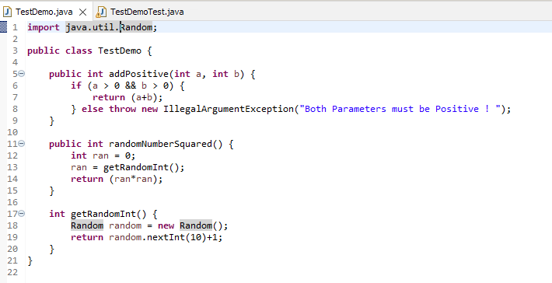

**Screenshots of Running Application:**

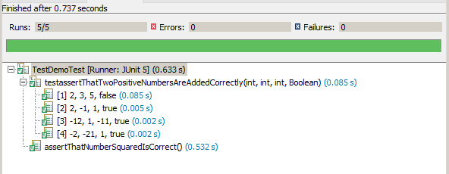

**URL to GitHub Repository:**

https://github.com/david2joh/sqlWeek6.git