# Relational Databases with MySQL Week 3 Coding Assignment

**Screenshots:**

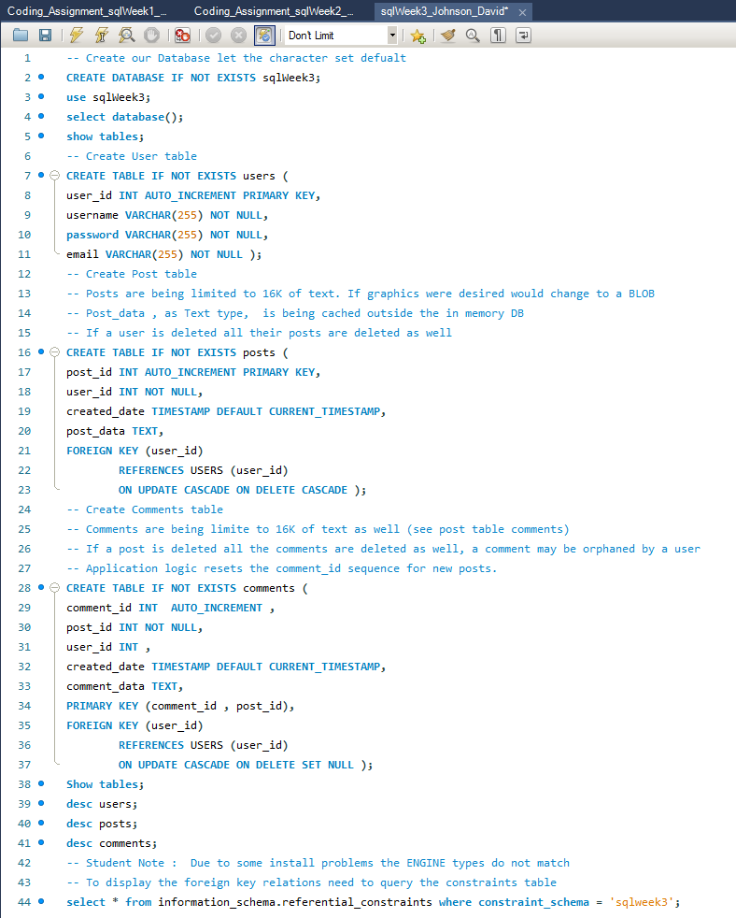

**Results of running main script :**

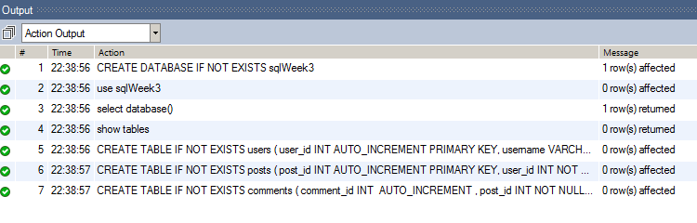

**show tables;**

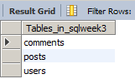

**desc users;**

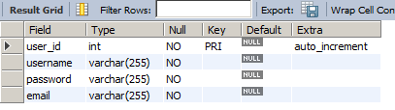

**desc posts;**

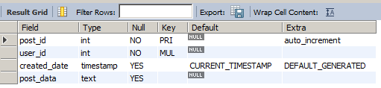

**desc comments;**

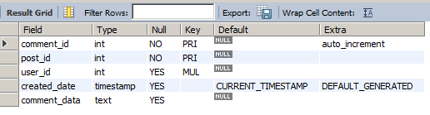

**Schema View of result of running main script.**

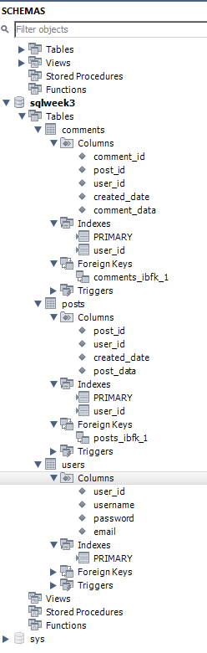

// Student note : due to an Engine mismatch verified foreign key from the schema

// constraints table

**select * from information_schema.referential_constraints where constraint_schema = 'sqlweek3';**



**URL to GitHub Repository:**

https://github.com/david2joh/sqlweek3.git