Module2 - R Markdown Document 1

D.PIERROT

17/06/2020

# This is a level 1 header

## R Markdown

### This is a level 3 header

This is an R Markdown document. Markdown is a simple formatting syntax for authoring HTML, PDF, and MS Word documents. For more details on using R Markdown see <http://rmarkdown.rstudio.com>.

Here is a link to [GOOGLE](http://google.com)

Here is a word in **bold** and another word in **bold**.

Here is a word in *italics* and another word in *italics*.

When we compile our document, we are using the rmarkdown package.

Here are some example of R commands :

2+2  
 mean(c(1,2,3?4))

Here is an exmpale of blockquote :

2+2  
mean(c(1,2,3,4))

Here is an exmpale of blockquote :

This is a block qoute. This paragraph has two lines

1. This is a list inside a block quote
2. second item

Here is an exmpale of nested blockquote :

This is a block qoute. This paragraph has two lines

This text is nested

Here is an example of a numbered list :

1. Breakfast
   1. food
      1. eggs
      2. toast
      3. bacon b drink
      4. apple juice
2. Lunch
   1. taco
3. Dinner
   1. baked chicken
   2. broccoli
   3. rice

Here is an example of a non-numbered list :

* Breakfast
  + food
    - eggs
    - toast
    - bacon
  + drink
    - apple juice
* Lunch
  + taco
* Dinner
  + baked chicken
  + broccoli
  + rice

When you click the **Knit** button a document will be generated that includes both content as well as the output of any embedded R code chunks within the document. You can embed an R code chunk like this:

summary(cars)

## speed dist   
## Min. : 4.0 Min. : 2.00   
## 1st Qu.:12.0 1st Qu.: 26.00   
## Median :15.0 Median : 36.00   
## Mean :15.4 Mean : 42.98   
## 3rd Qu.:19.0 3rd Qu.: 56.00   
## Max. :25.0 Max. :120.00

## Including Plots

You can also embed plots, for example:

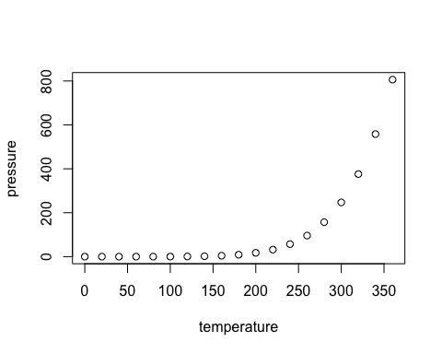

Note that the echo = FALSE parameter was added to the code chunk to prevent printing of the R code that generated the plot.