Blockchain Rental Property System

Contents
1. Project Scope
2. Requirements Analysis
2.1 Functional Requirements and Event Decomposition
2.2 Scenario Modeling
2.3 Data Dictionary, Entities and CRUD
2.4 Activity and State Diagrams
2.5 Requirement Evaluation and Alternatives
3. Design
3.1 Process Design, Sequence Diagrams and CRC Cards
3.2 Class Structure, Database and Interfaces
4. Conclusion

1. Project Scope
Renting a flat still runs on paper contracts, manual bank transfers and a lot of trust between people who often do not know each other. Deposits go missing, rent is paid late, and neither side has a record they can rely on. The Blockchain Rental Property System (BRPS) puts the whole rental process online and keeps a tamper-proof history of every agreement and payment.
The word “blockchain” here means a permissioned ledger built inside SQL Server: an append-only table where each row stores the hash of the row before it. This gives us the immutability of a blockchain without the cost of a public network, and it fits naturally into a normal ASP.NET Core + MSSQL application.

1.1 Objectives
- Let landlords list properties and tenants search and rent them online.
- Turn an agreed lease into a stored agreement with fixed, enforceable rules.
- Collect rent automatically each month and flag late payments.
- Hold the deposit in a controlled escrow record and release it by the agreed rules.
- Keep a verifiable, append-only history of agreements and payments.

1.2 Scope
In scope:
- Registration, login and KYC status for tenants and landlords.
- Property listing, review and search.
- Agreement creation, e-signing and activation.
- Rent collection, deposit escrow and the hash-linked ledger.
- Basic dispute handling reviewed by an administrator.
Out of scope:
- Repairs and physical property management.
- Mortgage lending and credit scoring.
- Integration with a public blockchain such as Ethereum.

1.3 Stakeholders and Deliverables
Stakeholder | Interest
Tenant | Rents a property, pays rent and deposit, can raise a dispute.
Landlord | Lists properties, approves tenants, receives rent and settles deposits.
Administrator | Confirms identities, sets fees and settles disputes.

Main deliverables are the requirements and analysis models in this document, the database design, and the ASP.NET Core application that implements them.

1.4 Assumptions and Success Criteria
We assume users have verified email and pass a basic KYC check, and that payments go through an external payment gateway. The project is successful if an agreement can be created in a few minutes, rent is collected without manual work, and the ledger can be re-checked at any time to prove no record was altered.

2. Requirements Analysis

2.1 Functional Requirements and Event Decomposition
Starting from what each user actually wants to get done, the main goals are:
Actor | Goal
Tenant | Find a property, rent it, pay rent and deposit.
Landlord | List a property, approve a tenant, get paid, settle the deposit.
Administrator | Verify users and resolve disputes.

Event decomposition lists the events the system reacts to and the response to each one. This later becomes the use-case list.
Event | Type | Response
Landlord adds a property | External | Create and review the listing
Tenant asks to rent | External | Create a draft agreement
Both parties sign | External | Activate the agreement and escrow the deposit
Rent due date arrives | Temporal | Charge rent and update the ledger
Payment fails | State | Flag the payment as late and start a grace period
Lease ends | Temporal | Close the agreement and release the deposit
A party raises a dispute | External | Open a case for the administrator

The resulting functional requirements:
ID | Requirement | Priority
FR-1 | Users can register, log in and link a verified identity. | Must
FR-2 | Landlords can create and submit property listings for review. | Must
FR-3 | Tenants can search and filter approved properties. | Must
FR-4 | The system creates a rental agreement and records both signatures. | Must
FR-5 | The system reserves the deposit in an escrow record. | Must
FR-6 | The system charges rent on each due date and records the result. | Must
FR-7 | Late payments trigger a grace period and a penalty. | Should
FR-8 | The deposit is released or split at the end of the lease. | Must
FR-9 | Every payment and agreement change is written to the hash-linked ledger. | Must
FR-10 | Users can raise disputes that an administrator resolves. | Should

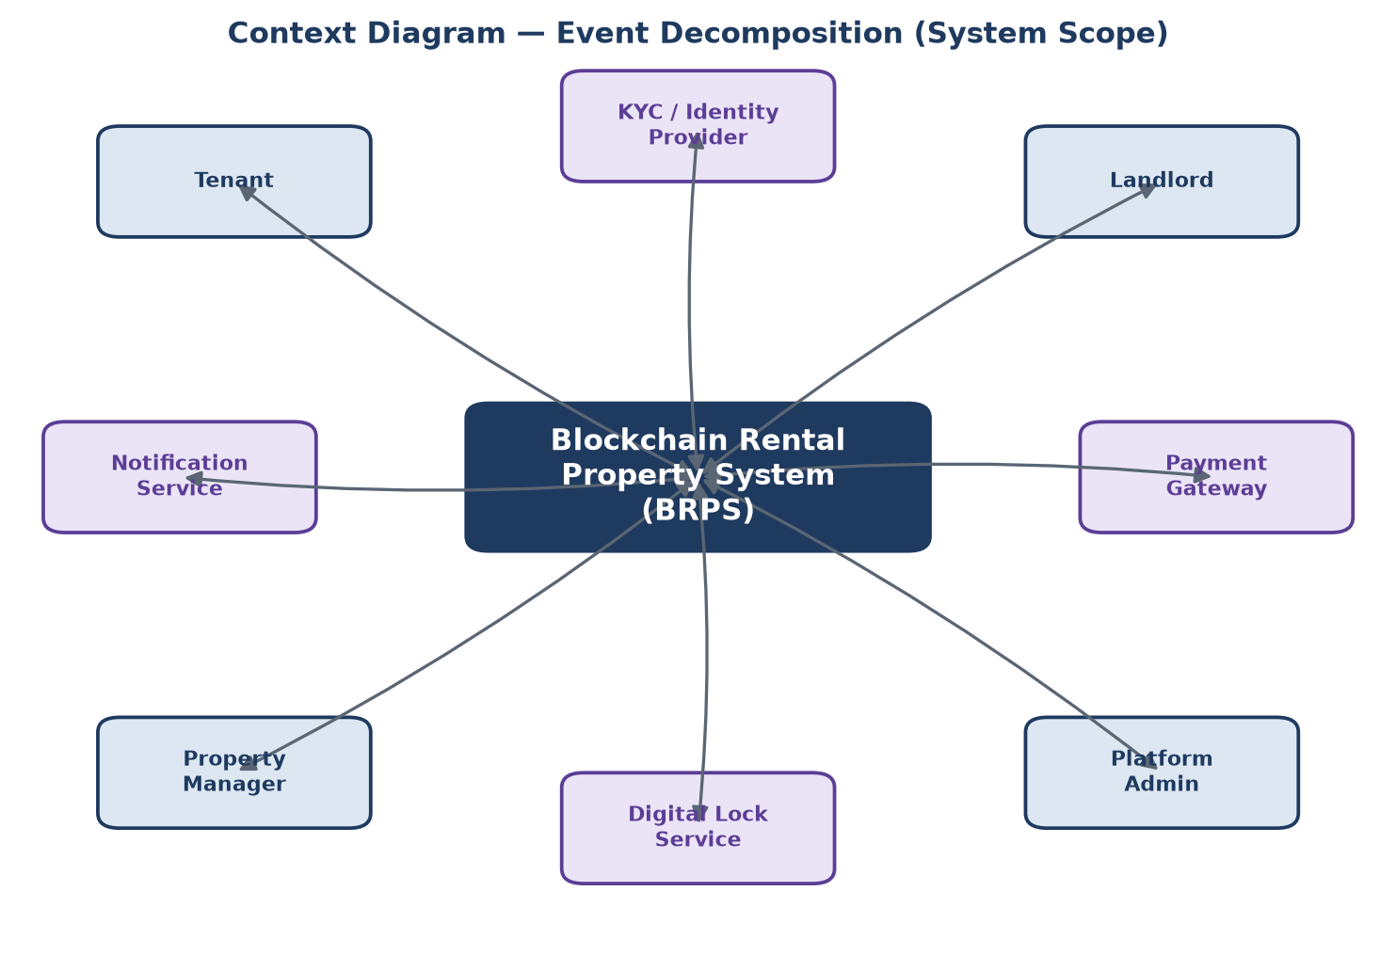
Figure 1. Context diagram showing the system boundary and the outside parties it talks to.
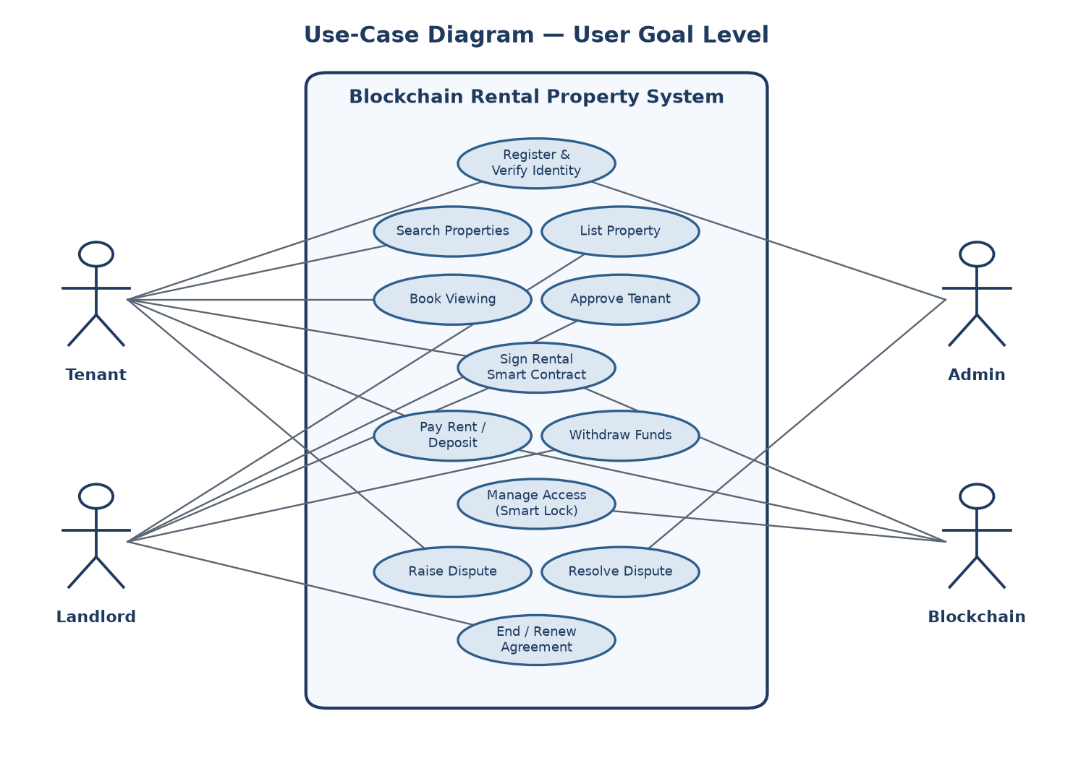
Figure 2. Use-case diagram at the user-goal level.

2.2 Scenario Modeling
The most important use case is signing and funding an agreement. It is described here at three levels of detail.

Brief
A verified tenant checks the lease terms and signs. The system checks KYC and funds, creates the agreement, reserves the deposit, and once the landlord signs too, activates the lease and grants access.

Intermediate
- Tenant opens the draft agreement and reviews rent, deposit and dates.
- Tenant signs and submits.
- System checks KYC status and available funds.
- System creates the RentalAgreement record and reserves the deposit in escrow.
- Landlord is notified and countersigns.
- System activates the agreement, grants access and writes an entry to the ledger.

Fully developed
Field | Detail
Use case | Sign and fund rental agreement (UC-04)
Primary actor | Tenant
Preconditions | Tenant and landlord are registered and KYC-verified; the property is listed; a draft agreement exists.
Main flow | 1. Tenant reviews terms. 2. Tenant signs. 3. System checks KYC and funds. 4. System creates the agreement and reserves the deposit. 5. Landlord signs. 6. System activates the lease, grants access and writes a ledger row.
Alternative | A property manager may sign in place of the landlord.
Exception 1 | If KYC or funds fail, the request is rejected and the tenant is told why.
Exception 2 | If the landlord does not sign in time, the deposit is refunded and the draft is cancelled.
Postcondition | Agreement is Active, deposit is escrowed, and a ledger entry exists.

2.3 Data Dictionary, Entities and CRUD
The data dictionary defines the main stored fields. Only the core entities are shown in full; the rest follow the same pattern.
User
Field | Type | Notes
user_id | INT IDENTITY | Primary key
full_name | NVARCHAR(120) | Display name
email | NVARCHAR(120) | Unique
role | TINYINT | Tenant, Landlord or Admin
kyc_status | TINYINT | Unverified / Pending / Verified

Property
Field | Type | Notes
property_id | INT IDENTITY | Primary key
owner_id | INT | FK to User
address | NVARCHAR(255) | Location
rent_amount | DECIMAL(18,2) | Monthly rent
status | TINYINT | Draft / Listed / Rented / Delisted

RentalAgreement
Field | Type | Notes
agreement_id | INT IDENTITY | Primary key
property_id | INT | FK to Property
tenant_id | INT | FK to User
rent_amount | DECIMAL(18,2) | Agreed rent
state | TINYINT | Draft / Pending / Active / InArrears / Closed

Relationships: a landlord owns many properties; a property has many agreements over time; an agreement has one escrow record and many payments; an agreement may have several disputes.
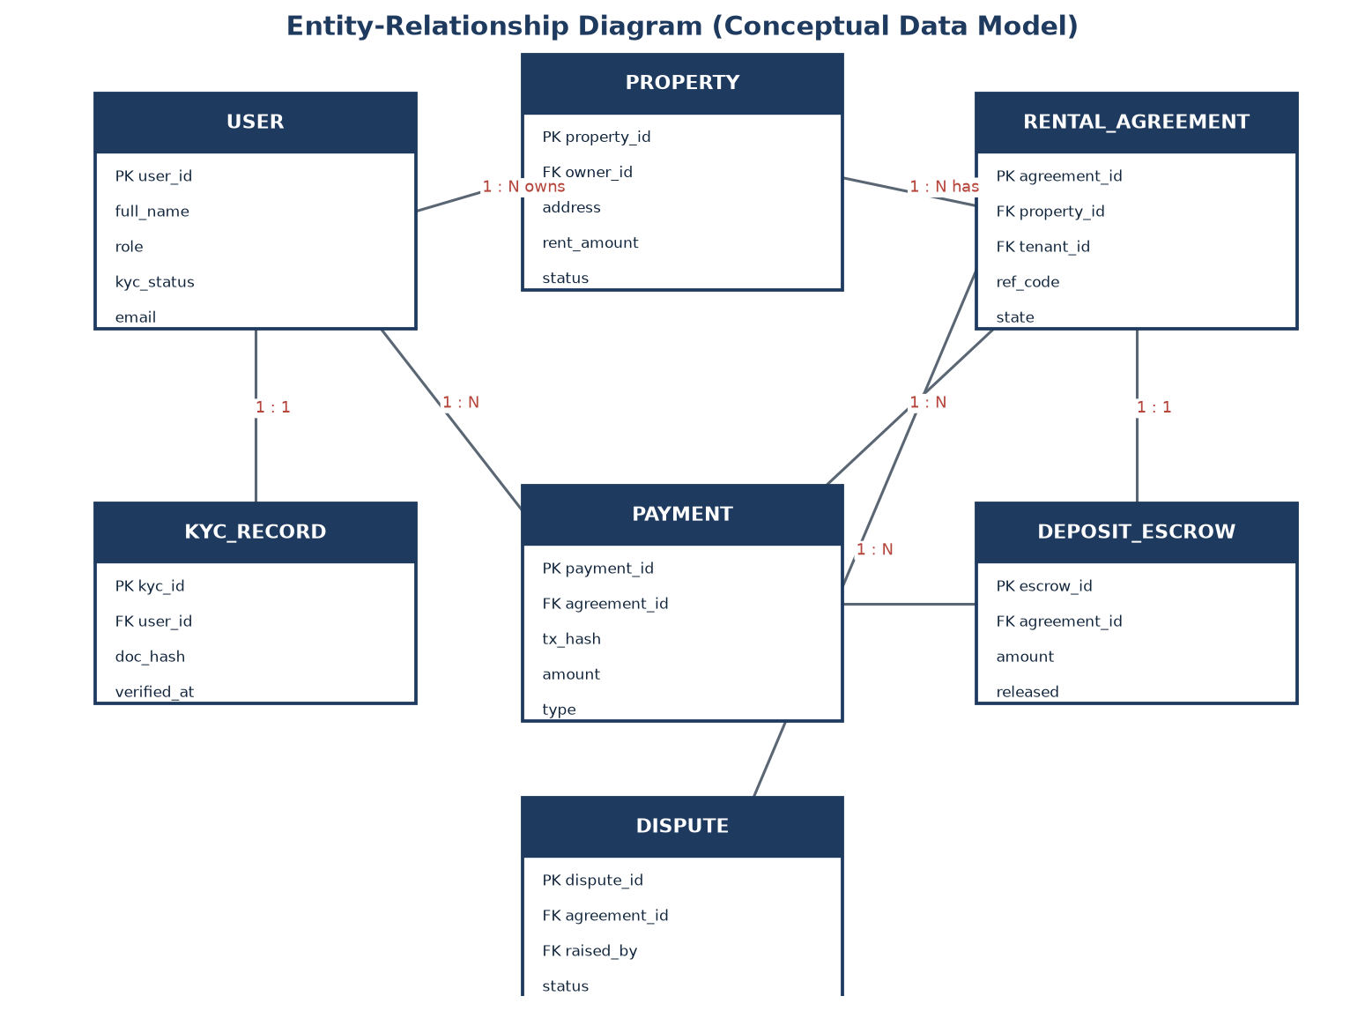
Figure 3. Entity-relationship diagram of the SQL Server schema.

CRUD analysis
The CRUD matrix checks that every entity is created, read, updated and deleted somewhere, and that no use case touches data it should not.
Use case \ Entity | User | Property | Agreement | Payment | Escrow
Register / verify | C U | - | - | - | -
List property | R | C U | - | - | -
Sign and fund | R | R U | C U | - | C
Collect rent | R | R | R U | C | R
Release deposit | R | R | U | C | R U D
Handle dispute | R | R | R U | R | R U

C = create, R = read, U = update, D = delete.

2.4 Activity and State Diagrams
The two activity diagrams below cover signing an agreement and the monthly rent run. Each decision point acts as a guard: a failed check ends the flow safely instead of leaving the data half-updated.
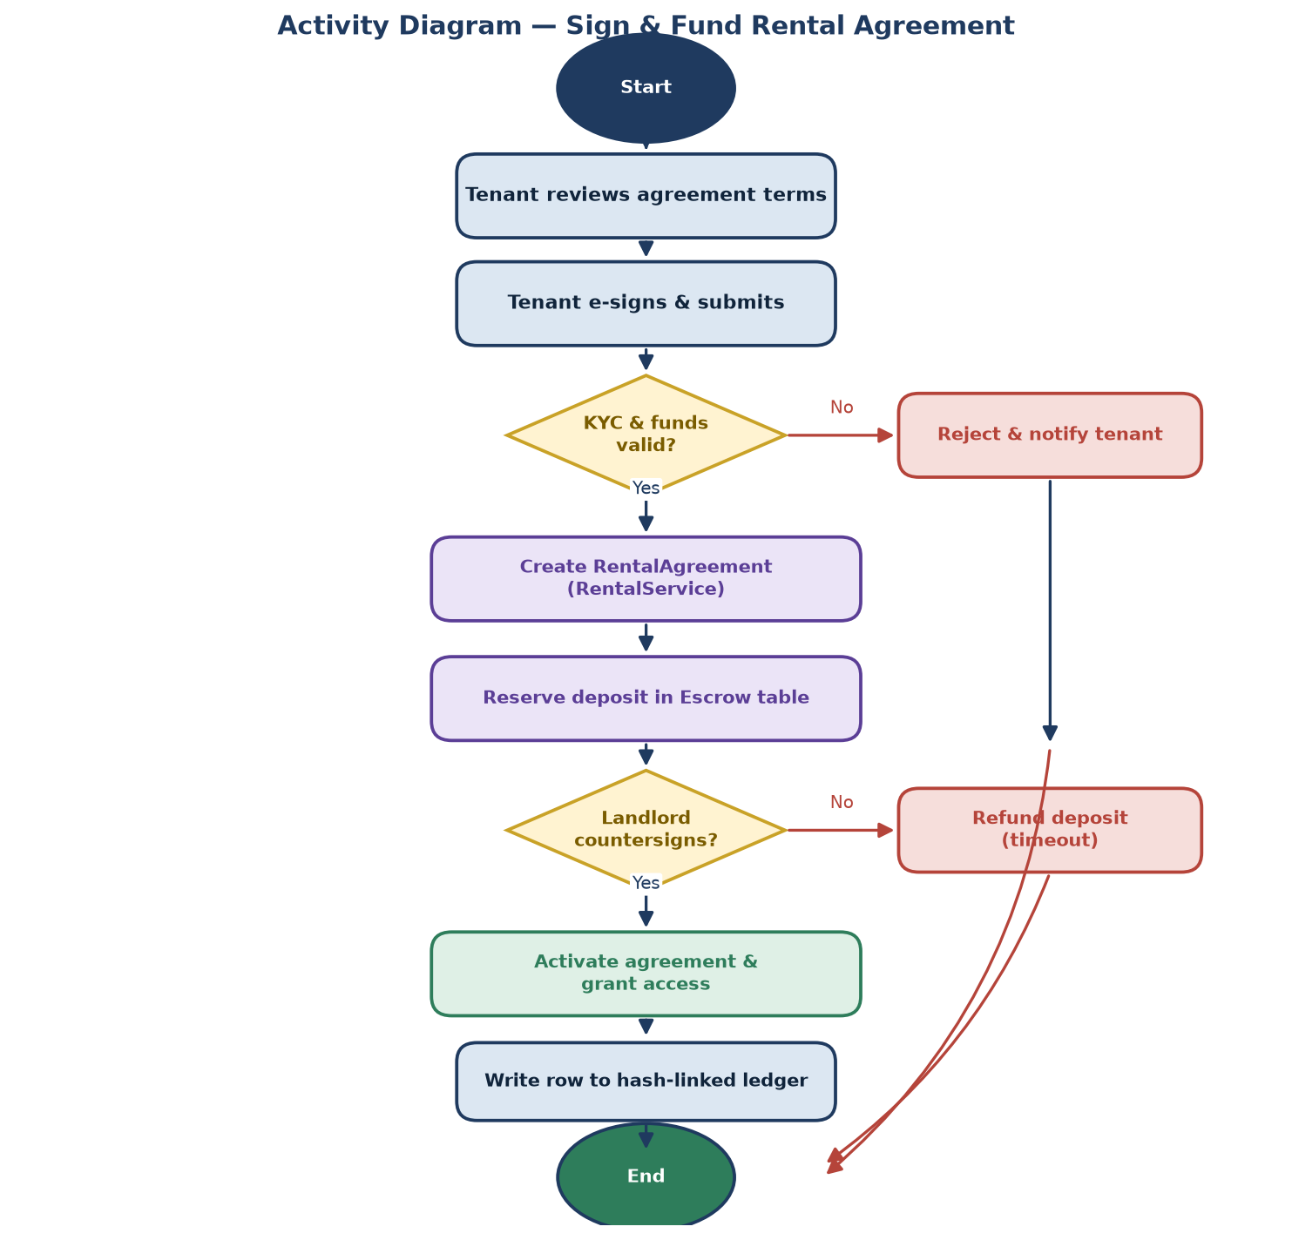
Figure 4. Signing and funding a rental agreement.
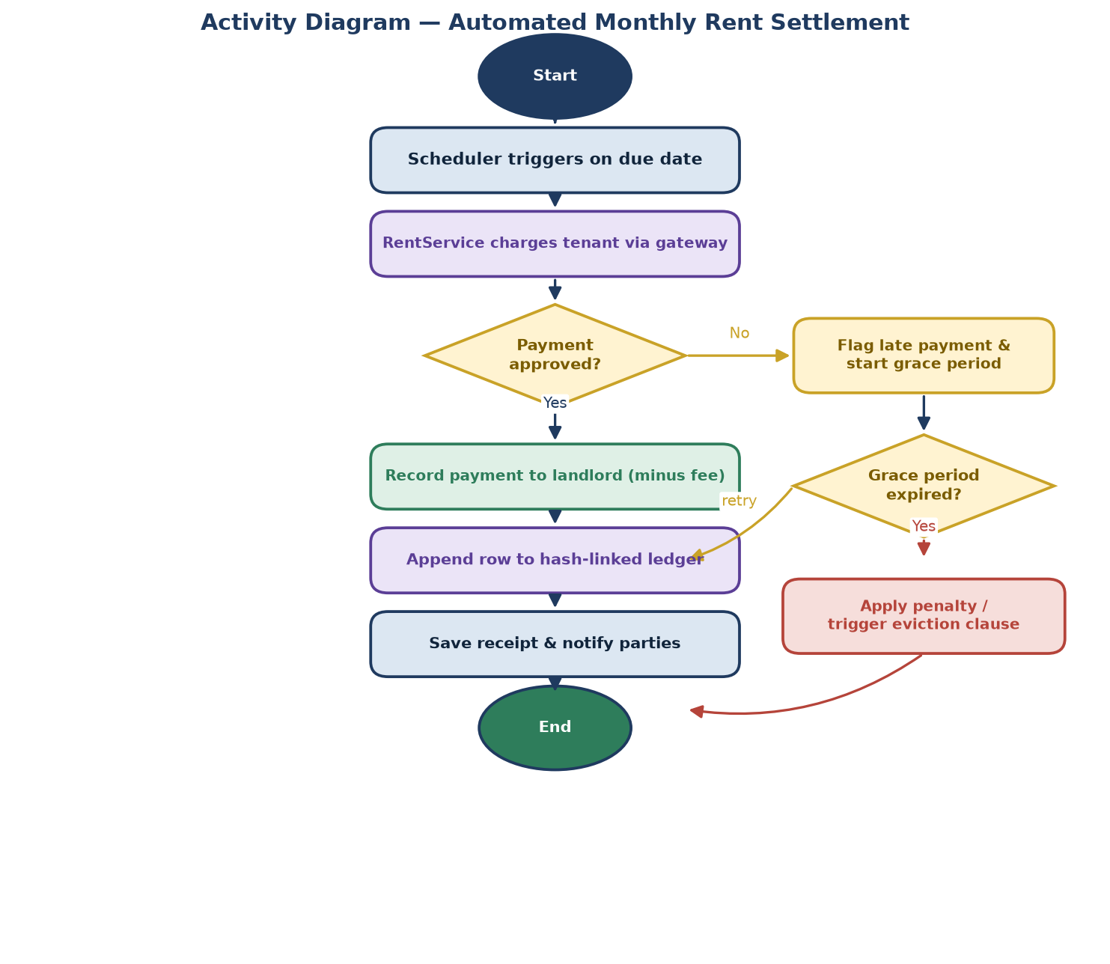
Figure 5. Automated monthly rent collection.
State diagrams show the life of the two objects that change state the most.
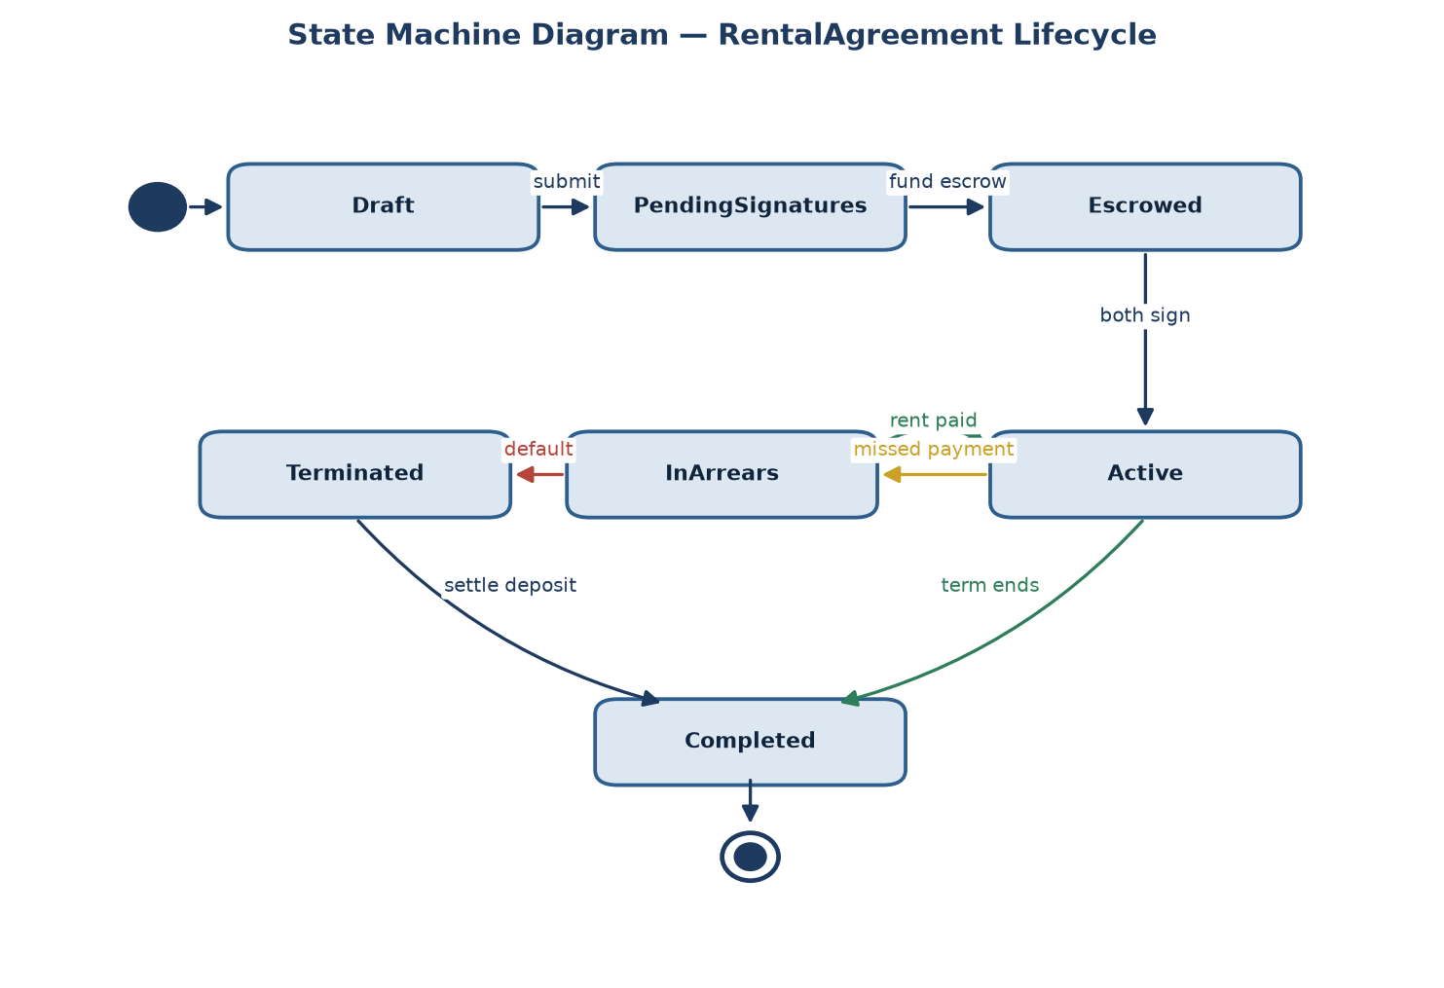
Figure 6. RentalAgreement states.
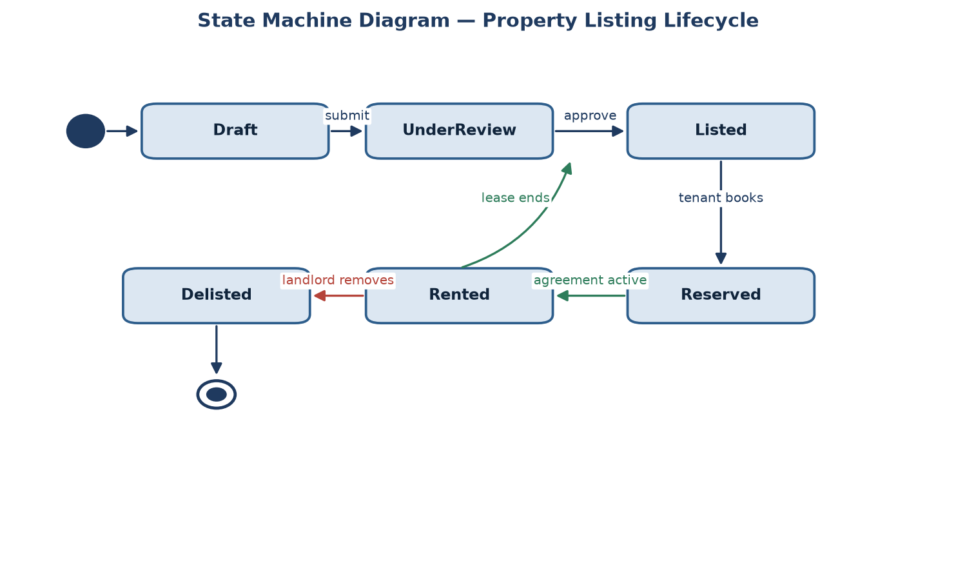
Figure 7. Property listing states.

2.5 Requirement Evaluation and Alternatives
Besides the functional requirements, a few non-functional ones shaped the design:
Area | Requirement
Security | Payments go through the gateway; passwords hashed; roles enforced.
Integrity | The ledger is append-only and each row is hash-linked to the last.
Performance | Normal pages respond within about two seconds.
Usability | A tenant can rent a property without any crypto knowledge.

The main design decision was how to get “blockchain-style” immutability. Three options were considered:
Option | Verdict
Public blockchain (Ethereum) | Strong immutability but high cost, slow, and hard for non-crypto users. Rejected.
Hash-linked ledger table in MSSQL | Immutability we can verify, cheap and simple to build on our stack. Chosen.
Plain audit log | Easy but a row can be edited without trace. Rejected.

For data access we chose Entity Framework Core over raw ADO.NET, because it keeps the code readable and still lets us drop to SQL for the ledger checks where we need it.
Priorities (MoSCoW): listing, agreements, escrow, rent collection and the ledger are must-haves; penalties and disputes are should-haves; smart-lock access is a nice extra.

3. Design

3.1 Process Design, Sequence Diagrams and CRC Cards
The application is built in the usual ASP.NET Core layers. Controllers handle web requests, service classes hold the business rules, and Entity Framework Core talks to SQL Server. All money-related actions go through the services so the rules live in one place.
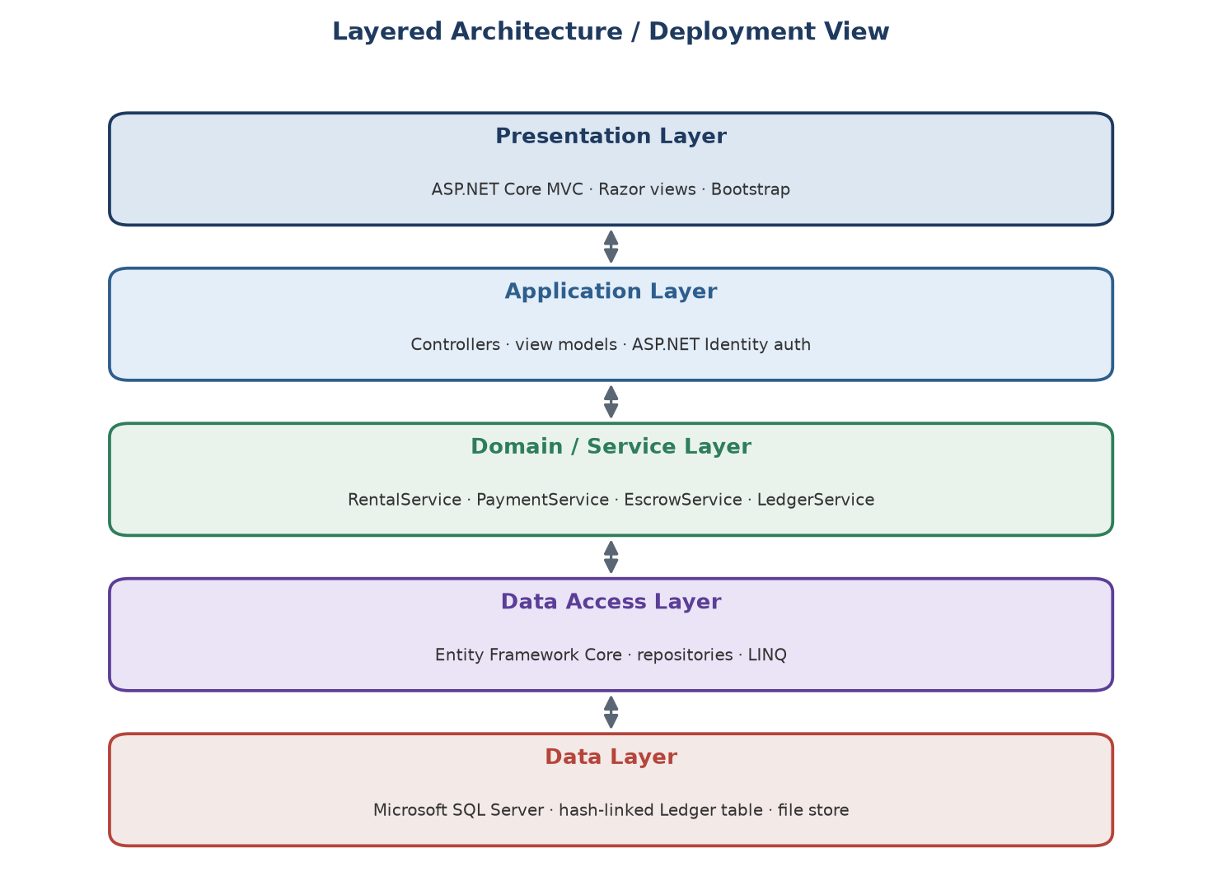
Figure 8. Layered architecture of the application.
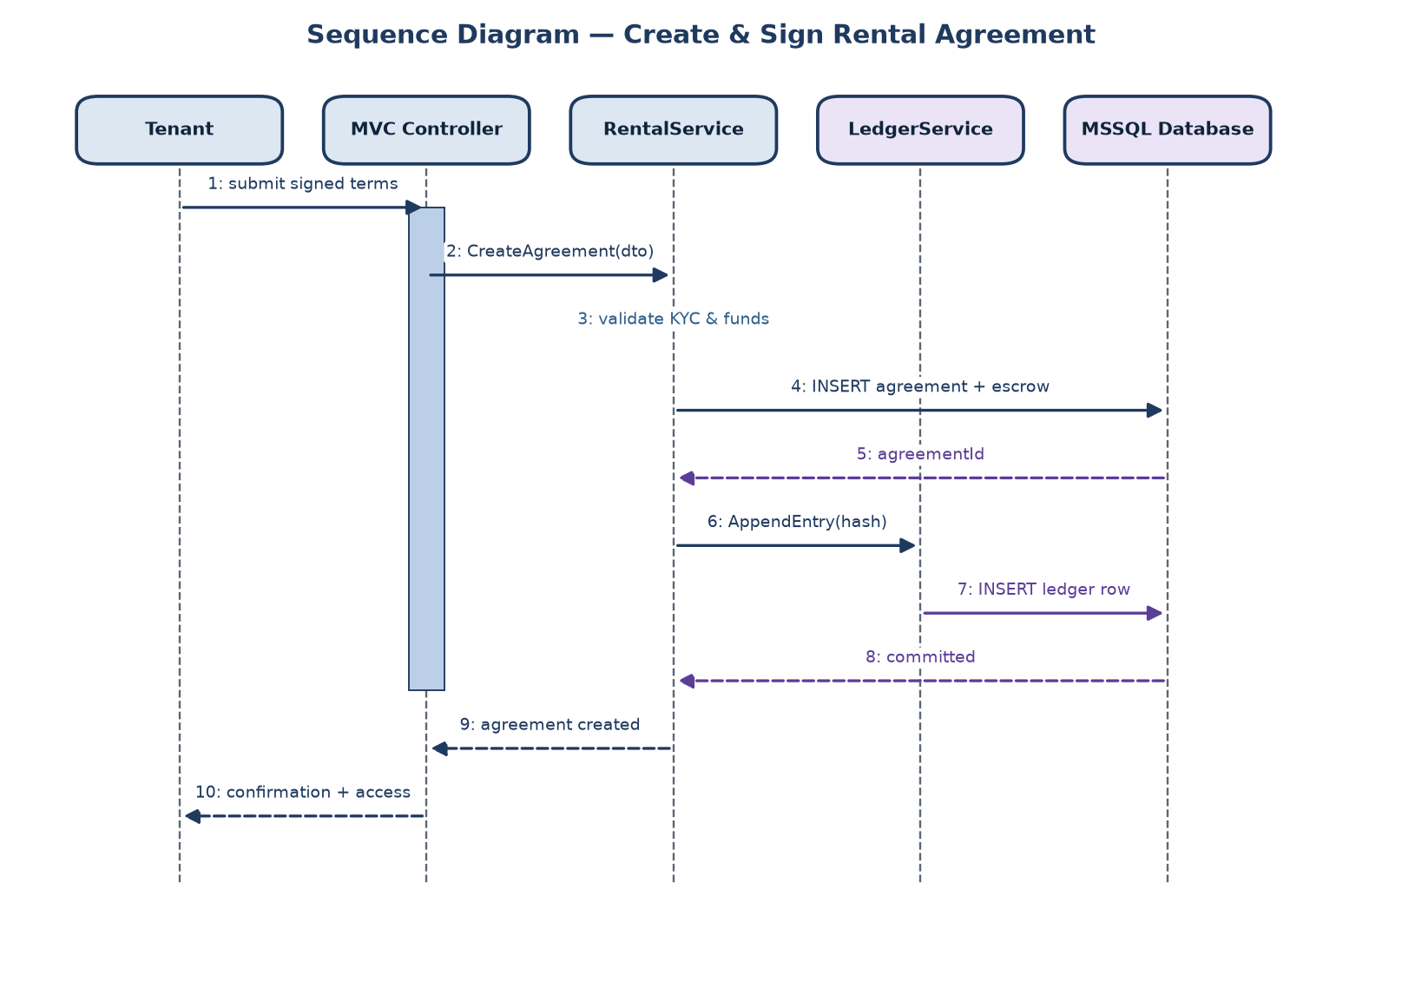
Figure 9. Creating and signing an agreement.
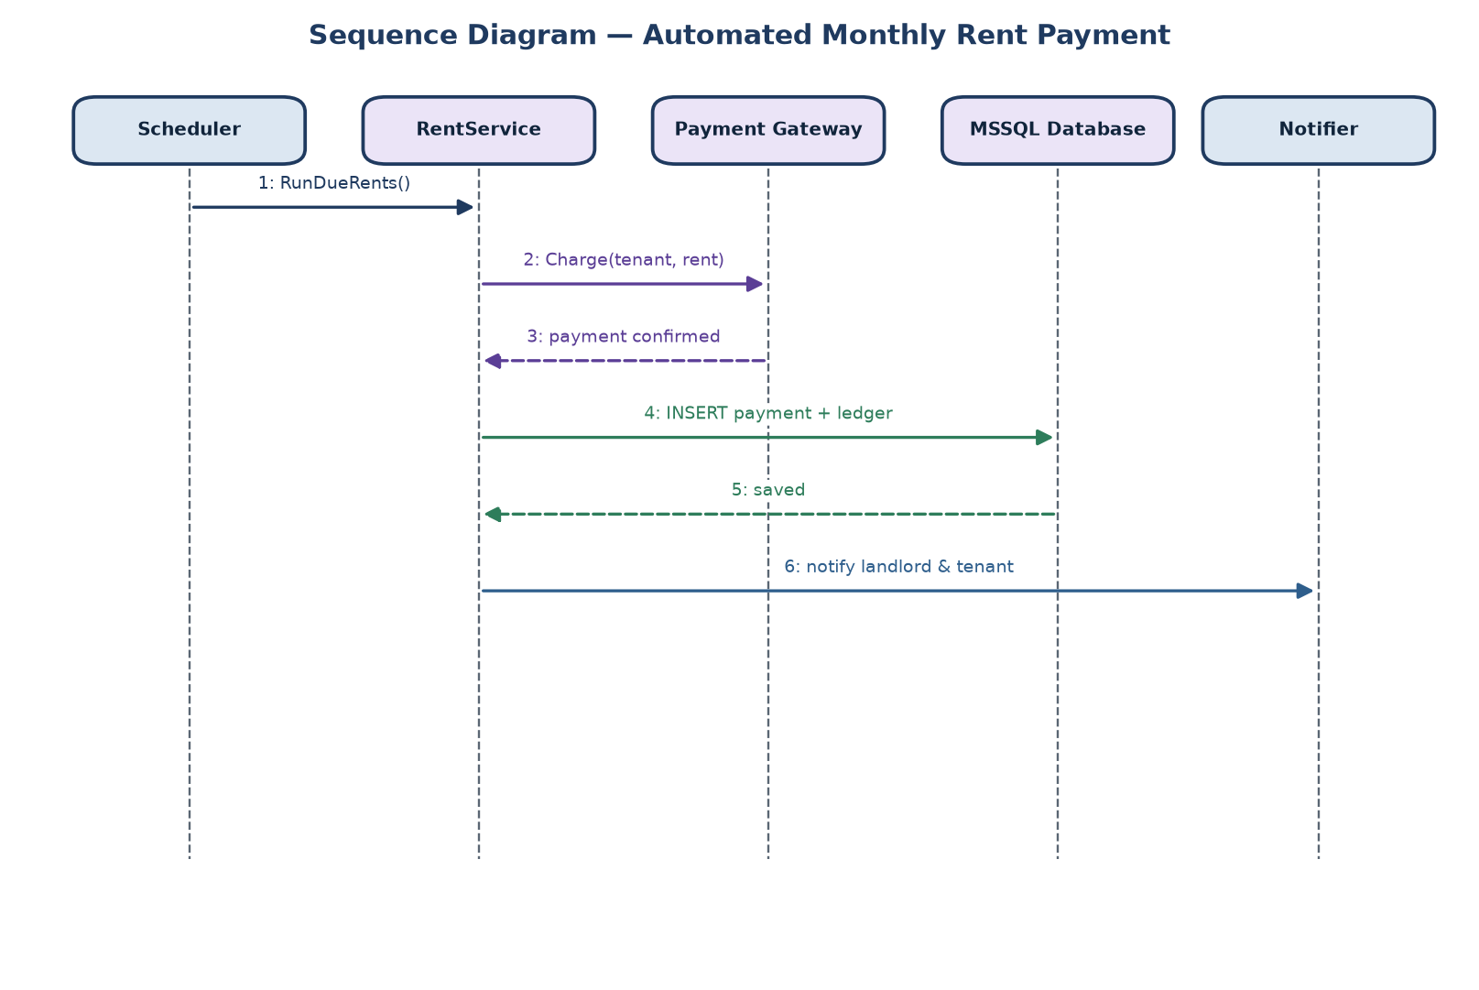
Figure 10. The monthly rent run.

CRC cards
CRC cards summarise what each key class does and who it works with.
Class: RentalService
Responsibilities | Collaborators
• Create and activate agreements  • Record signatures  • Run the monthly rent job | • Property  • RentalAgreement  • EscrowService  • LedgerService

Class: EscrowService
Responsibilities | Collaborators
• Reserve the deposit  • Release or split it at lease end | • RentalAgreement  • Payment

Class: LedgerService
Responsibilities | Collaborators
• Hash and append each record  • Verify the chain on request | • Payment  • RentalAgreement

3.2 Class Structure, Database and Interfaces
The domain classes and how they relate are shown below. RentalAgreement is the centre of the model; it owns an escrow record and a list of payments, and the LedgerService records everything that changes.
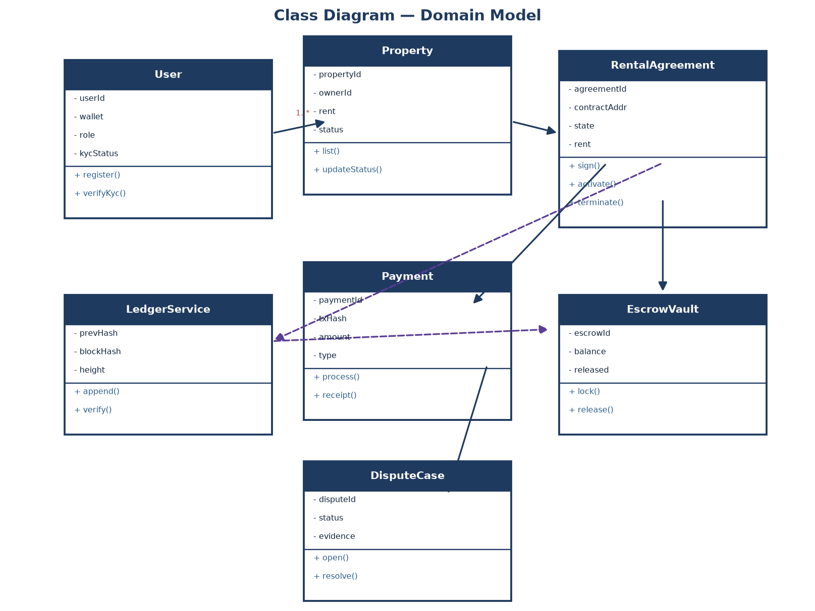
Figure 11. Class diagram of the domain model.

Database design
SQL Server holds the data in a normalised schema. The main tables and keys:
Table | Primary key | Foreign keys
Users | user_id | -
Properties | property_id | owner_id → Users
RentalAgreements | agreement_id | property_id, tenant_id
Payments | payment_id | agreement_id → RentalAgreements
Escrows | escrow_id | agreement_id → RentalAgreements
LedgerEntries | entry_id | agreement_id (nullable)

The LedgerEntries table is what makes the history tamper-evident:
CREATE TABLE LedgerEntries (
entry_id INT IDENTITY PRIMARY KEY,
agreement_id INT NULL REFERENCES RentalAgreements(agreement_id),
data NVARCHAR(400) NOT NULL,
prev_hash CHAR(64) NOT NULL,
entry_hash CHAR(64) NOT NULL, -- SHA256(prev_hash + data)
created_at DATETIME2 NOT NULL DEFAULT SYSUTCDATETIME()
);

Interfaces
The business logic sits behind small C# service interfaces, which keeps the controllers thin and makes the services easy to test.
public interface IRentalService
{
int CreateAgreement(AgreementDto dto);
void Sign(int agreementId, int userId);
void RunDueRents(DateTime asOf);
void ReleaseDeposit(int agreementId, decimal toTenant, decimal toLandlord);
}
The web interface follows normal MVC routes:
Method | Route | Purpose
GET | /properties | Browse and search listings
POST | /properties/create | Landlord adds a property
POST | /agreements/create | Start and sign an agreement
GET | /agreements/{id} | View an agreement and its payments
POST | /disputes/create | Raise a dispute

4. Conclusion
This document worked through the rental system from scope to design. The analysis covered the functional requirements, the main scenario, the data and its CRUD usage, and the activity and state behaviour. The design turned that into a layered ASP.NET Core application backed by SQL Server, with a hash-linked ledger giving the blockchain-style immutability the project is about. The result is a design that could be implemented directly on the .NET stack.

References
- Satzinger, Jackson and Burd – Systems Analysis and Design in a Changing World.
- Larman – Applying UML and Patterns.
- Microsoft Learn – ASP.NET Core and Entity Framework Core documentation.
- Microsoft Learn – SQL Server T-SQL reference.

