Software Engineering
(application of engineering practice to software development process )
Variety of Software Products
Real time: air traffic control, games, face detection
Embedded systems: digital camera, GPS, face detection
Data processing: telephone billing, pensions
Information systems:
Operation Activities Management Systems
Managerial Information System,
Decision Support Systems
System software: operating systems, compilers
Communications: routers, mobile telephones, automation
Offices: word processing, video conferences
Scientific: simulations, weather forecasting
Graphical: film making, design
etc., etc., etc., ....

Quality Characteristics of Software
- Functionality – to perform what a user really needs
- Reliability – to work without failure
- Usability – user friendliness
- Efficiency – not to be resource consuming
- Maintainability – to be easily adapted to different situation
- Portability – among different platforms

Software Systems Development Lifecycle
- Project planning
- Analysis of requirements
- Design
- Implementation
- Maintenance and Support

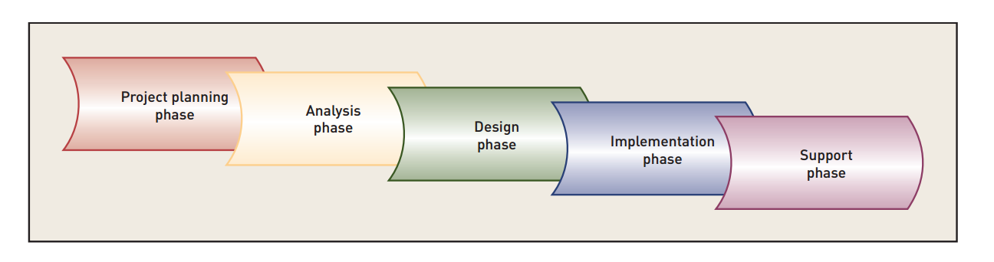
Information System Development Phases
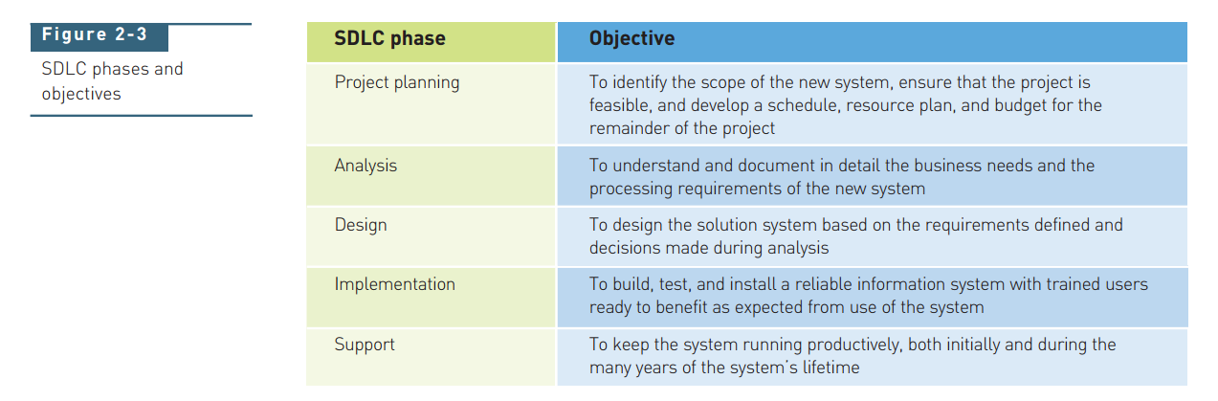
Project Planning Activities
- Define the problem
- Produce the project schedule
- Confirm project feasibility
- Staff the project
- Launch the project

Principles of Software Design
- Should not suffer form “tunnel vision”
- Should be traceable from analysis model
- Should not reinvent the wheel
- Should exhibit uniformity and integration
- Should be structured to accommodate change
- Design is not Coding, Coding is not Design
- Should be assessed for quality
- Should be reviewed to minimize conceptual errors
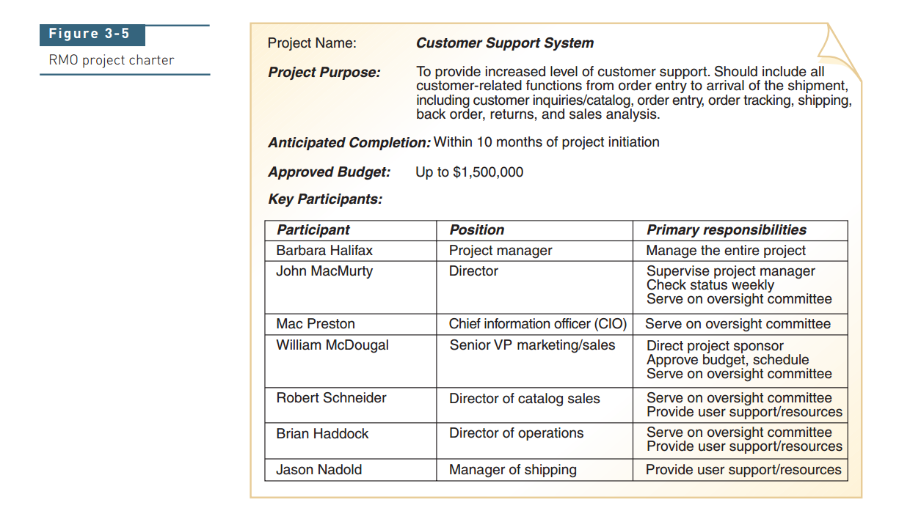

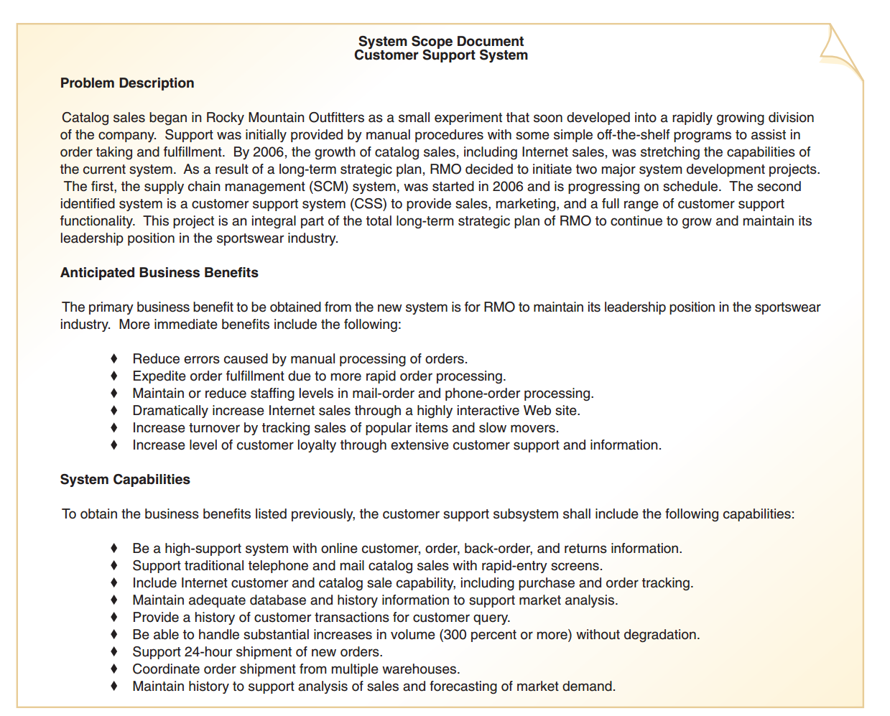

A Scoping Example
The conveyor line sorting system (CLSS) sorts boxes moving along a conveyor line. Each box is identified by a bar code that contains a part number and is sorted into one of six bins at the end of the line. The boxes pass by a sorting station that contains a bar code reader and a PC. The sorting station PC is connected to a shunting mechanism that sorts the boxes into the bins. Boxes pass in random order and evenly spaced, The line is moving at five feet per minute.
CLSS software receives input information from a bar code reader at time intervals that conform to the conveyor line speed. Bar code data will be decoded into box identification format. The software will do a look-up in a part number database containing a maximum of 1000 entries to determine a proper bin location for the box currently at the reader (sorting station). The proper bin location is passed to a sorting shunt that will position boxes in the appropriate bin. A record for the bin destination for each box will be maintained for later recovery and reporting. CLSS software will also receive input from a pulse tachometer that will be used to synchronize the control signal to the shunting mechanism. Based on the number of pulse generated between the sorting station and the shunt, the software will produce a control signal to the shut to properly position the box.
Contsraints
- Hardware constraints (the bar code reader, the shunt, the PC);
- Available memory;
- Overall conveyor line configuration (evenly spaced boxes).

A Scoping Example
Customer Support System
Problem Description
Catalog sales began as a small experiment that soon developed into a rapidly growing division of a Company. Support was initially provided by manual procedures with some off-the-shelf programs to assist in order taking and fulfillment. By 2006, the growth of catalog sales, including internet sales, was stretching the capabilities of the current system. The Company decided to initiate two major system development projects.
The first, the supply chain management (SCM) system, was started in 2006 and is progressing in schedule. The second identified system is a customer support system (CSS) to provide sales, marketing, and a full range of customer support functionality. This project is an integral part of the total long-term strategic plan of the Company to continue to grow and maintain its leadership position in the sportswear industry.
Anticipated Business Benefits
The primary business benefit to be obtained from the new system is for the Company to maintain its leadership position in the sportswear industry. More immediate benefits include the following:
- Reduce errors caused by manual processing of orders;
- Expedite order fulfillment due to more rapid order processing;
- Maintain or reduce staffing levels in mail-order or phone-order processing;
- Dramatically increase Internet sales through a highly interactive Web site;
- Increase turnover by tracking sales of popular items and slow movers;
- Increase level of customer loyalty through extensive customer support and information.
System Capabilities
To obtain business benefits listed previously, the customer support subsystem shall include the following capabilities:
- Be a high-support system with online customer, order, back-order, and returns in formation;
- Support traditional telephone and mail catalog sales with rapid-entry screens;
- Include Internet customer and catalog sale capability, including purchase and order tracking;
- Maintain adequate database and history information to support market analysis;
- Provide a history of customer transactions for customer query;
- Be able to handle substantial increases in volume (300 percent and more) without degradation;
- Support 24-hour shipment of new orders;
- Coordinate order shipment from multiple warehouses;
- Maintain history to support analysis of sales and forecasting of market demand.

