MSSE670 Code Execution Document
David Dietrich
Regis University

Author Note
Email: ddietrich@regis.edu
Cell: 769-972-0837
Hours: Mon-Fri: 8:00 AM – 7:00 PM CST / Sun: 10:00 AM – 3:00 PM CST

A screen shot of the compiled project is included below. It shows cleanly compiled code with no errors.
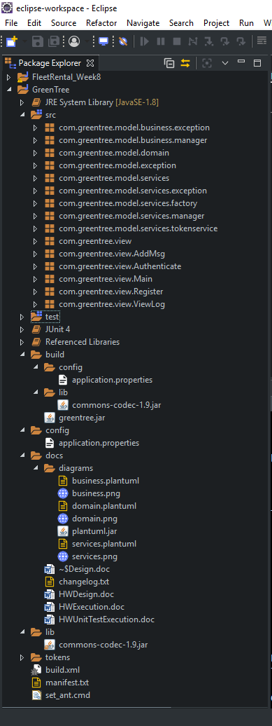
The application .class files were compiled using Apache Ant. Ant was downloaded from http://ant.apache.org/ and extracted to the local disk. A terminal was opened and used to execute “set_ant.cmd” from the root of the project dir. This configured the necessary environment variables for Ant to function.
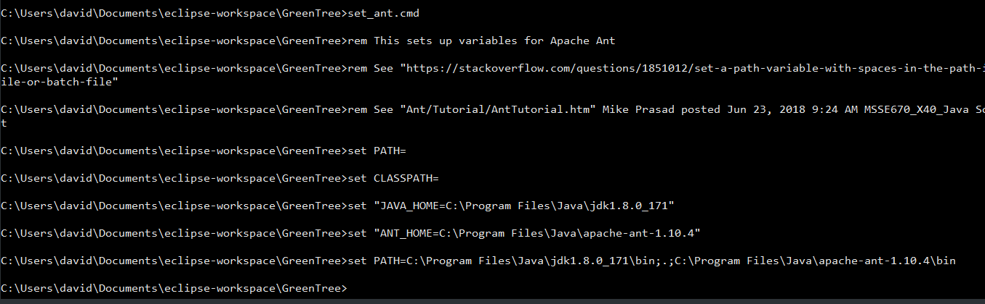
The Ant build file “build.xml” was written with targets defined to compile, build, and execute a “greentree.jar” file. The default target “compile” compiled .class files into the /bin directory using the /src directory.
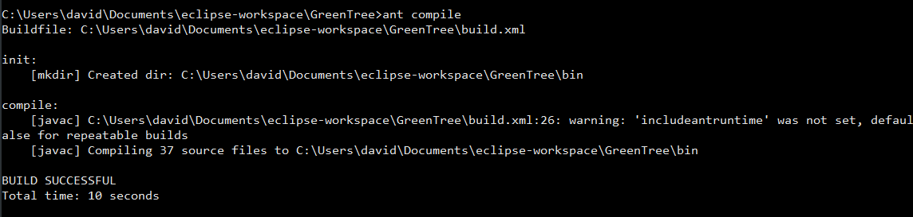
The “testjar” target was then used to build and execute “greentree.jar”.
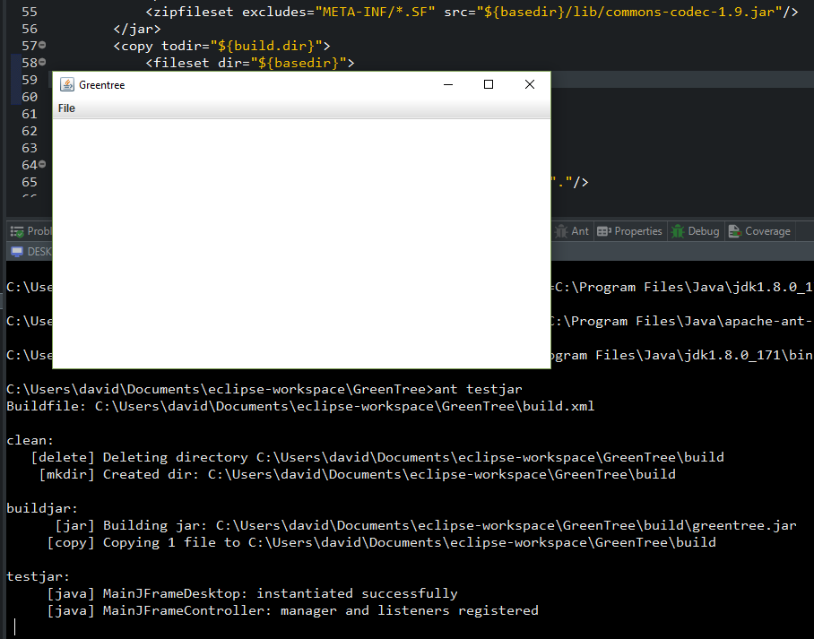
Each menu option in the resulting GUI opened a corresponding window with “close”, “minimize”, and “maximize” buttons. All the functions of each window worked as expected.
