MSSE672 Code Execution Document
David Dietrich
Regis University

Author Note
Email: ddietrich@regis.edu
Cell: 769-972-0837
Hours: Mon-Fri: 8:00 AM – 7:00 PM CST / Sun: 10:00 AM – 3:00 PM CST

A screen shot of the compiled project is included below. It shows cleanly compiled code with no errors.
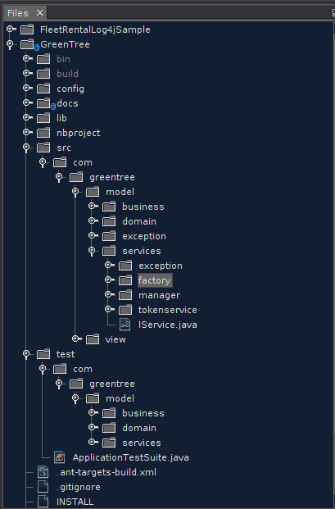

The screenshots below show the application UI.
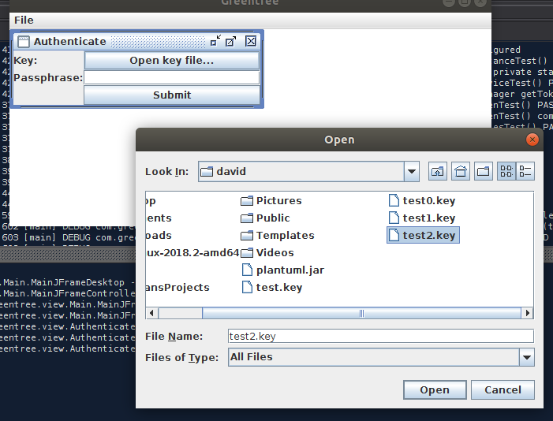
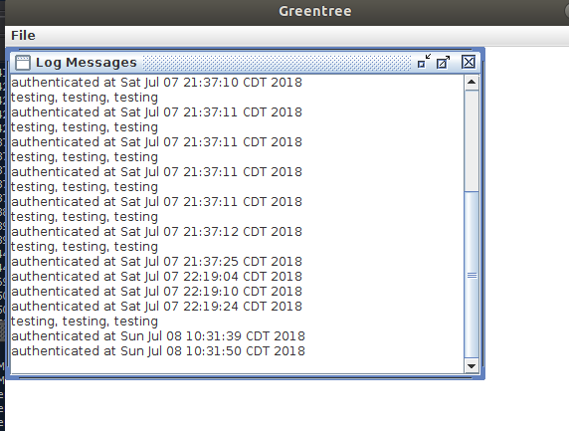

The screenshot below shows Log4j debug output from application execution.
