MSSE672 JUnit Test Document
David Dietrich
Regis University

Author Note
Email: ddietrich@regis.edu
Cell: 769-972-0837
Hours: Mon-Fri: 8:00 AM – 7:00 PM CST / Sun: 10:00 AM – 3:00 PM CST

The screen shot below shows successful JUnit test execution for the GreenTree project.
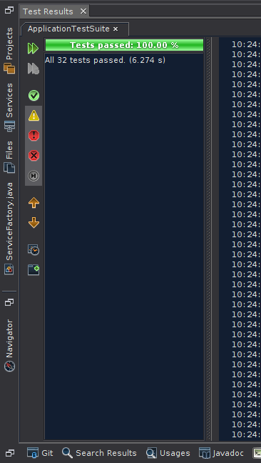
The screenshot below shows Log4j debug output from the above JUnit text execution.
