CPE301 – SPRING 2019

Design Assignment X

Student Name: David Pajar

Student #: 2000534865

Student Email: pajard1@unlv.nevada.edu

Primary Github address: <https://github.com/david702/CPE301>

Directory:

1. **COMPONENTS LIST AND CONNECTION BLOCK DIAGRAM w/ PINS**

Atmel Studio used to create assembly file.

1. **INITIAL/MODIFIED/DEVELOPED CODE OF TASK 1/A**

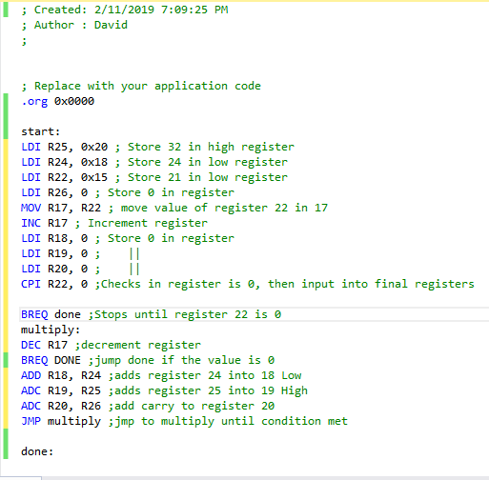

1. **SCREENSHOTS OF EACH TASK OUTPUT (ATMEL STUDIO OUTPUT)**

Before:

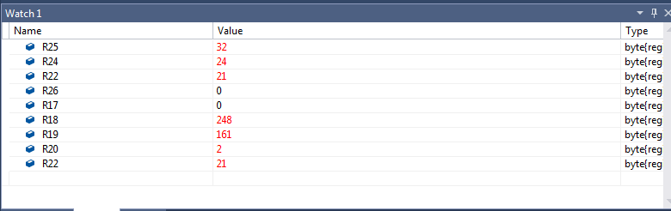

After:

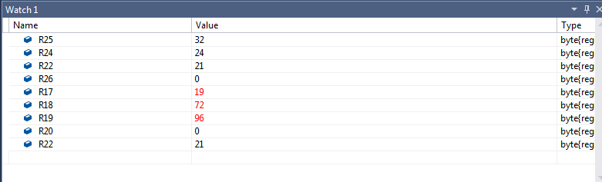

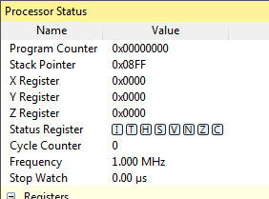

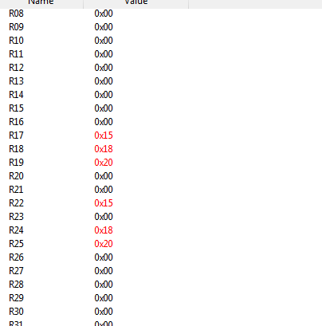

1. **GITHUB LINK OF THIS DA**

https://github.com/david702/CPE301

**Student Academic Misconduct Policy**

<http://studentconduct.unlv.edu/misconduct/policy.html>

“This assignment submission is my own, original work”.

David Pajar