David Pajar

CPE301 – SPRING 2019

Design Assignment 1B

Student Name: David Pajar

Student #: 2000534865

Student Email: pajard1@unlv.nevada.edu

Primary Github address: https://github.com/david702

Directory: CPE301

* **COMPONENTS LIST AND CONNECTION BLOCK DIAGRAM w/ PINS**

Components used atmel studio software and atmega328p

* **INITIAL/DEVELOPED CODE OF TASK 1/B**

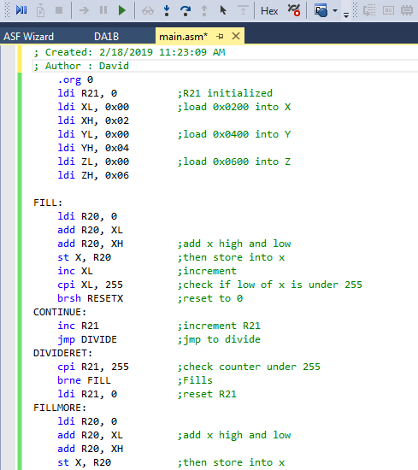

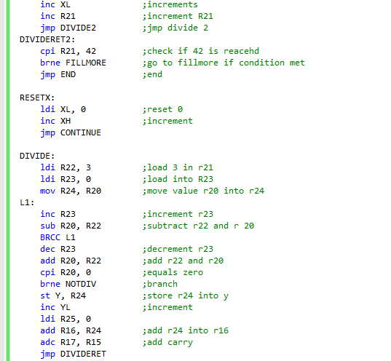

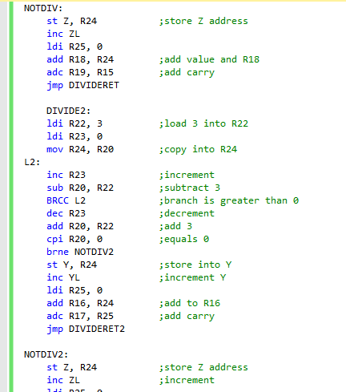

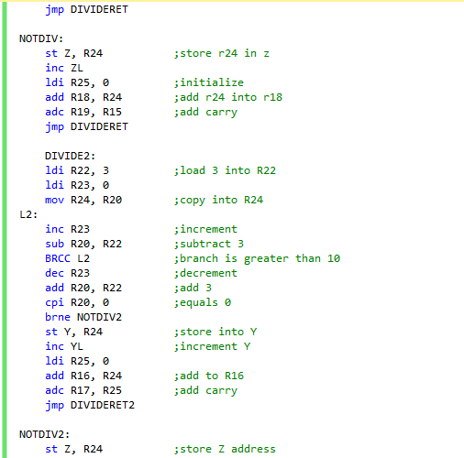

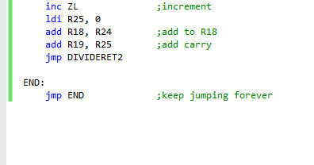

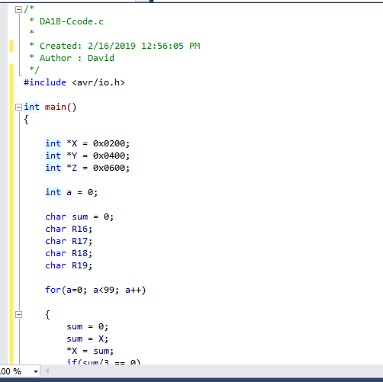

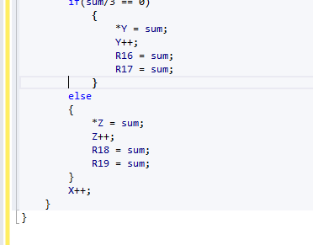

* **SCREENSHOTS OF EACH TASK OUTPUT (ATMEL STUDIO OUTPUT)**

register 0x0200 value:

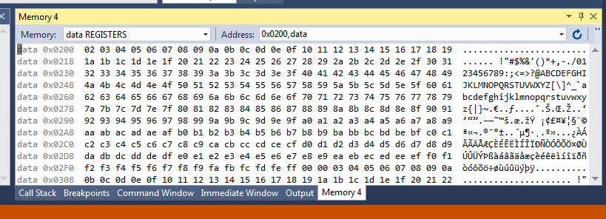

register 0x0400 value: 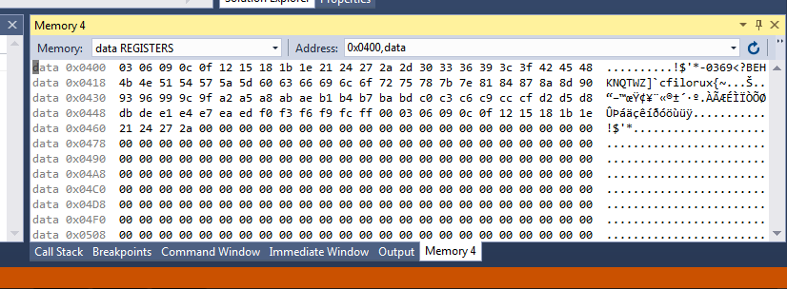

register 0x0600 value:

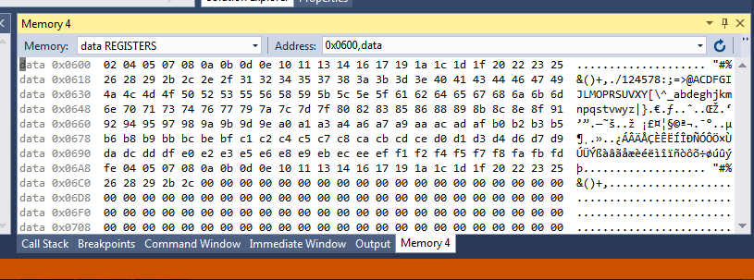

* **SCREENSHOT OF EACH DEMO (BOARD SETUP)**

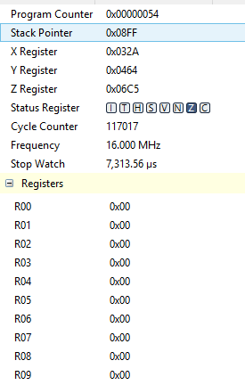

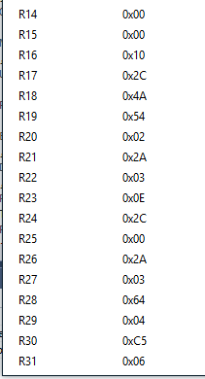

* **VIDEO LINKS OF EACH DEMO**
* **GITHUB LINK OF THIS DA**

[www.github.com/david702/CPE301](https://github.com/sawar1/UNLV301)

**Student Academic Misconduct Policy**

<http://studentconduct.unlv.edu/misconduct/policy.html>

“This assignment submission is my own, original work”.

David Pajar