CPE301 – SPRING 2019

Design Assignment 2A

Student Name: David Pajar

Student #: 2000534865

Student Email: pajard1@unlv.nevada.edu

Primary Github address: https://github.com/david702

Directory: CPE301

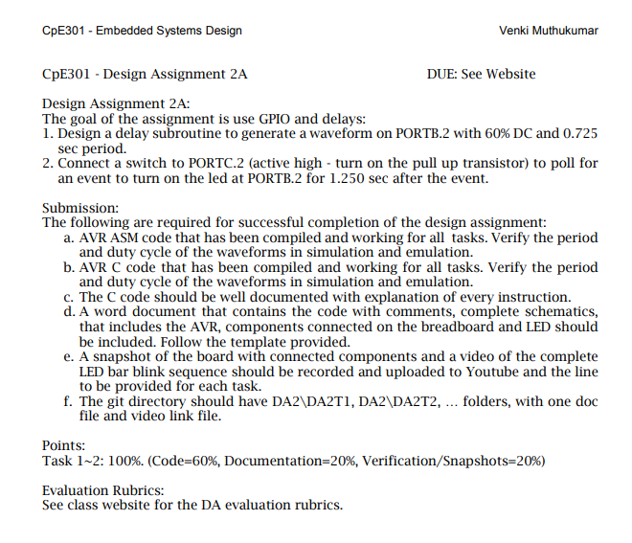

1. **COMPONENTS LIST AND CONNECTION BLOCK DIAGRAM w/ PINS**

Components: atmega328p

1. **INITIAL/MODIFIED/DEVELOPED CODE OF TASK 1/A**

**Task 1**

***Assembly code***

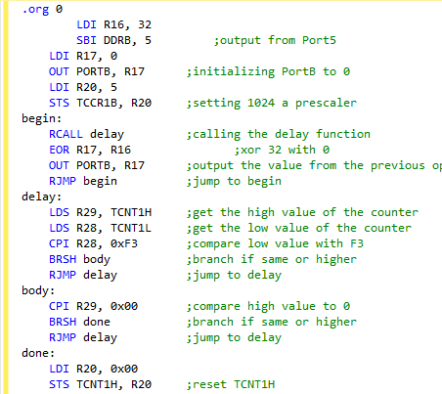

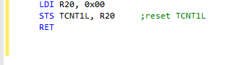

***C Code***

# 

1. **DEVELOPED MODIFIED CODE OF TASK 2/A**

**Task 2**

***Assembly Code***

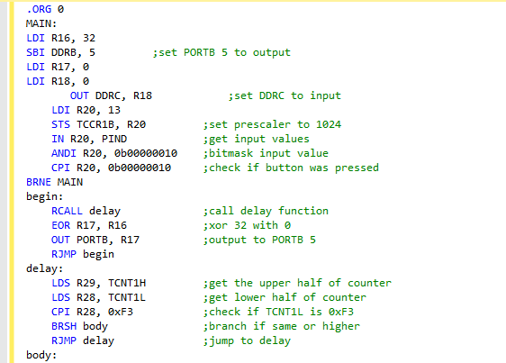

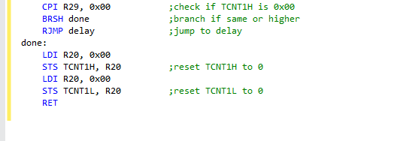

***C Code***

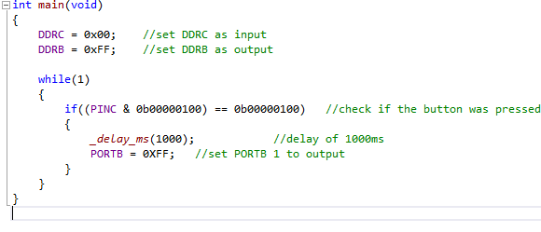

1. **SCREENSHOTS OF EACH TASK OUTPUT (ATMEL STUDIO OUTPUT)**

Port B (HIGH)

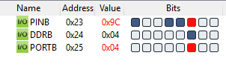

1. **VIDEO LINKS OF EACH DEMO**

https://youtu.be/ScFfX-Vjg1k

“This assignment submission is my own, original work”.

David Pajar