Beta Testing Agreement

February, the 6th, 2008

Dr. Stéphane GALLAND
Systems and Transports Laboratory
University of Technology of Belfort-Montbéliard
Rue Ernest Thierry-Mieg
90010 BELFORT cedex, FRANCE

Dear Stéphane GALLAND:

Thank you for agreeing to participate in the SensAble Technologies, Inc. (“SensAble”) OpenHaptics Beta Testing program. By participating in this program you will have the opportunity to help shape new products and features for future releases of the OpenHaptics™ systems. Your influence in the OpenHaptics product direction can be very beneficial to your company’s product development process. This simple agreement summarizes SensAble’s obligations to you and our expectations of you and your company in this program.

Under mutual confidential disclosure agreement (see APPENDIX A), SensAble agrees to provide the following to participants in the OpenHaptics Beta Testing program:

- A variety of documents and files, including specifications, , for review and feedback.
- Access to product management, engineering management and product specialists, as needed, to discuss trade-offs, details and user requirements.
- Early prototype versions of software intended for testing new feature design.
- Beta software and documentation before general availability to the entire customer base.
- Technical support during the beta testing period.

Under mutual confidential disclosure agreement, participants in the OpenHaptics Beta Testing program agree to the following terms and conditions:

- To install at least one seat of beta software and assign at least one beta tester per seat.
- To provide SensAble with the names, titles, phone numbers, and e-mail addresses of all beta testers and their supervisors.
- To allow SensAble personnel to contact beta testers by phone and e-mail a reasonable number of times during the beta period to obtain feedback on the product.
- Beta testers will take notes on the product throughout the beta period and will provide these and any supporting files to SensAble.
- To serve as references for SensAble in the marketing of OpenHaptics systems provided that the product has delivered the promised benefits.
- To permit SensAble to use data from the beta program, in marketing collateral, including but not limited to Web site materials, data sheets, brochures, white papers, and press releases. However, no permission is granted to SensAble for use of any tradename or trademark of participant, or the names of any participant beta testers, without separate written permission.
- SensAble reserves the right not to delay the First Customer Shipment (FCS) of future OpenHaptics releases due to waiting for Beta feedback.

Your signature below indicates that you agree to the above terms and conditions of the SensAble OpenHaptics Beta Testing program.

This Beta Testing Agreement is in effect for the period of one year beginning on February, the 10th 2008. Either party may terminate the Agreement by giving the other party ten (10) days written notice. As set forth in Appendix A, the confidentiality obligations shall survive termination.

Thank you for your participation, and we look forward to collaborating with you to help improve the OpenHaptics product.

For: Systems and Transports Laboratory For: SENSABLE TECHNOLOGIES, INC.
By: On: February, the 6th 2008 By: On:

Professor Abderraffia KOUKAM

For: Systems and Transports Laboratory
By: On: February, the 6th 2008
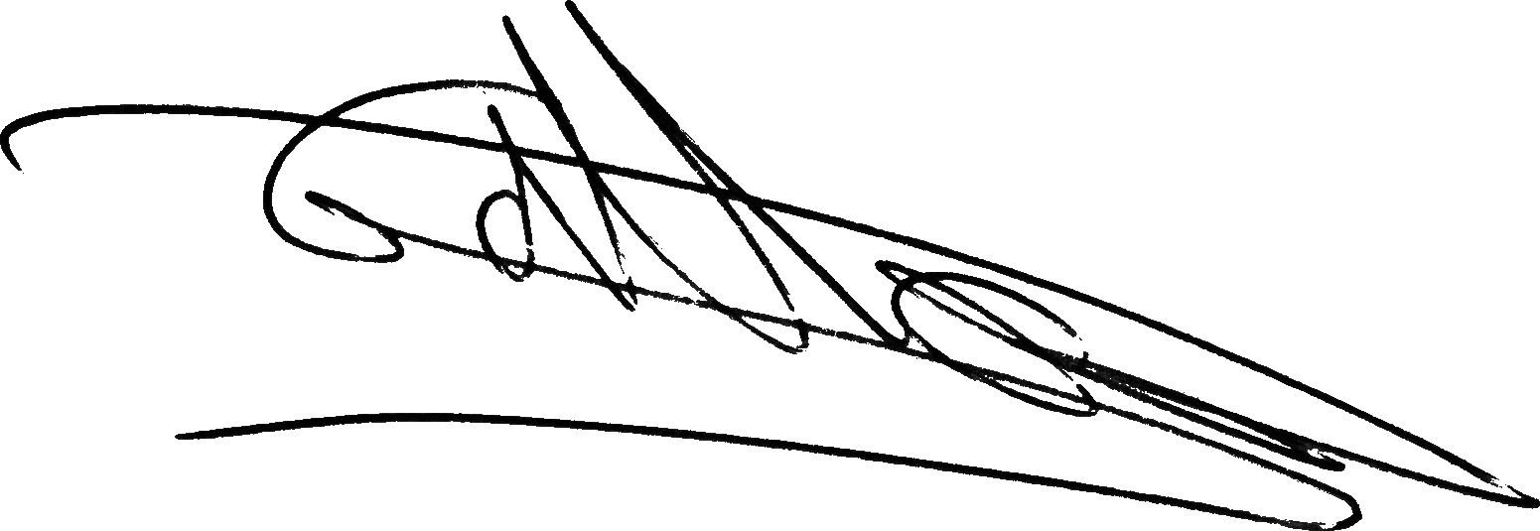

Dr. Stéphane GALLAND

APPENDIX A – Mutual Non Disclosure Agreement

I. IDENTIFICATION OF PROPRIETARY INFORMATION
A. Either party may disclose to the other party certain types of information which includes any written document, data, drawing, screen, graphic, electronic transmission, correspondence, oral or verbal communication, presentation, material, part or other form of information including, but not limited to, design information, specifications, manufacturing, assembly, and/or test procedures, performance data, and business data relating to the design, coding, manufacture, production, or use of software, hardware or apparatus relating to force reflecting haptic interfaces and components thereof produced by DISCLOSER. Information also includes any documentation or communication relating to cost, quantity, delivery schedule, production schedule, forecast, specifications, quality, reliability, procedures, processes, or performance provided to RECIPIENT by DISCLOSER. Any party disclosing information hereunder shall be deemed “DISCLOSER” with respect to such information and any party receiving information hereunder shall be deemed “RECIPIENT” with respect to such information.
B. The foregoing information shall be deemed “Proprietary Information” if: (1) in the case of a written disclosure, DISCLOSER affixes to the document an appropriate legend, such as “Proprietary” or “Confidential”, and/or (2) in the case of an oral or visual disclosure, DISCLOSER makes a contemporaneous oral statement or delivers to RECIPIENT a written statement within thirty (30) days to the effect that such disclosure is proprietary, confidential, or the like.
C. Notwithstanding the foregoing, “Proprietary Information” shall not include information which RECIPIENT can demonstrate by written records: (1) is at the time of disclosure or becomes a matter of public knowledge through no fault of RECIPIENT, (2) is rightfully received by RECIPIENT from a third party without restriction on disclosure, (3) is independently developed by RECIPIENT without the use of DISCLOSER’s Proprietary Information, (4) is in the possession of RECIPIENT prior to its disclosure by DISCLOSER, or (5) is disclosed pursuant to a valid order of a court or authorized government agency provided that RECIPIENT has given DISCLOSER an opportunity to defend, limit, or protect such disclosure.

II. USE OF PROPRIETARY INFORMATION
RECIPIENT shall use Proprietary Information received from the DISCLOSER only for the purpose of carrying out the responsibilities of this agreement.

III. RESPONSIBILITIES OF RECIPIENT
A. RECIPIENT agrees (1) not to disclose Proprietary Information to any third party and (2) to protect the Proprietary Information with at least the degree of care with which it protects its own proprietary information, but in no case with less than a reasonable degree of care.
B. Within thirty (30) days of a written request by DISCLOSER, RECIPIENT shall (1) destroy or return to DISCLOSER all documents received from DISCLOSER which contain Proprietary Information, all documents it may have created which reveal any Proprietary Information, and all copies of the foregoing, and (2) deliver to DISCLOSER a certificate stating that RECIPIENT has complied with such request.

IV. DISCLOSURE PERIOD AND CONFIDENTIALITY PERIOD
A. The period during which DISCLOSER may disclose Proprietary Information under this Agreement shall begin on the date of the first disclosure of Proprietary Information (which may be prior to the date of this Agreement) and shall end upon termination of the Agreement.
B. The obligation set forth in Articles II and III shall (1) terminate five (5) years from the initial date of disclosure of the particular item of Proprietary Information and (2) survive the termination or expiration of this Agreement.

V. MISCELLANEOUS
A. RECIPIENT shall not acquire any intellectual property rights from DISCLOSER other than by a separate written agreement. The disclosure of Proprietary Information by DISCLOSER does not constitute a warranty that such information does not infringe the rights of any third party.
B. This Agreement does not create any partnership, joint venture, or agency between the parties.
C. Before exporting or reexporting any Proprietary Information, RECIPIENT must comply with all applicable regulations of the U.S. Department of Commerce Office of Export Administration and/or other applicable agencies.
D. This Agreement is the complete and exclusive statement of the understanding of the parties regarding the subject matter hereof and supersedes all prior or contemporaneous communications. This Agreement may be amended only by a writing signed by both parties.
E. This Agreement shall be interpreted and enforced according to the laws of the Commonwealth of Massachusetts (excluding conflict of law rules).

