**Hidden Markov Model**

We worked on the HP stock data between the years 2010-2017.

The data that we have contains information about:

* Open: Opening stock price of the day
* Close: Closing stock price of the day
* High: Highest stock price of the day
* Low: Lowest stock price of the day

We tested multiple numbers of hidden states and calculated the AIC for each number.

We chose 24 hidden states based on AIC results

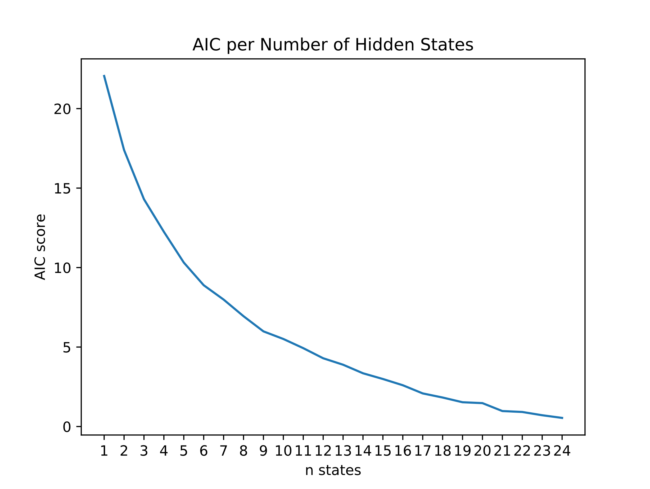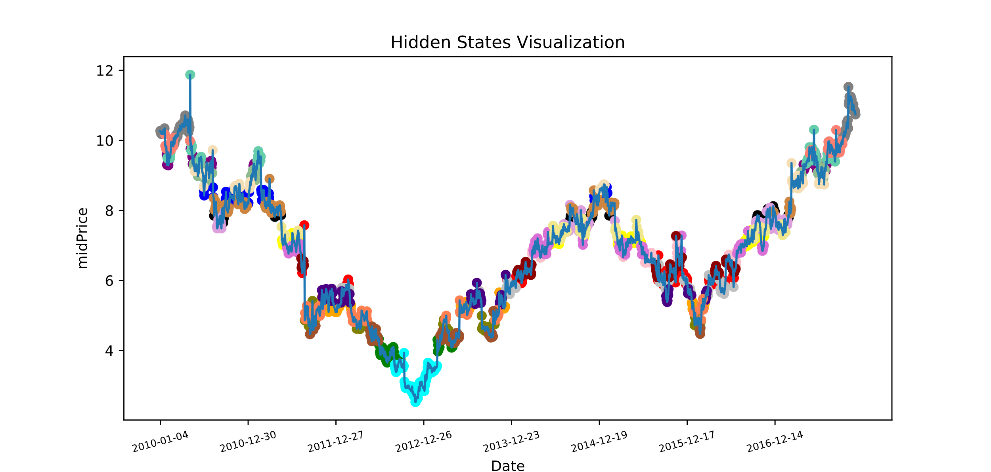

(24)