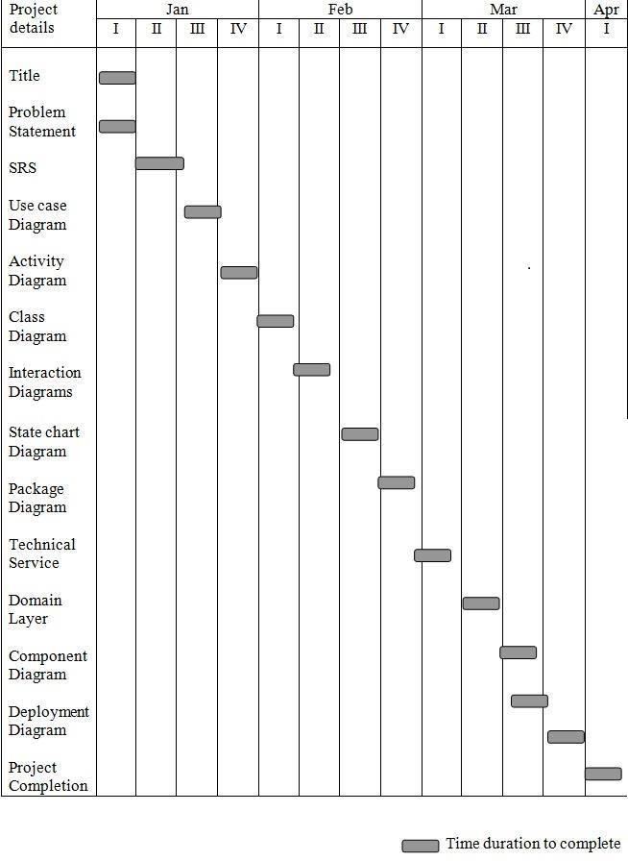



Register

book details

Students

bookbank

issueing the book

collecting the book

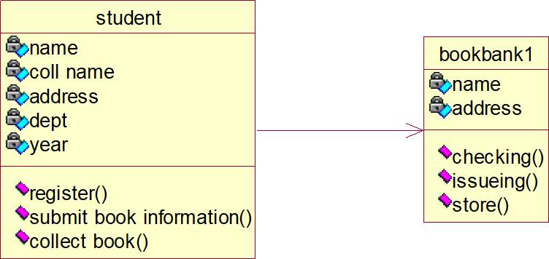



register

submit book details

checking

issues

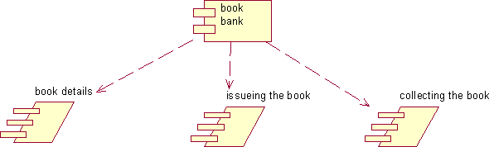

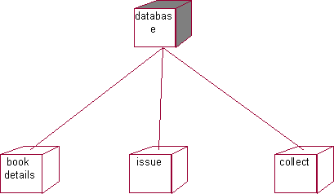

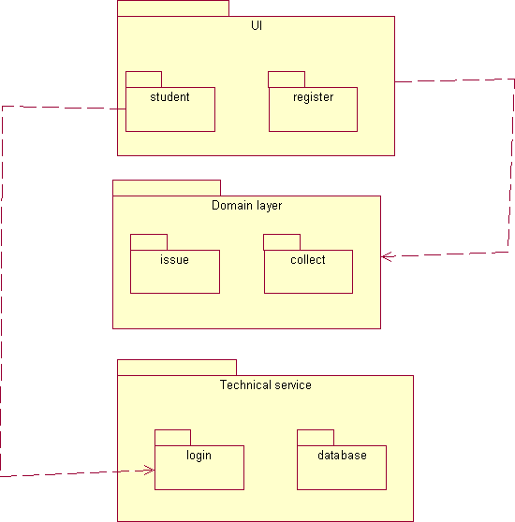

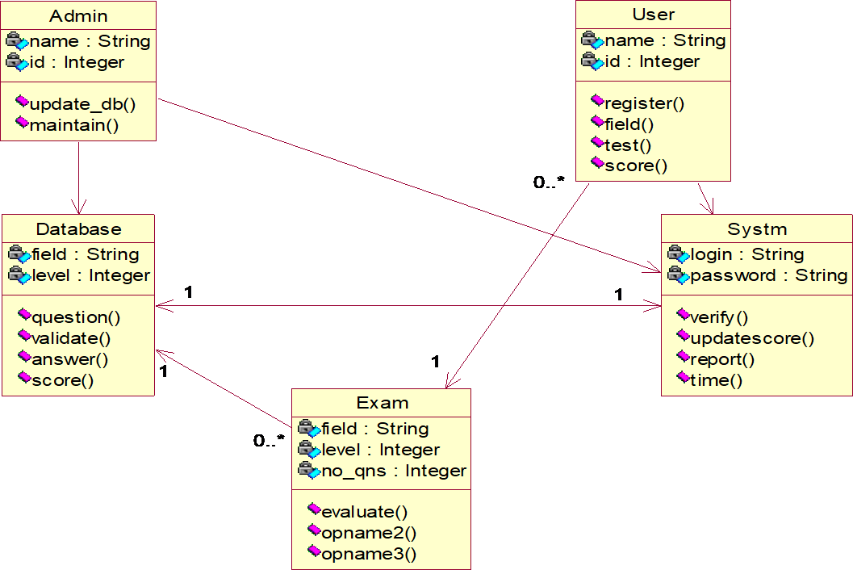



Idle

Start

entry/ User & System at Idle State exit/ Ask for Password

entry/ Login & Password exit/ Successful Login

Test

entry/ Take the Test

exit/ User terminates/finishes or time expires

Report

Verify

entry/ Score Generated exit/ Report Generated

entry/ Completion of Test exit/ Verification Complete

TCP/IP

TCP/IP

LPT1

Printer

Database

Client PC

Server

