PowerShell is Power:  
This code represents the backend of an API call I developed to ping VMs,  
It verifies if a service run on a computer.  
If the service does run it will return status code 200, if not it will be 400.  
For security reasons I can’t show the full API structure, just the backend.  
  
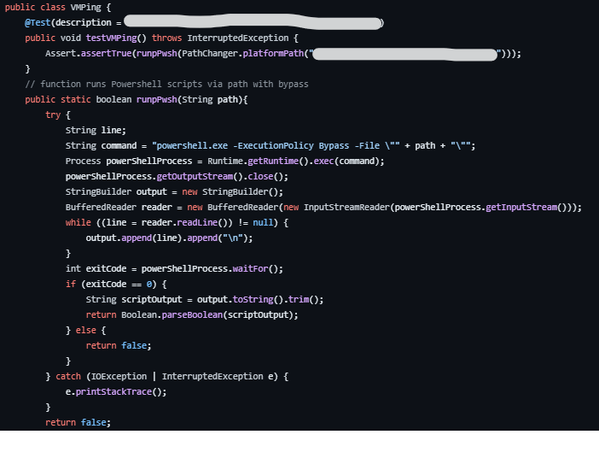

Script itself:  
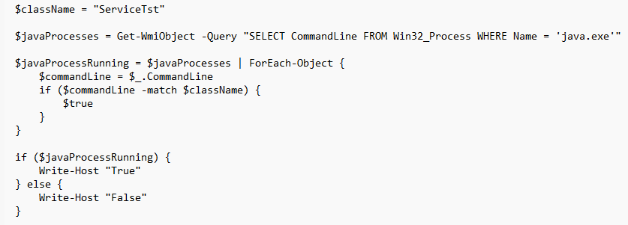

Pwsh Script: