**User manual of automated examination system**

Contents

1. Login page 2

2. Student page 3

1) View Account and Upcoming Exam 3

2) Finish Exam / doing exam paper(s) 4

3) View Result (receiving exam result) 6

3. Teacher Interface 8

1) View Information 8

2) Create a new exam paper for class 9

3) Set up an Examination 9

4) Set up question for Exam 11

5) Marking exam paper 13

6) Notices of marking paper 16

7) Viewing exam reports 16

View Report of Instructed Class 17

4. Admin Interface 21

1) Managing student’s and teacher’s accounts 21

2) Student management Interface 22

3) Teachers management Interface 23

4) Class Management Interface 24

5) Managing students and subjects in a class 26

1) Managing students 26

2) Managing subjects 28

# 1. Login page

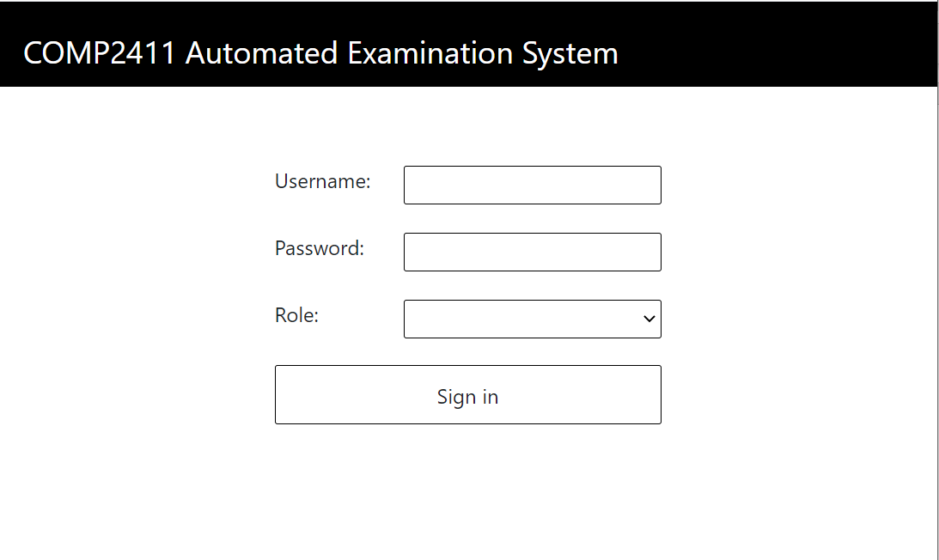 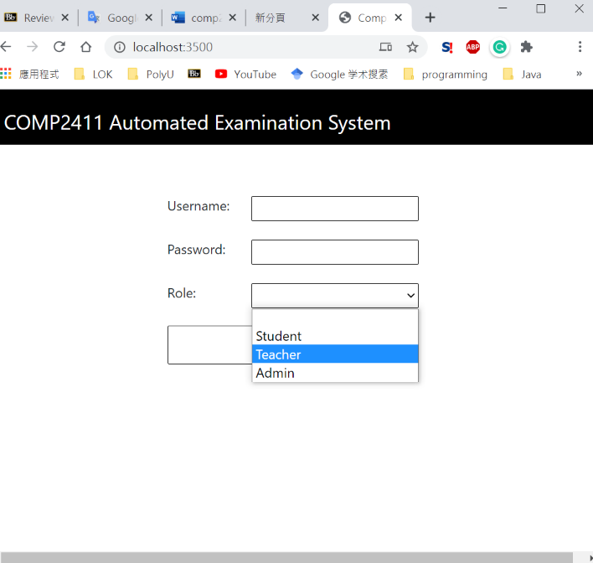

The Login webpage of examination system is very simple and clear. You just need to choose your role in selected option. Then, enter the username, password and click ‘Sign in’ to enter your home page. If you forget to input username, password and Role. The system will show a red block to remind you. It will show ‘bad credentials’ if you enter wrong username, password or role.

We will first view the webpages and functions of Student’s interface, then teachers’, finally the admin interface.

Login Parameters

|  |  |
| --- | --- |
| Username: | root |
| Password: | P@ssw0rd |

# 2. Student page

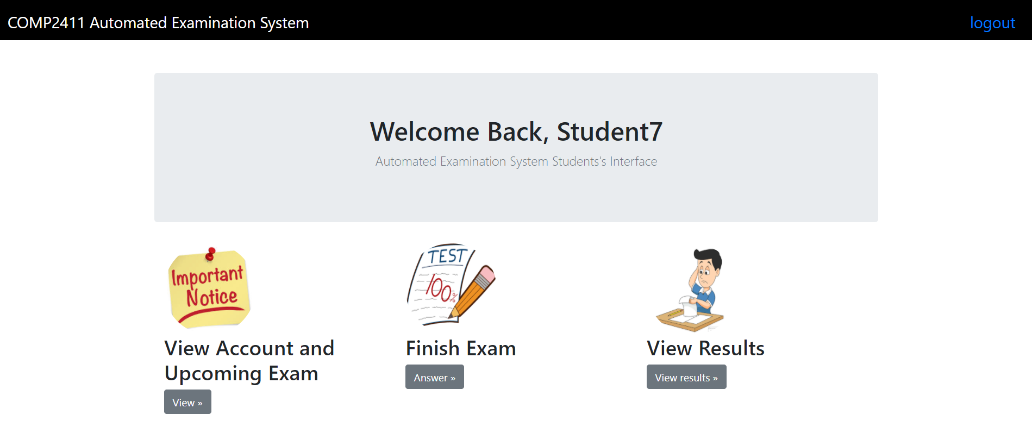

If you are a student, you will see this page after you login. Successfully. On this page, you can do 4 actions.

* First, you can logout by simply click the word ‘logout’ which is at the top right corner.
* Second, you can view your account information and exam schedule by clicking ‘view’ button.
* Third, once you click the ‘Answer’ button, you can complete your exam.
* Forth, you can check your exam result on ‘View Result’ page.

## 1) View Account and Upcoming Exam

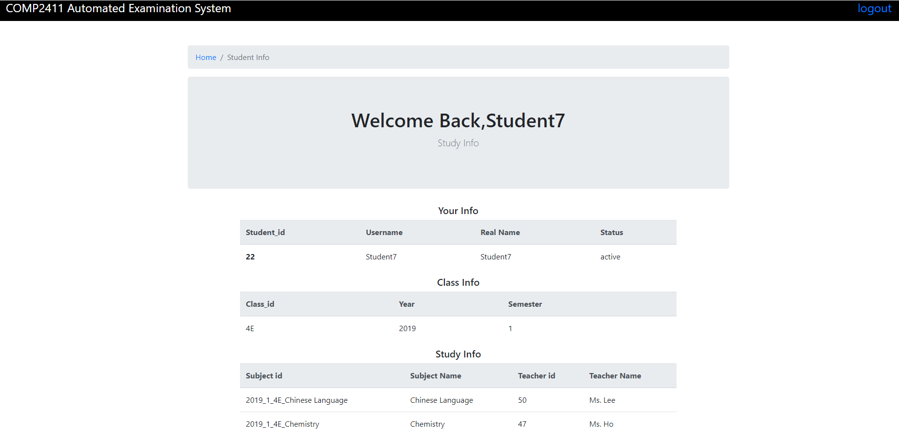

In this webpage, there is information about user’s real name, username, current status, information of the class he/she attend and the subjects they study this semester.

By the way, if you want to back to the previous page, click the blue text in the directory list.



## 2) Finish Exam / doing exam paper(s)

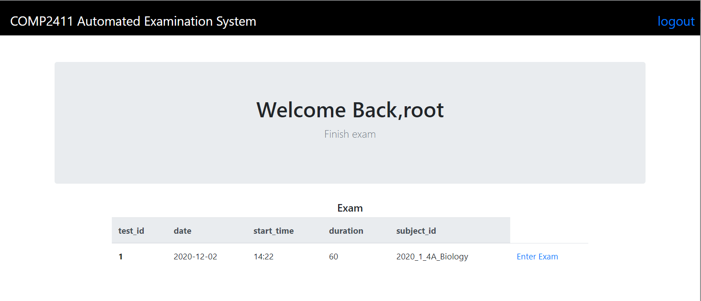

In this webpage, it will show a table of your exam schedule. The table contains some details about your examination, include the test_id, date, start time, duration and subject_id with class. If you want to start the exam, click ‘Enter Exam’ to start your examination.

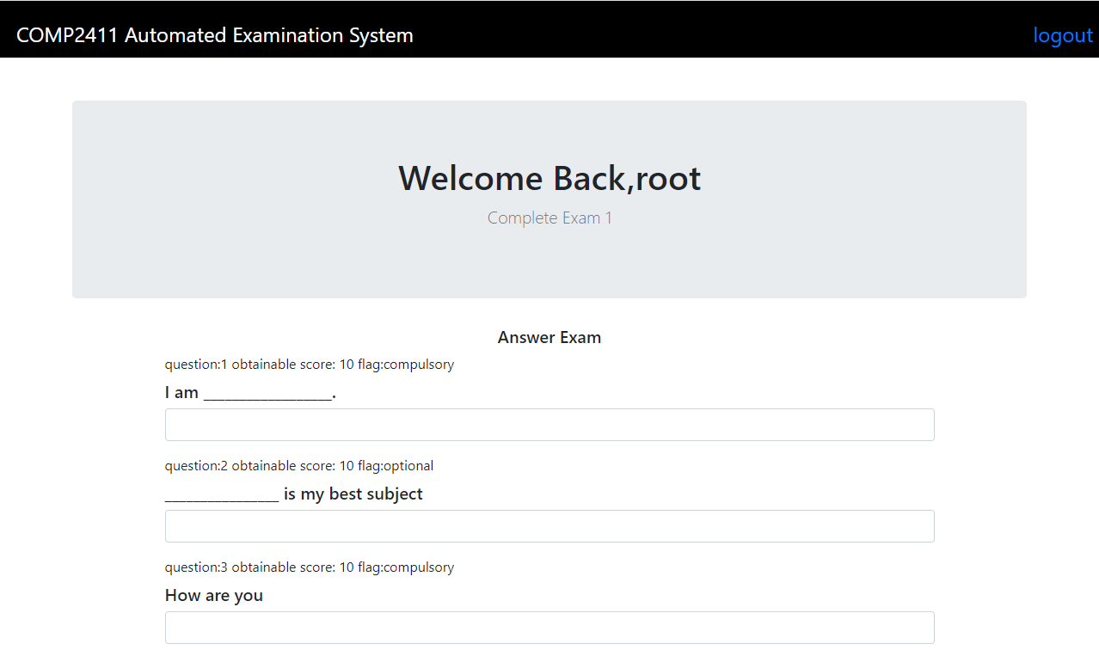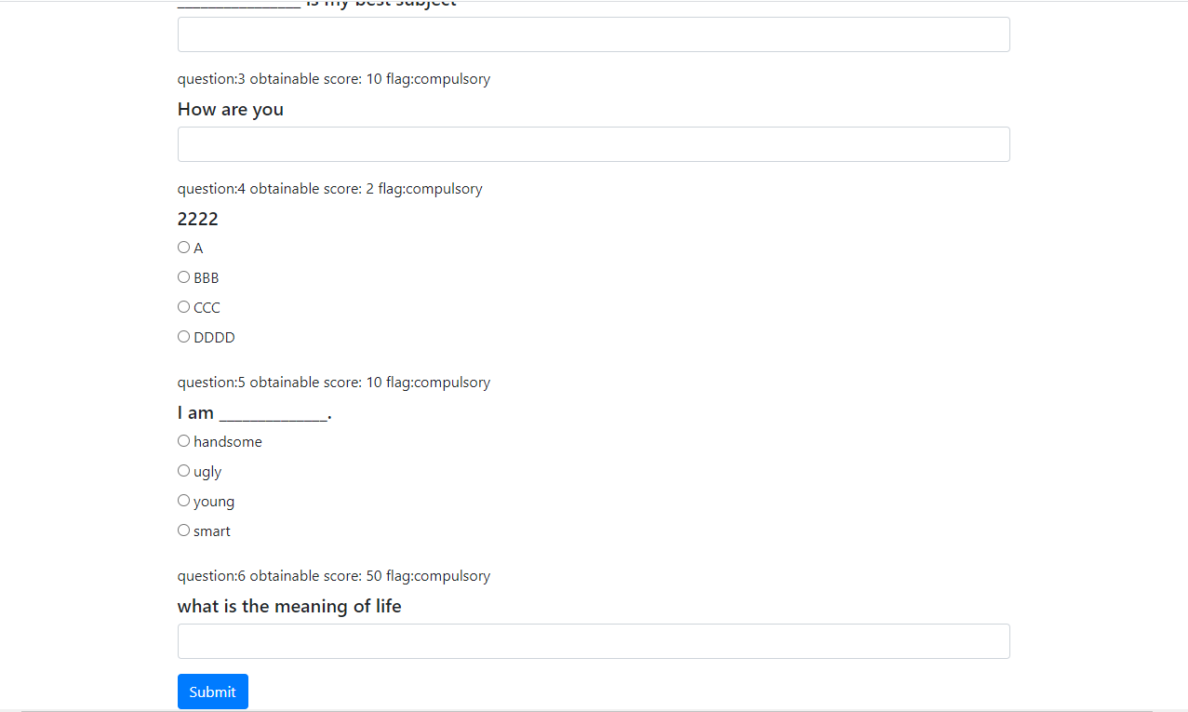

When entering the exam, there will be a list of questions for you to answer. You can scope down or up to answer further questions and review your answers. There are 3 types of questions, include MC (multiple choice), Fill in the blank and long questions. After you complete the exam paper, you should roll to the bottom and click the ‘Submit’ button to hand-in your answers.

If the question is optional, it will show ‘Bonus Question’ on the top right side of the question:

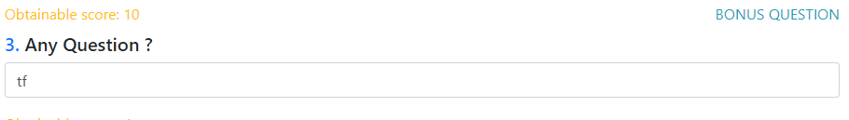

After you submit the exam paper, you cannot redo the paper again to avoid plagiarism. The system will remove the URL of exam paper automatically.

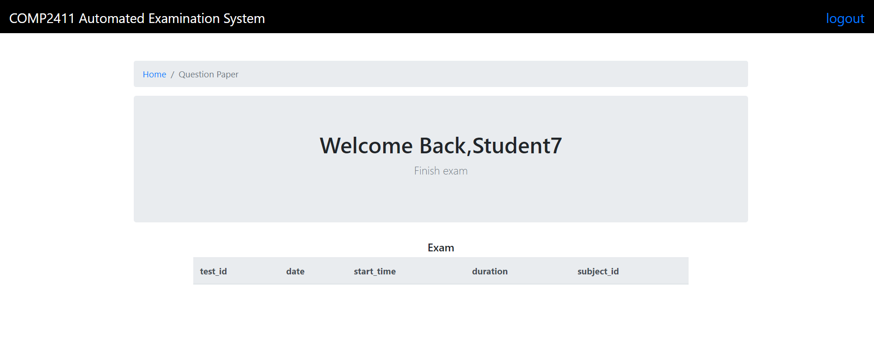

## 3) View Result (receiving exam result)

To check your exam result, you can click ‘View Result’ to view your grades. The grades will be released when subject teachers mark all the papers for students and compile grades completely.

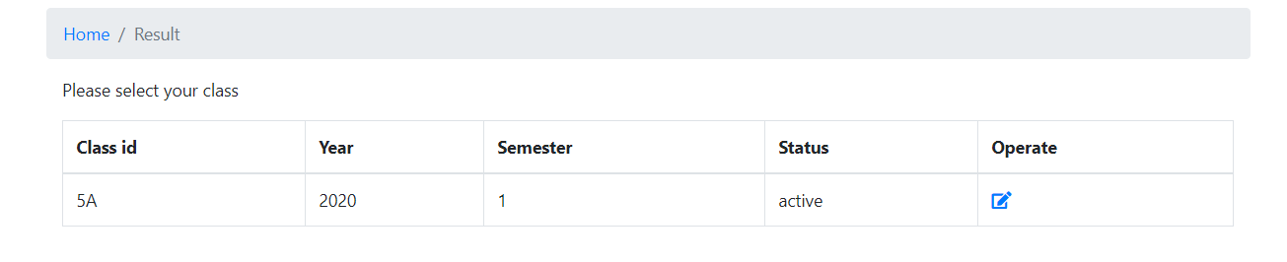

First the student selects the class he belongs in. As he may belong to multiple class prior to this semester, there might be multiple records.

The report will show up after clicking the “operate” button. The website will render all the graded subjects records in that class.

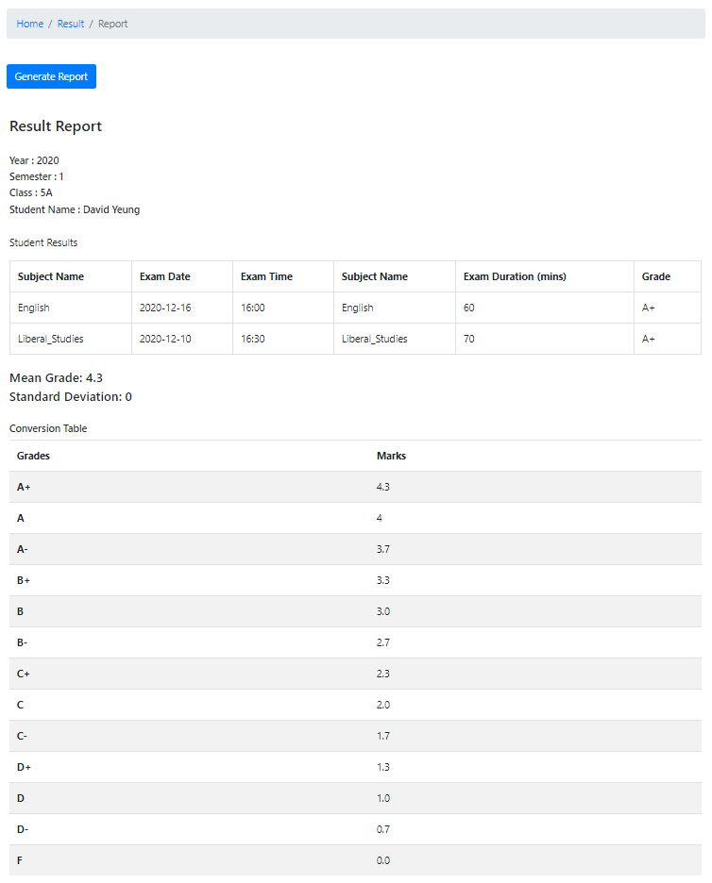

Report Sample

# 3. Teacher Interface

If you were teachers, you can see the below interface after successfully login:

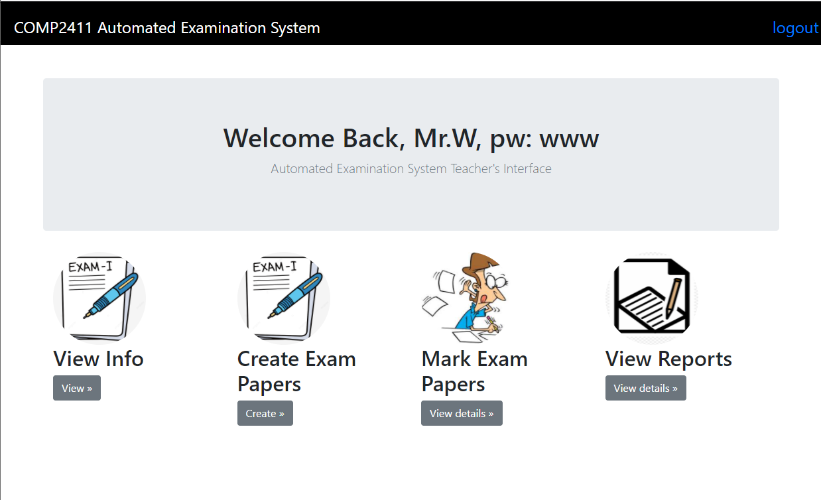

## 1) View Information

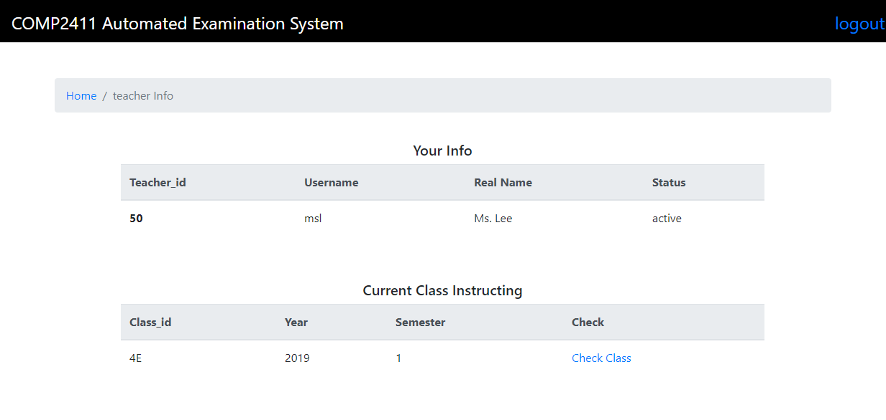

You can check your personal information in teacher Info. Also, it will list out the class that you are going to teach. To further view the students in this class, you can click ‘Check Class’ to see more information.

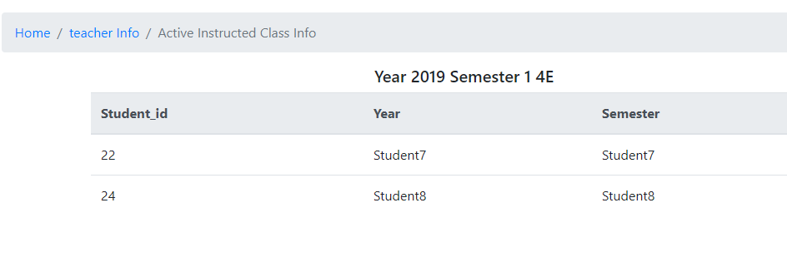

## 2) Create a new exam paper for class

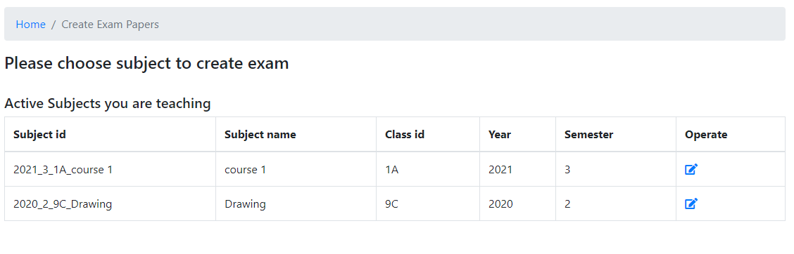

## 3) Set up an Examination

If you want to set up an exam paper for class, choose the second choice (Create Exam paper) to enter exam management interface.

Then, click the picture of Operate column to enter creating exam paper interface.

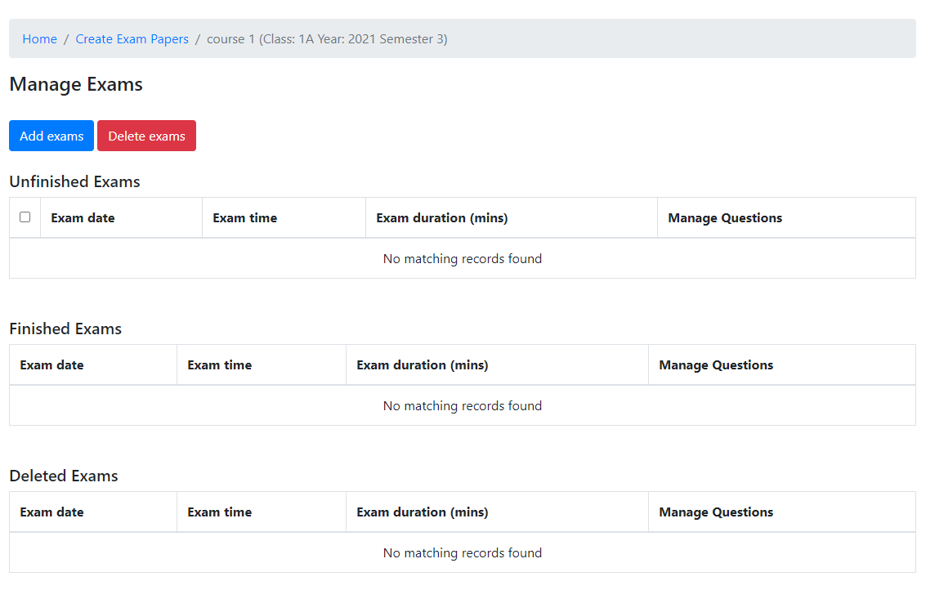

Here, clicks blue button to create paper, select unfinished exams then click the red button to delete exam(s).

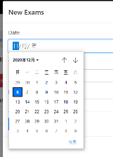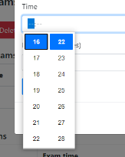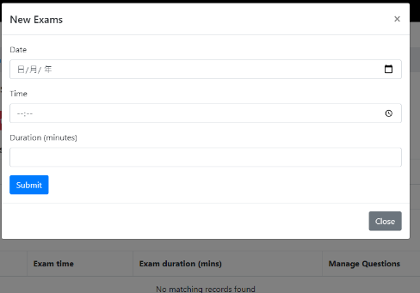

Input exam date, time and duration to create an exam. There are calendar and time input for user to input the information easily and accurately.

## 4) Set up question for Exam

After creating exam, you can enter a new interface to set up questions. (This icon → )

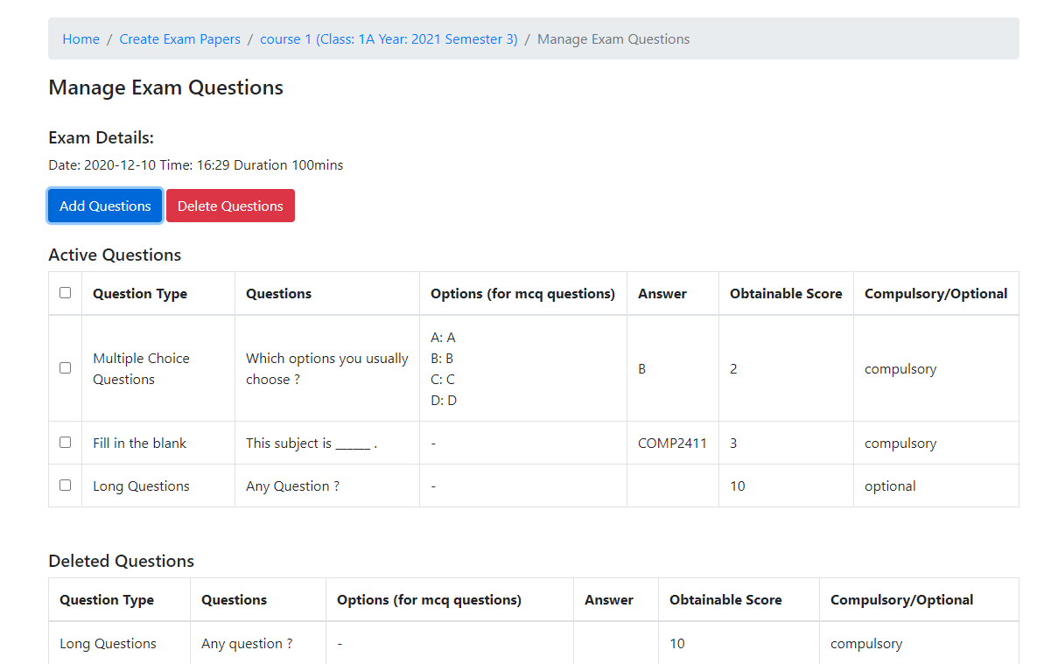

Again, the blue button for creating questions and red for deleting question(s). There are 3 types of questions, include MC (Multiple choices), fill in the blank and long questions. For each question, you can choose whether it is compulsory or optional. Questions default as compulsory questions. To change it to optional, untick the box of Compulsory:

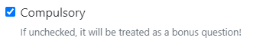

For mc question, it is not allowed to have an empty answer for choices. If users forget to input all answer, a pop-up window will be shown to remind users: 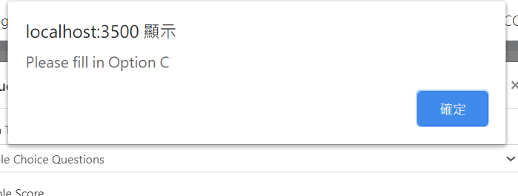

For fill-in-the-blank and long question, you can determine whether it is open-ended question (leave a blank on ‘Correct Answer’ text box). If it is, the system will not mark this question automatically. Teachers need to mark the paper by another function of exam system (which will be demonstrated later)

Question type — **Multiple choices (MC)**

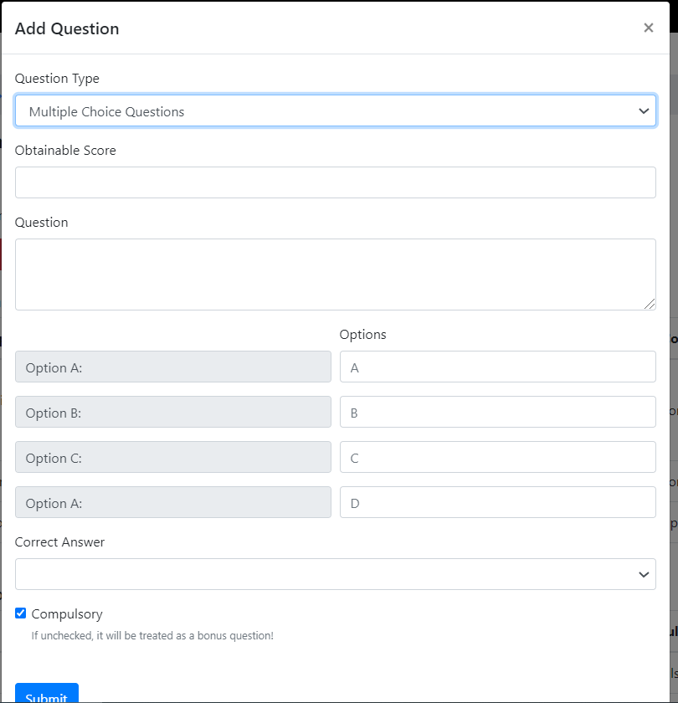

Question type — Fill **in the blank**

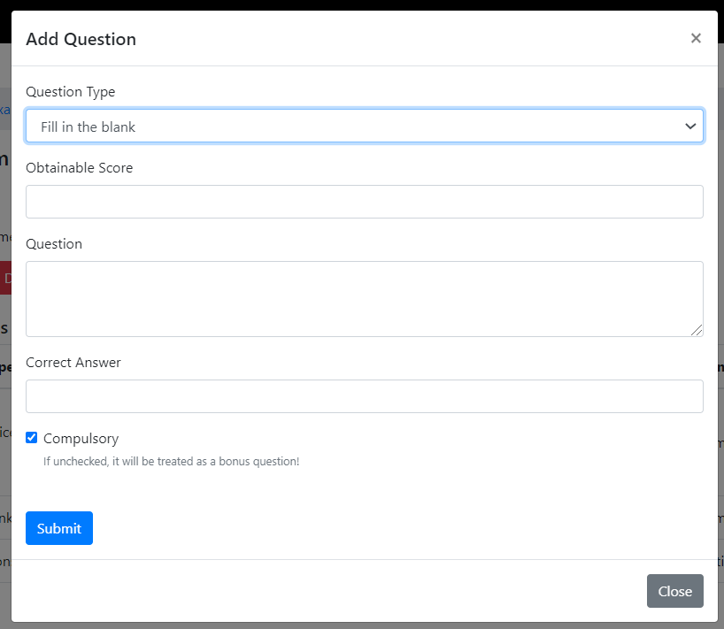

Question type — **Long question**

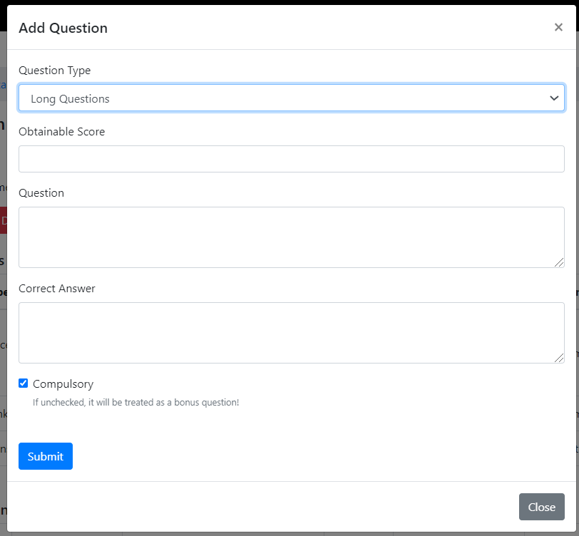

## 5) Marking exam paper

The interface of the paper you can mark is like other interfaces, click this () button to enter the examinations of subject.

Since one subject may have more than one exam, so you need to choose which exam you are going to mark.

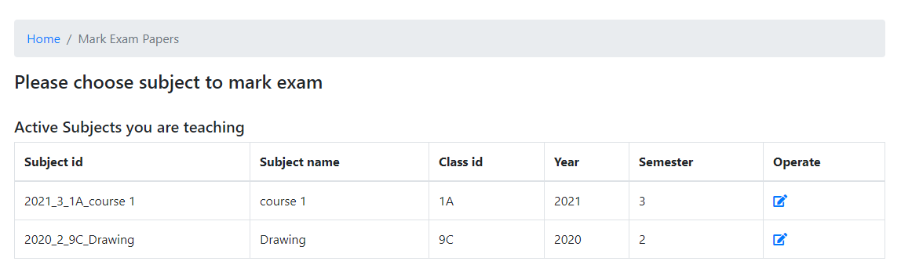

Select () which exam you are going to mark the papers.

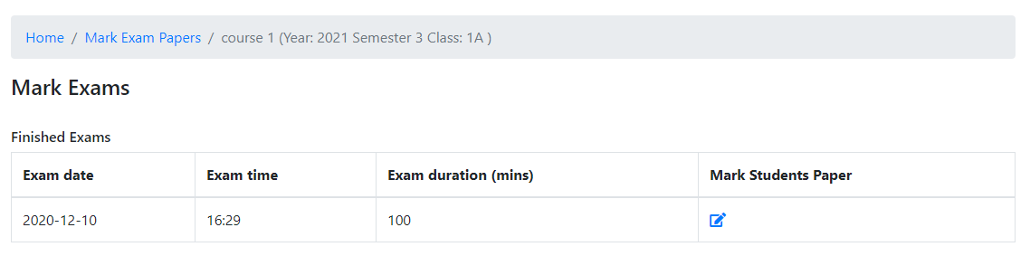

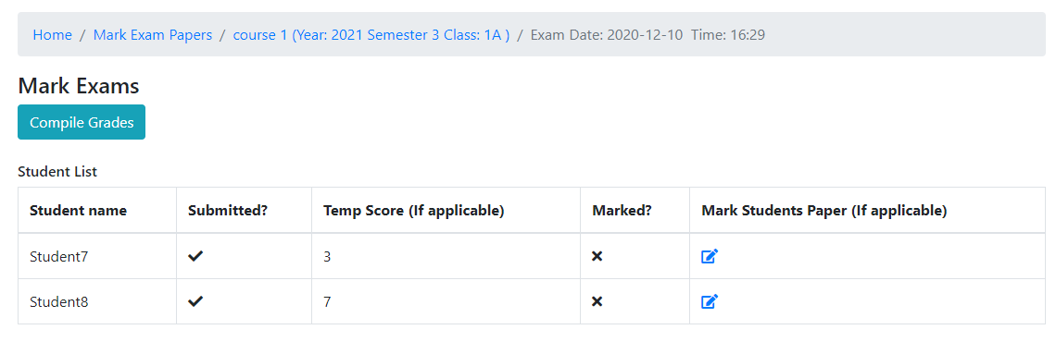

Here is a list of students’ exam papers. It records who students are required to attempt this exam, whether he has submitted the paper, temp score and status of marking. Temp Score means the temporary score that MC and fill in the blank questions are marked by system automatically. When students submit the answer paper, the system will mark the questions which provide suggested answer.

You should compile Grades (Cyan color button) after marking all student’s papers. The ‘Marked?’ column will show a tick () on the field if you have updated the status of student’s papers.

If you compile grade while have not finished marking, system will interrupt your action and pop up a window to remind you:

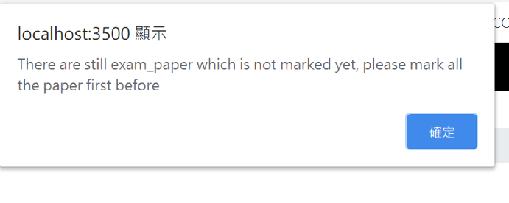

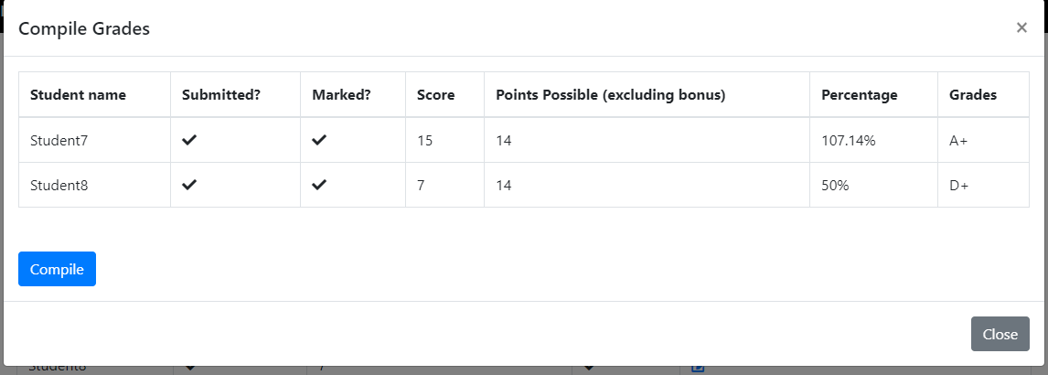

After compiling the grades, the system will generate a preview of student’s grades. If you have no problem with this result, press the blue button to continue, otherwise, click grey button to close this pop-up window and modify your marked paper.

Please make sure that all the students have submitted the papers and their records, scores and grades are correct. Since once you compile the grades, students cannot submit paper anymore and you cannot modify the scores and grades.  
  
As there may be bonus questions in the exam papers, students may achieve marks > 100%, they will be graded as A+ as well.

To further mark each paper, click  to enter marking paper interface.  
  
Grade conversion Table

|  |  |
| --- | --- |
| Mark | Grade |
| 95 or above | A+ |
| [90 95) | A |
| [85 90) | A- |
| [80 85) | B+ |
| [75 80) | B |
| [70 75) | B- |
| [65 70) | C+ |
| [60 65) | C |
| [55 60) | C- |
| [50 55) | D+ |
| [45 50) | D |
| [40 45) | D- |
| Below 40 | F |

## 6) Notices of marking paper

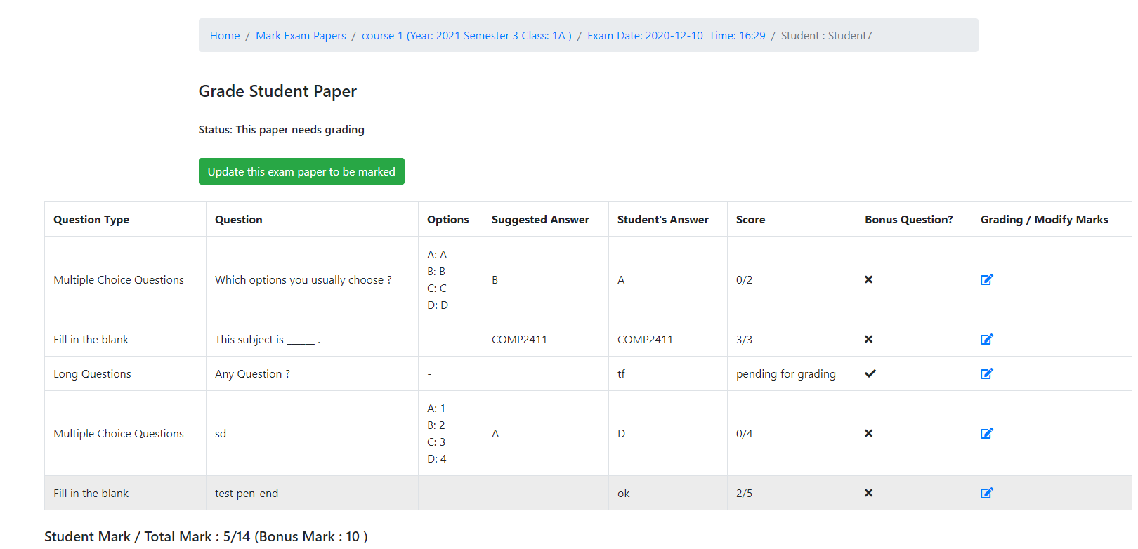

Long Question and some of the Fill-in-the-blank need teachers to mark and calculate scores manually. Please pay attention to the ‘Score’ column, if that field exists ‘pending for grading’, it means this question need teachers to mark it manually. Click  to modify the scores of questions.

After finishing marking, click the green button ‘Update this exam paper to be marked’ to change the status of this paper.

## 7) Viewing exam reports

Teachers can view the report of student’s exam performance after compiling the grades. First, you need to choose which class you want to see, the performance of your instructed class(es) or the student’s performance of your instructed subject.

Instructed class means you can see all the examinations performance of subjects, even the subjects are not taught by you as you are the class teacher.

Instructed subject means you can only view the exam performance of the subjects you are teaching in different classes because one teacher can have many subjects.

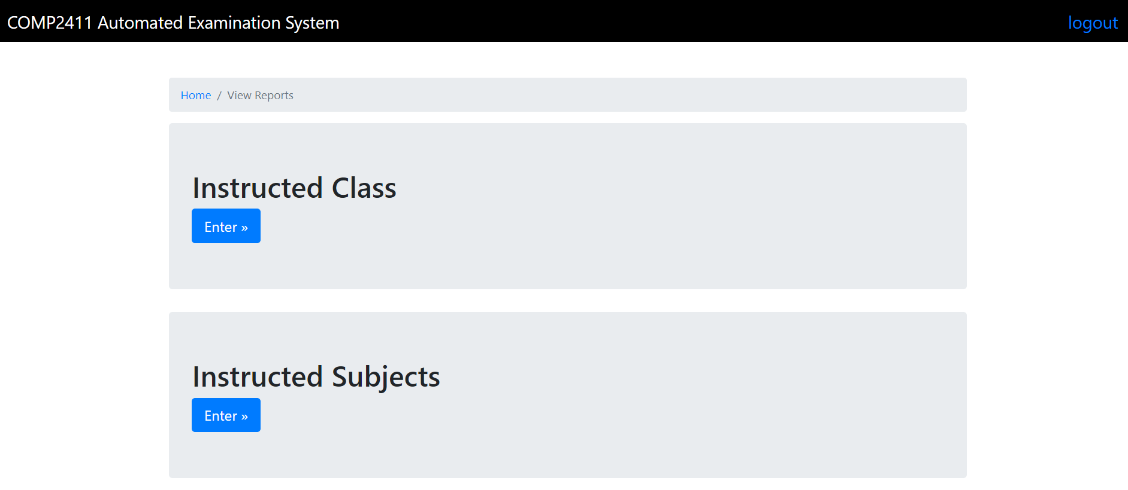

If you want to view the exam performance of your instructed class, then you need to select the class, subjects of class, and exam of subject separately to view the report.

### View Report of Instructed Class

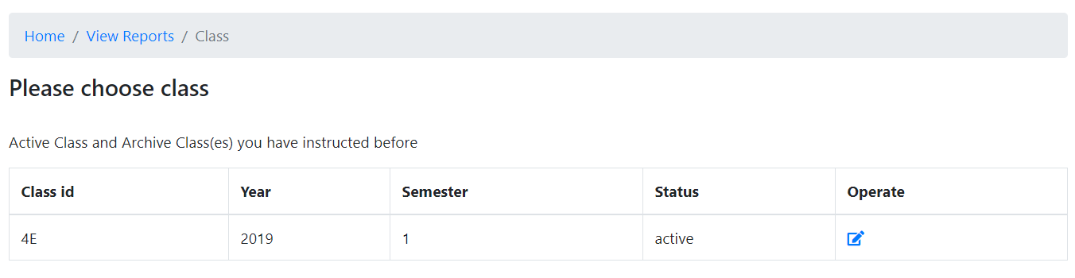

Choose the class that you want to check. You may check the archived class in previous year as well.

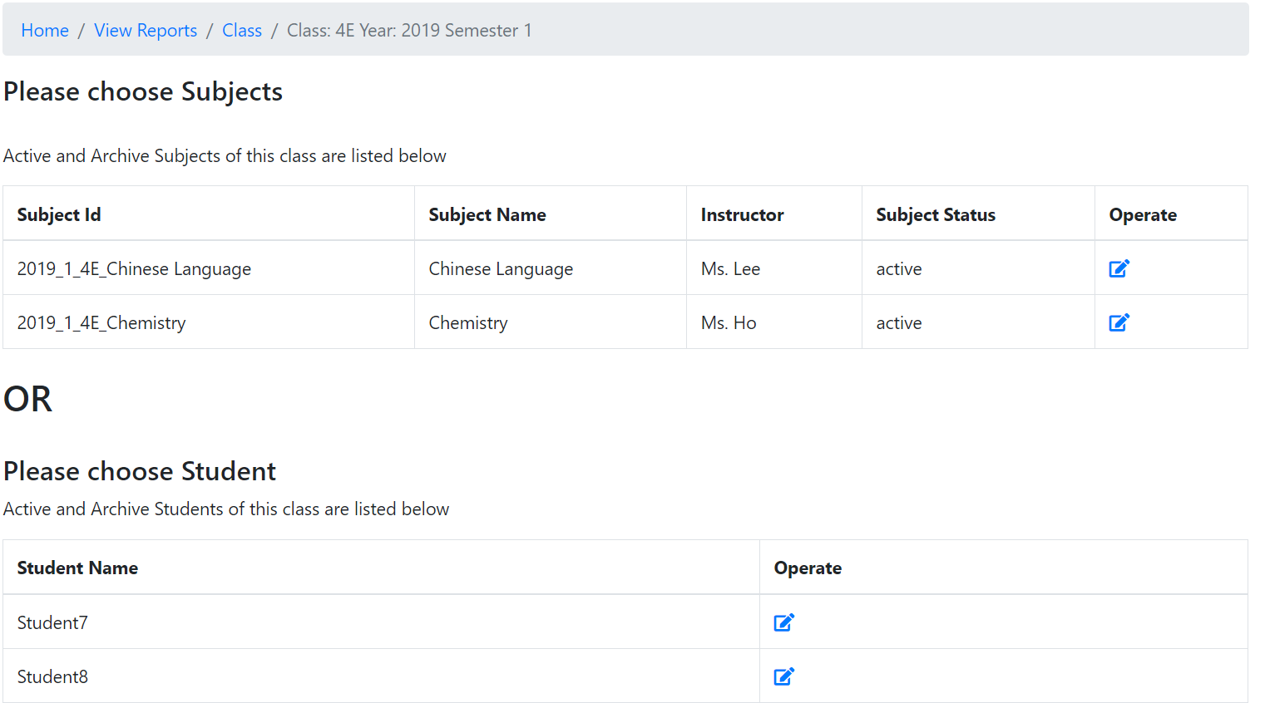

Second, select to view by subject or view by student.

- If you choose view by student, the student report of that class will be generated. You may store the report by clicking “Generate Report”.

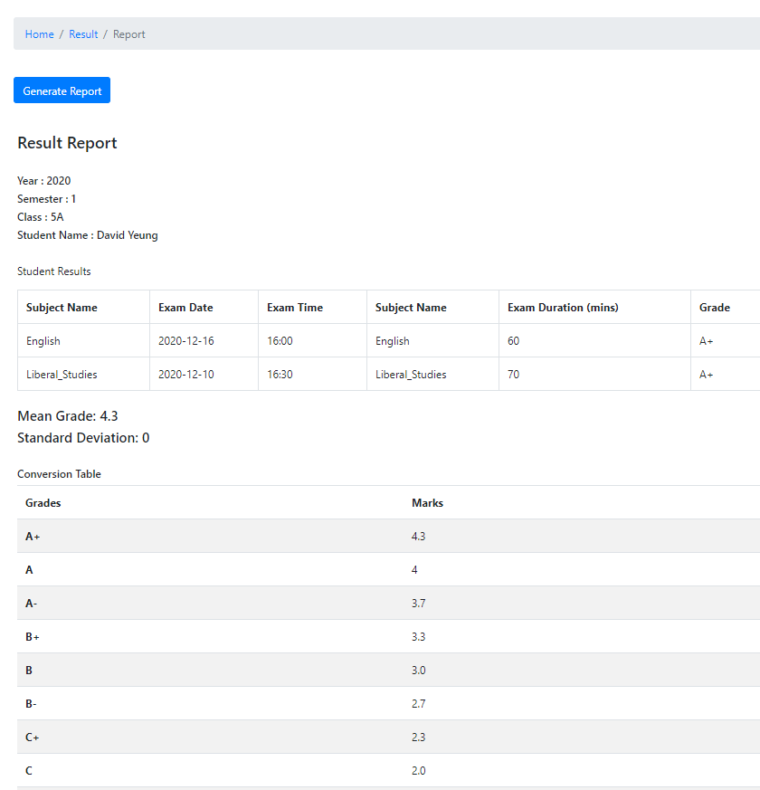

- View By Subject

If you choose view by subject, please select the subject you want to view. Afterwards, click the exam report you want to check, a report will be generated for you containing all the students sitting on that exam. You may store the report by clicking “Generate Report”.

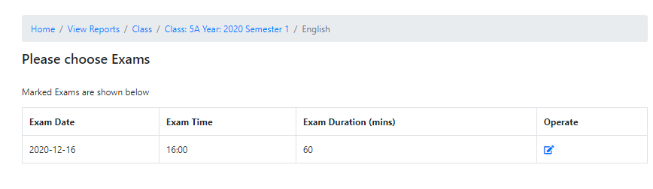

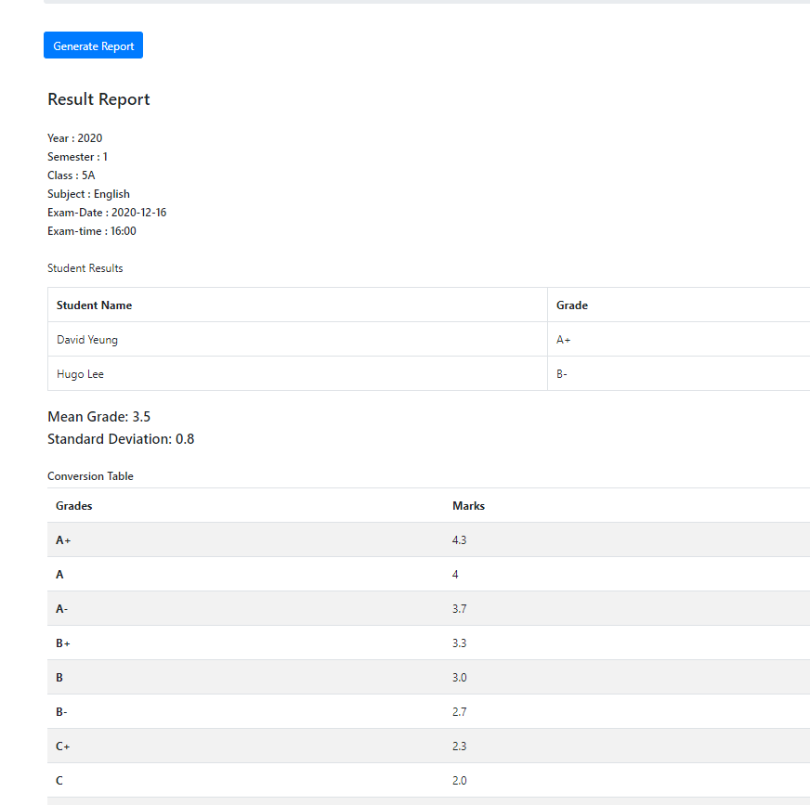

If you want to view report of your instructed subjects, first select the subjects and class, then select the exam to view the report. A report with the same format as “view by subject” in class teacher mode. You may also store the report by clicking “Generate Report”.

↓↓↓↓↓↓↓↓↓↓↓↓↓↓↓↓↓↓↓↓↓↓↓↓↓↓↓↓↓↓↓↓↓↓↓↓↓↓↓

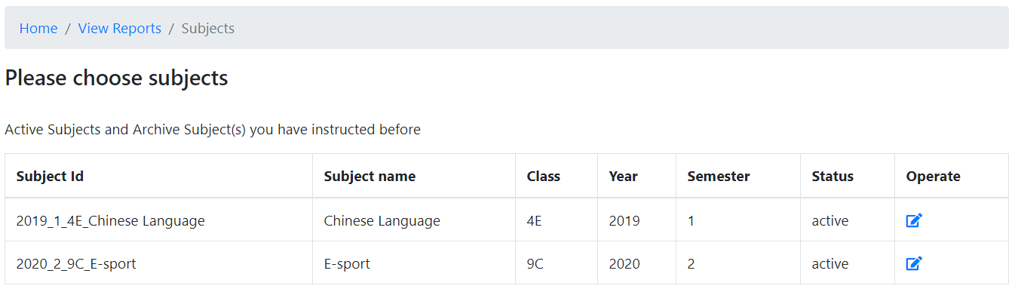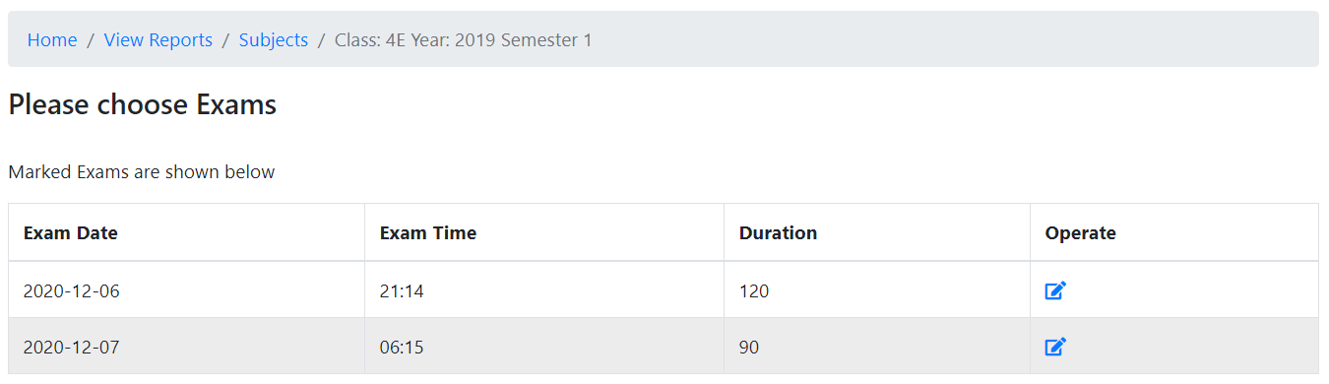

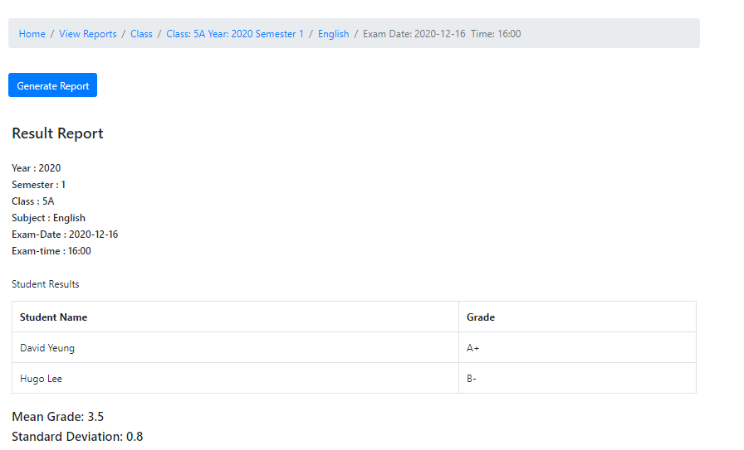

# 4. Admin Interface

If you were an admin, there are mainly 2 operations you can do. You can view and modify the student's or teacher's accounts. You can add a new student or teacher or achieve their account. Also, you can manage the class through this system.

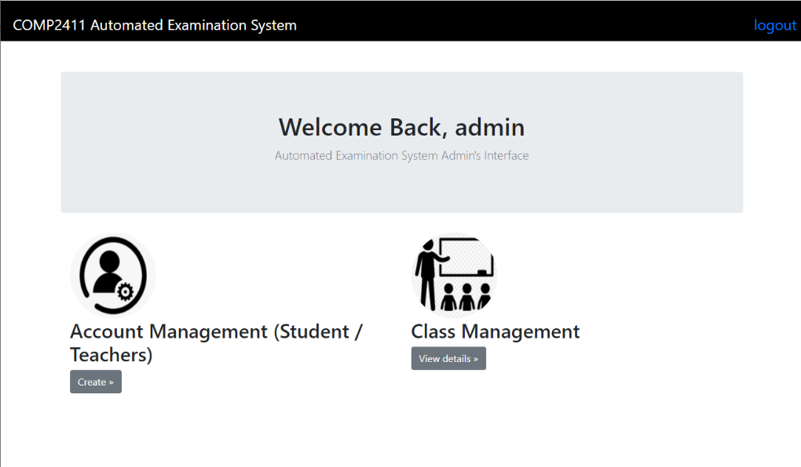

## 1) Managing student’s and teacher’s accounts

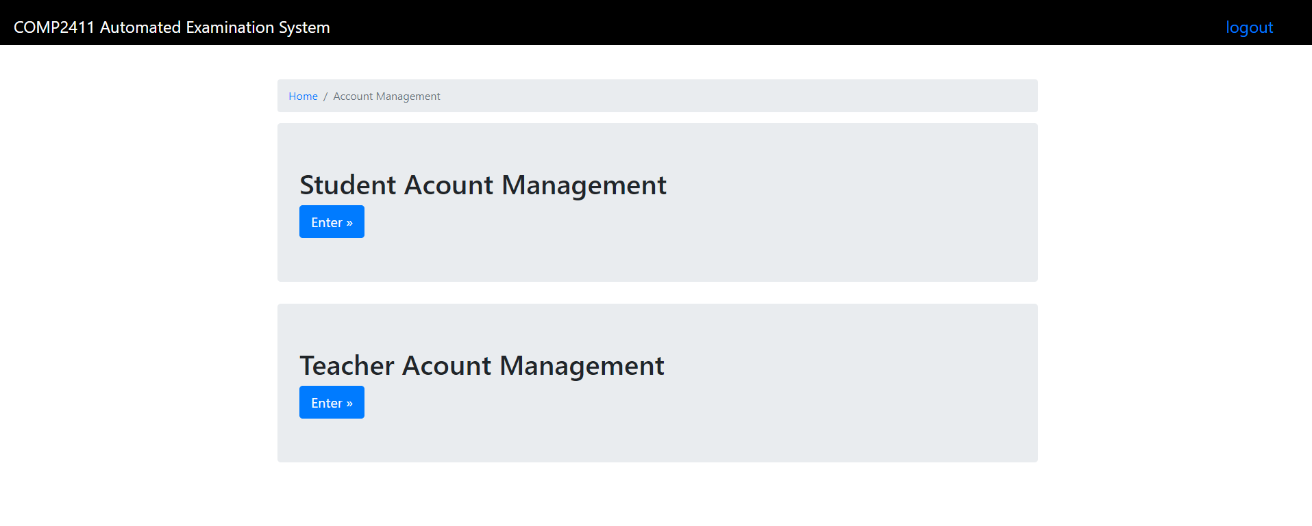

After you enter the Account Management Interface, first you need to choose to modify student's or teacher's accounts. Clicking the ‘Enter’ button to enter the management interface that you want.

By the way, if you want to back to the previous page, click the blue text in the directory list.



## 2) Student management Interface

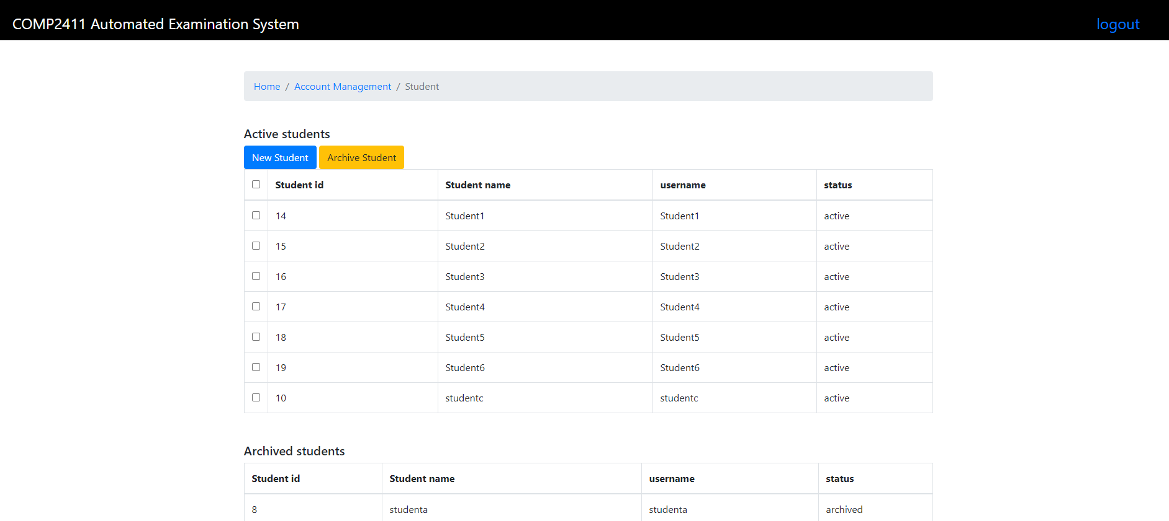

If you choose to manage the student account, you will see the above web page. To add a new student, you can click the ‘New Student’ button, then there will be a pop-up window for you to enter the student name, username and password. After inputting the information, click ‘Submit’ to create a new student account, or click ‘close’ to cancel this action.

If the students do not study anymore, you can archive the student’s account. Noting the selected box in front of the student_id to mark who you want to archive, then click ‘Archive Student’ to archive the student’s account(s). All records related to the student, including class enrolment records, examination results, and attempt data will be archived.

## 3) Teachers management Interface

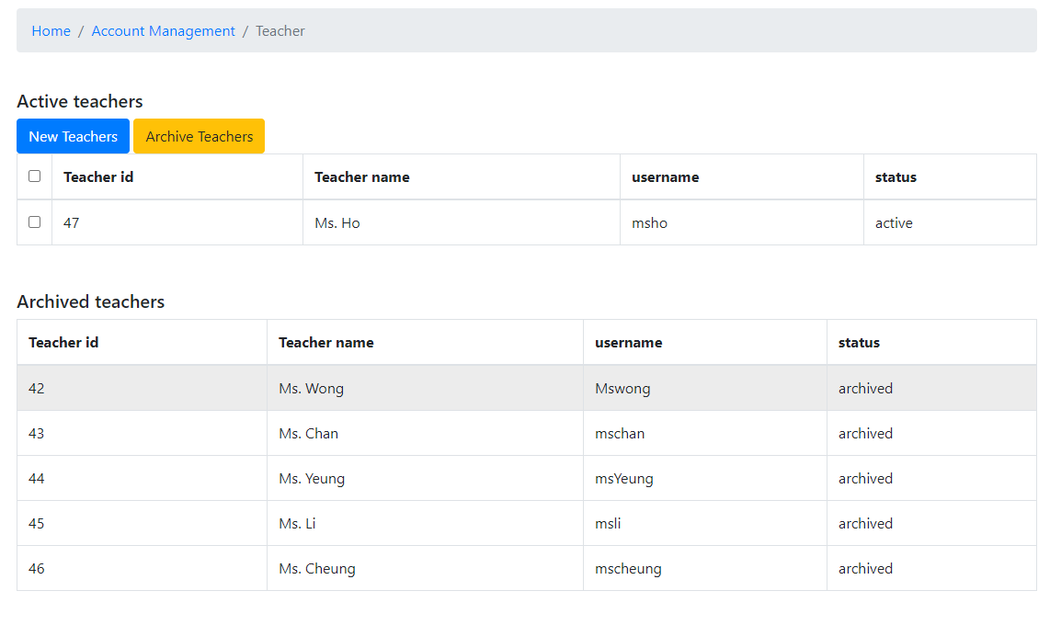

The method of managing teacher’s accounts is similar to managing students. Following the above steps then you can access to the same result for teachers.

If the teacher is archived, all subjects and class he/she is instructing, exam paper records will be archived.

## 4) Class Management Interface

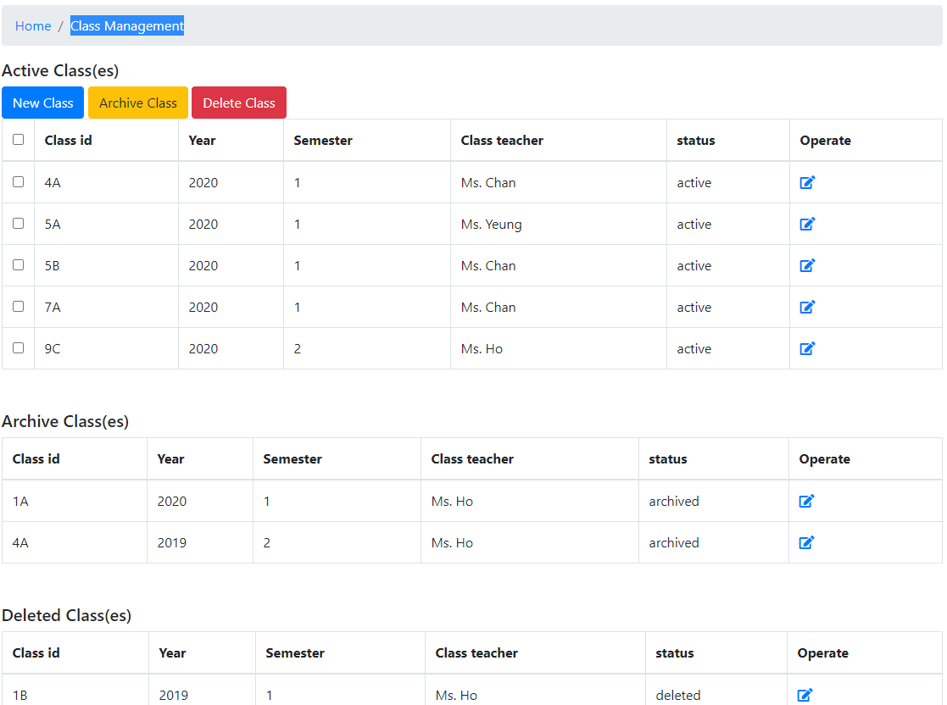

In this interface, you can view the status and information of classes, create new classes, archive and delete classes.

If you want to archive and delete class(es), first select the class by selection box, then click the ‘Archive Class’ (Yellow button) or ‘Delete Class’ (Red button) to execute your operation.

For archive records, all subject records, examination records, enrolment records under the class will be archived, while for deleting records, all subject records, examination records, enrolment records will be deleted.

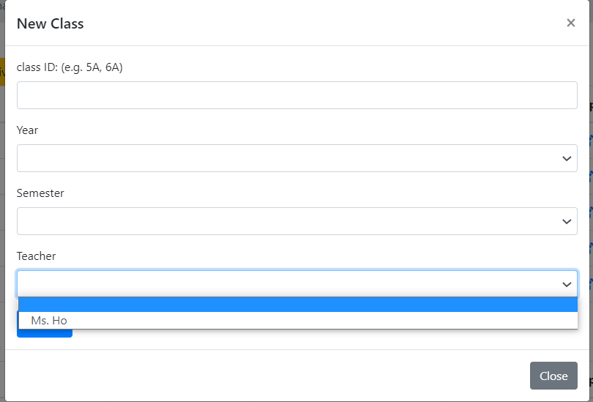

To create a new class, you need to click the ‘New Class’ button and fill in the information in the pop-up window to create a class. Year, Semester and Teacher attributes are selected choices.

Remember, each teacher should instruct one class only at the same time. But they can teach more than one subject in different classes. If you create a second class for the existed teacher, you will receive a warning from a pop-up window: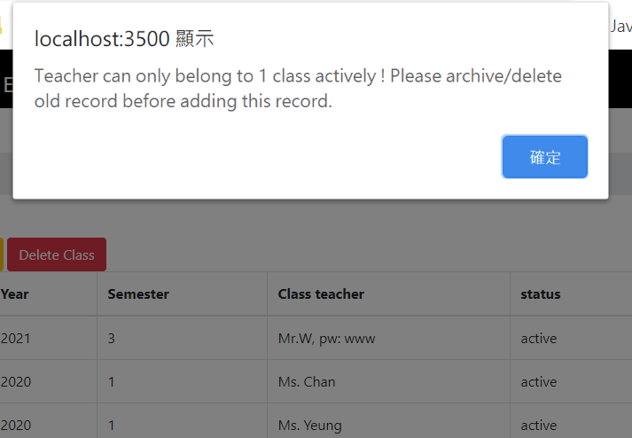

## 5) Managing students and subjects in a class

### 1) Managing students

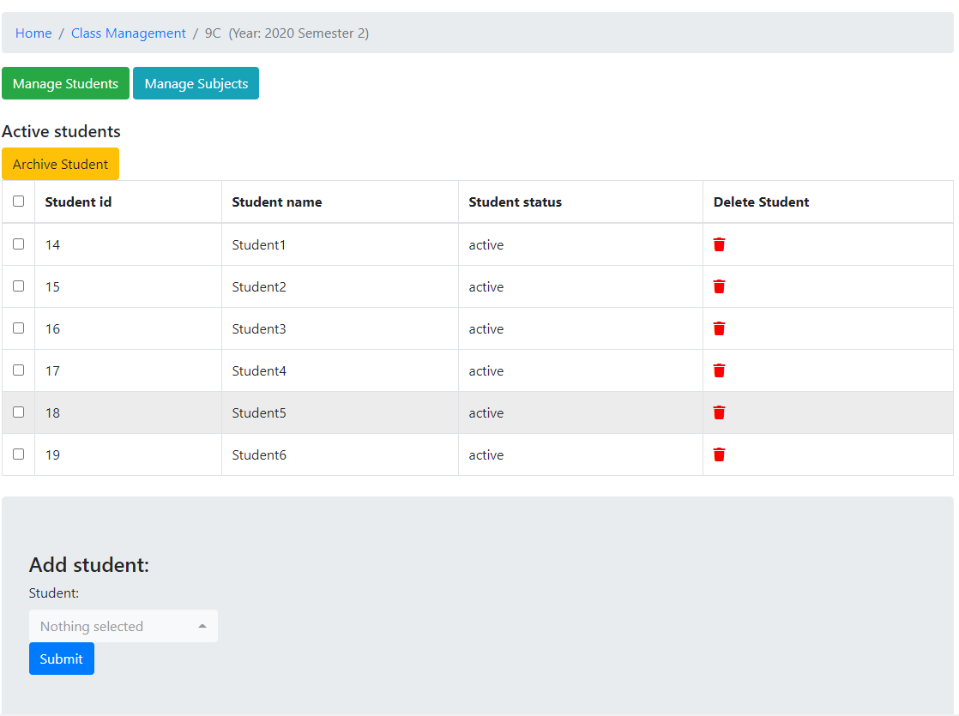

To manage the students and subjects in a class, click the ‘operate’ field which is at the right-hand side column of each class row. Then, you would see the above interface. Similar to other operations, you can add, archive and delete students in a class. Also, like class management, if the student is archived / deleted, the system will undergo cascade archive or deletion.

Please remind that each student can only attend one class. So there will pop-up alert window if you add a student who already has class.

Here is a demonstration of assigning duplicate student into different classes:

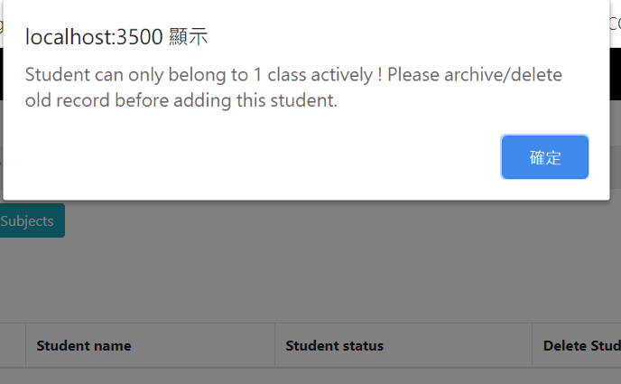

### 2) Managing subjects

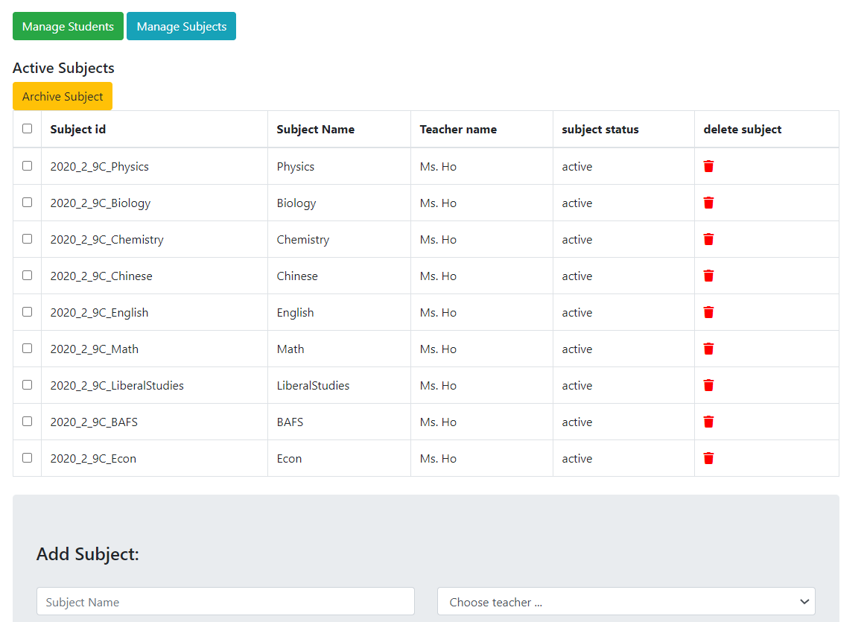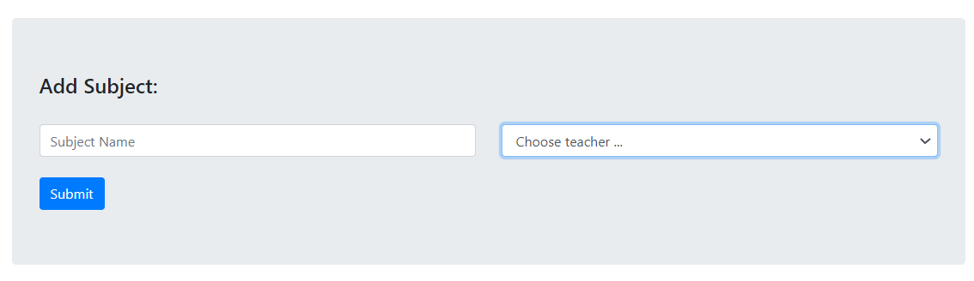

If you click the ‘Manage Subjects’ button (Cyan colour one), you can add new subjects, archive and delete them. To add a new subject to class, you need to input the Subject name and select the teacher who is going to teach this subject for this class. Then click ‘submit’ button to update the record of subject of this class.