Parallel Programming Exercise HW01(A)-0406

Author: | 朱紹勳( b06501018@ntu.edu.tw)
Student ID | b06501018
Department | Engineering Science and Ocean Engineering
(If you and your team member contribute equally, you can use (co-first author), after each name.)

Problem and Proposed Approach
Every process compute p+1, then reduce all the result to global solution, after then, print the result

Theoretical Analysis Model

Performance Benchmark

Conclusion and Discussion
Appendix(optional):
(If something else you want to append in this file, like picture of life game)
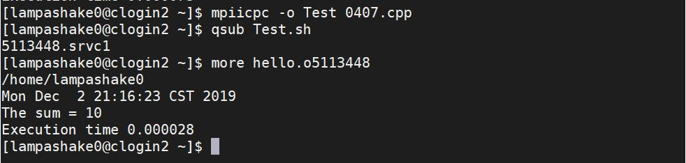
#PBS-l select=1:ncpus=2:mpiprocs=4
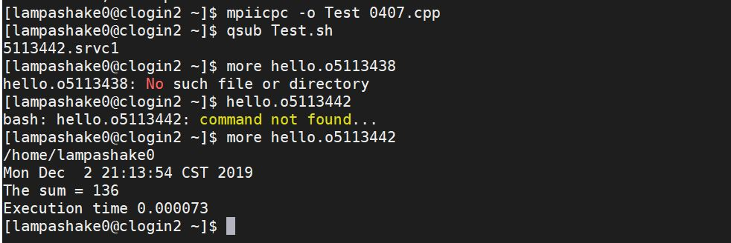
#PBS-l select=1:ncpus=4:mpiprocs=16

