Parallel Programming Exercise HW02(B)-0409

Author: | 朱紹勳( b06501018@ntu.edu.tw)
Student ID | b06501018
Department | Engineering Science and Ocean Engineering
(If you and your team member contribute equally, you can use (co-first author), after each name.)

Problem and Proposed Approach
Find the largest gap between

Theoretical Analysis Model
χ is time needed to mark a cell
μ is time needed to compare two integers
Sequential execution time : χ n sqrt(n)
Reduction time : λlog p
Expected execution time : χ n sqrt(n) + λlog p

Execute sequential algorithm
χ =0.288 nsec
λ=1.506 usec

Performance Benchmark
Processors | 1 | 2 | 4 | 8 | 16
Real execution time | 0.2881219387 | 0.1516421059 | 0.08327167791 | 0.0503571033 | 0.0318107998
Estimate execution  time |  | 0.1440015061 | 0.07200391271 | 0.0360045180 | 0.0180060240
Speedup |  | 1.90 | 3.46 | 5.71 | 9.06
Karp-flatt metrics |  | 0.052 | 0.044 | 0.057 | 0.051
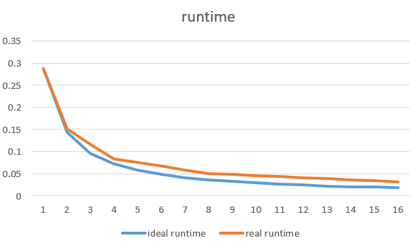
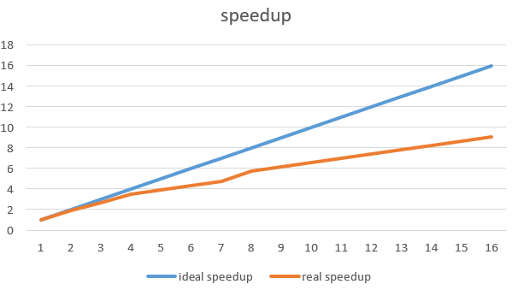
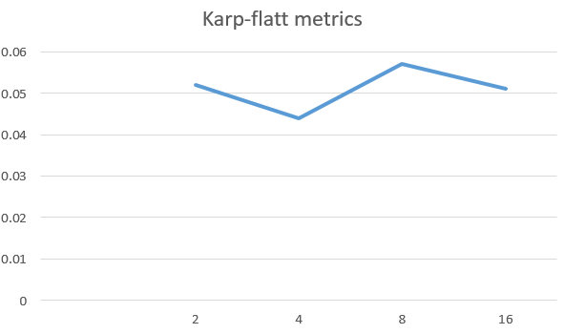

Conclusion and Discussion
1. What is the speedup respect to the number of processors used?

The speedup keeps increasing when the number of processors used increases.

2. How can you improve your program further more?

1. use sample code, with have a better method to find prime

3. How does the communication and cache affect the performance of your program?

The author of the sample code improved the hit rate. Therefore, I guess the main effect to the performance is communication. We need to do two kinds of communication in this program. One is reduction, and the other is send/receive.

4. How does the Karp-Flatt metrics reveal?
In process 4~16, the Karp-flatt metrics keep in range of 0.04 and 0.05, which indicate a large part of serial code. Indeed, the way to find prime in my program is very simple, with have complexity of O(sqrt(n)), I think this is where the larger serial code be.

Appendix(optional):
(If something else you want to append in this file, like picture of life game)

