Parallel Programming Exercise HW04(A)-0614

Author: | 朱紹勳( b06501018@ntu.edu.tw)
Student ID | b06501018
Department | Engineering Science and Ocean Engineering
(If you and your team member contribute equally, you can use (co-first author), after each name.)
林奕青

Problem and Proposed Approach
Game of life sequential version. The textbook had provided rowwise, columnwise, blockwise decomposition for matrix multiplication. However, I had a hard time to complete the parallel version(I will place the uncompleted parallel version in the folder too), the scene shot below is the sequential version.

Appendix(optional):
(If something else you want to append in this file, like picture of life game)
Generation 1:
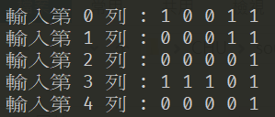
Generation 2
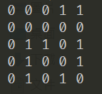
Generation 3
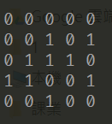

Generation 4
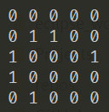
Generation 5
