Parallel Programming Exercise HW07(A)-1004

Author: | 朱紹勳( b06501018@ntu.edu.tw)
Student ID | b06501018
Department | Engineering Science and Ocean Engineering
(If you and your team member contribute equally, you can use (co-first author), after each name.)
陳彥彰 林奕青

Problem and Proposed Approach
Use Monte Carol method to find the volumn of a cube

This problem is pretty easy. The cube is 3-dimesion object, we prepare 3 random number use c++ rand() to represent a specific test in one iteration (x,y,z) in range of 0~2, then use line-point distance formula to find if the point has greater distance than 0.15(d/2), if so, the point is counted. After all the iteration(n set 5000000), find the ratio of point which d>0.15, the volume is the ratio multiply by 8(2x2x2).

Theoretical Analysis Model
χ is time needed to determine if a point is in cube or not
λis time needed to reduce
n is the
Sequential execution time : χ n
Reduction time : λlog p
Expected execution time : χ n/p + λlog p

Execute sequential algorithm
χ =54.48 nsec
λ=1.506 usec

Performance Benchmark
Processors | 1 | 2 | 3 | 4 | 5 | 6 | 7 | 8
result | 7.77165 | 7.77176 | 7.77164 | 7.77157 | 7.77155 | 7.77146 | 7.77148 | 7.77195
Real execution time | 0.2724 | 0.1456 | 0.0978 | 0.0738 | 0.0612 | 0.0512 | 0.0452 | 0.0402
Estimate execution  time |  | 0.1362 | 0.0908 | 0.0681 | 0.0544 | 0.0454 | 0.0389 | 0.0340
Speedup |  | 1.87 | 2.80 | 3.69 | 4.45 | 5.32 | 6.02 | 6.77
Karp-flatt metrics |  | 0.007 | 0.035 | 0.028 | 0.031 | 0.025 | 0.027 | 0.026
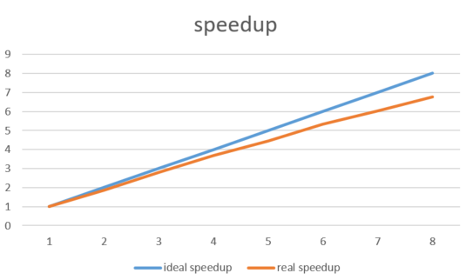
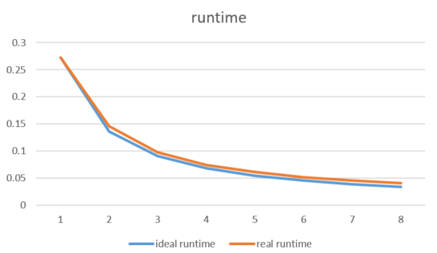
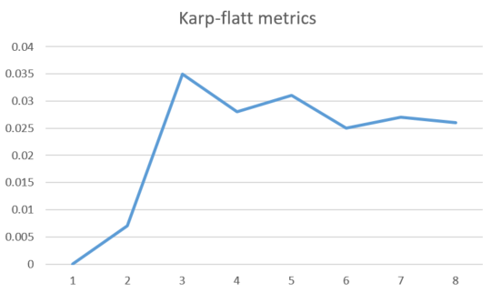

Conclusion and Discussion
What is the speedup respect to the number of the processor used?
The speedup keeps increasing when the number of processors used increases.

How can you improve your program further more?
The result of this program is pretty ideal to me, all result from eight process have maximum error about 0.00034. First, the RNG can be better, or increase the number of iteration, however, we must avoid overflow, furthermore the accuracy of is drastically decrease at n = 500000000.

How does the Karp-Flatt metrics and real?
The Karp-Flatt metrics keep in the range around 0.03, with indicate serial code effect the parallelism, however, this program is pretty simple. According to further experiment, when p = 32, the speed up is 13.39, which has a great difference between estimation, and the Karp-Flatt metrics increase to 0.049, which shows when the process increase in some degree, the communication dose effect the speed of this simple program.

Appendix(optional):
(If something else you want to append in this file, like picture of life game)

