Parallel Programming Exercise HW02(C)-0412

Author: | 朱紹勳( b06501018@ntu.edu.tw)
Student ID | b06501018
Department | Engineering Science and Ocean Engineering
(If you and your team member contribute equally, you can use (co-first author), after each name.)

Problem and Proposed Approach
Problem : Compute the value of π.
<Sol> Edit the sample code on textbook. Parallelize the loop part of the sample code. Each processor computes a summation. Then use reduction to sum them all. After dividing the result with 3n, we get the value of π.

Theoretical Analysis Model
χ is time needed to compute a part of area
Sequential execution time : χ n
Reduction time : λ ceil(log p)
Expected execution time : χ n / p + λ ceil(log p)

Execute sequential algorithm
χ = 224 nsec
λ=1.506 usec

Performance Benchmark\
Processors | 1 | 2 | 4 | 8 | 16
Real execution time | 0.0000112057 | 0.0000128746 | 0.0000220735 | 0.0000408283 | 0.0000779209
Estimate execution  time | 0.0000112057 | 0.0000071 | 0.000005812 | 0.000005918 | 0.00000672
Speedup |  | 0.87 | 0.51 | 0.28 | 0.145
Karp-flatt metrics |  | 1.14 | 2.28 | 3.93 | 7.39

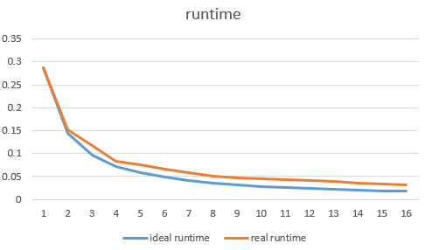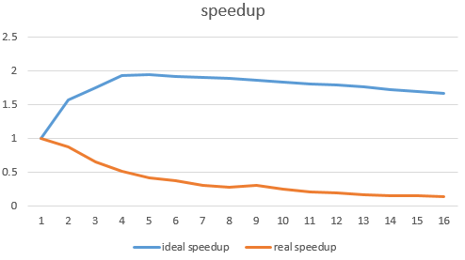
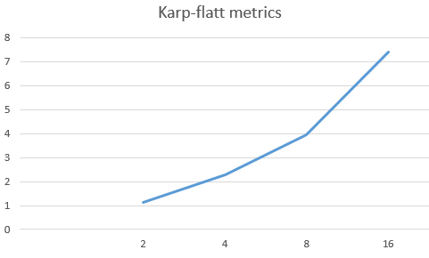

Conclusion andDiscussion
What is the speedup respect to the number of processors used?

The is don’t necessity to parallel, the n is too small, parallel this code only increase the communication latency, which make the speedup even smaller than 1.

2. How can you improve your program further more?

The sequential version is already good enough, the parallel version is needed
only the n increase. According to the textbook, the task should at least 10 time the size of the process.

4. How does the Karp-Flatt metrics reveal?
The karp-Flatt metrics increase very fast. The parallel version even doesn’t increase the speedup of this simple program. The parallel version is needed
only the n increase, or use a more complex version to find pi.
Appendix(optional):

