Parallel Programming Exercise HW03(A)-0511

Author: | 朱紹勳( b06501018@ntu.edu.tw)
Student ID | b06501018
Department | Engineering Science and Ocean Engineering
(If you and your team member contribute equally, you can use (co-first author), after each name.)

Problem and Proposed Approach
Find the summation of divide number(big number computing).

There is no data type in c/c++ that can provide 100 digit precision of float number, which make this simple problem become a little complex. For big number computing, Me and my classmate use array to store all the divide number, then write the function to add items from two array, the carry should always be considered. Because mpi only provide MPI_SUM for basic data type, use big number commuting result should use send and recv, then add the result by using our self-defined function.

Theoretical Analysis Model
χ is time needed to mark a cell
λis time needed to compare two integers
n is the number of items(1000000)
m is the number of digit(100)
Sequential execution time : χ nm
Reduction time : λlog p
Expected execution time : χ nm/p + λlog p

Execute sequential algorithm
χ =11.479 nsec
λ=1.506 usec

Performance Benchmark
Processors | 1 | 2 | 3 | 4 | 5 | 6 | 7 | 8
Real execution time | 1.147924 | 0.574637 | 0.404301 | 0.344083 | 0.286593 | 0.249715 | 0.202429 | 0.1744
Estimate execution  time | 1.147924 | 0.573963 | 0.382643 | 0.2869 | 0.229588 | 0.191324 | 0.163993 | 0.143495
Speedup |  | 1.99 | 2.83 | 3.34 | 4.01 | 4.59 | 5.67 | 6.58
Karp-flatt metrics |  | 0.005 | 0.03 | 0.066 | 0.061 | 0.06 | 0.034 | 0.03

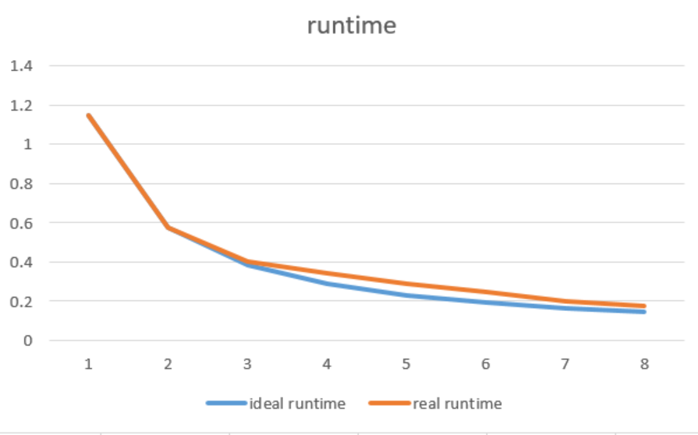
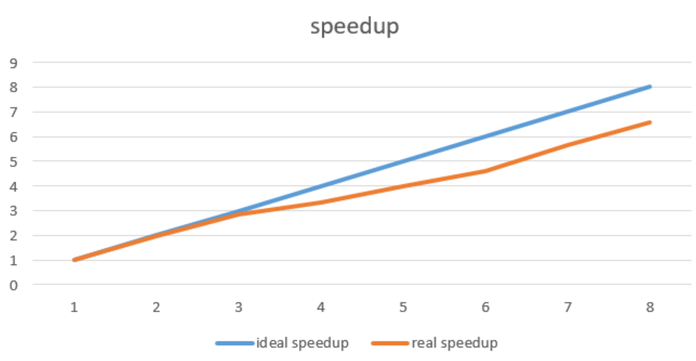

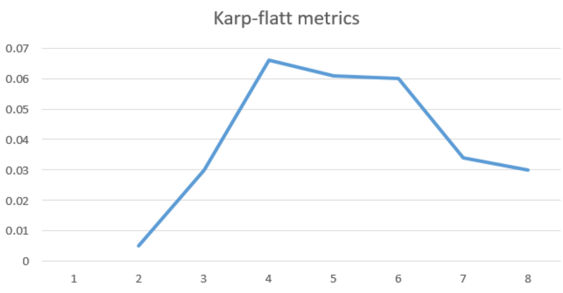

Conclusion and Discussion
What is the speedup respect to the number of the processor used?
The speedup keeps increasing when the number of processors used increases.

How can you improve your program further more?
I want to use Reduction first, however the big number computing require special operation for summation(addto), the reduction only have MPI_SUM, MPI_MAX…, so I have to use send and recv, then add the number by using array.
How does the Karp-Flatt metrics and Iso-efficiency metrics reveal?
The Karp-Flatt metrics have increase in the first place, which indicate a large part serial code is inside the program, for example dividebyn() and addto() function are all sequential code. However, the metrics decrease for unknown reason at using 7 & 8 processor, the Karp-flatt metrics should never decrease, I think the better solution is to doing the experiment for several time then get the average of running time, which should give me a more accurate result.

Appendix(optional):
(If something else you want to append in this file, like picture of life game)

