Parallel Programming Exercise HW05(A)-0810

Author: | 朱紹勳( b06501018@ntu.edu.tw)
Student ID | b06501018
Department | Engineering Science and Ocean Engineering
(If you and your team member contribute equally, you can use (co-first author), after each name.)

Problem and Proposed Approach
Data distribution of matrix: checkerboard
Data distribution of vector: blocked across process in col 0
O(n*n/p + n log p / sqrt(p) )
use the sample code, mv3.c, gen-double-matrix.c, MyMPI.c
First use gen-double-matrix.c to generate a matrix and a vector with double data type. Then compile the mv3.c. mv3.c will read the matrix and vector generate from gen-double-matrix.c, and show the result of matrix-vector multiplication.

Theoretical Analysis Model
O(n*n/p + n log p / sqrt(p) )

Processors | 1 | 2 | 3 | 4 | 5 | 6 | 7 | 8
Real execution time | 0.000212 | 0.000214 | 0.000248 | 0.000251 | 0.000280 | 0.000260 | 0.000247 | 0.000302
Speedup |  | 0.99 | 0.85 | 0.84 | 0.75 | 0.81 | 0.85 | 0.70
Karp-flatt metrics |  | 1.02 | 1.26 | 1.25 | 1.41 | 1.28 | 1.20 | 1.48
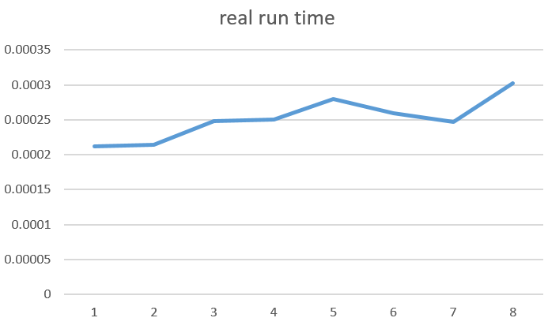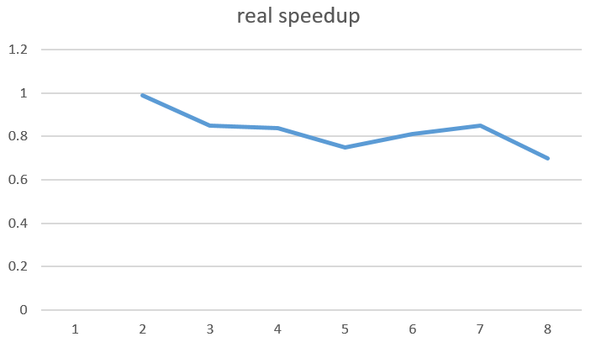
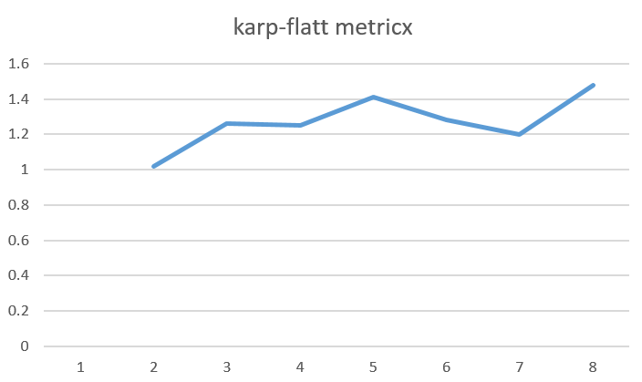

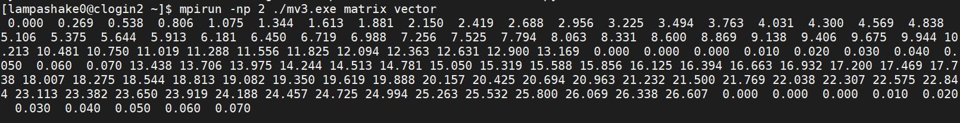
MV5) N = 120, Processes = 2, Time = 0.000214 sec,Mflop = 134.52
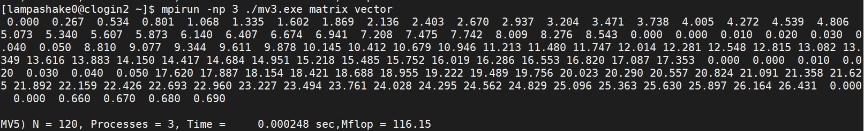
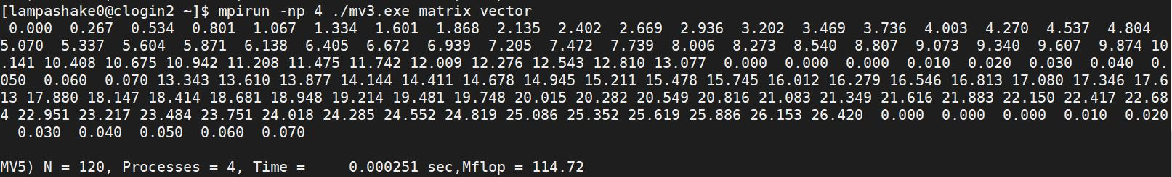

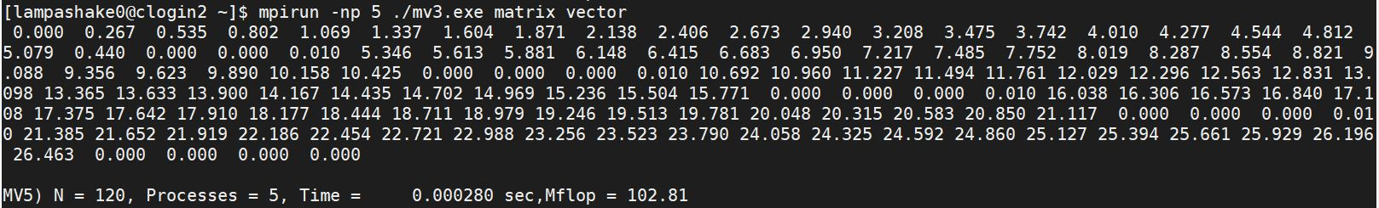

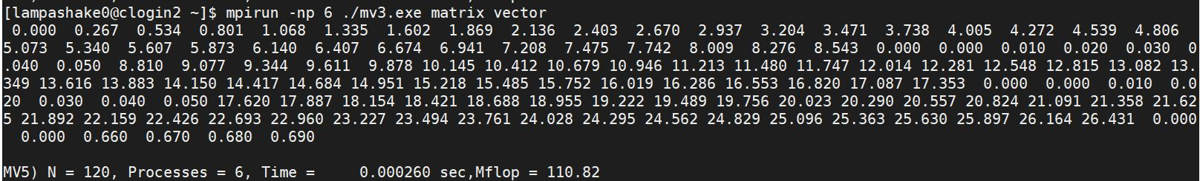

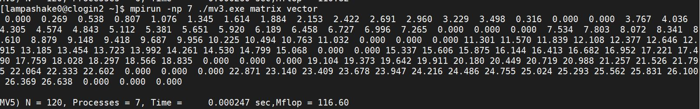

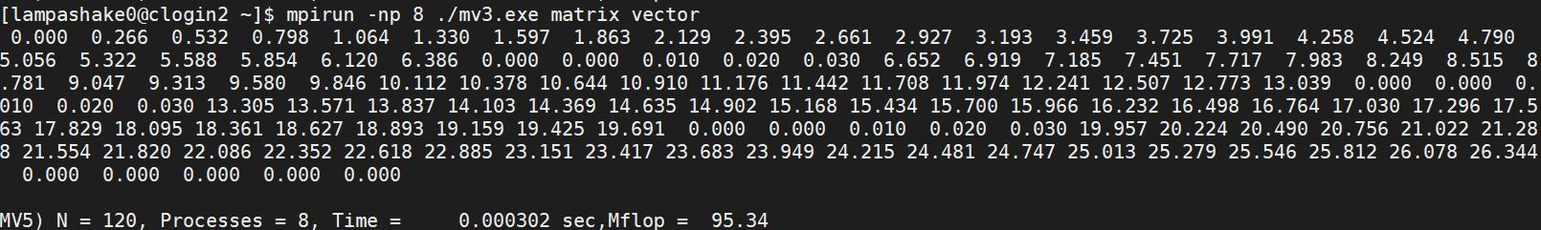

Conclusion and Discussion
What is the speedup respect to the number of the processor used?
Unlike what had written in the textbook, the speedup didn’t increase when the process increase.
How can you improve your program further more?
The sample code is from textbook, where is not much I can improve.
How does the Karp-Flatt metrics reveal?
The Karp-Flatt metrics is unstable is different in different process, so I can’t tell what is the real cause of the bad performance, however, the benchmark example in the textbook is a 1000X1000 matrix multiply a 1000 size vector, in the sample code or double matrix generator, the size of multiplication is much smaller. It is my explain about the bad performance – the size of the computation is too small, if the size increase, we might have the chance to get similar result as in the textbook.
Appendix(optional):
(If something else you want to append in this file, like picture of life game)

