Parallel Programming Exercise HW06(A)-0910

Author: | 朱紹勳( b06501018@ntu.edu.tw)
Student ID | b06501018
Department | Engineering Science and Ocean Engineering
(If you and your team member contribute equally, you can use (co-first author), after each name.)
陳彥彰 林奕青

Problem and Proposed Approach
Find perfect number, using data decomposition or manager-worker.

Theoretical Analysis Model
χ is time needed to determine if a point is in cube or not
λis time needed to reduce
n is the pow(2,i)
m is the first n perfect number
Sequential execution time : χ(i*sqrt(n)+mp)
Reduction time : λlog p
Expected execution time : χ (i*sqrt(m)/p+mp) + λlog p

Performance Benchmark
Processors | 1 | 2 | 3 | 4 | 5 | 6 | 7 | 8
Real execution time |  | 0.000034 | 0.000027 | 0.000023 | 0.000022 | 0.00002 | 0.00002 | 0.000023
Estimate execution  time |  | 0.000034 | 0.000017 | 0.000013 | 0.000008 | 0.000007 | 0.000006 | 0.000005
Speedup |  |  | 1.26 | 1.47 | 1.55 | 1.7 | 1.7 | 1.47
Karp-flatt metrics |  |  | 0.7 | 0.52 | 0.51 | 0.5 | 0.5 | 0.62

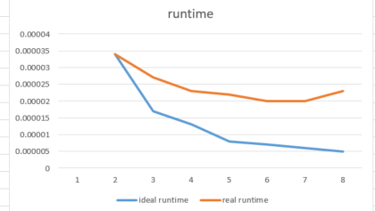
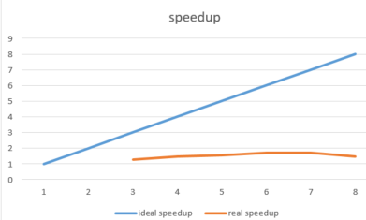
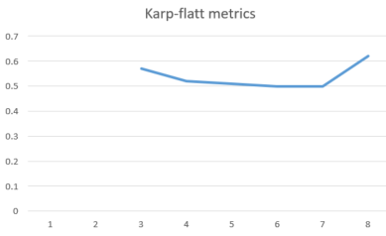

Conclusion and Discussion
What is the speedup respect to the number of the processor used?
Unfortunately, the data decomposition & manager-worker both have little effect to speedup of finding perfect number.
How can you improve your program further more?
Although I implement manger-worker, the improvement is still very little

How does the Karp-Flatt metrics reveal?
The speedup stay at maximum of 1.6~1.7 when the process is greater than 5, and the Karp-Flatt metrics increase., which shows increase of process can not really help the whole program to run faster.
Appendix(optional):
(If something else you want to append in this file, like picture of life game)

