//

// GameViewController.swift

// Cannon

//

import AVFoundation

import SpriteKit

// sounds defined once and reused throughout app

var blockerHitSound: AVAudioPlayer!

var targetHitSound: AVAudioPlayer!

var cannonFireSound: AVAudioPlayer!

class GameViewController: UIViewController {

// called when GameViewController is displayed on screen

override func viewDidLoad() {

super.viewDidLoad()

do{

// load sounds when view controller loads

blockerHitSound = try AVAudioPlayer(contentsOfURL:

NSURL(fileURLWithPath: NSBundle.mainBundle().pathForResource(

"blocker_hit", ofType: "wav")!), fileTypeHint: nil)

targetHitSound = try AVAudioPlayer(contentsOfURL:

NSURL(fileURLWithPath: NSBundle.mainBundle().pathForResource(

"target_hit", ofType: "wav")!), fileTypeHint: nil)

cannonFireSound = try AVAudioPlayer(contentsOfURL:

NSURL(fileURLWithPath: NSBundle.mainBundle().pathForResource(

"cannon_fire", ofType: "wav")!), fileTypeHint: nil)

}catch {

print(error)

}

let scene = GameScene(size: view.bounds.size) // create scene

scene.scaleMode = .AspectFill // resize scene to fit the screen

let skView = view as! SKView // get GameViewController's SKView

skView.showsFPS = true // display frames-per-second

skView.showsNodeCount = true // display # of nodes on screen

skView.ignoresSiblingOrder = true // for SpriteKit optimizations

skView.presentScene(scene) // display the scene

}

}

//

// GameScene.swift

// Cannon

//

import AVFoundation

import SpriteKit

// used to identify objects for collision detection

struct CollisionCategory {

static let Blocker : UInt32 = 1

static let Target: UInt32 = 1 << 1 // 2

static let Cannonball: UInt32 = 1 << 2 // 4

static let Wall: UInt32 = 1 << 3 // 8

}

// global because no type constants in Swift classes yet

private let numberOfTargets = 9

class GameScene: SKScene, SKPhysicsContactDelegate {

// game elements that the scene interacts with programmatically

private var secondsLabel: SKLabelNode! = nil

private var cannon: Cannon! = nil

// game state

private var timeLeft: CFTimeInterval = 10.0

private var elapsedTime: CFTimeInterval = 0.0

private var previousTime: CFTimeInterval = 0.0

private var targetsRemaining: Int = numberOfTargets

// called when scene is presented

override func didMoveToView(view: SKView) {

self.backgroundColor = SKColor.whiteColor() // set background

// helps determine game element speeds based on scene size

var velocityMultiplier = self.size.width / self.size.height

if UIDevice.currentDevice().userInterfaceIdiom == .Pad {

velocityMultiplier = CGFloat(velocityMultiplier * 6.0)

}

// configure the physicsWorld

self.physicsWorld.gravity = CGVectorMake(0.0, 0.0) // no gravity

self.physicsWorld.contactDelegate = self

// create border for objects colliding with screen edges

self.physicsBody = SKPhysicsBody(edgeLoopFromRect: self.frame)

self.physicsBody?.friction = 0.0 // no friction

self.physicsBody?.categoryBitMask = CollisionCategory.Wall

self.physicsBody?.contactTestBitMask = CollisionCategory.Cannonball

createLabels() // display labels at scene's top-left corner

// create and attach Cannon

cannon = Cannon(sceneSize: size,

velocityMultiplier: velocityMultiplier)

cannon.position = CGPointMake(0.0, self.frame.height / 2.0)

self.addChild(cannon)

// create and attach medium Blocker and start moving

let blockerxPercent = CGFloat(0.5)

let blockeryPercent = CGFloat(0.25)

let blocker = Blocker(sceneSize: self.frame.size,

blockerSize: BlockerSize.Medium)

blocker.position = CGPointMake(self.frame.width * blockerxPercent,

self.frame.height * blockeryPercent)

self.addChild(blocker)

blocker.startMoving(velocityMultiplier)

// create and attach targets of random sizes and start moving

let targetxPercent = CGFloat(0.6) // % across scene to 1st target

var targetX = size.width * targetxPercent

for _ in 1 ... numberOfTargets {

let target = Target(sceneSize: self.frame.size)

target.position = CGPointMake(targetX, self.frame.height * 0.5)

targetX += target.size.width + 5.0

self.addChild(target)

target.startMoving(velocityMultiplier)

}

}

// create the text labels

func createLabels() {

// constants related to displaying text for time remaining

let edgeDistance = CGFloat(20.0)

let labelSpacing = CGFloat(5.0)

let fontSize = CGFloat(16.0)

// configure "Time remaining: " label

let timeRemainingLabel = SKLabelNode(fontNamed: "Chalkduster")

timeRemainingLabel.text = "Time remaining:"

timeRemainingLabel.fontSize = fontSize

timeRemainingLabel.fontColor = SKColor.blackColor()

timeRemainingLabel.horizontalAlignmentMode = .Left

let y = self.frame.height -

timeRemainingLabel.fontSize - edgeDistance

timeRemainingLabel.position = CGPoint(x: edgeDistance, y: y)

self.addChild(timeRemainingLabel)

// configure label for displaying time remaining

secondsLabel = SKLabelNode(fontNamed: "Chalkduster")

secondsLabel.text = "0.0 seconds"

secondsLabel.fontSize = fontSize

secondsLabel.fontColor = SKColor.blackColor()

secondsLabel.horizontalAlignmentMode = .Left

let x = timeRemainingLabel.calculateAccumulatedFrame().width +

edgeDistance + labelSpacing

secondsLabel.position = CGPoint(x: x, y: y)

self.addChild(secondsLabel)

}

// test whether an SKPhysicsBody is the cannonball

func isCannonball(body: SKPhysicsBody) -> Bool {

return body.categoryBitMask & CollisionCategory.Cannonball != 0

}

// test whether an SKPhysicsBody is a blocker

func isBlocker(body: SKPhysicsBody) -> Bool {

return body.categoryBitMask & CollisionCategory.Blocker != 0

}

// test whether an SKPhysicsBody is a target

func isTarget(body: SKPhysicsBody) -> Bool {

return body.categoryBitMask & CollisionCategory.Target != 0

}

// test whether an SKPhysicsBody is a wall

func isWall(body: SKPhysicsBody) -> Bool {

return body.categoryBitMask & CollisionCategory.Wall != 0

}

// called when collision starts

func didBeginContact(contact: SKPhysicsContact) {

var cannonball: SKPhysicsBody

var otherBody: SKPhysicsBody

// determine which SKPhysicsBody is the cannonball

if isCannonball(contact.bodyA) {

cannonball = contact.bodyA

otherBody = contact.bodyB

} else {

cannonball = contact.bodyB

otherBody = contact.bodyA

}

// cannonball hit wall, so remove from screen

if isWall(otherBody) || isTarget(otherBody) ||

isBlocker(otherBody) {

cannon.cannonballOnScreen = false

cannonball.node?.removeFromParent()

}

// cannonball hit blocker, so play blocker sound

if isBlocker(otherBody) {

let blocker = otherBody.node as! Blocker

blocker.playHitSound()

timeLeft -= blocker.blockerTimePenalty()

}

// cannonball hit target

if isTarget(otherBody) {

--targetsRemaining

let target = otherBody.node as! Target

target.removeFromParent()

target.playHitSound()

timeLeft += target.targetTimeBonus()

}

}

// fire the cannon if there is not a cannonball on screen

override func touchesBegan(touches: Set<UITouch>, withEvent event: UIEvent?) {

for touch in touches {

let location = touch.locationInNode(self)

cannon.rotateToPointAndFire(location, scene: self)

}

}

// updates to perform in each frame of the animation

override func update(currentTime: CFTimeInterval) {

if previousTime == 0.0 {

previousTime = currentTime

}

elapsedTime += (currentTime - previousTime)

timeLeft -= (currentTime - previousTime)

previousTime = currentTime

if timeLeft < 0 {

timeLeft = 0

}

secondsLabel.text = String(format: "%.1f seconds", timeLeft)

// check whether game is over

if targetsRemaining == 0 || timeLeft <= 0 {

runAction(SKAction.runBlock({self.gameOver()}))

}

}

// display the game over scene

func gameOver() {

let flipTransition = SKTransition.flipHorizontalWithDuration(1.0)

let gameOverScene = GameOverScene(size: self.size,

won: targetsRemaining == 0 ? true : false,

time: elapsedTime)

gameOverScene.scaleMode = .AspectFill

self.view?.presentScene(gameOverScene, transition: flipTransition)

}

}

self.addChild(cannon)

// create and attach medium Blocker and start moving

let blockerxPercent = CGFloat(0.5)

let blockeryPercent = CGFloat(0.25)

let blocker = Blocker(sceneSize: self.frame.size,

blockerSize: BlockerSize.Medium)

blocker.position = CGPointMake(self.frame.width * blockerxPercent,

self.frame.height * blockeryPercent)

self.addChild(blocker)

blocker.startMoving(velocityMultiplier)

// create and attach targets of random sizes and start moving

let targetxPercent = CGFloat(0.6) // % across scene to 1st target

var targetX = size.width * targetxPercent

for _ in 1 ... numberOfTargets {

let target = Target(sceneSize: self.frame.size)

target.position = CGPointMake(targetX, self.frame.height * 0.5)

targetX += target.size.width + 5.0

self.addChild(target)

target.startMoving(velocityMultiplier)

}

}

// create the text labels

func createLabels() {

// constants related to displaying text for time remaining

let edgeDistance = CGFloat(20.0)

let labelSpacing = CGFloat(5.0)

let fontSize = CGFloat(16.0)

// configure "Time remaining: " label

let timeRemainingLabel = SKLabelNode(fontNamed: "Chalkduster")

timeRemainingLabel.text = "Time remaining:"

timeRemainingLabel.fontSize = fontSize

timeRemainingLabel.fontColor = SKColor.blackColor()

timeRemainingLabel.horizontalAlignmentMode = .Left

let y = self.frame.height -

timeRemainingLabel.fontSize - edgeDistance

timeRemainingLabel.position = CGPoint(x: edgeDistance, y: y)

self.addChild(timeRemainingLabel)

// configure label for displaying time remaining

secondsLabel = SKLabelNode(fontNamed: "Chalkduster")

secondsLabel.text = "0.0 seconds"

secondsLabel.fontSize = fontSize

secondsLabel.fontColor = SKColor.blackColor()

secondsLabel.horizontalAlignmentMode = .Left

let x = timeRemainingLabel.calculateAccumulatedFrame().width +

edgeDistance + labelSpacing

secondsLabel.position = CGPoint(x: x, y: y)

self.addChild(secondsLabel)

}

// test whether an SKPhysicsBody is the cannonball

func isCannonball(body: SKPhysicsBody) -> Bool {

return body.categoryBitMask & CollisionCategory.Cannonball != 0

}

// test whether an SKPhysicsBody is a blocker

func isBlocker(body: SKPhysicsBody) -> Bool {

return body.categoryBitMask & CollisionCategory.Blocker != 0

}

// test whether an SKPhysicsBody is a target

func isTarget(body: SKPhysicsBody) -> Bool {

return body.categoryBitMask & CollisionCategory.Target != 0

}

// test whether an SKPhysicsBody is a wall

func isWall(body: SKPhysicsBody) -> Bool {

return body.categoryBitMask & CollisionCategory.Wall != 0

}

// called when collision starts

func didBeginContact(contact: SKPhysicsContact) {

var cannonball: SKPhysicsBody

var otherBody: SKPhysicsBody

// determine which SKPhysicsBody is the cannonball

if isCannonball(contact.bodyA) {

cannonball = contact.bodyA

otherBody = contact.bodyB

} else {

cannonball = contact.bodyB

otherBody = contact.bodyA

}

// cannonball hit wall, so remove from screen

if isWall(otherBody) || isTarget(otherBody) ||

isBlocker(otherBody) {

cannon.cannonballOnScreen = false

cannonball.node?.removeFromParent()

}

// cannonball hit blocker, so play blocker sound

if isBlocker(otherBody) {

let blocker = otherBody.node as! Blocker

blocker.playHitSound()

timeLeft -= blocker.blockerTimePenalty()

}

// cannonball hit target

if isTarget(otherBody) {

--targetsRemaining

let target = otherBody.node as! Target

target.removeFromParent()

target.playHitSound()

timeLeft += target.targetTimeBonus()

}

}

// fire the cannon if there is not a cannonball on screen

override func touchesBegan(touches: Set<UITouch>, withEvent event: UIEvent?) {

for touch in touches {

let location = touch.locationInNode(self)

cannon.rotateToPointAndFire(location, scene: self)

}

}

// updates to perform in each frame of the animation

override func update(currentTime: CFTimeInterval) {

if previousTime == 0.0 {

previousTime = currentTime

}

elapsedTime += (currentTime - previousTime)

timeLeft -= (currentTime - previousTime)

previousTime = currentTime

if timeLeft < 0 {

timeLeft = 0

}

secondsLabel.text = String(format: "%.1f seconds", timeLeft)

// check whether game is over

if targetsRemaining == 0 || timeLeft <= 0 {

runAction(SKAction.runBlock({self.gameOver()}))

}

}

// display the game over scene

func gameOver() {

let flipTransition = SKTransition.flipHorizontalWithDuration(1.0)

let gameOverScene = GameOverScene(size: self.size,

won: targetsRemaining == 0 ? true : false,

time: elapsedTime)

gameOverScene.scaleMode = .AspectFill

self.view?.presentScene(gameOverScene, transition: flipTransition)

}

}

// test whether an SKPhysicsBody is a blocker

func isBlocker(body: SKPhysicsBody) -> Bool {

return body.categoryBitMask & CollisionCategory.Blocker != 0

}

// test whether an SKPhysicsBody is a target

func isTarget(body: SKPhysicsBody) -> Bool {

return body.categoryBitMask & CollisionCategory.Target != 0

}

// test whether an SKPhysicsBody is a wall

func isWall(body: SKPhysicsBody) -> Bool {

return body.categoryBitMask & CollisionCategory.Wall != 0

}

// called when collision starts

func didBeginContact(contact: SKPhysicsContact) {

var cannonball: SKPhysicsBody

var otherBody: SKPhysicsBody

// determine which SKPhysicsBody is the cannonball

if isCannonball(contact.bodyA) {

cannonball = contact.bodyA

otherBody = contact.bodyB

} else {

cannonball = contact.bodyB

otherBody = contact.bodyA

}

// cannonball hit wall, so remove from screen

if isWall(otherBody) || isTarget(otherBody) ||

isBlocker(otherBody) {

cannon.cannonballOnScreen = false

cannonball.node?.removeFromParent()

}

// cannonball hit blocker, so play blocker sound

if isBlocker(otherBody) {

let blocker = otherBody.node as! Blocker

blocker.playHitSound()

timeLeft -= blocker.blockerTimePenalty()

}

// cannonball hit target

if isTarget(otherBody) {

--targetsRemaining

let target = otherBody.node as! Target

target.removeFromParent()

target.playHitSound()

timeLeft += target.targetTimeBonus()

}

}

// fire the cannon if there is not a cannonball on screen

override func touchesBegan(touches: Set<UITouch>, withEvent event: UIEvent?) {

for touch in touches {

let location = touch.locationInNode(self)

cannon.rotateToPointAndFire(location, scene: self)

}

}

// updates to perform in each frame of the animation

override func update(currentTime: CFTimeInterval) {

if previousTime == 0.0 {

previousTime = currentTime

}

elapsedTime += (currentTime - previousTime)

timeLeft -= (currentTime - previousTime)

previousTime = currentTime

if timeLeft < 0 {

timeLeft = 0

}

secondsLabel.text = String(format: "%.1f seconds", timeLeft)

// check whether game is over

if targetsRemaining == 0 || timeLeft <= 0 {

runAction(SKAction.runBlock({self.gameOver()}))

}

}

// display the game over scene

func gameOver() {

let flipTransition = SKTransition.flipHorizontalWithDuration(1.0)

let gameOverScene = GameOverScene(size: self.size,

won: targetsRemaining == 0 ? true : false,

time: elapsedTime)

gameOverScene.scaleMode = .AspectFill

self.view?.presentScene(gameOverScene, transition: flipTransition)

}

}

}

}

// updates to perform in each frame of the animation

override func update(currentTime: CFTimeInterval) {

if previousTime == 0.0 {

previousTime = currentTime

}

elapsedTime += (currentTime - previousTime)

timeLeft -= (currentTime - previousTime)

previousTime = currentTime

if timeLeft < 0 {

timeLeft = 0

}

secondsLabel.text = String(format: "%.1f seconds", timeLeft)

// check whether game is over

if targetsRemaining == 0 || timeLeft <= 0 {

runAction(SKAction.runBlock({self.gameOver()}))

}

}

// display the game over scene

func gameOver() {

let flipTransition = SKTransition.flipHorizontalWithDuration(1.0)

let gameOverScene = GameOverScene(size: self.size,

won: targetsRemaining == 0 ? true : false,

time: elapsedTime)

gameOverScene.scaleMode = .AspectFill

self.view?.presentScene(gameOverScene, transition: flipTransition)

}

}

Type to enter text

//

// Blocker.swift

// Cannon

//

import AVFoundation

import SpriteKit

enum BlockerSize: CGFloat {

case Small = 1.0

case Medium = 2.0

case Large = 3.0

}

class Blocker : SKSpriteNode {

// constants for configuring a blocker

private let blockerWidthPercent = CGFloat(0.025)

private let blockerHeightPercent = CGFloat(0.125)

private let blockerSpeed = CGFloat(5.0)

private let blockerSize: BlockerSize

// initializes the Cannon, sizing it based on the scene's size

init(sceneSize: CGSize, blockerSize: BlockerSize) {

self.blockerSize = blockerSize

super.init(

texture: SKTexture(imageNamed: "blocker"),

color: UIColor.clearColor(),

size: CGSizeMake(sceneSize.width * blockerWidthPercent,

sceneSize.height * blockerHeightPercent *

blockerSize.rawValue))

// set up the blocker's physicsBody

self.physicsBody =

SKPhysicsBody(texture: self.texture!, size: self.size)

self.physicsBody?.friction = 0.0

self.physicsBody?.restitution = 1.0

self.physicsBody?.linearDamping = 0.0

self.physicsBody?.allowsRotation = true

self.physicsBody?.usesPreciseCollisionDetection = true

self.physicsBody?.categoryBitMask = CollisionCategory.Blocker

self.physicsBody?.contactTestBitMask = CollisionCategory.Cannonball

}

// not called, but required if subclass defines an init

required init?(coder aDecoder: NSCoder) {

fatalError("init(coder:) has not been implemented")

}

// applies an impulse to the blocker

func startMoving(velocityMultiplier: CGFloat) {

self.physicsBody?.applyImpulse(CGVectorMake(0.0,

velocityMultiplier * blockerSpeed * blockerSize.rawValue))

}

// plays the blockerHitSound

func playHitSound() {

blockerHitSound.play()

}

// returns time penalty based on blocker size

func blockerTimePenalty() -> CFTimeInterval {

return CFTimeInterval(BlockerSize.Small.rawValue)

}

}

}

// returns time penalty based on blocker size

func blockerTimePenalty() -> CFTimeInterval {

return CFTimeInterval(BlockerSize.Small.rawValue)

}

}

//

// Target.swift

// Cannon

//

import SpriteKit

import AVFoundation

// enum of target sizes

enum TargetSize: CGFloat {

case Small = 1.0

case Medium = 1.5

case Large = 2.0

}

// enum of target sprite names

enum TargetColor: String {

case Red = "target_red"

case Green = "target_green"

case Blue = "target_blue"

}

// arrays of enum constants used for random selections;

// global because Swift does not yet support class variables

private let targetColors =

[TargetColor.Red, TargetColor.Green, TargetColor.Blue]

private let targetSizes =

[TargetSize.Small, TargetSize.Medium, TargetSize.Large]

class Target : SKSpriteNode {

// constants for configuring a blocker

private let targetWidthPercent = CGFloat(0.025)

private let targetHeightPercent = CGFloat(0.1)

private let targetSpeed = CGFloat(2.0)

private let targetSize: TargetSize

private let targetColor: TargetColor

// initializes the Cannon, sizing it based on the scene's size

init(sceneSize: CGSize) {

// select random target size and random color

self.targetSize = targetSizes[

Int(arc4random_uniform(UInt32(targetSizes.count)))]

self.targetColor = targetColors[

Int(arc4random_uniform(UInt32(targetColors.count)))]

// call SKSpriteNode designated initializer

super.init(

texture: SKTexture(imageNamed: targetColor.rawValue),

color: UIColor.clearColor(),

size: CGSizeMake(sceneSize.width * targetWidthPercent,

sceneSize.height * targetHeightPercent *

targetSize.rawValue))

// set up the target's physicsBody

self.physicsBody =

SKPhysicsBody(texture: self.texture!, size: self.size)

self.physicsBody?.friction = 0.0

self.physicsBody?.restitution = 1.0

self.physicsBody?.linearDamping = 0.0

self.physicsBody?.allowsRotation = true

self.physicsBody?.usesPreciseCollisionDetection = true

self.physicsBody?.categoryBitMask = CollisionCategory.Target

self.physicsBody?.contactTestBitMask =

CollisionCategory.Cannonball

}

// not called, but required if subclass defines an init

required init?(coder aDecoder: NSCoder) {

fatalError("init(coder:) has not been implemented")

}

// applies an impulse to the target

func startMoving(velocityMultiplier: CGFloat) {

self.physicsBody?.applyImpulse(CGVectorMake(0.0,

velocityMultiplier * targetSize.rawValue * (targetSpeed +

CGFloat(arc4random_uniform(UInt32(targetSpeed) + 5)))))

}

// plays the targetHitSound

func playHitSound() {

targetHitSound.play()

}

// returns time bonus based on target size

func targetTimeBonus() -> CFTimeInterval {

switch targetSize {

case .Small:

return 3.0

case .Medium:

return 2.0

case .Large:

return 1.0

}

}

}

self.physicsBody?.friction = 0.0

self.physicsBody?.restitution = 1.0

self.physicsBody?.linearDamping = 0.0

self.physicsBody?.allowsRotation = true

self.physicsBody?.usesPreciseCollisionDetection = true

self.physicsBody?.categoryBitMask = CollisionCategory.Target

self.physicsBody?.contactTestBitMask =

CollisionCategory.Cannonball

}

// not called, but required if subclass defines an init

required init?(coder aDecoder: NSCoder) {

fatalError("init(coder:) has not been implemented")

}

// applies an impulse to the target

func startMoving(velocityMultiplier: CGFloat) {

self.physicsBody?.applyImpulse(CGVectorMake(0.0,

velocityMultiplier * targetSize.rawValue * (targetSpeed +

CGFloat(arc4random_uniform(UInt32(targetSpeed) + 5)))))

}

// plays the targetHitSound

func playHitSound() {

targetHitSound.play()

}

// returns time bonus based on target size

func targetTimeBonus() -> CFTimeInterval {

switch targetSize {

case .Small:

return 3.0

case .Medium:

return 2.0

case .Large:

return 1.0

}

}

}

//

// Cannon.swift

// Cannon

//

import AVFoundation

import SpriteKit

class Cannon : SKNode {

// constants

private let cannonSizePercent = CGFloat(0.15)

private let cannonballSizePercent = CGFloat(0.075)

private let cannonBarrelWidthPercent = CGFloat(0.075)

private let cannonBarrelLengthPercent = CGFloat(0.15)

private let cannonballSpeed: CGFloat

private let cannonballSpeedMultiplier = CGFloat(0.25)

private let barrelLength: CGFloat

private var barrelAngle = CGFloat(0.0)

private var cannonball: SKSpriteNode!

var cannonballOnScreen = false

// initializes the Cannon, sizing it based on the scene's size

init(sceneSize: CGSize, velocityMultiplier: CGFloat) {

cannonballSpeed = cannonballSpeedMultiplier * velocityMultiplier

barrelLength = sceneSize.height * cannonBarrelLengthPercent

super.init()

// configure cannon barrel

let barrel = SKShapeNode(rectOfSize: CGSizeMake(barrelLength,

sceneSize.height * cannonBarrelWidthPercent))

barrel.fillColor = SKColor.blackColor()

self.addChild(barrel)

// configure cannon base

let cannonBase = SKSpriteNode(imageNamed: "base")

cannonBase.size = CGSizeMake(sceneSize.height * cannonSizePercent,

sceneSize.height * cannonSizePercent)

self.addChild(cannonBase)

// position barrel based on cannonBase

barrel.position = CGPointMake(cannonBase.size.width / 2.0, 0.0)

}

// not called, but required if subclass defines an init

required init?(coder aDecoder: NSCoder) {

fatalError("init(coder:) has not been implemented")

}

// rotate cannon to user's touch point, then fire cannonball

func rotateToPointAndFire(point: CGPoint, scene: SKScene) {

// calculate barrel rotation angle

let deltaX = point.x

let deltaY = point.y - self.position.y

barrelAngle = CGFloat(atan2f(Float(deltaY), Float(deltaX)))

// rotate the cannon barrel to touch point, then fire

let rotateAction = SKAction.rotateToAngle(

barrelAngle, duration: 0.25, shortestUnitArc: true)

// perform rotate action, then call fireCannonball

self.runAction(rotateAction, completion: {

if !self.cannonballOnScreen {

self.fireCannonball(scene)

}

})

}

// create cannonball, attach to scene and start it moving

private func fireCannonball(scene: SKScene) {

cannonballOnScreen = true

// determine starting point for cannonball based on

// barrelLength and current barrelAngle

let x = cos(barrelAngle) * barrelLength

let y = sin(barrelAngle) * barrelLength

let cannonball = createCannonball(scene.frame.size)

cannonball.position = CGPointMake(x, self.position.y + y)

// create based on barrel angle

let velocityVector =

CGVectorMake(x * cannonballSpeed, y * cannonballSpeed)

// put cannonball on screen, move it and play fire sound

scene.addChild(cannonball)

cannonball.physicsBody?.applyImpulse(velocityVector)

cannonFireSound.play()

}

// creates the cannonball and configures its physicsBody

func createCannonball(sceneSize: CGSize) -> SKSpriteNode {

cannonball = SKSpriteNode(imageNamed: "ball")

cannonball.size =

CGSizeMake(sceneSize.height * cannonballSizePercent,

sceneSize.height * cannonballSizePercent)

// set up physicsBody

cannonball.physicsBody =

SKPhysicsBody(circleOfRadius: cannonball.size.width / 2.0)

cannonball.physicsBody?.friction = 0.0

cannonball.physicsBody?.restitution = 1.0

cannonball.physicsBody?.linearDamping = 0.0

cannonball.physicsBody?.allowsRotation = true

cannonball.physicsBody?.usesPreciseCollisionDetection = true

cannonball.physicsBody?.categoryBitMask =

CollisionCategory.Cannonball

cannonball.physicsBody?.contactTestBitMask =

CollisionCategory.Target | CollisionCategory.Blocker |

CollisionCategory.Wall

return cannonball

}

}

func rotateToPointAndFire(point: CGPoint, scene: SKScene) {

// calculate barrel rotation angle

let deltaX = point.x

let deltaY = point.y - self.position.y

barrelAngle = CGFloat(atan2f(Float(deltaY), Float(deltaX)))

// rotate the cannon barrel to touch point, then fire

let rotateAction = SKAction.rotateToAngle(

barrelAngle, duration: 0.25, shortestUnitArc: true)

// perform rotate action, then call fireCannonball

self.runAction(rotateAction, completion: {

if !self.cannonballOnScreen {

self.fireCannonball(scene)

}

})

}

// create cannonball, attach to scene and start it moving

private func fireCannonball(scene: SKScene) {

cannonballOnScreen = true

// determine starting point for cannonball based on

// barrelLength and current barrelAngle

let x = cos(barrelAngle) * barrelLength

let y = sin(barrelAngle) * barrelLength

let cannonball = createCannonball(scene.frame.size)

cannonball.position = CGPointMake(x, self.position.y + y)

// create based on barrel angle

let velocityVector =

CGVectorMake(x * cannonballSpeed, y * cannonballSpeed)

// put cannonball on screen, move it and play fire sound

scene.addChild(cannonball)

cannonball.physicsBody?.applyImpulse(velocityVector)

cannonFireSound.play()

}

// creates the cannonball and configures its physicsBody

func createCannonball(sceneSize: CGSize) -> SKSpriteNode {

cannonball = SKSpriteNode(imageNamed: "ball")

cannonball.size =

CGSizeMake(sceneSize.height * cannonballSizePercent,

sceneSize.height * cannonballSizePercent)

// set up physicsBody

cannonball.physicsBody =

SKPhysicsBody(circleOfRadius: cannonball.size.width / 2.0)

cannonball.physicsBody?.friction = 0.0

cannonball.physicsBody?.restitution = 1.0

cannonball.physicsBody?.linearDamping = 0.0

cannonball.physicsBody?.allowsRotation = true

cannonball.physicsBody?.usesPreciseCollisionDetection = true

cannonball.physicsBody?.categoryBitMask =

CollisionCategory.Cannonball

cannonball.physicsBody?.contactTestBitMask =

CollisionCategory.Target | CollisionCategory.Blocker |

CollisionCategory.Wall

return cannonball

}

}

}

}

//

// GameOverScene.swift

// Cannon

//

import SpriteKit

class GameOverScene: SKScene {

// configure GameOverScene

init(size: CGSize, won: Bool, time: CFTimeInterval) {

super.init(size: size)

self.backgroundColor = SKColor.whiteColor()

let greenColor =

SKColor(red: 0.0, green: 0.6, blue: 0.0, alpha: 1.0)

let gameOverLabel = SKLabelNode(fontNamed: "Chalkduster")

gameOverLabel.text = (won ? "You Win!" : "You Lose")

gameOverLabel.fontSize = 60

gameOverLabel.fontColor =

(won ? greenColor : SKColor.redColor())

gameOverLabel.position.x = size.width / 2.0

gameOverLabel.position.y =

size.height / 2.0 + gameOverLabel.fontSize

self.addChild(gameOverLabel)

let elapsedTimeLabel = SKLabelNode(fontNamed: "Chalkduster")

elapsedTimeLabel.text =

String(format: "Elapsed Time: %.1f seconds", time)

elapsedTimeLabel.fontSize = 24

elapsedTimeLabel.fontColor = SKColor.blackColor()

elapsedTimeLabel.position.x = size.width / 2.0

elapsedTimeLabel.position.y = size.height / 2.0

self.addChild(elapsedTimeLabel)

let newGameLabel = SKLabelNode(fontNamed: "Chalkduster")

newGameLabel.text = "Begin New Game"

newGameLabel.fontSize = 24

newGameLabel.fontColor = greenColor

newGameLabel.position.x = size.width / 2.0

newGameLabel.position.y =

size.height / 2.0 - gameOverLabel.fontSize

self.addChild(newGameLabel)

}

// not called, but required if you override SKScene's init

required init?(coder aDecoder: NSCoder) {

fatalError("init(coder:) has not been implemented")

}

// present a new GameScene when user touches screen

override func touchesBegan(touches: Set<UITouch>, withEvent event: UIEvent?) {

let doorTransition =

SKTransition.doorsOpenHorizontalWithDuration(1.0)

let scene = GameScene(size: self.size)

scene.scaleMode = .AspectFill

self.view?.presentScene(scene, transition: doorTransition)

}

}

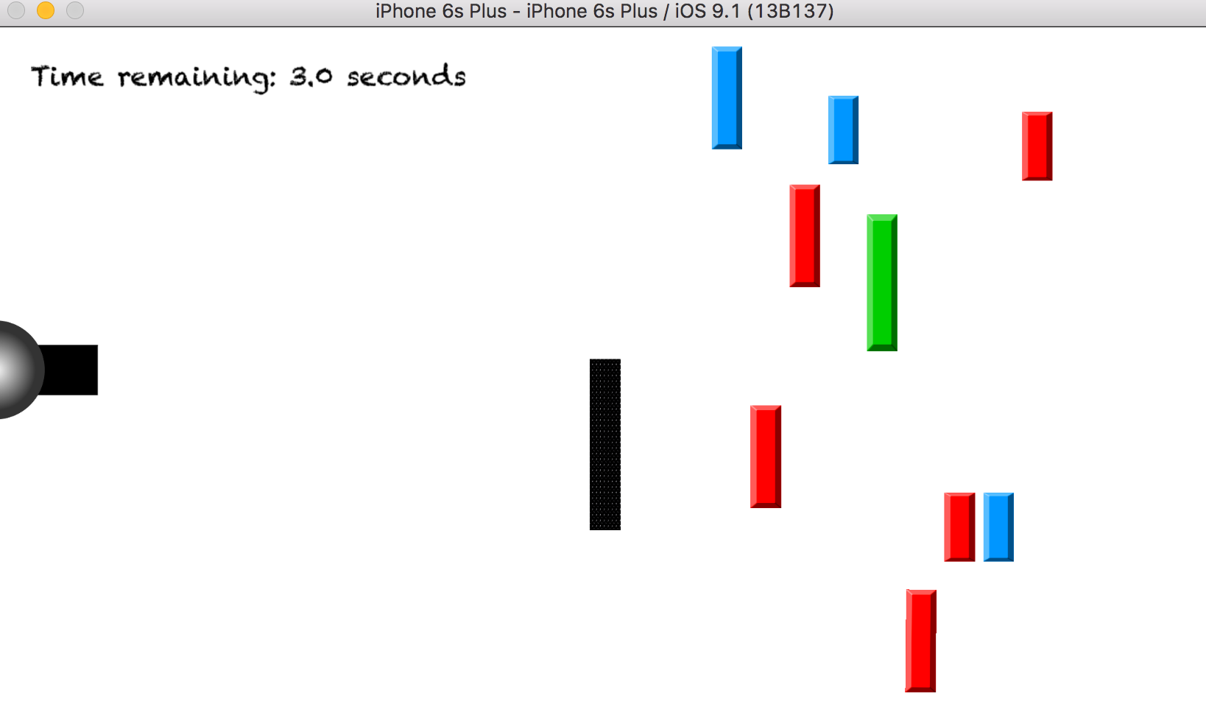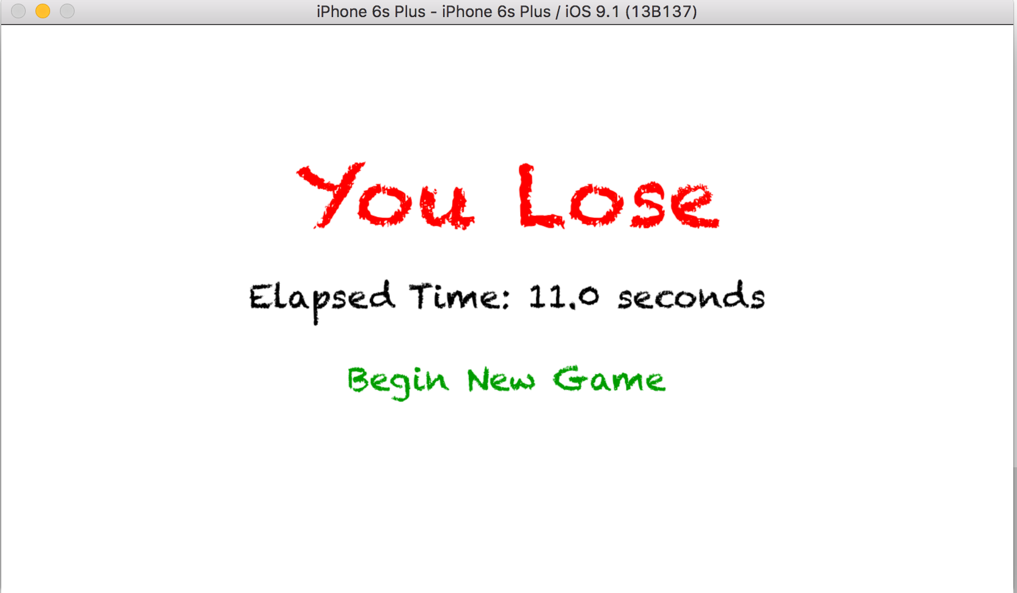

scene.scaleMode = .AspectFill

self.view?.presentScene(scene, transition: doorTransition)

}

}