Jammy Cake

E project Documentation

This is to certify that

**Bappah Jamila**

**And**

**David Akpele**

Successfully designed a

**Jammy Cake**

And Submitted.

Date of issue: **28-Jun-2021**

**ACKNOWLEDGMENT**

We would like to express our special thanks and gratitude to our faculty as well as the head of Aptech Ibadan who gave us the opportunity to do this wonderful project on this topic, which also helped us in doing a lot of Research and came to know about so many new thing, we are really grateful to them.

**SYPNOSIS**

The cake shop focus on ordering and distributing cake for different customer all over the country. It is a user friendly website where you can search, navigate and view any details of different cake such as birthday, marriage, Anniversary, Engagement and so on.

Jammy cake factory has kept Category menu simple by providing individual details pages for each product where the customers can Zoom the product image, select different cake flavors like Red velvet, Chocolate, Coconut, Vanilla, Caramel and so on and also a privilege for the customers to select the quantity for **Egg** on the cake there we have **with Egg** or **Less Egg**.

**Customer Details Page**

On the click on Process Order, a page will display on the browser to fill in their shipping address details such as: **Name, Email, Telephone Number, Country, state, Apartment suit.**

* In other to keep track on each customer order’s, we’ve set each product to have item code which will help us keep relational database clean and simple.
* Having customer details help us to make delivery to our customer based on the information provided

Jammy cake factory used localStorage as their database center to keep all customer details immediately the AddToCart button is clicked.

**Advantage of the local Storage Database**

* To store customer data.
* Help to keep track on customer order by using the item code.
* It stored data for a long time pending the session is set Empty
* Customer can always access their data or continue a page where the stopped.

E Project Design

DFD’s

CLIENTS

NETWORK

SERVER

* Enter website address.
* View our home to view some of our top new products.
* You can view the details of any cake.
* You can zoom each product image to see the whole product state.

**FlowChart:**

Yes

No

Yes

No

No

Yes

No

Yes

Preheat pan?

Taste test

Allow cake to cool

Remove cake from oven

Allow cake to cook

Set timer for specified time

Put filled pan in Oven

Fill pan to specified level

Preheat for 10minutes

Is oven correct temperature?

Preheat oven to specified temperature

Do you need to preheat oven?

Stir Ingredients

Is there any lumps?

Measure Ingredients

Get Ingredients

**Screenshots**

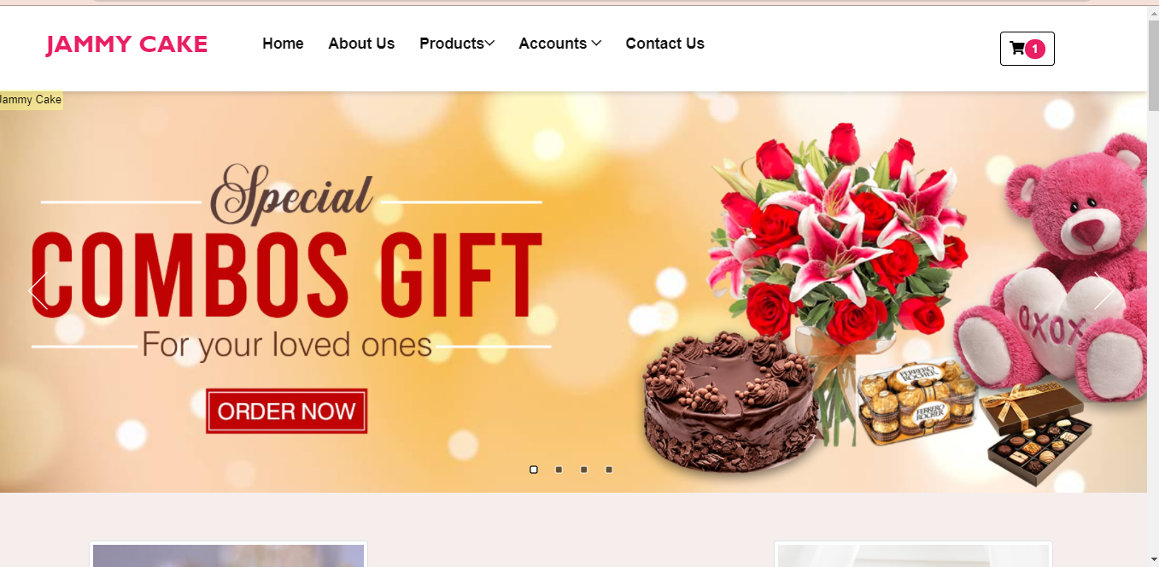

Figure 00:1 –website Banner

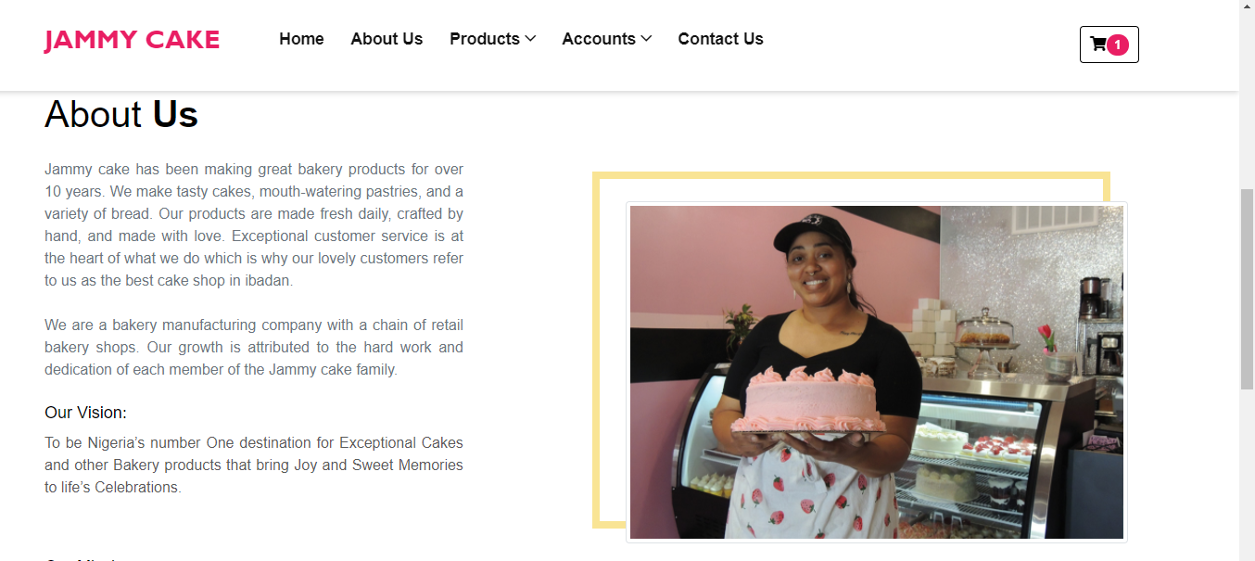

Figure:002 –About-us page

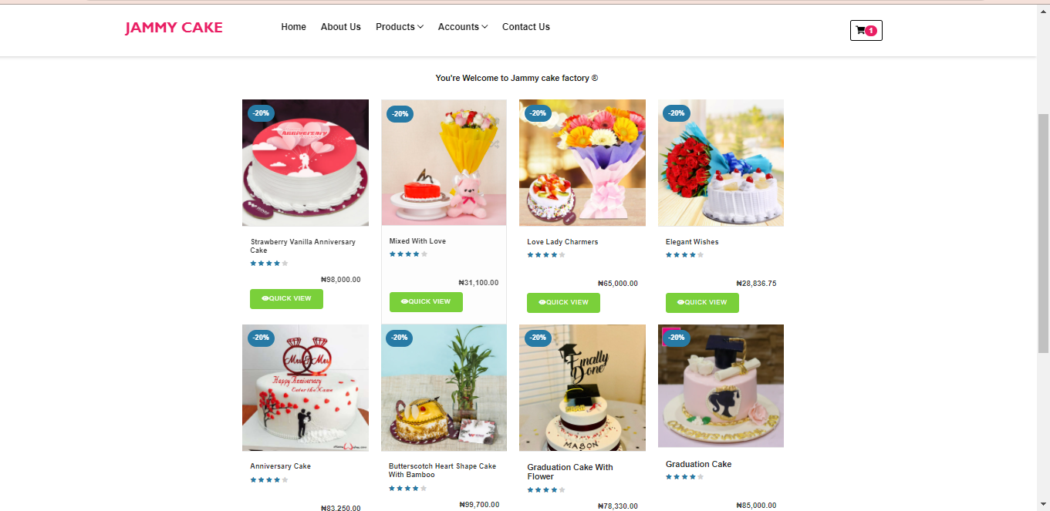

Figure: 003 –Product page

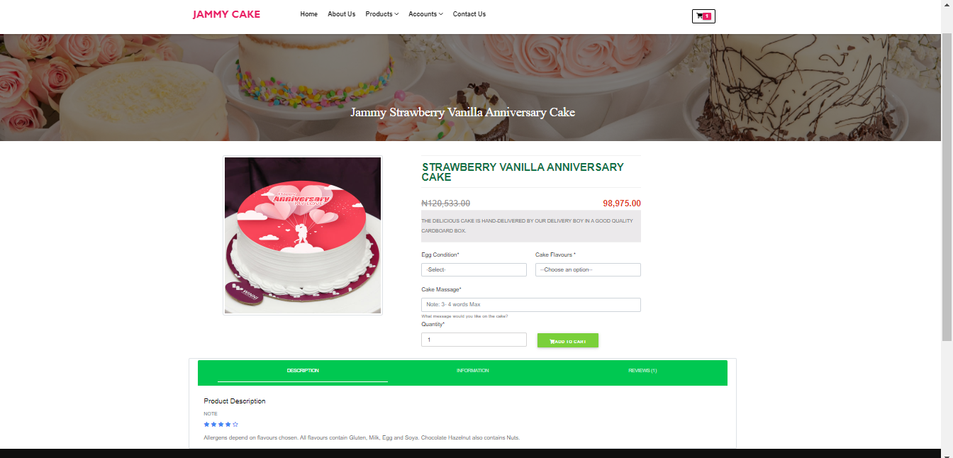

Figure:004 –Individual product page

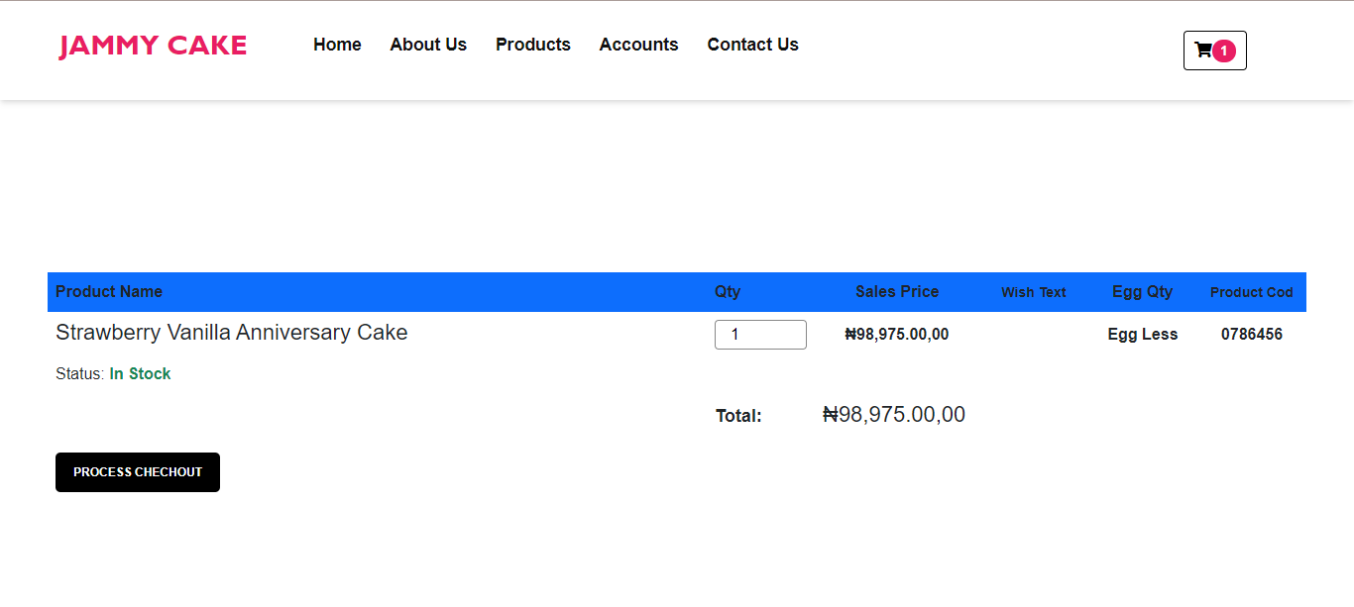

Figure: 005 –Cart Page

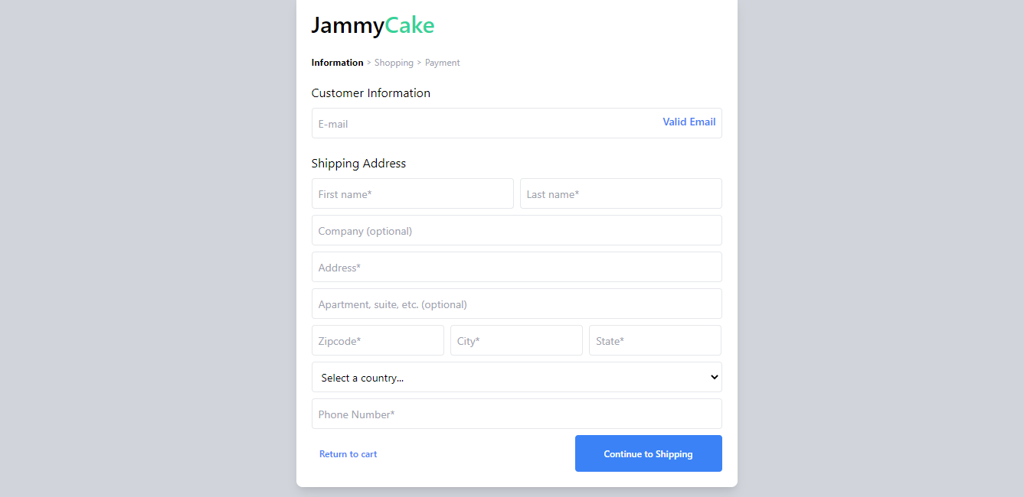

Figure: 006–Process checkout page that will take customer details.

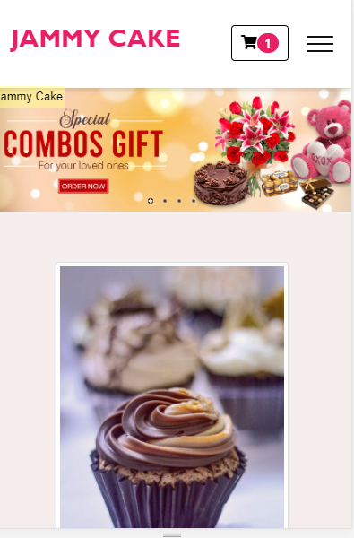

Figure:007 – Jammy cake on Mobile View

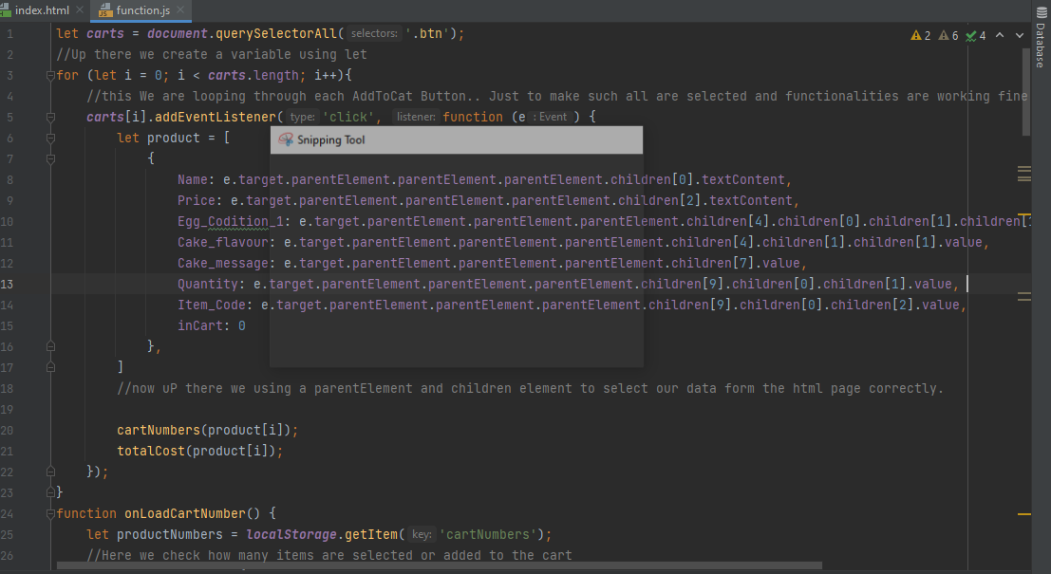

Figure: 008 – code with Comment 001

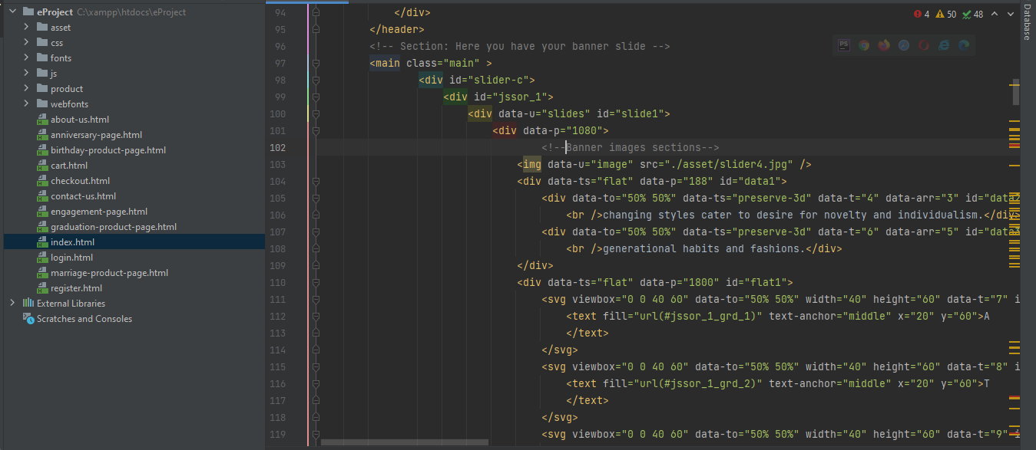

Figure: 009 – code the comment 002

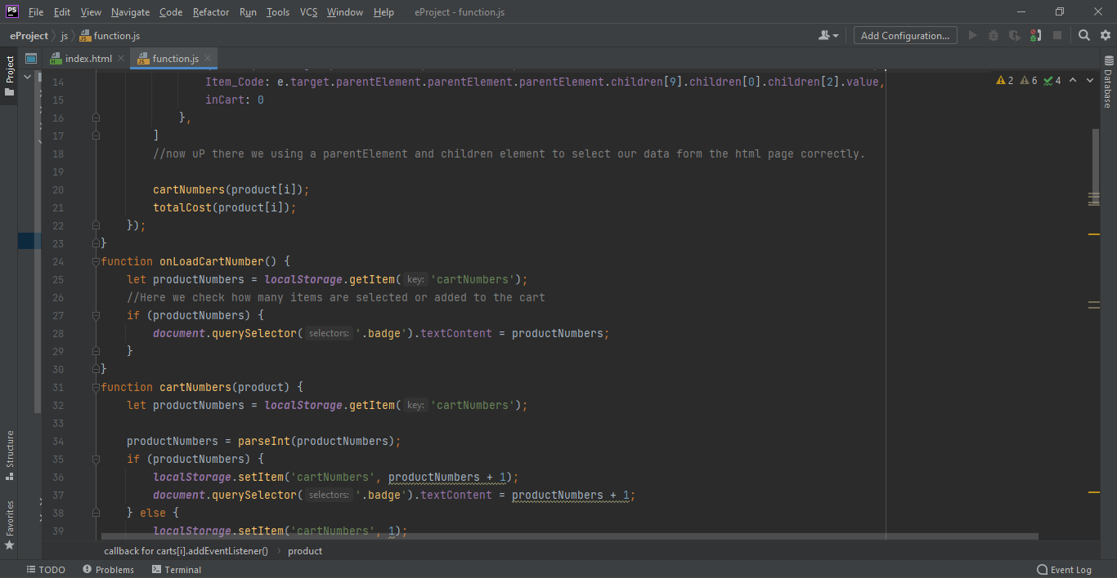

Figure: 010 –Code with comment 002

**Users guide**

This website is like every regular ecommerce website that you use on a daily basis, it is easily accessible and you just have to use your mouse to navigate through the website and it takes you to the page that you want to.

This website can be used on any web browser e.g. Chrome, Firefox, safari etc.

**Developer’s guide**

Html is the latest evolution of the standard that defines Html. It is a new version of the Html, with new element, attributes, and behavior, and a large set of technologies that allows the building of more diverse and powerful websites.

This website was styled using Html5, CSS, and BootStrap designed to be useable by all Open Web developers.